 | Foundation | KS1 | LKS2 | UKS2
Autumn | Features of a face  Line drawing  Colour mixing  Painting  Cutting, using tools  Observational drawing  Collage  Printing  Sculpture  Giuseppe Arcimboldo  Pablo Picasso  Jackson Pollock  Alma Thomas  Henri Matisse  Andy Goldsworthy  Eric Carle | Year 1: Kandinsky (drawing)  Year 2: Angela Oates (drawing) | Year 3: Vincent Van Gogh (still life)  Year 4: Geraldine Theurot (one point perspective landscape drawing – pencil and watercolour) | Year 5: Romero Britto and other pop artists (acrylic painting)  Year 6: Frankauerbach (drawing and sculpture)
Spring |  | Year 1: Jen Stark and Yoyoi Kusama (paper sculpture)  Year 2: Sandra Victorino (painted clay pot) | Year 3: Cho Rising, Tilia Holmes and Edward Lear (clay – fossil relief tiles)  Year 4: Chen Rong (painted clay) | Year 5: Galileo Galilei and Maria Sibylla Merian (drawing)  Year 6: Nnenna Okore and Kevin Iris (wire sculpture)
Summer |  | Year 1: Galal Yousif (paint)  Year 2: Alfred Wallis (paint) | Year 3:Katsushika Hokusai and Stephen Bishop (watercolour)  Year 4: Georgia O’Keeffe (watercolour painting) | Year 5: Henry Moore and Barbara Hepworth (clay)  Year 6: A range of artists – Hockney, Cezanne, Monet (painting/ drawing)
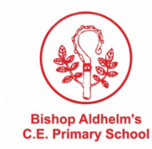
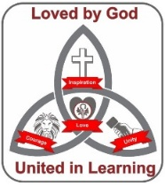
Curriculum Map: Art

