

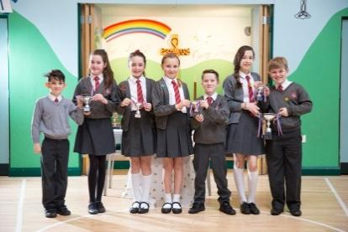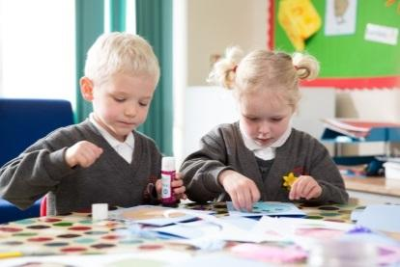

Important Dates for Parents

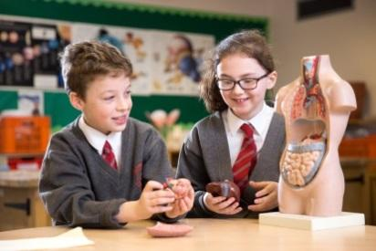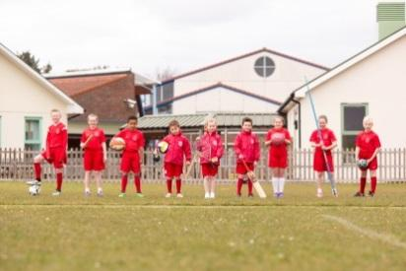

2026-2027

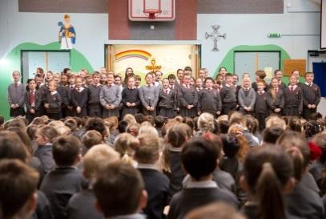

Tuesday 1st September 2026 | INSET Staff School Improvement Days (school closed for children)
Wednesday 2nd September 2026 | INSET Staff School Improvement Days (school closed for children)
Thursday 3rd September 2026 | INSET Staff School Improvement Days (school closed for children)
Friday 4th September 2026 | INSET Staff School Improvement Days (school closed for children)
Monday 7th September 2026 | Children return to school
Monday 7th September 2026 | Foundation Small Group Sessions
Tuesday 8th September 2026 | Foundation Small Group Sessions
Wednesday 9th September 2026 | Foundation children in full time
Friday 11th September 2026 | Blue House Winners Day- Children in Blue House can come to school wearing non-school uniform.
Wednesday 16th September 2026 | 3:30-4:30pm: Time Together – Vision Launch & Meet the Teacher for Year 1, 2 and 6
Thursday 17th September 2026 | 3:30-4:30pm: Time Together – Vision Launch & Meet the Teacher for Year 3, 4 and 5
Thursday 17th September 2026 | 9-10:30: NHS School Nursing Team - Parent Drop-in Session
Monday 21st September 2026 | 1:15-3:15pm: Year 1 and Year 2 Sports Day
Tuesday 22nd September 2026 | 9:15am-11:15am: Year 3 and Year 4 Sports Day  1:15-3:15pm: Year 5 and Year 6 Sports Day
Wednesday 23rd September 2026 | 1.30pm - 2.30pm: Tour for potential new EYFS Parents 2027/2028
Friday 25th September 2026 | 9-11am: Macmillan Coffee Morning
Monday 28th September 2026 | 1:15-3:15pm: Reserve Year 1 and Year 2 Sports Day
Tuesday 29th September 2026 | 9:15-11:15am: Reserve Year 3 and Year 4 Sports Day  1:15-3:15pm: Reserve Year 5 and Year 6 Sports Day
Thursday 1st October 2026 | Start of Black History Month
Friday 2nd October 2026 | 9:30-10:30am: Tour for potential new EYFS Parents 2027/2028
Friday 2nd October 2026 | National Poetry Day
Monday 5th October 2026 | 9-11am: KS2 Harvest Festival @St Aldhelm’s Church - Pupils only
Monday 5th October 2026 | 1:30-2pm: EYFS & KS1 Harvest Festival in school – Pupils only
Tuesday 6th October 2026 | House Captains’ trip to Poole Food Bank
Tuesday 6th October 2026 | 1:30-2:30pm: Tour for potential new EYFS Parents 2027/2028
Wednesday 7th October 2026 | Little Bears Toddler Group 10am – 11am – Autumn Theme
Wednesday 7th October 2026 | Foundation Parents’ Phonics Workshop 09:15  Foundation Parents’ Phonics Workshop 14:30  Foundation Parents’ Phonics Workshop 17:00
Tuesday 13th October 2026 | 9:30-10:30am: Tour for potential new EYFS Parents 2027/2028
Monday 19th October 2026 | 1:30-2:30pm: Tour for potential new EYFS Parents 2027/2028
Wednesday 21st October 2026 | Inclusion Day presentations to parents at 9am and 2pm
Thursday 22nd October 2026 | 3:30pm - Time Together: Stay and Play for prospective families 2027/2028
Friday 23rd October 2026 | Last Day of Half Term for children
Monday 26th October – Friday 30th October 2026 | Half Term Holiday
Saturday 31st October 2026 | Year 6 Deadline for applying for Secondary School Places
Monday 2nd November 2026 | Children Return to School
Monday 2nd November 2026 | 2:00pm: Time Together - Headteacher and Governor Reviews
Tuesday 3rd November 2026 | 1:30-2:30pm: Tour for potential new EYFS Parents 2027/2028
Tuesday 3rd November 2026 | 3:30-7:00pm: Time Together - Parent Consultations
Wednesday 4th November 2026 | Little Bears Toddler Group 10am – 11am - Fireworks theme
Wednesday 4th November 2026 | 3:30-6:00pm: Time Together - Parent Consultations
Friday 6th November 2026 | 9:30-10:30am: Tour for potential new EYFS Parents 2027/2028
Tuesday 10th November 2026 | 9:30-10:30am: Tour for potential new EYFS Parents 2027/2028
Wednesday 11th November 2026 | Remembrance Day – 2 minute silence at 11am
Sunday 15th November 2026 | Family Worship at Bishop Aldhelm’s - 5pm
Monday 16th - Friday 20th November 2026 | Anti-bullying (Friendship) Week: Make a noise about bullying  Odd Socks Day – Monday 16th November
Monday 16th November 2026 | Whole School Photos – Fraser Portraits
Tuesday 17th November 2026 | Sibling Photos – Fraser Portraits
Friday 20th November 2026 | Children in Need Day
Friday 20th November 2026 | 1:30-2:30pm: Tour for potential new EYFS Parents 2027/2028
Friday 27th November 2026 | INSET Staff School Improvement Days (school closed for children)
Monday 30th November 2026 | St Andrew’s Day
Wednesday 2nd December 2026 | Little Bears Toddler Group 10am – 11am – Christmas Theme
Thursday 3rd December 2026 | 4:30-5:30pm: Foundation Parents Christmas Story Telling with hot chocolate
Monday 7th December 2026 | 9:30-10:30am: Tour for potential new EYFS Parents 2027/2028
Monday 7th December 2026 | 2:00-3:00pm: Foundation Nativity Themed Christmas Production
Tuesday 8th December 2026 | 9:30-10:30am: Foundation Nativity Themed Christmas Production
Tuesday 8th December 2026 | 10am-1pm: KS2 Carol Service Rehearsal  1-2.30pm: KS2 Carol Service – St Aldhelm’s Church (Pupils only)  5-6pm: KS2 Carol Service – St Aldhelm’s Church (families invited)
Wednesday 9th December 2026 | 09:30-10:30am: Preschool Nativity event  2:00-3:00pm: Preschool Nativity event
Thursday 10th December 2026 | 9:30-10:30am: Year 1 Christmas Performance
Thursday 10th December 2026 | 2:00-3:00pm: Year 1 Christmas Performance
Thursday 10th December 2026 | Choir at the Lighthouse
Friday 11th December 2026 | 9:30-10:30am: Year 2 Nativity Themed Christmas Production
Friday 11th December 2026 | 2:00-3:00pm: Year 2 Nativity Themed Christmas Production
Monday 14th December 2026 | 1:30-2:30pm: Tour for potential new EYFS Parents 2027/2028
Monday 14th December 2026 | EYFS & Y6 Christingle Service at 2:30pm
Tuesday 15th December 2026 | Early Years and KS1 Father Christmas Visit
Wednesday 16th December 2026 | Christmas Jumper Day  Christmas Lunch  2:00pm: Whole School Christmas Outdoor Celebration (families invited). Weather Permitting.
Friday 18th December 2026 | Christmas Parties in Year Groups. Non-school uniform.
Friday 18th December 2026 | 3:15pm: Last Day of Term
Monday 21st December 2026– Friday 3rd January 2027 | Christmas Holiday
Monday 4th January 2027 | INSET Staff School Improvement Days (school closed for children)
Tuesday 5th January 2027 | Children Return to School
Wednesday 6th January 2027 | Little Bears Toddler Group 10am – 11am – Winter Theme
Wednesday 6th January 2027 | 3:30pm - Time Together: Stay and Play for prospective families 2027/2028
Monday 11th January 2027 | 1:30-2:30pm: Tour for potential new EYFS Parents 2027/2028
Tuesday 12th January 2027 | 3:30-4:00pm: Year 1 - Time Together - Parent Meeting- Phonics Screening Test
Wednesday 13th January 2027 | 5:00-6:00pm: Year 6 – Time Together - Parent Meeting- KS2 SATs and Residential Talk
Thursday 14th January 2027 | 3:30-4:30pm: Year 4 – Time Together - Parent Meeting- Multiplication Check
Friday 15th January 2027 | Deadline for parents to apply for a primary school place for September 2027
Monday 1st – 5th February 2027 | Children’s Mental Health Week
Wednesday 3rd February 2027 | Little Bears Toddler Group 10am – 11am – Lunar New Year Theme
Thursday 4th February 2027 | Foundation Parents’ Maths Workshop – 14:15 (classrooms)
Friday 5th February 2027 | NSPCC Number Day
Monday 8th February 2027 | 2:45-3:30pm- Time Together Year 3 Celebration of Work
Tuesday 9th February 2027 | Safer Internet Day
Tuesday 9th February 2027 | Year 1 – Time Together: Phonics Workshop – parents invited to join a phonics lesson in classrooms 09:00
Tuesday 9th February 2027 | 2:45-3:30pm- Time Together - Year 2 Celebration of Work
Wednesday 10th February 2027 | 2:30-3:15pm Preschool Celebration of Work
Thursday 11th February 2027 | 2:45-3:30pm- Time Together - Year 4 and 5 Celebration of Work
Friday 12th February 2027 | 2:45-3:30pm- Time Together - Year 6 Celebration of work- come and see your child’s work from the first part of the year.
Friday 12th February 2027 | 3:15pm: Last Day of Term
Monday 15th February - Friday 19th February 2027 | Half Term Holiday
Tuesday 23rd February 2027 | 3:30-6:00pm: Time Together - Parent Consultations
Wednesday 24th February 2027 | Inclusion Day presentations to parents at 9am and 2pm
Thursday 25th February 2027 | 3:30-7:00pm: Time Together - Parent Consultations
Monday 1st March 2027 | St David’s Day
Wednesday 3rd March 2027 | Little Bears Toddler Group 10am – 11am – Easter Theme
Thursday 4th March 2027 | World Book Day
Sunday 7th March 2027 | Family Worship at Bishop Aldhelm’s - 5pm
Wednesday 10th March 2027 | Class Photos/Year 6 Leavers Photos – Fraser Portraits
Tuesday 16th March 2027 | Young Carers’ Day
Tuesday 16th March 2027 | Spring Choir Showcase at 5pm – venue to be confirmed
Wednesday 17th March 2027 | Y4 Ukelele Concert – 2:15pm
Wednesday 17th March 2027 | St Patrick’s Day
Thursday 18th March 2027 | 9:00am: Time together - Headteacher and Governor Reviews
Friday 19th March 2027 | World Down Syndrome Day – Odd Socks Day
Monday 22nd March 2027 | Year 3 & 5 Easter Experience @ St Aldhelm’s Church
Tuesday 23rd March 2027 | Early Years & KS1 Easter Experience @ Bishop Aldhelm’s
Wednesday 24th March 2027 | Year 4 & 6 Easter Experience @ St Aldhelm’s Church
Wednesday 24th March 2027 | 3:15pm: Last Day of Term for children
Thursday 25th March 2027 | INSET Staff School Improvement Days (school closed for children)
Friday 26th March – Friday 9th April 2027 | Easter Holiday
Monday 13th April 2027 | Children Return to School
Monday 13th – Friday 17th April 2027 | STEM Week
Friday 23rd April 2027 | St George’s Day
Wednesday 5th May 2027 | Little Bears Toddler Group 10am – 11am – Spring Theme
Saturday 8th May 2027 | VE Day
Monday 10th May – Thursday 13th May 2027 | Year 6 SATs week
Monday 24th May 2027 | Foundation Parents’ Writing Workshop
Friday 28th May 2027 | 3:15pm: Last Day of Half Term
Monday 31st May – Friday 4th June 2027 | Half Term Holiday
Monday 7th June 2027 | Children Return to School
Wednesday 9th June 2027 | Little Bears Toddler Group 10am – 11am – Music Theme
Monday 7th June – Friday 18th June 2027 | Year 4 Multiplication Check Window
Monday 14th June – Friday 18th June 2027 | Year 1 Phonic Assessment Week
Monday 14th June – Friday 18th June | National Sports Week
Monday 14th June 2027 | Y6 Leavers’ Service at Salisbury Cathedral
Wednesday 16th June 2027 | 9am- Time Together - Headteacher and Governor Reviews
Friday 18th June 2027 | 3:30-5:30pm: PSA Summer Fayre
Wednesday 23rd June 2027 | 9.15am – 11.15am: Parent Partnership – Pre-School and Foundation Sports Day
Thursday 24th June 2027 | Dream Jobs Day
Friday 25th June 2027 | Whole School Transition Event (including Primary to Secondary)
Sunday 27th June 2027 | Family Worship at Bishop Aldhelm’s – 5pm
Tuesday 29th June 2027 | Summer Choir Concert – 5pm – venue to be confirmed
Wednesday 30th June 2027 | RESERVE DATE:  9.15am – 11.15am: Parent Partnership – Pre-School and Foundation Sports Day
Friday 2nd July 2027 | Year 6 St Aldhelm’s Head Pilgrimage
Friday 2nd – Sunday 4th July 2027 | Year 6 Residential (PGL)
Monday 5th July 2027 | 2:45-3:30pm- Time Together– Foundation and Year 3 Celebration of Work
Monday 5th July 2027 | Year 3 recorder concert in the Hall – 2:30pm
Tuesday 6th July 2027 | Inclusion Day presentations to parents at 9am and 2pm
Tuesday 6th July 2027 | 2:45-3:30pm- Time Together - Year 1 and 2 Celebration of Work
Wednesday 7th July | Little Bears Toddler Group 10am – 11am – Teddy Bears’ Picnic
Thursday 8th July 2027 | 2:45-3:30pm- Time Together - Year 4 and 5 Celebration of Work
Friday 9th July 2027 | Annual reports available on DCPro
Tuesday 13th July 2027 | 1:30pm: Year 6 Show (1)  5pm: Year 6 Show (2)
Thursday 15th July 2027 | 2.00pm- Pre-School Graduation
Friday 16th July 2027 | Diversity Day
Tuesday 20th July 2027 | 10am-2pm: Year 6 Leavers Service Rehearsal – St Aldhelm’s Church  5pm: Year 6 Leavers Service – Families Invited – St Aldhelm’s Church
Thursday 22nd July 2027 | 3:15pm: Last Day of Term for children

Dates are subject to change

