 | Foundation | KS1 | LKS2 | UKS2
Autumn |  | Nutrition: Smoothies (Y1)  Nutrition: Healthy wraps (Y2) | Nutrition: Seasonal crumble (Y3)  Nutrition: Biscuits (Y4) | Structures: Bridges (Y5)  Textiles: Waistcoat (Y6)
Spring |  | Textiles: Puppets (Y1)  Structures: Chair (Y2) | Textile: Cushions (Y3)  Textile: Book Sleeve (Y4) | Nutrition: Bolognese (Y5)  Nutrition: Three course meal (Y6)
Summer | Nutrition: Soup | Structures: Windmill (Y1)  Textiles: Pouch (Y2) | Mechanisms: Pneumatic toys (Y3)  Mechanisms: Moving Vehicles (Y4) | Textiles: Soft toys (Y5)  Structures/Mechanisms: Designing new playground apparatus (Y6)
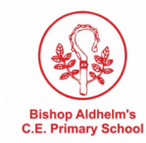
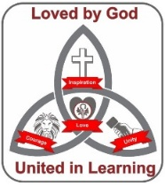
Curriculum Map: Design and Technology

In addition to the following, Bishop Aldhelm’s provides:
- Enterprise days
- STEM week
- Additional crafts at Christmas like pop up and applique cards.

