 | Foundation | KS1 | LKS2 | UKS2
Autumn 1 | The Natural World
Autumn 2 | The Natural World | Map Makers (Y1)  Geography of our school (Y2) | Farming and agriculture (Y3)  All around the world (Y4) | Rivers (Y5)  Trade (Y6)
Spring 1 | The Natural World
Spring 2 | The Natural World | The UK (Y1)  Continents and Oceans (Y2) | The UK (Y3)  Coasts (Y4) | North America (Y5)  Local impact (Y6)
Summer 1 | The Natural World
Summer 2 | The Natural World | Poole and Juba (Y1)  Polar and Deserts (Y2) | Volcanoes and Earthquakes (Y3)  Europe (Y4) | South America (Y5)  Local impact (Y6)
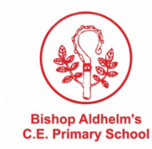
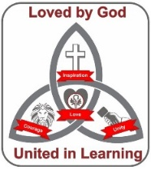
Curriculum Map: Geography

