 | Foundation | KS1 | LKS2 | UKS2
Autumn 1 | Past and Present | Year 1: Kings and Queens  Year 2: The Gunpowder Plot | Year 3: Ancient Egypt | Year 5: Anglo-Saxons  Year 6: World War Two
Autumn 2 | Past and Present |  | Year 4: Mayan Civilisation
Spring 1 | Past and Present | Year 1: Grandparents  Year 2: The Great Fire of London |  | Year 5: Vikings
Spring 2 | Past and Present |  | Year 3: Stone Age to Bronze Age  Year 4: Ancient Greeks | Year 6: Tudors
Summer 1 | Past and Present | Year 1: Grace Darling  Year 2: Significant People |  | Year 5: The History of Poole  Year 6: Local History
Summer 2 | Past and Present |  | Year 4: Roman Britain
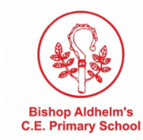
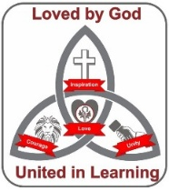
Curriculum Map: History

