 | Foundation | KS1 | LKS2 | UKS2
Autumn 1 | (PS)  Listening and responding to sounds (EYFS) | We’ve Got Rhythm (Y1)  Peter and the Wolf (Y2) | Get on Board (Y3)  Musical Journeys 1 (Y4) | The building blocks of music. (Y5)  The music of World War II (Y6)
Autumn 2 | (PS)  Singing (EYFS) | Nativity Performance (Y1)  Nativity Performance (Y2) | Light Fantastic/Christmas Choir (Y3)  Digital Music Production – A spooky story/Christmas Choir (Y4) | Digital music production – Grime/Christmas Choir (Y5)  Beat it/Christmas Choir (Y6)
Spring 1 | (PS)  Instruments of the Orchestra (EYFS) | Carnival of the Animals (Y1)  Great Fire of London (Y2) | Digital Music Production – Underwater (Y3)  Ukulele first access (Y4) | Journey into space (Y5)  Rap and Beatboxing (Y6)
Spring 2 | (PS)  Beat and Rhythm (EYFS) | Musical Explorers (Y1)  Using Symbols to Represent Pitch (Y2) | Musical Processes (Y3)  Ukulele first access (Y4) | Musical Architects (Y5)  Digital Music Production – Hip Hop (Y6)
Summer 1 | (PS)  World Music (EYFS) | Toys (Y1)  Pirates (Y2) | Rocking Recorders 1 (Y3)  A Young person’s guide to the orchestra (Y4) | Samba First Access (Y5)  Keyboard Composition (Y6)
Summer 2 | (PS)  Performance (EYFS) | My Singing Voice (Y1)  Perfect Pulse (Y2) | Rocking Recorders 2 (Y3)  Painting with sound. (Y4) | Samba first access (Y5)  Production (Y6)
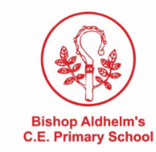
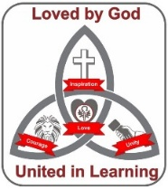
Curriculum Map: Music

