 | Foundation | KS1 | LKS2 | UKS2
Autumn 1 | Me and my relationships | Me and my relationships | Me and my relationships | Me and my relationships
Autumn 2 | Valuing difference | Valuing difference | Valuing difference | Valuing difference
Spring 1 | Keeping safe | Keeping safe | Keeping safe | Keeping safe
Spring 2 | Rights and respect | Rights and respect | Rights and respect | Rights and respect
Summer 1 | Being my best | Being my best | Being my best | Being my best
Summer 2 | Growing and changing | Growing and changing | Growing and changing | Growing and changing
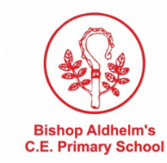
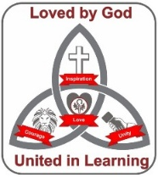
Curriculum Map: PSHE

In addition to the following, Bishop Aldhelm’s provides:
- Dream jobs day (KS2)
- Play street visit (pre-school, foundation and KS1)
- Dorset fire service visit
- BCP Road safety team
- SCARF workshop week (foundation – Year 6)

