 | Foundation | KS1 | LKS2 | UKS2
Autumn 1 | Christianity | Judaism (Y1)  Christianity (Y2) | Sikhi (Y3)  Judaism (Y4) | Hinduism (Y5)  Islam (Y6)
Autumn 2 | Judaism | Christianity (Y1)  Christianity (Y2) | Christianity (Y3)  Christianity (Y4) | Christianity (Y5)  Islam (Y6)
Spring 1 | Islam | Christianity (Y1)  Islam (Y2) | Christianity (Y4)  Judaism (Y4) | Hinduism (Y5)  Christianity (Y6)
Spring 2 | Hinduism | Christianity (Y1)  Christianity (Y2) | Christianity (Y4)  Christianity (Y4) | Christianity (Y5)  Humanism (Y6)
Summer 1 | Sikhi | Christianity (Y1)  Islam (Y2) | Sikhi (Y3)  Humanism (Y4) | Hinduism (Y5)  Islam (Y6)
Summer 2 | Christianity | Judaism(Y1)  Islam (Y2) | Sikhi (Y3)  Christianity (Y4) | Christianity (Y5)  Islam (Y6)
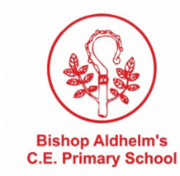
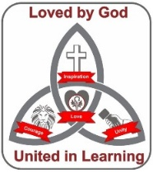
Curriculum Map: RE

