How to use Google Classroom
We now ask that your complete all home learning in the red homework books and then upload the work onto Google Classroom. Here’s how it works…
Type in google classroom to your browser and select the address shown.
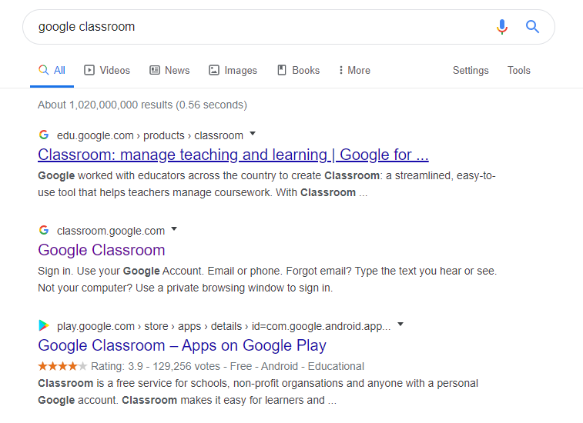
Sign in with your email and password
Type in your school email address. 16initiallastname@bishopaldhelms.poole.sch.uk
For example and email for John Doe would be 16jdoe@bishopaldhelms.poole.sch.uk
Password : red-1234
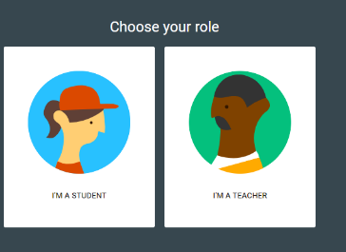
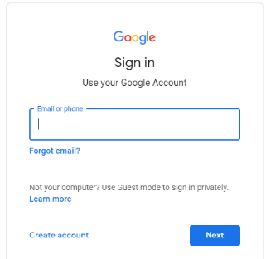
Select student

Click on the plus sign
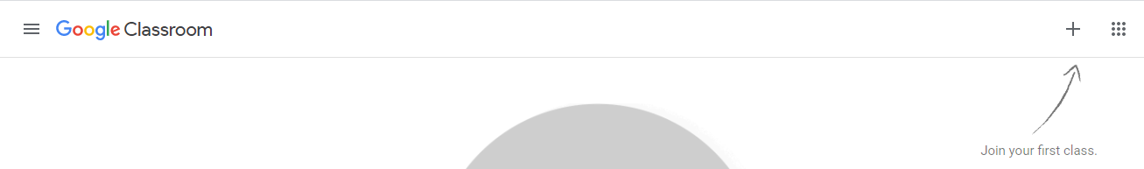
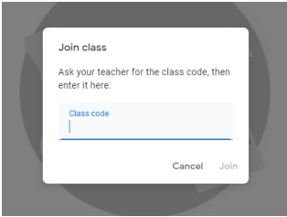
Add the code for your class
4RH - 6uofca2 4SP – pyqothd 4VP - b5vjgn4

Now you will be able to share the work you are proud of. The teachers and other children will be able to see your work.

