At Bishop Aldhelm’s C.E. Primary School we are learning phonics through the ‘Letters and Sounds’ programme. Our aim is for our children to be able to read with accuracy and confidence, and above all to love reading.
When learning to read the children will:
- Learn that sounds (phonemes) are represented by written letters (graphemes)
- Learn all the digraphs (sounds represented by two letters) and trigraphs (sounds represented by three letters) to be able to sound out and blend most words for reading.
- Learn how to blend words with these sounds in.
- Learn that there are a number of words that do not follow this phonetic code and they learn to read these as ‘Tricky Sight Words’.
- Learn to read words using ‘sound buttons’ (segmenting and blending).
- Read stories featuring words they have learned to sound out.
- Show that they comprehend the stories by answering questions.
The sounds are learnt in phases:
- Phase 2 s, a, t, p, i, n, m, d, g, o, c, k, ck, e, u, r, h, b, f, ff, l, ll, ss.
- Phase 3j, v, w, x, y, z, zz, qu Consonant digraphs: ch chip, sh shop, th thing, ng string Vowel digraphs: ai snail, ee see, igh high, oa boat, oo look/zoo, ar car, or, ur fur, ow cow/blow, oi boil, ear hear, air fair, ure pure, er letter.
- Phase 4 consolidating knowledge of graphemes in reading and spelling words containing adjacent consonants and polysyllabic words.
- Phase 5 ay day, oy boy, wh when, a-e make, ou out, ir girl, ph photo, e-e these, ie tie, ue blue, ew new, i-e like, ea eat, aw saw, oe toe, au Paul, o-e home, u-e rule.
What is the phonics screening check? The National phonics screening check is a statutory assessment that was introduced in 2012 to all Year 1 pupils and is a quick and easy check of your child’s phonics knowledge. Any children who do not meet the required standard in Year 1 will receive extra support and retake the check in Year 2. Any children who do not pass in Year 2 will continue to receive support until they have a confident knowledge of phonics.

What is in the phonics screening check? It comprises of a list of 40 words and nonsense words. It will assess phonics skills and knowledge learnt through Foundation and Year 1. The check is very similar to tasks the children already complete during phonics lessons and will in no way seem like a ‘test’ to the children.

What are Nonsense or ‘Alien’ words and why are they included? These are words that can be phonetically decoded but not actual words with an associated meaning e.g. brip, snorb. These words are included in the check specifically to assess whether your child can decode a word using phonic skills and not their memory. The alien words will be shown to your child with a picture of an alien. The children will be asked what the aliens name is by reading the word. This will make the check a bit more fun and provides the children with a context for the nonsense word. Crucially it does not provide any clues, so your child has to be able to decode it. Children generally find nonsense words amusing so they will probably enjoy reading these words.

On the final page of this booklet you will find links to websites that you can use with your child to help them practice and apply their phonics knowledge! We will also be setting different phonics games as homework on Education City so please use your child’s log in and enjoy! The children at Bishop Aldhelm’s love their phonics lessons and will enjoy showing you what they can do!
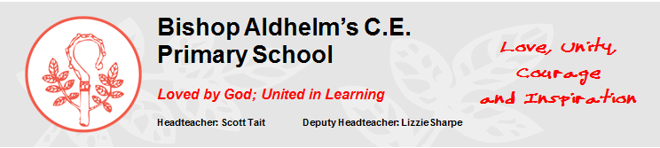
Year 1 Phonics
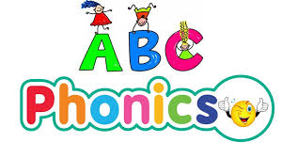
Free Phonic Apps | Phonic Apps with a cost
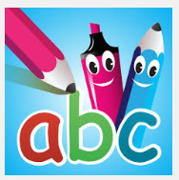 Pocket Phonics | 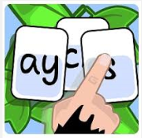Forest Phonics
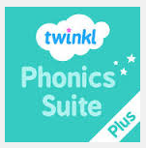 Twinkl phonics | 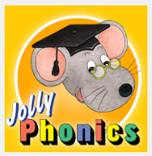 Jolly Phonics songs
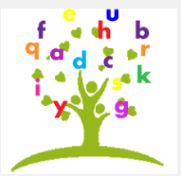 Phonics fun | 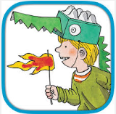Phonics Spelling Dictionary
 Zat Phonics | 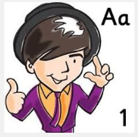 Mr Thorne Phonics
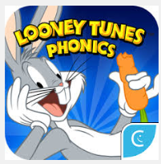Looney Tunes Phonics | * Not all Apps will work on every device.
Phonics Websites
http://www.bishopaldhelms.poole.sch.uk/classescurriculum/phonics/
- http://www.letters-and-sounds.com/what-is-letters-and-sounds.html
- https://www.teachyourmonstertoread.com/
- http://www.phonicsplay.co.uk/
- www.bbc.co.uk/schools/wordsandpictures/phonics/
- www.bbc.co.uk/schools/ks1bitesize/literacy/
- www.ictgames.com/literacy.htm
- http://resources.woodlands-junior.kent.sch.uk/interactive/literacy.html
- http://www.readingbear.org/
- http://www.magickeys.com/books/phonics.html
- http://www.mrthorne.com/

