Yr11 to A Level Business

Online business learning opportunities for
A level business students

Extended preparation work for 6th form
__________________________________

This pack details the topics that you may be covered curing the course of A level Business.

Pick an activity and work through the pack. The pack includes links to many sources of information about business studies that you can have a look at online during the year 11 to year 12 transition period and some suggested activities for you to complete.

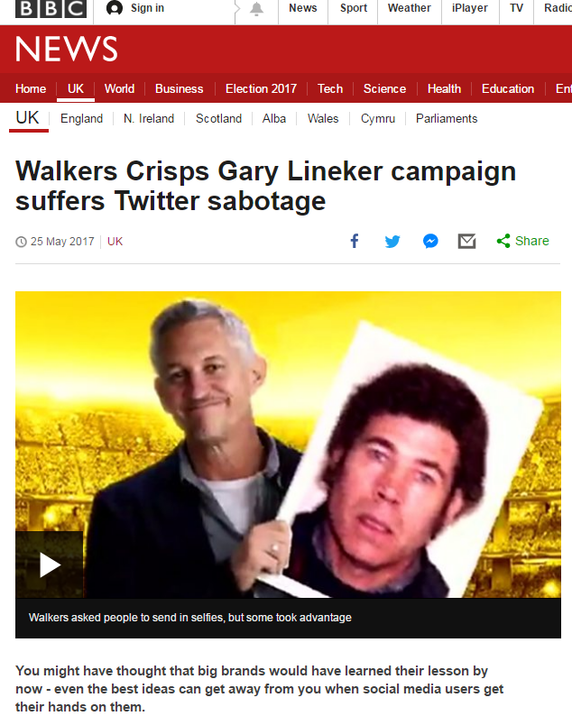
Documentaries
If you have access to on demand programs, Netflix or Amazon prime, watch some of the documentaries and films listed below and make some notes about the topics that they cover, the questions that are asked, the issues that are raised.

Activity: Summarise the documentary/film on an A4 page using the 5 Ws: When? Who? Where? What? Why? If appropriate, add a 6th W: What next?

- The Nine to Five with Stacey Dooley - BBC iPlayer
- Tricky Business - https://www.channel4.com/programmes/tricky-business Channel 4 On Demand
- Beauty Laid Bare - BBC iPlayer
- The True Cost - Netflix
- Broken – Episode on IKEA - Netflix
- Flat pack empire – BBC2 iPlayer
- Inside Cadbury chocolate secrets unwrapped - https://www.youtube.com/watch?v=BB3lJuMNUEk
- Food unwrapped - Channel 4 on demand
- Inside the supermarket - https://www.youtube.com/watch?v=_qwucutFTsQ
- Panorama Amazon: What they know about us – BBC iPlayer
- Panorama Amazon: The Truth Behind the Click – BBC iPlayer and/or https://www.youtube.com/watch?v=JwrUYS9UTeU
- Pepsi vs Coke – Amazon prime video
- Jobs Vs Gates: The Hippie and The Nerd – Amazon prime video
- Starbuck unfiltered – Amazon prime video
- Facebook – Cracking the code – Amazon prime video
- Data centre the true cost of the internet – Amazon prime video
- Learn from The Experts - Jeff Bezos, Amazon Founder – Amazon prime video
- Learn from The Experts - Elon Musk, Tesla and SpaceX – Amazon prime video
- The millennial dream – Amazon prime video
- Business mindset for success – Amazon prime video
- Steve jobs – Billion Dollar Hippie – Netflix
- American Factory – Netflix
- Inside Waitrose – Channel 5 on My5
- Inside the factory – BBC2
- Dragons Den – BBC2

Films
- The Founder – Dvd – Amazon prime video or Netflix – Franchising
- Deep Water Horizon – DVD - Amazon prime video – Ethical issues
- Trump – What’s the deal – Amazon prime video
- The Internship – Amazon Prime video
- The Social Network – Netflix
- The Big Short – Netflix
- The Great Hack – Netflix
- Enron: the smartest guys in the room – Amazon Prime and lots of analysis on YouTube

Books/Audiobooks

Course textbook
Edexcel A level Business, 5th Edition - Hall, Jones, Raffo. ISBN: 978-1-4479-8354-5

It is recommended you buy the course textbook for private study in the 6th form study centre and for extended learning opportunities at home.

Books for wider reading
If you have access to Google Books, Amazon e-books, audio books or any other such online facility, read one of the suggestions below.

Activity: Write a book review. If you're stuck on what to say, imagine you're talking to someone who is asking you whether they should read the book.

- Start with a couple of sentences describing what the book is about: write a synopsis.
- Discuss what you particularly liked about the book: why should students read this book?
- Mention anything you disliked about the book
- Give some key facts
- Try and list some of the A level concepts mentioned in the topics list.
- Round up your review: Summarise some of your thoughts on the book by suggesting the type of reader you'd recommend the book to. For example: younger readers, older readers, fans of relationship drama/mystery stories/comedy. Are there any books or series you would compare it to?
- Give the book a rating, for example a mark out of five or ten, if you like!

- Anyone can do it – Duncan Bannatyne
- The Rise And Fall Of Marks & Spencer - and How It Rose Again – Judi Bevan
- What You See Is What You Get: My Autobiography - Alan Sugar
- Management in ten words - Terry Leahy
- Screw it lets do it – Richard Branson
https://www.youtube.com/watch?v=h9FkeyvdA2M
- The Virgin Way – Richard Branson
Audio Book (free) - https://www.youtube.com/watch?v=5wz40rdz7i4
- The New One Minute Manager – Blanchard & Johnson
Audio Book (free) - https://www.youtube.com/watch?v=ar4lrwXM4ao

Wake Up and Change Your Life by Duncan Bannatyne
https://www.youtube.com/watch?v=zqLVkMeJwE4&list=PLosYlgqowJvECmirOpdlI_Ynw5Lb4M-Tf&index=10&t=0s

Topical business news articles and videos
Get the BBC and the Guardian news apps and check the Business headlines every day, read 2-3 good articles a week.

Activity: Pick an article of your choice and summarise your findings on an A4 page using the 5 Ws: When? Who? Where? What? Why? If appropriate, add a 6th W: What next?

Below are some ideas to get you started:
- Impact of Coronavirus: https://www.tutor2u.net/business/reference/business-impact-and-response-to-the-coronavirus-crisis
- Impact of Coronavirus on cash flow and liquidity: https://www.reuters.com/article/us-health-coronavirus-easyjet/big-uk-airlines-ground-most-of-their-fleets-to-survive-coronavirus-idUSKBN2130S9
and https://www.bbc.co.uk/news/business-52027342?intlink_from_url=https://www.bbc.co.uk/news/topics/c77jz3mdmy3t/iag&link_location=live-reporting-story
- Non-price factors affecting demand: https://www.bbc.co.uk/news/amp/business-52066454
- Corporate Social Responsibility: https://www.tutor2u.net/business/reference/corporate-social-responsibility-during-the-coronavirus-pandemic
- Food supply: https://www.bbc.co.uk/news/business-52020648
- Agriculture, food supply and migration: https://uk.reuters.com/video/watch/the-race-to-save-americas-harvest-idOVC7O0TEN
- Oil industry retrenchment: https://www.theguardian.com/business/2020/apr/01/bp-to-cut-spending-amid-most-brutal-oil-price-rout-in-decades
- On Twitter, search for posts with the handles #Theme1 #alevelbusiness and follow the autors
- On Twitter, follows @revisionstation, @tutor2business, @twoteachers.

Quantitative skills

Activity: Listen to the video below and practice some calculations

- Index numbers: https://www.tutor2u.net/business/reference/quantitative-skills-in-a-level-business-index-numbers
- Percentage change : https://www.tutor2u.net/business/reference/business-maths-calculating-percentage-changes
- Exchange rates https://www.tutor2u.net/business/reference/business-maths-exchange-rates
- All other quantitative skills for the whoe course are referenced here: https://www.tutor2u.net/business/collections/business-maths

Biz Quiz

Activity: test your knowledge of current affairs.
Click on the links below and for all questions that are incorrect, find the relevant news article and read about it.

- https://www.tutor2u.net/business/blog/the-biz-quiz-6-march-2020
- https://www.tutor2u.net/business/blog/the-biz-quiz-13-march-2020
- https://www.tutor2u.net/business/blog/the-biz-quiz-27-march-2020
- And try the quiz for subsequent weeks

Online websites
Find the online courses below and go through the course content.

Activities
Make revision cards for keywords
Make mind maps with pros and cons of various concepts, e.g. pros and cons of a franchise.
Make a formula list and add some example calculations

- Seneca Learning – search for A level Business then choose Edexcel https://www.senecalearning.com/ then study Theme 1 topics in order
- Tutor2u reference library – https://www.tutor2u.net/business/reference
- YouTube videos – subscribe to the following channels: tutor2u, TakingTheBiz, Business As Usual

Podcasts

Activities
Make revision cards for keywords.
Draw diagrams and label them.
Make mind maps with pros and cons of various concepts, e.g. pros and cons of a franchise.
Make a formula list and add some example calculations

Efficiency and productivity
https://www.listennotes.com/podcasts/revise-a-level/operational-performance-zqDYtCScRly/

Pricing
https://www.listennotes.com/podcasts/revise-a-level/decision-making-pricing-a-l7Jkg6TS-sc/

Pricing decisions
https://www.listennotes.com/podcasts/revise-a-level/a-level-business-pricing-104HhoZXA3T/

PED and YED
https://www.listennotes.com/podcasts/revise-a-level/interpreting-ped-and-yed-a-G69jaVzkAsd/

Market research
https://www.listennotes.com/podcasts/revise-a-level/market-research-a-level-XhQS6TDc5iH/

Market mapping
https://www.listennotes.com/podcasts/revise-a-level/market-mapping-a-level-ZW51hHAda-P/

Marketing objectives
https://www.listennotes.com/podcasts/revise-a-level/setting-marketing-objectives-pgGOoZ6a3RA/

Raising Finance
https://www.listennotes.com/podcasts/revise-a-level/a-level-business-raising-R672m5eU0O9/

Limited Liability
https://www.listennotes.com/podcasts/revise-a-level/a-level-business-limited-dFP8zKNLobg/

Typical Student Expectations in a Business area

At Sixth Form, it is expected that students take a more pro-active approach to their studies and develop independent learning skills. In Business, it is important to foster a mature and professional working environment that gives students an opportunity to learn. Part of this is taking responsibility for your progress. Therefore, you will be referred for additional study sessions if it is felt that you require extra time to consolidate your knowledge and exam technique. If you feel you require any help and/or guidance with your work, please speak to your teacher.

The following is expected:

- Conduct and behaviour in lessons should reflect that of a professional working environment. If your behaviour does not allow learning to occur, you will be reminded of this and you may be asked to leave the lesson and sent to the study centre to continue your work. If this occurs, you will be referred to the Head of Year to explain your conduct.

- Folder and textbook are to be brought to every lesson. Failure to do so on 3 occasions will again result in phone call or email home. If there is an issue with you bringing your folder and textbook to each lesson, please speak to your teacher.

- Students must turn up on time to every lesson. It is very disruptive to have students walking in late and is not fair on the rest of the group. Your teacher will not wait for you to start the lesson. If a pattern emerges of continued poor punctuality you will be asked to attend extra study sessions and referred to the Head of Year to explain yourself.

- If you are absent from a lesson, it is your responsibility to catch up on the missed work. You will be expected to contact your teacher to ask for work and to use ClassCharts for resources and homework. It may well be the topic that comes up in a future assessment, Pre-Public Examinations, or your final exam. Do not rely on your peers, as they are not the subject specialists.

- If your absence is unauthorised or you do not contact the teacher on your return you will be required to catch up during an extra study session.

Deadlines and Submitting Work

For every taught hour you are expected to be carrying out at least one extra hour of work. This could be finishing class work/activities, creating revision resources, practicing exam questions and/or completing effective revision on previously learnt content. This means 5 hours a week of working on your A level Business on top of taught lessons. This work can either be completed in your timetabled study time or at home.

- Deadlines must be met. If you do not meet a deadline expect a letter home and an extra study period.

- All homework will be posted on ‘Class Charts’ (including content and deadlines). Any issues with homework set should be addressed through contacting your teacher either in person or via email.

- Your teacher will not accept work that is:
    - Submitted by e-mail
    - Not printed off
    - Left on the teacher’s desk

- All work must be submitted in the format with which you will be assessed. In units where you will be examined (A level) your work should be handwritten. For coursework units (BTec) your work should be word processed.

- If an extension is required for class-based assessments or homework this should be requested in person to the class teacher at least 24 hours prior to submission. These will be granted on a case by case basis.

Failure to meet any of these expectations to a satisfactory standard will result in consequences including a formal meeting with the Head of Year and parents.

