**Bishop Challoner Catholic College**

**Pupil Premium**

**Attainment for All**



**Pupil Premium at Bishop Challoner Catholic College: The Attainment for All Strategy**

**Contents**

Pages 1-5 Introduction to Attainment for All

*Academic Excellence*

*Personal Excellence*

Page 6 Teaching and Learning

Page 7 Targeted Academic Support

Page 8 Pastoral Provision

Page 9 Aspirations and extra-curricular

Page 10 Personalised Provision

**Pupil Premium at Bishop Challoner Catholic College: The Attainment for All Strategy**

**What can we do?**

At Bishop Challoner Catholic College, we ensure that every decision we make and everything we implement in the school will be set up so no disadvantage is entrenched. We aim to ensure that PP pupils achieve in line with non-PP pupils both in terms personal and academic excellence.

**What barriers might a PP student face?**

Pupil premium students may face issues in the following areas:

- Educational support structures at home

- Literacy and numeracy levels

- Study habits/ study skills

- Confidence/ engagement/ standards

- Language for learning deficit- vocabulary and cultural capital

- Attendance and punctuality

- Social/ emotional/ behavioural issues

- Lower aspirations

- Previous negative associations of education

- Reduced available resources

**How do we address these issues?**

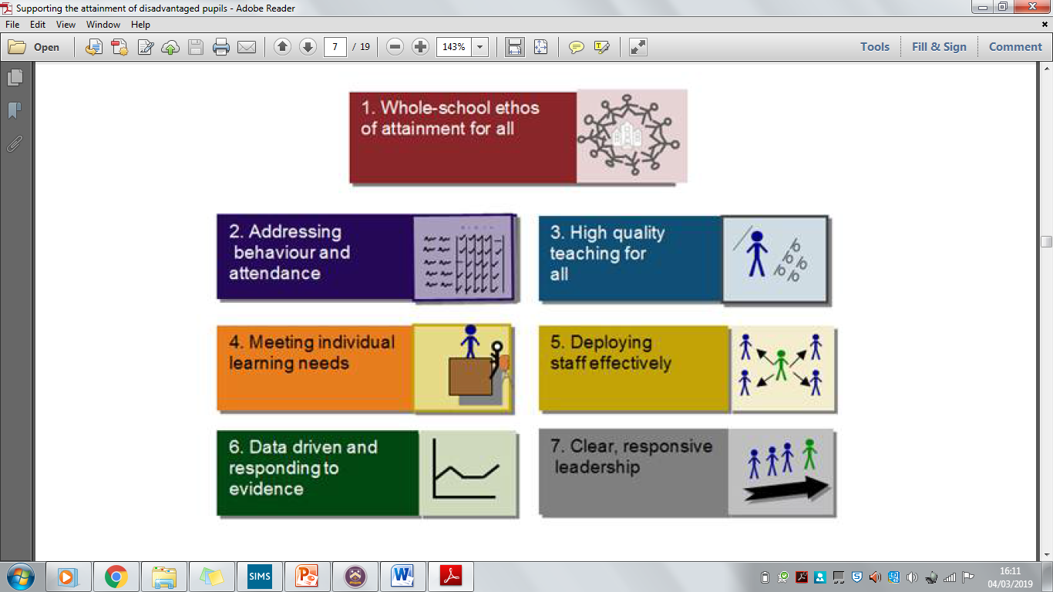

Figure 1 DFE Supporting the attainment of disadvantaged pupils

**Academic Excellence for All**

|  |  |  |
| --- | --- | --- |
| Teaching and Learning | **Area to Support** | **Initiatives** |
| Educational support structures at home | - CPD pathways ensures that the quality of teaching is maintained across the school.  - Structured curriculum.  - Staff retention initiatives. Retaining staff[1] and minimising turnover ensures that pupils have a stable teaching base. |
| Numeracy levels | - Targeted one to one maths interventions address misconceptions in KS3.  - Banding structure allows for small class sizes to ensure pupils are supported. |
| Literacy levels | - The NGRT is used to assess and monitor the reading levels of all pupils.  - Tailored book clubs are used to develop pupils reading skills.  - Pupils who did not meet AR are supported by the SEN department in Corrective Reading.  - Additional teaching time for previously lower attaining English groups to develop literacy.  - Pre-teaching of specific vocabulary and key terms across the school curriculum.  - Equal Access to Reading Project (EAR)- a range of texts are studied by all pupils in English lessons  - The library is accessible for all pupils from 8am until 4.30pm. |
| Study habits/ study skills | - Class Charts supports student organisation and study habits.  - Homework club. There is space in the library and SEND department for pupils to study before and after school.  - Study sessions.  - Revision packs given to all PP students at no cost.  - Pre-planned and structured revision materials sent to all parents and given to all pupils.  - Revision tasks are provided on the school website.  - Revision strategies are modelled in the lessons. |
| Confidence, engagement and standards | - Questioning and AFL strategies- ensuring that all students are engaging in learning. Linked to quality of teaching.  - Making learning applicable to real life.  - Seating plans and implementation of the behaviour policy.  - Quality of teaching is developed through CPD pathways.  - Financial support for netbooks given to all PP students. Netbook provision is based on research by the EEF. |
| Language for learning- the ‘velcro’ to access the curriculum | - Whole school vocabulary initiatives.  - Collect and reward the use of vocabulary.  - New vocabulary is explicitly taught.  - New information is presented explicitly in small amounts.  - Articulation and verbal answers are modelled. |
| Cultural capital | - Rich curriculum across the school.  - Option pathways.  - Ensuring that 1/3 of PP students access all extra-curricular clubs and trips. |

**Personal Excellence for All**

|  |  |  |
| --- | --- | --- |
| Pastoral Care | Attendance and punctuality | - Attendance workshops/ assemblies.  - Attendance raffles.  - Pastoral support systems.  - Funded transport. |
| Social/ Emotional/ Behavioural Issues | - Banding structure ensures PP students are supported from entry into the school.  - Class Charts provides detailed guidance, for selected pupils, regarding appropriate strategies to support learning.  - Supported by pastoral team including HoY, AHoY and student services. Contributions to HoY and AHoY salary.  - Working with Student Support Services.  *-* Good behaviour is modelled in lessons.  - Seating plans used to ensure that behaviour is monitored. |
| Extra-curricular and aspirations | Lower aspirations[2] | - Ensuring the same proportion of PP students accept work experience placements as NPP.  - Addressing lower aspirations through subject specific trips and career development opportunities.  - Extra-curricular opportunities highlight a variety of opportunities for students.  School support for music lessons, skill based activities.  -Aim Higher career aspirations- working alongside Birmingham University, Wolverhampton, Warwick and UCB to raise aspiration of children who have no previous links to higher education.  - Wesleyan Schools Programme links with local businesses and community. |
| Previous negative associations of education | - Positive logs used on Class Charts to monitor student successes.  - Large range of extra-curricular activities for pupils to engage with. |
| Provision | Reduced available resources | - Biometric catering system  - Schoolcomms systems means the school is cashless.  - Netbook costings support. |

**Attainment for All: Five Areas of Focus**

The support we offer students to overcome these barriers falls into 5 key areas:

* Teaching and learning
* Targeted academic support
* Pastoral care and provision
* Extra-curricular
* Personalised provision

**Why is outstanding teaching at the heart of what we do?**

When the quality of instruction is at its best, poorer pupils benefit disproportionately[3] i.e. those with less financial support for social and cultural experience home are more dependent on school. Therefore, the priority for the school to close the Pupil Premium vs non Pupil Premium gap is to deliver a consistently good quality of teaching provision.

**How do we use targeted academic support?**

A wide body of research highlights the benefit of targeted academic support, particularly for those Pupil Premium pupils who are not making good progress. Through robust standardised testing, we are able to identify those pupils who are most at need. Teaching assistants deliver a range of structured small-group interventions as well as one-to-one support.

**How does our pastoral system support pupil premium students?**

Through our pastoral system, we are able to provide dedicated and high quality support for our students. Individual student needs are identified and focused support is provided. We employ a student support coordinator to liaise with parents, and train student social workers to support the pupils’ needs at home. The impact of this is increased attendance and pastoral awareness of educational issues that relate to those pupils in receipt of pupil premium.

**Why are extra-curricular and aspirational provisions important in our school?**

At Bishop Challoner Catholic College, we recognise that it is important for students to learn a variety of skills that go beyond the classroom. Skills learnt in a variety of situations are integral to a young person’s sense of self, confidence and soft skills. It is crucial that pupil premium students are given equal access to these opportunities, allowing them to fulfil their potential.

**What does our personalised provision look like?**

It is important that all students are equal. To ensure this is always the case certain provision must be in place to ensure that pupils do not feel stigmatised by their financial background. This includes our netbook scheme, biometric catering system and financial support for specific pupil needs.

**Teaching and Learning**

At Bishop Challoner Catholic College, we recognise the importance of ‘quality teaching first’[4]. As a result, the school focuses on ensuring that all pupils are able to access, participate and enjoy the curriculum in each key stage. The strategies deployed across the school are supported by the EEF toolkit and extensive research.

We understand that many pupils will struggle to access the topics and concepts in each subject area and so ensure that new materials, vocabulary and terms are explicitly taught and explained.

The funds are allocated under this heading as follows:

* CPD pathways selected by staff
* Staff retention initiatives
* Curriculum Planning
* Cultural Capital
* NQT training support

**Targeted academic support**

Alongside the SEND department at Bishop Challoner Catholic College, targeted interventions are put in place to ensure that pupils are able to access the curriculum in a meaningful way. The interventions centre on supporting pupils with their numeracy and literacy.

The funds are allocated under this heading as follows:

- Corrective Reading

- Paired reading

- Toe by Toe

- Plus 1

- Power of 2

- Claro Coaching

- Touch Typing

- Pupil centred conversations

**Pastoral Care and Provision**

Within our pastoral system, we have a dedicated and high quality student support service team which works to support students on an emotional level. Individual student needs are identified and focused support is provided. We employ a student support manager to liaise with parents/carers, and train student social workers from the SSWIS program. This supports the pupils’ needs at school as well as at home. The impact of this is increased awareness of pastoral issues that relate to those pupils in receipt of pupil premium. This support contributes to the students’ learning and progress.

The funds are allocated under this heading as follows:

* Contribution to Head of Year and Assistant Head of Year costs
* Contribution to Student Services costs
* Pupil Premium co-ordination costs
* Attendance initiatives
* Class Charts costs
* Contribution to Student Social Worker support costs
* Other miscellaneous needs e.g. uniform, transport etc

**Aspirations and Extra-curricular**

A huge array of extra-curricular and enrichment activities are provided to students, many at little or no cost to pupil premium students. A proportion of this is funded by pupil premium. We also assist some of our pupil premium students who are financially unable to attend extra-curricular activities. This has an impact of engaging and motivating students whilst enabling them to participate fully in extra-curricular activities.

**To reflect the make-up of the school, it is essential that a minimum of 1/3 of pupils attending an extra-curricular activity/ residential trip are pupil premium.**

The funds are allocated under this heading as follows:

* Contribution to extra-curricular clubs and activities co-ordination
* Contribution to work experience and careers team

***Current clubs include:***

Badminton

Basketball

Book club

Choir

Cookery Club

Cricket

Debate Mate

Dodgeball

Drama Club

Duke of Edinburgh

Football

Gymnastics

Netball

Shows

Table tennis

Tampolining

Textiles

**Personalised provision**

All pupils should be able to access the resources they need for education. At Bishop Challoner Catholic College, we aim to ensure that no pupil is disadvantaged because of their economic circumstances.

To support pupils in this area, funding is spent on:

* Schoolcomms system
* Biometric catering upkeep
* Netbook and IT costs

1. EEF ‘Guidance to the Pupil Premium’ (2019)
2. Correlational evidence shows a significant link between pupil (Goodman and Gregg 2010; Strand 2007)
3. DFE: ‘Supporting the Attainment of Disadvantaged Pupils’
4. DFE ‘Supporting the Attainment of Disadvantaged Pupils’