Cambridge Technicals Vocational Business Study Period Guide – Autumn Term 2022

This guide is designed to help students with their independent revision for Year 12 Business in their study periods this term.

Which topics will you be studying?

- The Business Environment  - Customers and Communication | A summary of all the content can be found in the revision guide available on Teams.

Which exam board?
In Business we follow the OCR exam board and their Level 3 Cambridge Technical Extended Certificate. There are 5 modules which we cover as part of this course. For a detailed look at the specification for the year 12 modules click the below links:

Unit 1: https://www.ocr.org.uk/Images/294523-the-business-environment.pdf
Unit 4: https://www.ocr.org.uk/Images/294550-customers-and-communication.pdf

What useful revision activities should I be doing?
- Summarise a lesson in your exercise book using flash cards, or into a mind map.
- Test a partner using a knowledge organiser you have been given.
- Talk about a concept for one minute without stopping.
- Make a glossary of key terms for each unit of work.
- Write a quiz to test a partner on a key topic we have covered.
- Make a case study poster

Useful Resources:
- Seneca – an online revision tool that helps students revise and practice exam questions.
- 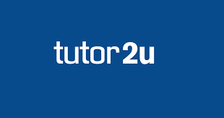

An important element of Business is being able to see how the current Business environment relates to the theory you are studying. A useful resource is the BBC News website Business section. This often relates to topics that we are studying or are going to study. Reading articles and summarising them will broaden you understanding of Business and enrich any future answers that you write. Press ctrl and click the logo below to take you to the BBC Business website.

