Worthing High School

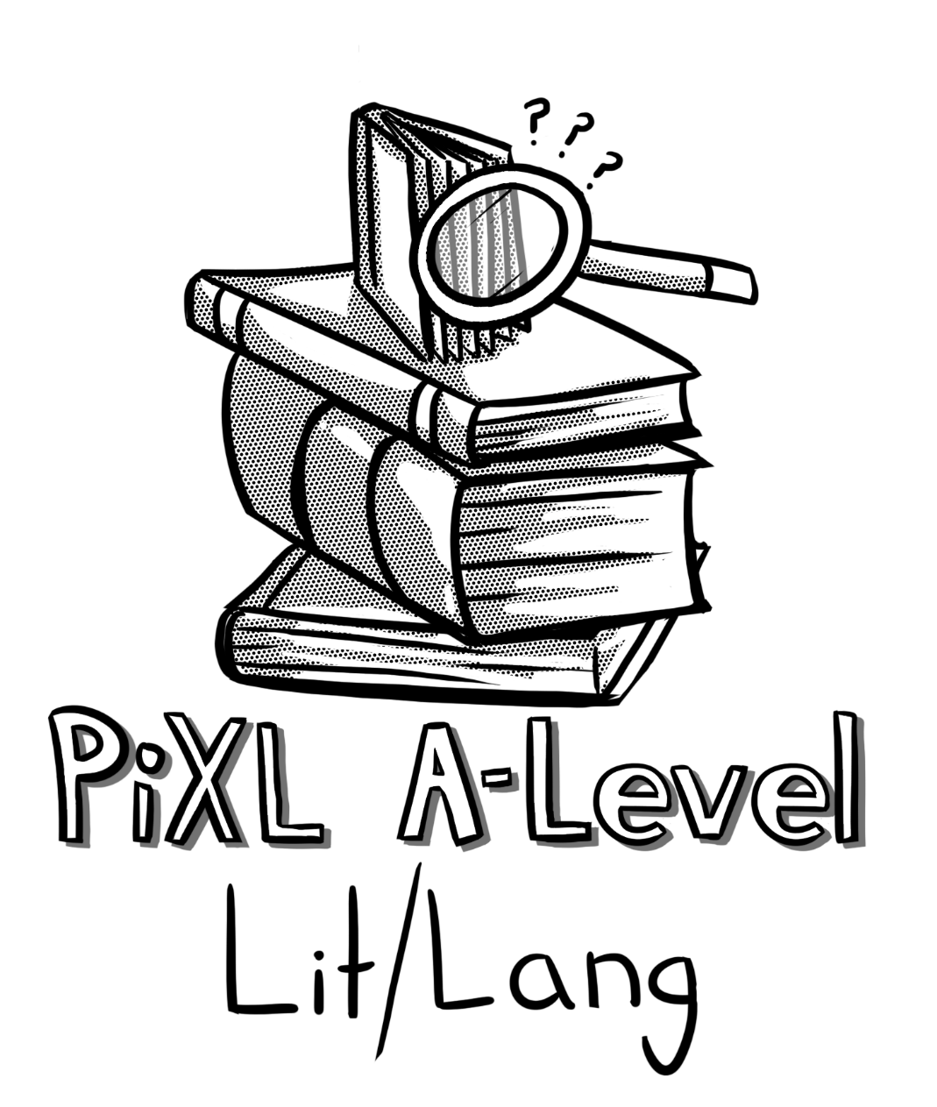
A Level English Literature / Language

So, you are considering Language and Literature at A Level?

This pack contains a varied programme of activities and resources to help you prepare to start an A Level in Language and Literature in September. It is aimed to be used after you complete your GCSE and throughout the remainder of the Summer Holidays to ensure you are ready to start the course, fully prepared, in September.

The resources include:

- Suggested reading and associated activities to prepare you for the types of texts you may encounter from September
- Links with activities to five websites where you can explore texts and ideas which you will come across during the course
- Glossary and activities which will help you become familiar with new terminology, key for the course
- A diagnostic assessment that will test your knowledge and understanding of the critical approach needed to succeed on this course
- Suggested visits and other activities which will enthuse, interest and sustain engagement

Where appropriate the tasks are linked to the course’s Assessment Objectives, which are listed below:

AO1 Apply concepts and methods from integrated linguistic and literary study as appropriate, using associated terminology and coherent written expression
AO2 Analyse ways in which meanings are shaped in texts
AO3 Demonstrate understanding of the significance and influence of the contexts in which texts are produced and received
AO4 Explore connections across texts, informed by linguistic and literary concepts and methods
AO5 Demonstrate expertise and creativity in the use of English to communicate in different ways

- Suggested Reading and Associated Activities

ACTIVITY 1
Find the extract from, ‘Notes on a Small Island’ by Bill Bryson which starts: ‘My first sight of England was on a foggy March night in 1973’ to ‘wasn't so much walking as being dragged along on three legs’. The extract can be located online, for example: http://www.welovethisbook.com/features/notes-small-island-extract
Identify aspects of Bryson’s writing which mimics a conversational tone and how this shapes our understanding of his viewpoint (AO1 & AO2).

Read, ‘The Yellow Wallpaper’ by Charlotte Perkins Gilman, it can be found here: http://image.guardian.co.uk/sys-files/Books/documents/2009/01/09/TheYellowWallpaper.pdf
Identify ten points in the short story where we are encouraged to feel sympathy for the narrator (AO1). Then, try and write 300 words of John’s account, considering his viewpoint and attitude towards his wife (AO5).

ACTIVITY 2

ACTIVITY 3
Choose two poems by either Sylvia Plath or two poems by Ted Hughes. Produce a Venn diagram looking at similarities and differences between the two poems. You should consider literary terms as well as linguistic terms, use the glossary included to help you (AO1 & AO4).

ACTIVITY 4
Find a blog online. Print out 2 pages and annotate it, paying
close attention to the conventions specific to this form and
how this allows it to meet its purpose (AO1 & AO3).

ACTIVITY 5
Locate a copy of your favourite book from when you were a child. Imagine you have been asked to rewrite it for a teenage audience. Write the blurb to indicate changes which you would need to make to the plot, structure and language (AO3 & AO5).

- Links with activities to five websites where you can
explore texts and ideas which you will come across
during the course.
ACTIVITY 1
Use YouTube to find THUG NOTES on a text you studied at GCSE, how does this appeal to its intended audience? Try and focus on the language and images used as well as the form (AO1 & AO3). Now write the opening for the script of another THUG NOTES for a different text, in the same style (AO5).

ACTIVITY 2
Find a conversation from BBC Radio 4’s Listening Project, use Google or look here: http://www.bbc.co.uk/programmes/articles/MrHK9VQvVkc6Jc8m2CzL7k/find-a-conversation
Listen to the conversation and note down how conversational language has been used to reflect speakers’ attitudes and values towards the chosen subject (AO1 & AO2). Do you notice anything specific because of WHO is speaking and WHERE they are from (AO3)?

Use this site to help you find an extract from a BBC script: http://www.bbc.co.uk/writersroom/scripts Print out and annotate
to show how your chosen script has been written to mimic
spontaneous speech (AO1 & AO3).

ACTIVITY 3

Use this link and read about transcripts, the conventions of transcripts and also the example given: http://www.languageinconflict.org/how-language-is-studied/conversation-analysis.html Now find your own example of a transcript and consider the relationship between the speakers, using the transcript only (AO1, AO2 & AO3). Can you also show how it is similar or different to the infamous BBC Newsnight interview between presenter Jeremy Paxman and Conservative MP Michael Howard which you read initially (AO4)?

ACTIVITY 4

Choose a short story from this site: https://www.reddit.com/r/shortstories Print it out and annotate choices the writer has made to engage the reader and create meaning (AO1 & AO2). Now, write the opening to your own short story using the transcript you chose in the previous task as inspiration (AO5). If you like the idea of writing short stories, you could always consider entering a competition like this: https://www.bristolprize.co.uk/

ACTIVITY 5

- Glossary and activities which will help you become familiar with new terminology, key for the course.

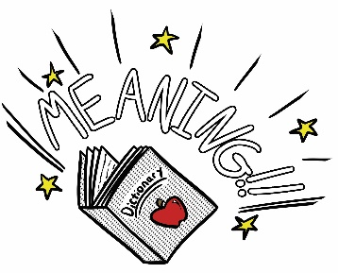
Lexis and Semantics:
- Denotative and connotational meanings: the literal (denotative) and associated (connotational) meanings of words and phrases.
- Figurative language: language used in a non-literal way to describe something in another’s terms (e.g. simile or metaphor).
- Semantic fields: groups of words connected by a common meaning.
- Synonyms: words that have equivalent meanings.
- Antonyms: words that have contrasting meanings.
- Hypernyms: words whose meanings contain other words, (e.g. animal contains dog, cat and fish).
- Hyponyms: words that can be included in a larger, more general category (e.g. the hyponyms car, bus, aeroplane as a form of the hypernym transport).
- Levels of formality: vocabulary styles including slang, colloquial, taboo and formal.
- Jargon: a technical vocabulary associated with a particular occupation or activity.
- Sociolect: a language style associated with a particular social group.
- Dialect: a language style associated with a particular geographical region.
- Neology: the process of new word formation, including the following: blends, compounds, acronyms, initialisms, eponyms.
- Semantic change: the process of words changing meaning, including
the following: narrowing, broadening, amelioration, pejoration,
semantic reclamation.
- List three colours and their connotational meanings.
1. ____________________________________________________________________________________
2. ____________________________________________________________________________________
3. ____________________________________________________________________________________

- Can you give 3 examples of antonyms to the word ‘kind’?
1. ____________________________________________________________________________________
2. ____________________________________________________________________________________
3. ____________________________________________________________________________________

- What neologisms can you think of from popular culture?
1. ____________________________________________________________________________________
2. ____________________________________________________________________________________
3. ____________________________________________________________________________________

ACTIVITY

Grammar:
- Phrase: a group of words centred around a head word.
- Head word: the central word in a phrase which gives the phrase its name (e.g. noun phrase, adjective phrase) and may be modified by other words.
- Modification: the adding of additional words to provide more detail to a head word in a phrase either before it (pre-modification) or after it (post-modification).
- Clause: a group of words centred around a verb, which may be either grammatically complete (main clause) or incomplete (subordinate clause).
- Active voice: a clause where the agent (doer) of an action is the subject.
- Passive voice: a clause where the patient (the entity affected by an action) is in the subject position, and the agent either follows or is left out.
- Tense: how the time of an event is marked (usually through verb inflection): past, present and future.
- Coordination: the joining of two or more independent clauses via co-ordinating conjunctions. Single words and longer phrases can also be co-ordinated.
- Subordination: the joining of two or more clauses where only one is independent (the main clause) and the others dependent (subordinate clause/clauses).
- Sentence: a larger unit of meaning, which may be formed of a single clause (simple sentence) or several clauses (compound or complex sentences).
- Sentence function: the purpose a sentence fulfils in communication: as a statement, question, command or exclamation. These are also referred to in many grammar books as (respectively): declaratives, interrogatives, imperatives and exclamatives.
- Word class: the grammatical category into which words can be placed, including noun, adjective, verb, adverb, determiner, pronoun, preposition, conjunction.
- Write a sentence which has a main and a subordinate clause, below:
____________________________________________________________________________________
____________________________________________________________________________________
____________________________________________________________________________________

- Considering sentence function, give an example of the following:
Interrogative: ________________________________________________________________________
Declarative: _________________________________________________________________________
Imperative: _________________________________________________________________________

- Give an example of each of the following:
Pronoun: ____________________________________________________________________________
Preposition: __________________________________________________________________________
Conjunction: _________________________________________________________________________

ACTIVITY

Some New Key Terms:
- Audience: the receivers or intended receivers of a text (written, spoken, multimodal). The concept of an ideal audience/reader is often found in critical discourse. Texts might also have multiple audiences.
- Discourses: used in many different (and sometime contradictory) ways in language study. Can be used to refer to a mode of language (e.g. spoken or written discourse), a register (e.g. medical or legal discourse), a way of thinking about and presenting something (e.g. representing language using a discourse of decay).
- Foregrounding: the way in which texts emphasise key events or ideas through the use of attention-seeking devices (in terms of lexis, semantics, phonology or grammar) that either repeat content (parallelism) or break established patterns (deviation). Deviation may be:
  - external: breaking from the normal conventions of language use, for example in the use of nonsense words or ungrammatical constructions
  - internal: breaking from a pattern that has previously been set up in the text for a striking effect.
- Genre: the way of categorising and classifying different types of texts according to their features or expected shared conventions. Genres come into being as the result of people agreeing about perceived similar characteristics in terms of content or style. Genres are fluid and dynamic and new genres continually evolve as a result of new technologies and cultural practices.
- Mode: the way in which language is communicated between text producer and text receiver and the physical channel through which this is carried out. At its simplest, this could be spoken or written (visual or auditory channel). Mode also encompasses ideas around planning and spontaneity, distance between text producer and receiver, how transitory or long-lasting a text is. Mode is more than a binary opposition, is sometimes visualised as a continuum and is constantly changing as new communication technologies blur the lines between older forms.
- Narrative: a type of text or discourse that functions to tell a series of events. A narrative is the organisation of experience told by a narrator to any number of narratees. A narrative has two distinctive parts:
  - the story: the events, places, characters and time of action that act as the building blocks of the narrative
  - the narrative discourse: the particular shaping of those building blocks into something worth telling through specific choices in language and structure.

Consider ‘The Yellow Wallpaper’ from the first section of this
advice sheet. How can you use the new key terms below in your
consideration of it?

Foregrounding:
____________________________________________________________________________________
____________________________________________________________________________________
____________________________________________________________________________________
____________________________________________________________________________________
____________________________________________________________________________________

Genre:
____________________________________________________________________________________
____________________________________________________________________________________
____________________________________________________________________________________
____________________________________________________________________________________
____________________________________________________________________________________

Narrative Discourse:
____________________________________________________________________________________
____________________________________________________________________________________
____________________________________________________________________________________
____________________________________________________________________________________
____________________________________________________________________________________

ACTIVITY

- A diagnostic assessment that will assess your knowledge and understanding of the critical approach needed to succeed on this course.

Based on the opening of, ‘The Handmaid’s Tale’, the extract can be found online, here: http://www.acgrenoble.fr/disciplines/anglais/file/Contributions/B2_C1/Celine_Leblanc/The_Handmaid_s_Tale_CHAPTER_ONE_extraitcorrige.pdf)

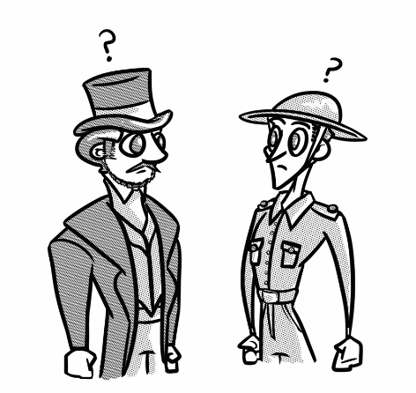
Read the opening paragraph of, ‘The Handmaid’s Tale’ by Margaret Attwood, which starts ‘We slept in what had once been the gymnasium’ to ‘powdering the dancers with a snow of light’.
Consider how Attwood presents setting in this extract.
You should write between around 500 words. Once finished, you should annotate your response with Assessment Objectives 1 and 2:

AO1 Apply concepts and methods from integrated linguistic and literary study as appropriate, using associated terminology and coherent written expression
AO2 Analyse ways in which meanings are shaped in texts

- Suggested visits and other activities which will enthuse, interest and sustain engagement.
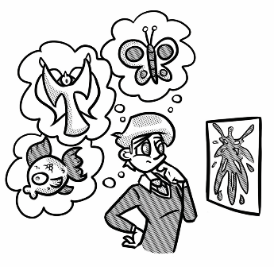
- Go to a gallery take a photo of painting or print which you feels ‘tells a story’. Write the story as a first person recount (AO5). Next, use the glossary, can you write an evaluation of choices you made, using some of these terms (AO1 & AO2)?

Whilst you are at the gallery buy a postcard of a piece of artwork which you think has a meaning or story behind it. Stick it down and identify key aspects of its arrangement: colour, contrasts, symbolism, interaction between subjects etc. (AO1). Next, for each of your ‘AO1’ points try and show a development in your understanding of how this adds to our interpretation and understanding (AO2).

- Use your Twitter account to develop your understanding of the course. Search for ‘hashtags’ which may be useful, such as: #AQALangLit, and accounts which you can follow, such as: or @SJHSEnglishLL. Favourite or retweet any links which you think may be useful for your Language and Literature studies (AO1-5).
ACTIVITY
Complete the signposting table below (AO1).
To indicate similarities | To indicate differences
Similarly | Conversely

- Next, find two pictures of celebrities, use signposts which compare and contrast to evaluate differences and similarities of how our perception has been shaped (AO1, AO2 & AO4).

- Transcribe a discussion between you and a friend which you have recorded on your phone, ensure you use the key below (AO1):

Commissioned by The PiXL Club Ltd.

This resource is strictly for the use of member schools for as long as they remain members of The PiXL Club. It may not be copied, sold, nor transferred to a third party or used by the school after membership ceases. Until such time it may be freely used within the member school.

All opinions and contributions are those of the authors. The contents of this resource are not connected with, nor endorsed by, any other company, organisation or institution.

PiXL Club Ltd endeavour to trace and contact copyright owners. If there are any inadvertent omissions or errors in the acknowledgements or usage, this is unintended and PiXL will remedy these on written notification.

