**Fundamental Skills for A-level Physics**

**A-level Physics – basics**

**Units**

Scientists around the world use the same internationally agreed system of units. These are called SI (Système International) units. The system is built upon seven **base units**.

*SI Base Units*

|  |  |  |
| --- | --- | --- |
| *Quantity* | *Name* | *Symbol* |
| Length |  |  |
|  | Kilogram |  |
|  |  | s |
|  | Ampere |  |
| Temperature |  | K |
| Amount of Substance |  | mol |
| Luminous Intensity | Candela | cd |

Quantities such as speed (ms-1) and density (kgm-3) which are not expressed in a single base unit are expressed in **derived units**.

*Derived units*

|  |  |  |  |  |
| --- | --- | --- | --- | --- |
| *Quantity* | *Symbol* | *Name of unit* | *Symbol for unit* | *Base units* |
| speed or velocity | v |  | ms-1 | ms-1 |
| acceleration | a |  | ms-2 | ms-2 |
| force | F |  |  | kgms-2 |
| energy | E |  |  | kgm2s-2 |
| power | P |  | W | kgm2s-3 |
| pressure | p |  | Pa | kgm-1s-2 |
| frequency | f | hertz | Hz | s-1 |
| charge | Q | coulomb |  | As |
| potential difference | V | volt |  | A-1kgm2s-3 |
| resistance | R |  | Ω | A-2kgm2s-3 |
| capacitance | C | farad | F | A2kg-1m-2s4 |
| magnetic flux | B | tesla | T | A-1kgs-2 |

**Homogeneity of an equation**

If an equation is written correctly it must be homogeneous; that is, the units of the quantities on the left hand side of the equation must be identical to those on the right hand side.

*Example*

The equation $F=\frac{mv^{2}}{r}$ describes the relationship between the force applied to an object of mass m so that it travels in a circle of radius r at a speed v. Show that it is homogeneous.

*Practice questions*

1. Show that $T=2π\sqrt{\frac{l}{g}}$ where T is the period of a pendulum (in seconds), l is the length of the pendulum and g is the acceleration due to gravity, is homogeneous.
2. The equation for the gravitational force of attraction between 2 bodies is given by $F=\frac{GM_{1}M_{2}}{r^{2}}$ where M1 and M2 are the masses of the 2 bodies and r is the distance between them. Find the base units for the gravitational constant G.

**Prefixes**

In Physics we have to deal with quantities from the very large to the very small. A prefix is something that goes in front of a unit and acts as a multiplier. This sheet will give you practice at converting figures between prefixes.

|  |  |  |  |  |  |
| --- | --- | --- | --- | --- | --- |
| **Symbol** | **Name** | **What it means** | | **How to convert** | |
| P | peta | 1015 | 1000000000000000 |  | ↓ x1000 |
| T |  | 1012 | 1000000000000 | ↑ ÷ 1000 | ↓ x1000 |
| G |  | 109 | 1000000000 | ↑ ÷ 1000 | ↓ x1000 |
| M |  | 106 | 1000000 | ↑ ÷ 1000 | ↓ x1000 |
| k | kilo |  | 1000 | ↑ ÷ 1000 | ↓ x1000 |
|  |  |  | 1 | ↑ ÷ 1000 | ↓ x1000 |
| m |  | 10-3 | 0.001 | ↑ ÷ 1000 | ↓ x1000 |
| μ |  | 10-6 | 0.000001 | ↑ ÷ 1000 | ↓ x1000 |
| n | nano |  | 0.000000001 | ↑ ÷ 1000 | ↓ x1000 |
| p | pico |  | 0.000000000001 | ↑ ÷ 1000 | ↓ x1000 |
| f | femto |  | 0.000000000000001 | ↑ ÷ 1000 |  |

Convert the figures into the prefixes required.

|  |  |  |  |  |
| --- | --- | --- | --- | --- |
| **s** | **ms** | **μs** | **ns** | **ps** |
| 134.6 |  |  |  |  |
| 96.21 |  |  |  |  |
| 0.773 |  |  |  |  |

|  |  |  |  |  |
| --- | --- | --- | --- | --- |
| **m** | **km** | **mm** | **Mm** | **Gm** |
| 12873 |  |  |  |  |
| 0.295 |  |  |  |  |
| 57.23 |  |  |  |  |

|  |  |  |  |  |
| --- | --- | --- | --- | --- |
| **kg** | **Mg** | **mg** | **g** | **Gg** |
| 94.76 |  |  |  |  |
| 0.000765 |  |  |  |  |
| 823.46 |  |  |  |  |

**Calculating Means**

The mean of repeat measurements is the best estimate of the true value, if there is no systematic error.

For each set of values calculate the mean and then calculate the mean ignoring any anomalous results.

|  |  |  |  |  |
| --- | --- | --- | --- | --- |
| **1** | **2** | **3** | **Mean** | |
| 4152 | 2996 | 4018 |  |  |
| 935.5 | 925.8 | 926.7 |  |  |
| 16.2 | 19.1 | 17.4 |  |  |
| 80.1316 | 80.1324 | 80.1466 |  |  |
| 2229 | 2011 | 1610 |  |  |
| 127.664 | 127.416 | 127.489 |  |  |
| 55.88 | 11.97 | 37.59 |  |  |
| 3.767 | 3.763 | 3.751 |  |  |

|  |  |  |  |  |  |
| --- | --- | --- | --- | --- | --- |
| **1** | **2** | **3** | **4** | **Mean** | |
| 63.10 | 62.97 | 62.53 | 62.99 |  |  |
| 465.98 | 463.40 | 466.96 | 155.56 |  |  |
| 3.61 | 7.39 | 3.55 | 3.64 |  |  |
| 73.71 | 70.98 | 74.19 | 72.38 |  |  |
| 2.058 | 1.566 | 2.078 | 1.787 |  |  |
| 416 | 402 | 189 | 986 |  |  |

|  |  |  |  |  |  |  |
| --- | --- | --- | --- | --- | --- | --- |
| **1** | **2** | **3** | **4** | **5** | **Mean** | |
| 140 | 220 | 90 | 180 | 140 |  |  |
| 56300 | 41200 | 58600 | 48300 | 53800 |  |  |
| 0.186 | 0.341 | 0.276 | 0.216 | 0.314 |  |  |
| 1.427 | 0.235 | 0.488 | 1.922 | 1.620 |  |  |
| 34 | 62 | 46 | 12 | 39 |  |  |
| 326.19 | 360.22 | 314.20 | 352.22 | 400.18 |  |  |
| 1.4 | 5.3 | 2.7 | 3.9 | 2.6 |  |  |

**Significant figures**

For each value state how many significant figures it is stated to.

|  |  |  |  |  |  |  |  |
| --- | --- | --- | --- | --- | --- | --- | --- |
| **Value** | **Sig Figs** | **Value** | **Sig Figs** | **Value** | **Sig Figs** | **Value** | **Sig Figs** |
| 2 |  | 1066 |  | 1800.45 |  | 0.07 |  |
| 2.0 |  | 82.42 |  | 2.483 x 104 |  | 69324.8 |  |
| 2.00 |  | 750000 |  | 2.483 |  | 0.0063 |  |
| 0.136 |  | 310 |  | 5906.4291 |  | 9.81 x 104 |  |
| 0.34 |  | 3.10 x 102 |  | 200000 |  | 6717 |  |
| 54.1 |  | 3.1 x 102 |  | 12.711 |  | 0.91 |  |

Add the values below then write the answer to the appropriate number of significant figures

|  |  |  |  |  |
| --- | --- | --- | --- | --- |
| **Value 1** | **Value 2** | **Value 3** | **Total Value** | **Total to correct sig figs** |
| 51.4 | 1.67 | 3.23 |  |  |
| 7146 | –32.54 | 12.8 |  |  |
| 20.8 | 18.72 | 0.851 |  |  |
| 1.4693 | 10.18 | –1.062 |  |  |
| 9.07 | 0.56 | 3.14 |  |  |

Multiply the values below then write the answer to the appropriate number of significant figures

|  |  |  |  |
| --- | --- | --- | --- |
| **Value 1** | **Value 2** | **Total Value** | **Total to correct sig figs** |
| 0.91 | 1.23 |  |  |
| 8.764 | 7.63 |  |  |
| 2.6 | 31.7 |  |  |
| 937 | 40.01 |  |  |

Divide value1 by value 2 then write the answer to the appropriate number of significant figures

|  |  |  |  |
| --- | --- | --- | --- |
| **Value 1** | **Value 2** | **Total Value** | **Total to correct sig figs** |
| 5.3 | 748 |  |  |
| 3781 | 6.434 |  |  |
| 91 x 102 | 180 |  |  |
| 5.56 | 22 x 10-3 |  |  |

For each value state how many significant figures it is stated to.

|  |  |  |  |  |  |  |  |
| --- | --- | --- | --- | --- | --- | --- | --- |
| **Value** | **Sig Figs** | **Value** | **Sig Figs** | **Value** | **Sig Figs** | **Value** | **Sig Figs** |
| 2.863 |  | 689671.49 |  | 100000 |  | 6.4981 x 107 |  |
| 100 |  | 356865 |  | 8.5 x 10-3 |  | 7.85 |  |
| 24.92 |  | 13 |  | 6400 |  | 17.99 |  |
| 5.18 x 1027 |  | 182.15 |  | 875.4 |  | 3.189 x 106 |  |

Calculate the mean of the values below then write the answer to the appropriate number of significant figures

|  |  |  |  |  |
| --- | --- | --- | --- | --- |
| **Value 1** | **Value 2** | **Value 3** | **Mean Value** | **Mean to correct sig figs** |
| 1 | 1 | 2 |  |  |
| 435 | 299 | 4130 |  |  |
| 500 | 600 | 900 |  |  |
| 3.038 | 4.925 | 3.6 |  |  |
| 720 | 498 | 168 |  |  |
| 1655 | 2996 | 140 |  |  |
| 0.230 | 925.8 | 56300 |  |  |
| 26017 | 19.1 | 0.186 |  |  |
| 2238 | 80.1324 | 1.427 |  |  |
| 9160.97 | 2011 | 34 |  |  |
| 62.99 | 127.416 | 326.19 |  |  |
| 155.56 | 11.97 | 1.4 |  |  |
| 3.64 | 3.763 | 700653 |  |  |
| 72.38 | 511.5 | 2670887 |  |  |
| 1.787 | 888 | 110.4 |  |  |
| 986 | 0.415 | 62.97 |  |  |
| 726161 | 25157 | 463.40 |  |  |
| 2670733 | 1014 | 7.39 |  |  |

**Calculating errors**

Complete the table.

|  |  |  |  |  |  |  |
| --- | --- | --- | --- | --- | --- | --- |
| **Variable** | **Reading 1** | **Reading 2** | **Reading 3** | **Mean Value** | **Uncertainty** | **% Uncertainty** |
| *A* | 121 | 118 | 119 |  |  |  |
| *B* | 599 | 623 | 593 |  |  |  |
| *C* | 3.3 | 3.6 | 3.2 |  |  |  |

What would be the percentage error in the following quantities?

|  |  |  |  |
| --- | --- | --- | --- |
|  |  |  |  |
|  |  |  |  |
|  |  |  |  |

Complete the table.

|  |  |  |  |  |  |  |
| --- | --- | --- | --- | --- | --- | --- |
| **Variable** | **Reading 1** | **Reading 2** | **Reading 3** | **Mean Value** | **Uncertainty** | **% Uncertainty** |
| *D* | 17 | 17 | 17 |  |  |  |
| *E* | 42.5 | 42.8 | 42.1 |  |  |  |
| *F* | 3.60 | 3.28 | 3.73 |  |  |  |
| *G* | 757 | 714 | 739 |  |  |  |

What would be the percentage error in the following quantities?

|  |  |  |  |
| --- | --- | --- | --- |
|  |  |  |  |
|  |  |  |  |
|  |  |  |  |
|  |  |  |  |

Complete the table.

|  |  |  |  |  |  |  |
| --- | --- | --- | --- | --- | --- | --- |
| **Variable** | **Reading 1** | **Reading 2** | **Reading 3** | **Mean Value** | **Uncertainty** | **% Uncertainty** |
| *H* | 58205 | 58309 | 58193 |  |  |  |
| *I* | 82.3 | 81.4 | 82.8 |  |  |  |
| *J* | 1985 | 1988 | 1980 |  |  |  |
| *K* | 43 | 19 | 27 |  |  |  |

*What would be the percentage error in the following quantities?*

|  |  |  |  |
| --- | --- | --- | --- |
|  |  |  |  |
|  |  |  |  |
|  |  |  |  |

Complete the table.

|  |  |  |  |  |  |  |  |
| --- | --- | --- | --- | --- | --- | --- | --- |
| **Variable** | **1** | **2** | **3** | **4** | **Mean Value** | **Uncertainty** | **% Uncertainty** |
| *L* | 11.49 | 11.56 | 11.63 | 10.53 |  |  |  |
| *M* | 385 | 322 | 408 | 328 |  |  |  |
| *N* | 2736 | 2729 | 2743 | 2643 |  |  |  |
| *O* | 5101 | 5108 | 5003 | 5098 |  |  |  |
| *P* | 125 | 137 | 167 | 142 |  |  |  |
| *Q* | 6124 | 6118 | 6510 | 6123 |  |  |  |
| *R* | 3.29 | 3.29 | 3.29 | 3.29 |  |  |  |
| *S* | 4589 | 4606 | 4644 | 4596 |  |  |  |
| *T* | 417 | 488 | 460 | 456 |  |  |  |
| *U* | 1.506 | 3.061 | 3.085 | 1.513 |  |  |  |
| *V* | 274 | 333 | 338 | 277 |  |  |  |
| *W* | 33.46 | 33.45 | 33.96 | 33.65 |  |  |  |

*What would be the percentage error in the following quantities?*

|  |  |  |  |
| --- | --- | --- | --- |
|  |  |  |  |
|  |  |  |  |
|  |  |  |  |
|  |  |  |  |
|  |  |  |  |
|  |  |  |  |
|  |  |  |  |
|  |  |  |  |

**Identifying Errors**

For each of the measurements listed below identify the most likely source of error what type of error this is and one method of reducing it.

|  |  |  |
| --- | --- | --- |
| **Measurement** | **Source** | **Type** |
| A range of values are obtained for the length of a copper wire |  |  |
|  | | |
| The reading for the current through a wire is 0.74A higher for one group in the class |  |  |
|  | | |
| A beaker of hot water left on the desk appears to have gained temperature |  |  |
|  | | |
| A mass of a beaker shows different values on different balances |  |  |
|  | | |
| A range of values are obtained for the bounce back height of a dropped ball |  |  |
|  | | |
| A few groups obtain different graphs of resistance vs light intensity for an LDR |  |  |
|  | | |
| The time period (time of one oscillation) of a pendulum |  |  |
|  | | |

**Lines of best fit**

Draw a line of best fit for each of the graphs.

**Calculating Gradients**

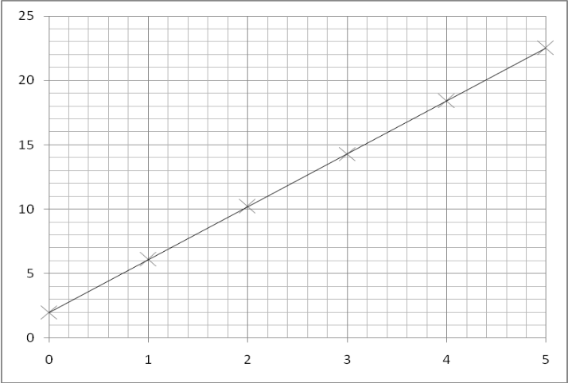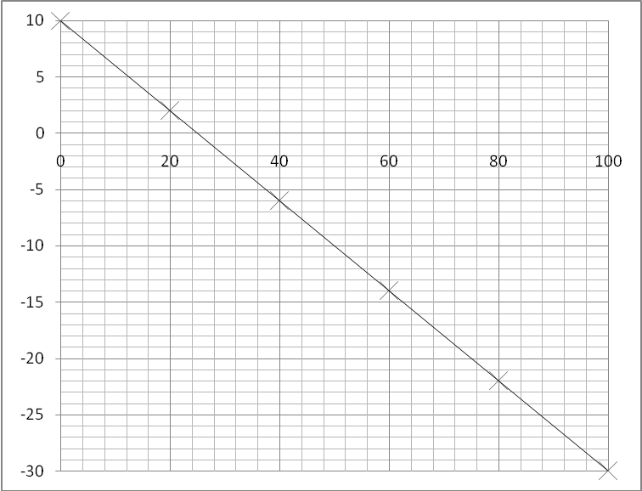Calculate the gradients of the graphs below. Work out the equation for the line.

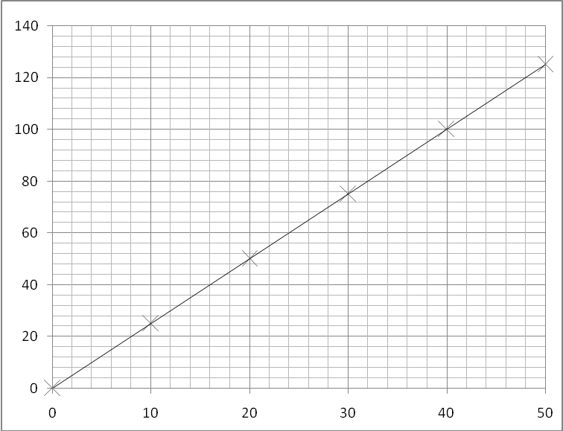

**Gradient Equations**

Complete the table below about graphs and gradients

|  |  |  |  |  |
| --- | --- | --- | --- | --- |
| **Equation** | **Graph** | **Rearrange Equation** | **Gradient** | **Intercept** |
|  | y plotted on the y axis |  | *m* | *c* |
| x plotted on the x axis |
|  | y axis = *V* |  | *R* | 0 |
| x axis = *I* |
|  | y axis = *t* |  |  |  |
| x axis = *Q* |
|  | y axis = *l* |  |  |  |
| x axis = *R* |
|  | y axis = *V* |  |  |  |
| x axis = *I* |
|  | y axis = *E/t* |  |  |  |
| x axis = *V* |
|  | y axis = *EK* |  |  |  |
| x axis = *f* |
|  | y axis = 1*/v* |  |  |  |
| x axis = *m* |
|  | y axis = *mg* |  |  |  |
| x axis = *EP* |
|  | y axis = *e* |  |  |  |
| x axis = 1*/F* |
|  | y axis = 1*/λ* |  |  |  |
| x axis = *f* |
|  | y axis = *a* |  |  |  |
| x axis = 1*/t* |
|  | y axis = *v2* |  |  |  |
| x axis = *s* |
|  |

Complete the table below about graphs and gradients

|  |  |  |  |  |
| --- | --- | --- | --- | --- |
| **Equation** | **Graph** | **Rearrange Equation** | **Gradient** | **Intercept** |
|  | y plotted on the y axis |  | *m* | *c* |
| x plotted on the x axis |
|  | y axis = *V* |  | *R* | 0 |
| x axis = *I* |
|  | y axis = *v* |  |  |  |
| x axis = *F/m* |
|  | y axis = *r* |  |  |  |
| x axis = *F/m* |
|  | y axis = *l* |  |  |  |
| x axis = *g* |
|  | y axis = *T*2 |  |  |  |
| x axis = *m* |
|  | y axis = *M* |  |  |  |
| x axis = *g* |
|  | y axis = *F* |  |  |  |
| x axis = *q/r2* |
|  | y axis = *V* |  |  |  |
| x axis = *Q* |
|  | y axis = ln (*Q/Q*0) |  |  |  |
| x axis = *t* |
|  | y axis = *ε* |  |  |  |
| x axis = *N* |
|  | y axis = *NP* |  |  |  |
| x axis = *NS* |
|  | y axis = *R3* |  |  |  |
| x axis = *A* |
|  | y axis = *T* |  |  |  |
| x axis = *V* |