OCR Cambridge Nationals – Level 3
Physical Education

Guide to the Qualification 2019/2020

&

Preparation for September

Content / Units:

Unit | Grading | Year and Qualification Type
Unit 2 – Sports Coaching | Task 1 (P1, P2, P3, P4, M1)  Task 2 (P6, P7, M3, D1)  Task 3 (P8, P9, P10, P11, P12, M4, M5, D2)  Task 4 (P5, D2) | Year 1 (Year 12)  Single and Double pupils.
Unit 8 – Sports Organisation | Task 1 (P1)  Task 2 (P2, M1)  Task 3 (P3, P4, P5, M2, M3, M4, D1, D2)  Task 4 (P6, P7, M5) | Year 1 (Year 12)  Double pupils only.
Unit 18 – Practical Skills | Task 1 (P1, P2, P3, M1, D1)  Task 2 (P4, P5, P6, M2, D2)  Task 3 (P7)  Task 4 (P8, P9, M3, M4, D3) | Year 1 (Year 12)  Double pupils only.
Unit 3 – Sports Development | Exam in the summer of Year 1 (Year 12). | Year 1 (Year 12)  Single and Double pupils.
Unit 1 – Body Systems | Exam in January of Year 2 (Year 13). | Year 2 (Year 13)  Single and Double pupils.
Unit 5 – Performance Analysis | Task 1 (P1, P2, M1)  Task 2 (P3, P4, P5, M2, D1)  Task 3 (P6, P7, M3, M4, D2) | Year 2 (Year 13)  Double pupils only.
Unit 13 – Health and Fitness Testing | Task 1 (P1, M1)  Task 2 (P2, P3, P4, M2, D1)  Task 3 (P5, P6, M3)  Task 4 (P7, P8, M4) | Year 2 (Year 13)  Double pupils only.
Unit 17 – Sports Injuries | Task 1 (P1, P2, P3, P4, M1, M2, D1)  Task 2 (P5, P6, P7, M3)  Task 3 (P8, P9, P10, M4, D2) | Year 2 (Year 13)  Single and Double pupils.
Unit 19 – Sports Psychology | Task 1 (P1, M1)  Task 2 (P2, M2, D1)  Task 3 (P3, P4, M3)  Task 4 (P5, M4, D2)  Task 5 (P6, P7, M5) | Year 2 (Year 13)  Single and Double pupils.
Unit 11 – PA for specific groups | Task 1 (P1)  Task 2 (P2, P3, M1)  Task 3 (P4)  Task 4 (P5, M2, D1) | Year 2 (Year 13)  Double pupils only.

Key Career Pathways – Where can this Qualification take you?

Studying Sport, Health and Fitness, Sport Science:
https://www.youtube.com/watch?v=UIHp_FaZSEc

Teacher of Physical Education
https://www.youtube.com/watch?v=AWUpRUt5Yg4

Sports Coaching
https://www.youtube.com/watch?v=30-qRHKoz2A

Physiotherapy
https://www.youtube.com/watch?v=ddqDUxU3H_s

Strength and Conditioning Coach
https://www.youtube.com/watch?v=_UKy0cvu-Pg

Performance Analyst
https://www.youtube.com/watch?v=ay4ajSwjdJk

Sports Partnership
https://www.youtube.com/watch?v=DyCTq-XI7Kc

Reading and Reflection

The role of Sport Science in the Elite Football Labour Process

Reflection

- What are your thoughts / opinions on the ideas presented in the above article?
- Does Football need Sport Science in order to facilitate the development of the sport?
- Do you think Sport Science helps increasing peak performance of Football players?

The Modern Olympic Games – Unit 8

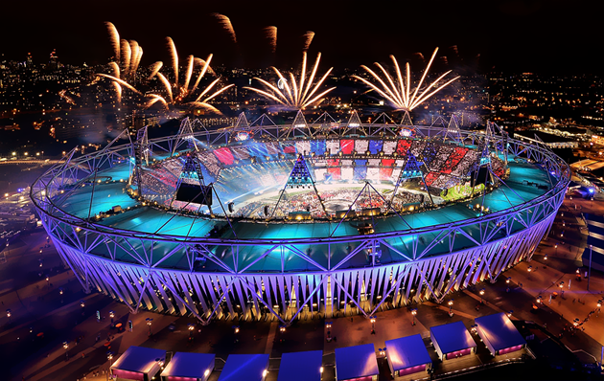
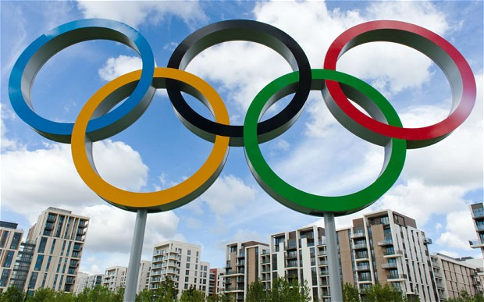

Organising Sporting Events – How many different roles and responsibilities do you know?

Task: Research the following roles and responsibilities in organising ANY Sporting Event:
- Security Marketing Media Officer
- Caterer Officials
- First Aider Healthy and Safety Oficer
- Sports Leader Steward
- Tutor/ Trainer/ Coach Event Organiser
- Finance Officer

Watch the following clip: https://www.youtube.com/watch?v=1BgAcGWShOk
Research the 8 basic key skills in Table Tennis, explaining how to perform each skill step by step (Unit 18)

Key Skills:
- Serving Forehand Push
- Forehand Drive Backhand Push
- Backhand Drive Forehand Loop
- Backhand Chop Topspin / Backspin

Model Answer (Skill: Serving):
- The ball should be visible to the opponent (open palm)
- The ball should be thrown up 6 inches or height of the net
- The ball should then be struck on the servers side before hitting the opponents side
- You must strike the ball behind the white line for the serve to be legal
- If the ball touches the net before hitting your opponents’ side it doesn’t count and the serve is reset. (This is known as a LET)

Your turn:

Watch the following Sporting Performance: https://www.youtube.com/watch?v=exzhSLlnWXk
Task: Review the performance and answer the following questions:

What key qualities made the performer successful / unsuccessful?

How was he able to support the overall performance of the team?

Are there any key skills (left foot passing, right foot shooting, control, movement off the ball) that stood out as either weaknesses or strengths?

Can you think of an example in the video?

What role did the players fitness (including Agility, Coordination, Balance, Speed) play in his success in the video?

Key / Command Words – Familiarise yourself!

Unit 1 – Body Systems
Unit 2 – Sports Coaching
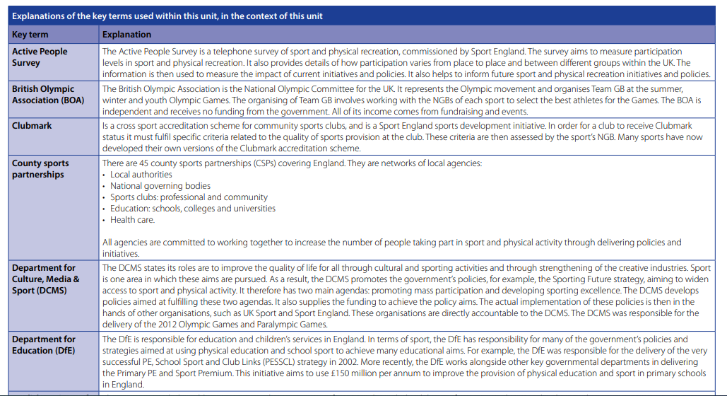
Unit 3 – Sports Organisation

Unit 4 – Working Safely

Unit 8 – Sporting Events
Unit 18 – Practical Skills
