

**Promoting Positive Emotional Health & Wellbeing Policy**

**A Whole School Approach**

**THIS POLICY APPLIES ACROSS ALL TRUST SCHOOLS AND SERVICES**

|  |
| --- |
| **Document Management:**  Date Policy Approved: 28 June 2017  Date Amended: November 2021  Next Review Date: November 2024  Version: 2  Approving Body: Standards Committee |

**Promoting Positive Emotional Health & Wellbeing**

**Rationale**

Research has found that in an average class of 30 15-year-old pupils:

* three could have a mental disorder
* ten are likely to have witnessed their parents separate
* one could have experienced the death of a parent
* seven are likely to have been bullied
* six may be self-harming

The Department for Education (DfE) recognises that: ‘in order to help their pupils succeed; schools have a role to play in supporting them to be resilient and mentally healthy’. Ofsted has highlighted that children and young people themselves say that they want to learn more about how to keep themselves emotionally healthy.

The National Institute for Health and Care Excellence (NICE) advises that primary schools and secondary schools should adopt a comprehensive, ‘whole school’ approach to promoting the social and emotional wellbeing of children and young people. Such an approach it says should move beyond learning and teaching to pervade all aspects of the life of a school, and has been found to be effective in bringing about and sustaining health benefits.

The DfE also identifies a whole-school approach to promoting good mental health as a protective factor for child and adolescent mental health. The report of the Children and Young People’s Mental Health and Wellbeing Taskforce (2015) identifies a national commitment to “encouraging schools to continue to develop whole school approaches to promoting mental health and wellbeing”.

This document should be read alongside statutory guidance on ‘Keeping Children Safe in Education ‘Supporting pupils at school with medical conditions and existing advice on targeted approaches for supporting pupils with, or at risk of developing mental health problems including:

* [Mental Health and Behaviour advice for Schools](https://www.gov.uk/government/publications/mental-health-and-behaviour-in-schools--2)
* [Promoting children and young peoples emotional health and wellbeing](https://www.gov.uk/government/publications/promoting-children-and-young-peoples-emotional-health-and-wellbeing)
* [Counselling in schools](https://www.gov.uk/government/publications/counselling-in-schools)

**Factors that put children at risk**

Certain individuals and groups of pupils are more at risk of developing mental health problems than others. These risks can relate to the child themselves, to their family, or to their community or life events. These risk factors which are listed in **Table 1** below are cumulative. Children exposed to multiple risks such as social disadvantage, family adversity and cognitive or attention problems are much more likely to develop behavioural problems.

**Factors that make children more resilient**

Some children, despite being exposed to significant risk factors, continue to develop into competent, confident and caring adults. An important key to promoting children’s mental health is therefore an understanding of the protective factors that enable children to be resilient when they encounter problems and challenges.

‘***Resilience seems to involve several related elements. Firstly, a sense of self-esteem and confidence; secondly a belief in one’s own self-efficacy and ability to deal with change and adaptation; and thirdly, a repertoire of social problem solving approaches.*’**

There is a complex interplay between risk factors in children’s lives and promoting their resilience. As social disadvantage and the number of stressful life events accumulate for children or young people, more factors that are protective are needed to act as a counterbalance. The key protective factors, which build resilience to mental health problems, are shown alongside the risk factors in **Table 1**, below.

The role that our can schools play in promoting the resilience of their pupils is vital, particularly so those children where their home life is less supportive. Our school will be safe and affirming places for children where they can develop a sense of belonging and feel able to trust and talk openly with adults about their problems.

**Table 1**

|  |  |  |
| --- | --- | --- |
|  | **Risk factors** | **Protective factors** |
| **In the child** | * Genetic influences * Low IQ and learning disabilities * Specific development delay or neuro-diversity * Communication difficulties * Difficult temperament * Physical illness * Academic failure * Low self-esteem | * Being female (in younger children) * Secure attachment experience * Outgoing temperament as an infant * Good communication skills, sociability * Being a planner and having a belief in control * Humour * Problem solving skills and a positive attitude * Experiences of success and achievement * Faith or spirituality * Capacity to reflect |
| **In the family** | * Overt parental conflict including domestic violence * Family breakdown (including where children are taken into care or adopted) * Inconsistent or unclear discipline * Hostile and rejecting relationships * Failure to adapt to a child’s changing needs * Physical, sexual, neglect or emotional abuse * Parental psychiatric illness * Parental criminality, alcoholism or personality disorder * Death and loss – including loss of friendship | * At least one good parent-child relationship (or one supportive adult) * Affection * Clear, consistent discipline * Support for education * Supportive long term relationship or the absence of severe discord |
| **In the School** | * Bulying * Discrimination * Breakdown in or lack of positive friendships * Deviant peer influences * Peer pressure * Poor pupil to teacher relationships | * Clear policies on behaviour and bullying * ‘Open door’ policy for children to raise problems * A whole-school approach to promoting good mental health * Positive classroom management * A sense of belonging * Positive peer influences |
| **In the community** | * Socio-economic disadvantage * Homelessness * Disaster, accidents, war or other overwhelming events * Discrimination * Other significant life events | * Wider supportive network Good housing * High standard of living * High morale school with positive policies for behaviour, attitudes and anti-bullying * Opportunities for valued social roles * Range of sport/leisure activities |

**Difficult events that may have an effect on pupils**

Form tutors and class teachers see their pupils day in, day out. They should know them well and be well placed to spot changes in behaviour that might indicate a problem. The balance between the risk and protective factors set out above is most likely to be disrupted when difficult events happen in pupils’ lives. These include:

* **loss or separation** – resulting from death, parental separation, divorce, hospitalisation, loss of friendships (especially in adolescence), family conflict or breakdown that results in the child having to live elsewhere, being taken into care or adopted, deployment of parents in armed forces families;
* **life changes** – such as the birth of a sibling, moving house or changing schools or during transition from primary to secondary school, or secondary school to sixth form; and
* **traumatic events** such as abuse, domestic violence, bullying, violence, accidents, injuries or natural disaster.
* **other traumatic incidents** such as a natural disaster or terrorist attack. Some groups could be susceptible to such incidents, even if not directly affected. For example, schools should ensure they are aware of armed forces families, who may have parents who are deployed in areas of terrorist activity and are surrounded by the issues in the media

Our Schools will provide to support children at such times, intervening where possible to help prevent mental health problems from developing.

**Promoting pupils’ mental health**

The following diagram presents the eight principles that will be adhered to by our schools to promote emotional health and wellbeing.



We will promote the emotional health & wellbeing of our pupils through:

* **a committed Senior Management Team** that sets a culture within the school that values all pupils; allows them to feel a sense of belonging; and makes it possible to talk about problems in a non-stigmatising way.
* **adopting an ethos of setting high expectations of attainment for all pupils with consistently applied support.** This includes clear policies on behaviour and bullying that set out the responsibilities of everyone in the school and the range of acceptable and unacceptable behaviour for children. These are available and understood clearly by all, and consistently applied by staff.
* **an effective strategic role Special Educational Needs Co-ordinator (SENCo),** ensuring all adults working in the school understand their responsibilities to children with Special Educational Needs and Disabilities (SEND), including pupils whose persistent mental health difficulties mean they need special educational provision. The SENCo will ensure colleagues understand how the school identifies and meets pupils’ needs, provide advice and support to colleagues as needed and liaise with external SEND professionals as necessary.
* **working with parents and carers as well as with the pupils themselves**, ensuring their opinions and wishes are taken into account and that they are kept fully informed so they can participate in decisions taken about them.
* **the continuous professional development for staff** that makes it clear that promoting good mental health is the responsibility of all members of school staff and informs them about the early signs of mental health problems, what is and isn’t a cause for concern, and what to do if they think they have spotted a developing problem.
* **establishing clear systems and processes to help staff who identify children and young people with possible mental health problems**; providing routes to escalate issues with clear referral and accountability systems. Our schools will work closely with other professionals to have a range of support services that can be put in place depending on the identified needs (both within and beyond the school). These will be set out clearly in the school’s published SEND policy and Local Offer.
* **working with others to provide interventions for pupils with mental health problems that use a graduated approach to inform a clear cycle of support:** an assessment to establish a clear analysis of the pupil’s needs; a plan to set out how the pupil will be supported; action to provide that support; and regular reviews to assess the effectiveness of the provision and lead to changes where necessary; and
* **a healthy school approach to promoting the health and wellbeing of all pupils in the school**, with priorities identified and a clear process of ‘planning, doing and reviewing’ to achieve the desired outcomes.

**Our Strategic Approach**

The following diagram describes our strategic and whole school approach to the promotion of emotional health & wellbeing. At the base of our model is the concept of universal provision whereby all our children are offered an entitlement of support and access to a curriculum and other provision including extra–curricular opporutities which helps to build independence and personal resiliance. Children that require a higher level of support or intervention will be identified through a systematic plan, do, review methodolgy. Children with particularly complex needs will be formally assessed before they access targeted intervertnions or are referred to specialist provision.

**Our Strategic Approach to Promoting Emotional Health & Wellbeing**

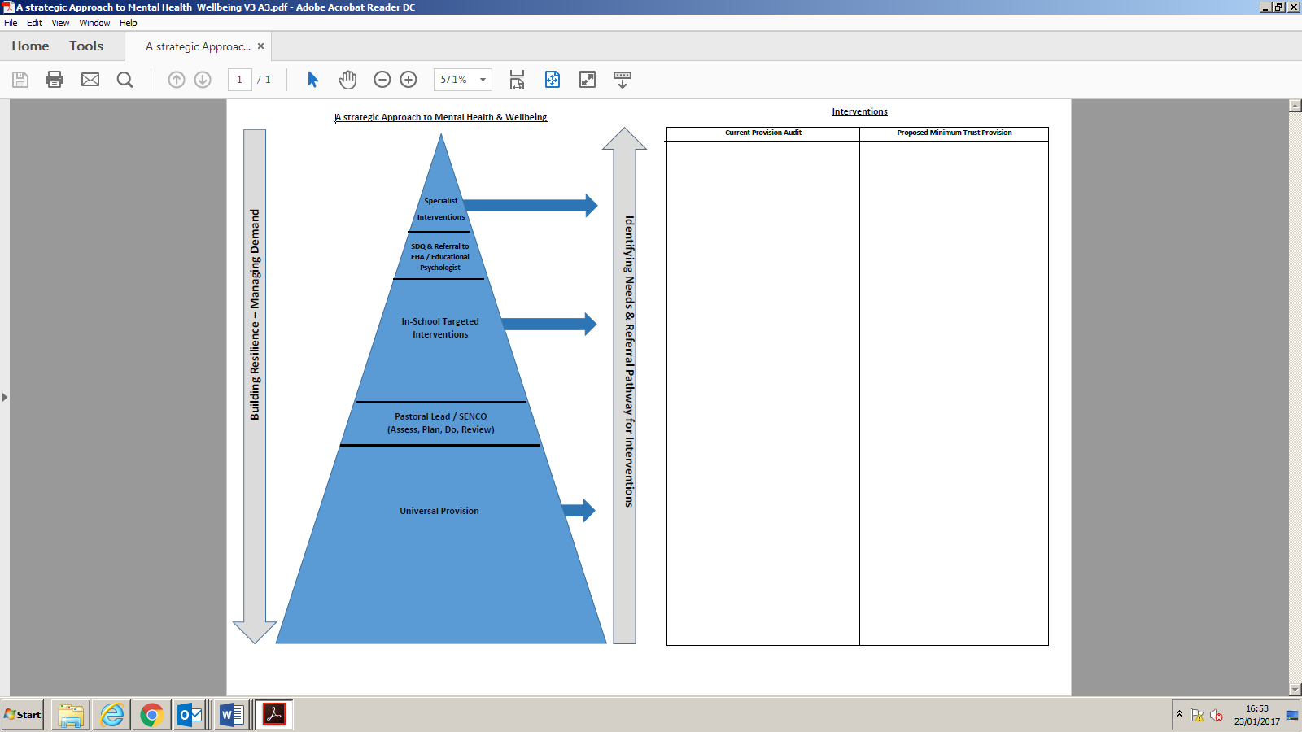

**Encouraging positive mental health**

**Creating a friendly environment** – We aim to create an environment where pupils feel comfortable to approach staff or peers when they have a problem. We will listen to pupils, engaging in conversation and responding appropriately to what has been said. Building a rapport with pupils instils trust. It is important that pupils have a trusted relationship with at least one member of staff so that any issues a pupil may have can be passed on – confident that they will receive the support they need.

**Talking about mental health** – We will provide pupils with the opportunity to acknowledge that everyone has mental health. Talking about mental health as a concept which is owned by all can not only reduce the stigma which surrounds the term, but can change pupils’ perceptions on what mental health is. Discussing mental health as a concept rather than an illness can show pupils that it is not something to be embarrassed or ashamed of. We will encourage this concept by integrating discussion on mental health in the curriculum, as well as dedicating some lessons to promoting pupil wellbeing.

**Care away from the classroom -** Pupils who suffer from mental health problems can sometimes find the classroom environment or lessons overwhelming. We will seek to provide safe spaces for pupils to go to that gives them necessary time out.

**Reducing the stigma -** The negative stigma which surrounds mental health can be reason enough for pupils not to come forward with any issues they may be experiencing. Keeping mental health issues from peers, parents or teachers can be detrimental to pupil welfare and other aspects of learning. We will therefore encourage discussion of mental health in a positive, judgement-free environment and promote a positive outlook on mental health by:

* Integrating discussions about mental health in the curriculum.
* Creating specific lesson plans in subjects such as art, RE or PE, which encourages self-expression, interaction with others, and learning about feelings and emotions.
* Training teachers about the benefits of positive mental health so that it can be transposed through teaching, helping pupils to feel more at ease discussing mental health issues.

**Identifying a problem -** Pupils spend a great deal of time at school so it is essential that our staff feel confident in building trusting relationships with pupils. We will therefore ensure that staff have a basic understanding of mental health and what the telling signs of a mental health problem are.

**Educational support** Once a pupil has come forward to a member of staff, they should be referred to a member of staff with responsibility for pastoral care who will assess need and provide the most appropriate intervention or referral to other agencies including CAMHS, or other NHS or specialist services.

**Guidance, Resources & Training**

[**Promoting and supporting mental health and wellbeing in schools and colleges**](https://www.gov.uk/guidance/mental-health-and-wellbeing-support-in-schools-and-colleges)– This Department for Education website signposts a range of resources and training including Senior mental health leads training to develop a whole school approach to mental health and wellbeing.

[**Mental Health and Wellbeing Resources for Teachers and Teaching Staff June 2021**](https://assets.publishing.service.gov.uk/government/uploads/system/uploads/attachment_data/file/993669/Mental_Health_Resources_for_teachers_and_teaching_staff_June_2021.pdf)– This Department for Education publication provides sources of mental health and wellbeing support for teachers, school staff and school leaders.

It will help you:

* find help and support in response to any feelings you are experiencing as a result of COVID-19
* signpost pupils and students to appropriate support, help and advice
* provide pupils and students with a list of resources so they can get support on a range of issues independently
* access advice on prioritising your own wellbeing and mental health

[**The Anna Freud Centre**](https://www.annafreud.org/schools-and-colleges/) **-** The Anna Freud Centre, runs a [network](https://www.annafreud.org/schools-and-colleges/) for schools and trusts and publish a variety of resources to support children’s mental health and wellbeing.