Governor Information Handbook

Contents:
- Our Vision and Values
- Meet the Governance Team
- Governance within a Multi-Academy Trust
- Your Responsibilities
- Local Governing Committee Annual Planner
- Key Documents
- School Monitoring Roles and Visits
- Training Available
Annex – Local Governing Committee Terms of Reference

Our Vision, Values & Virtues

Our vision and values are at the centre of all that we do and guide us in our mission. Virtues linked to these have been shaped and adopted by each of our Academies and drive their distinct character and ethos in providing outstanding education to our children and young people.

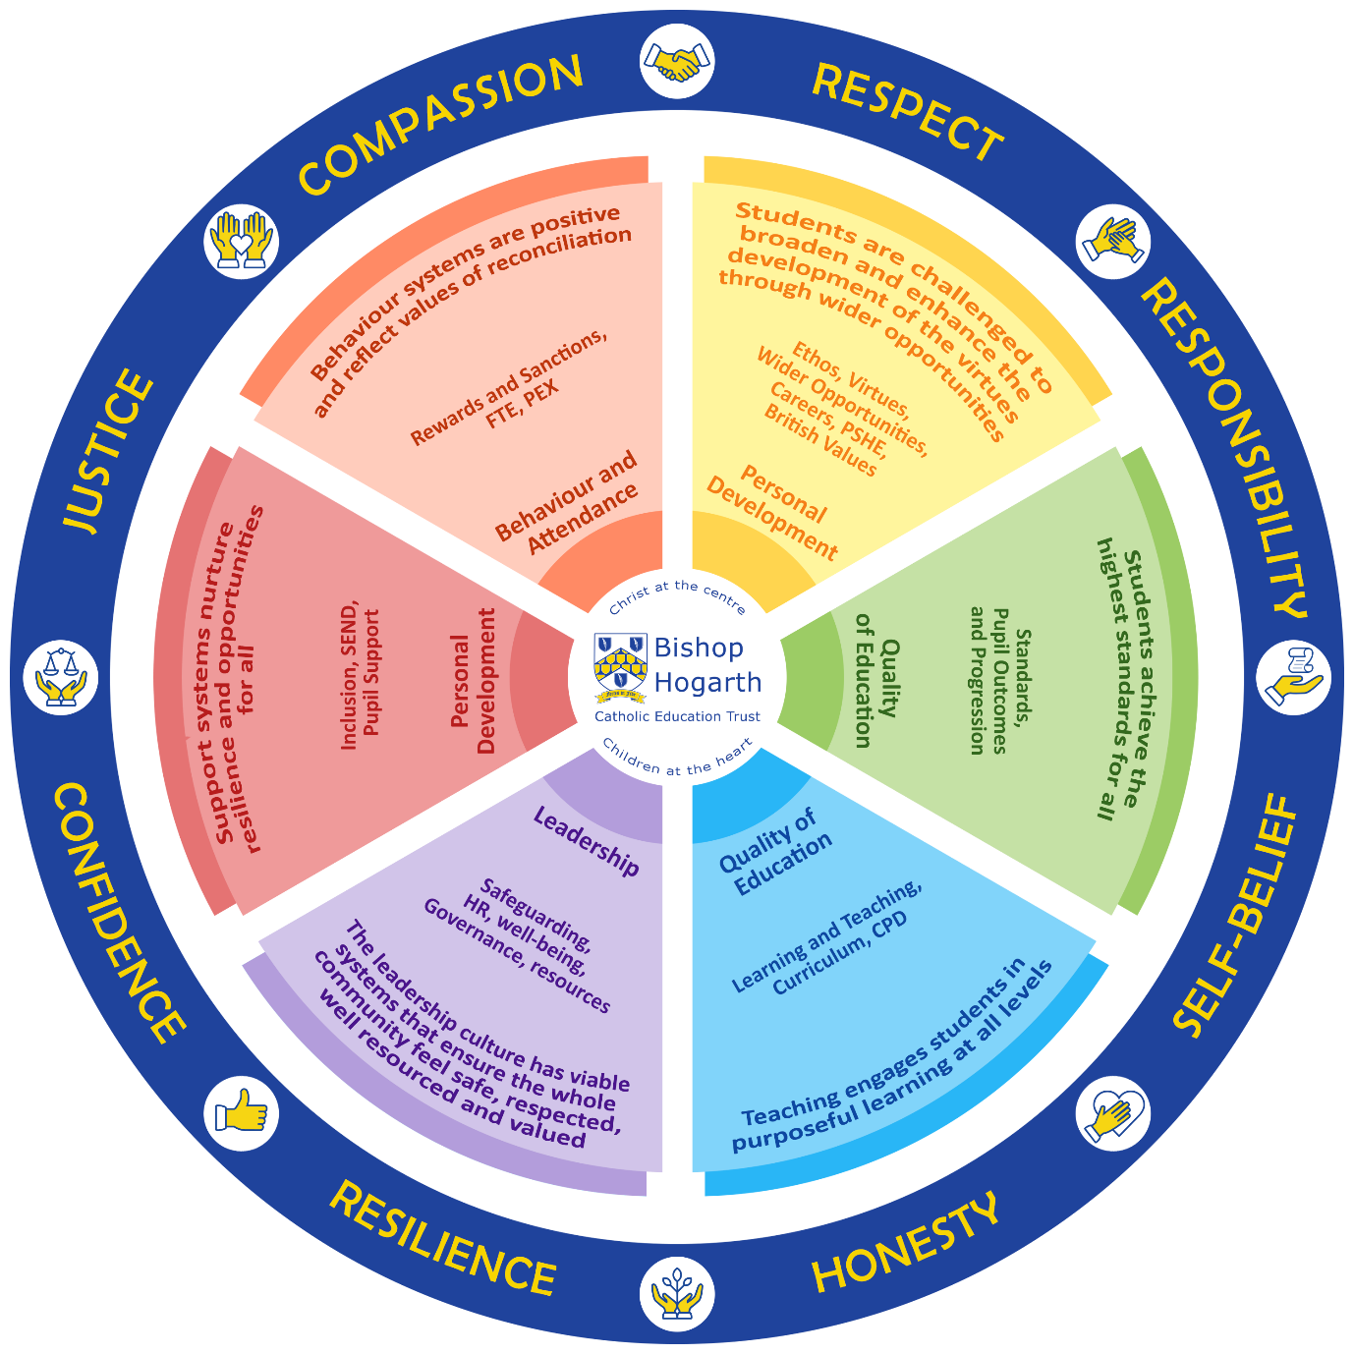

Our Vision
Our schools will be places of excellence – providing service and witness to children, their families and the wider Catholic community, adding value as a family of schools and enriching the learning and experience of all our young people so they may achieve their full potential.

Our Values

The following values underpin everything the Trust and our Schools will do:

BEING Just and Responsible

We seek to act justly, fairly and responsibly in all our relationships to ensure ‘The Common Good’ is upheld.

PROMOTING Spiritual and Human Development

We believe a knowledge of and a personal relationship with Christ gives meaning and purpose to our lives.

ACHIEVING Quality in Teaching and Learning

We believe everyone should gain dignity and self-worth through quality teaching and learning which allow all in our school community to excel.

SHOWING Respect for Every Person

We believe that all are created in the image of God and therefore we will respect the unique and intrinsic value of every person, promoting equality and celebrating diversity.

CREATING Community

We believe our schools to be faith communities where Gospel values of truth, honesty, forgiveness and reconciliation are lived and where there is special care for those most in need.

COMMUNICATING

We value the views and opinions of the communities whom we serve and will actively engage and respond.

Meet the Governance Team

We provide a comprehensive clerking service to schools within the Trust, including the preparation of minutes, agenda’s and paperwork. We also offer the provision of legal and procedural advice to all schools within our Trust, including the development and monitoring of all statutory Trust policies.

Julian Kenshole, Director of Governance Jordan Brown, Governance Manager

Ann Robinson-Ruddock, Clerk to Governors Lauren Jones, Governance Administrator

Steve Petch, Governance Administrator

Governance within a Multi-Academy Trust
The Bishop Hogarth Catholic Education Trust is a Multi-Academy Trust and as such is a single legal entity with one governing body (the Trust Board) which is accountable for all academies in the Trust. The Members of the Trust oversee the Trust Board holding the Directors to account and ensuring that the values and ethos of the Trust are upheld and the distinctiveness of the academies is preserved.

Each academy within the Trust has its own Local Governing Committee to which the Trust Board delegates functions to (through the Scheme of Delegation). Local Governing Committees are committees of the Trust Board and are accountable to the Directors. Members of the Local Governing Committees are to referred to governors. The Trust Board is the accountable body within the Trust and is responsible for the good governance of the Trust and its Academies.

The diagram below illustrates the Trust's reporting and decision-making structures. Decision-making is delegated wherever possible to Local Governing Committees but accountability ultimately rests with the Directors.

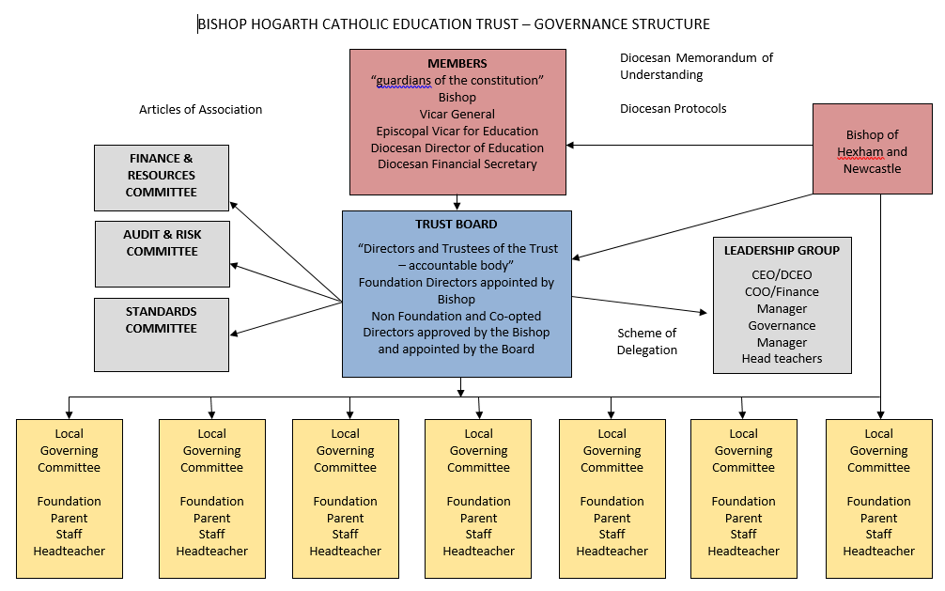
Bishop Hogarth Catholic Education Trust – Reporting & Decision-making Structure

To ensure effective collaboration and the dissemination of good practice, headteachers of each school meet as a Leadership Group. This group meets weekly. The Chairs of Local Governing Committees are invited to attend three of these meetings a year (termly) providing an opportunity to consider the impact of the Trust as a whole and contributing to the Trust Board in making strategic decisions about future priorities for the Trust and its Academies. The Leadership Group both supports and advises the Trust Board and facilitates communication between the Trust Board and the Local Governing Committees. To ensure that communication is maintained with governors either the CEO / Deputy CEO or Chief Operating Officer attends the meetings of the Local Governing Committees.

Decisions are taken at the level nearest to those affected by those decisions, which is compatible with the principles of solidarity and support for the common good while avoiding unnecessary bureaucracy. The Trust adopts a policy of earned autonomy and where governance responsibility is delegated, appropriate decision-making authority is given through the Scheme of Delegation.

For the sake of clarity, the table below provides a summary of the key responsibilities of Members, Directors and the Local Governing Committee.

Members | Directors | Local Governing Committee
- determine constitution and religious character  - oversee the Directors  - recognise any strategic partnerships  - delegate governance and management responsibility to the Directors (formally appointing and removing the Directors where necessary) | - hold governance accountability  - determine strategic vision and overarching strategic plan  - provide strategic leadership and governance  - provide challenge and support to senior leaders  - undertake the recruitment and performance of any chief executive officer  - develop and decide strategic and operational policies  - facilitate collaboration  - co-ordinate and oversee shared services and resources  - develop and oversee the implementation of Trust development plan  - approve of performance benchmarks  - approve overall Trust budget and approve School budget parameters  - monitor expenditure in accordance with appropriate authorisations  - oversee financial governance and risk management  - determine the Trust’s reserves/contingency policy  - ensure appropriate insurance or risk cover is put in place  - undertake recruitment of headteachers and facilitate the performance management of senior leaders  - develop shared staff training programmes and opportunities for professional development  - support the development and building of leadership and governance capacity at School level  - approve of site and asset management strategy  - oversee any significant capital expenditure and building projects ensuring compliance with Trust finance policy  - approve of all funding applications  - decision maker for all appeals | - decide the School’s strategic vision and uphold the School’s distinctiveness and unique character, in harmony with the Trust’s strategic vision and ethos  - support senior leadership team generally and with specific emphasis on target setting, pupil monitoring and analysing progress data to inform curriculum & budgeting priorities  - approve of School development/action plan  - approve of School budget as recommended by the Trust Central Team and support the head teacher in submitting the budget to the Trust Board for formal approval  - approve any significant capital expenditure  - oversee expenditure ensuring the School works within its budget and implements the Trust’s risk and financial management policies ensuring probity, prudence and efficiency  - play an active part in the recruitment of the headteacher  - support the senior leadership team in the development and review of an appropriate staffing structure  - support the head teacher in the recruitment and performance management of personnel  - responsible for staff welfare and well-being, supporting the senior leadership team in monitoring absence and sickness  - promote collaboration with other schools in the Trust  - develop and review delegated school policies (e.g. admissions, pupil behaviour, safeguarding)  - provide advice and feedback to the Directors, ensuring the School is meeting the needs of its community  - undertake all and any appropriate community consultation  - provide a point of contact for parents, carers and other members of the local community, maintaining an effective link to the wider community  - evaluate its performance ensuring appropriate training and development so that knowledge, skills and behaviour are appropriate for a dynamic education environment

The organisation and constitution of the Local Governing Committee is detailed in the Terms of Reference attached at Appendix 1

Your Responsibilities

Local Governing Committees provide leadership for schools and have delegated responsibility for school improvement, as such they act as the eyes and ears of the Trust and help Directors discharge their responsibility for providing accountability for the overall performance of the school and the educational outcomes for all groups of pupils.

As described in the Governance Handbook, DfE, Local Governing Committees share with the Board of Directors three core functions:

- ensuring clarity of vision, ethos and strategic direction.
- holding executive leaders to account for the educational performance of the organisation and its pupils, and the performance management of staff.
- overseeing the financial performance of the organisation.

The Governance Handbook further states that effective governance is based on six key features:

- strategic leadership
- accountability
- people
- structures
- compliance
- evaluation.

These features set out the way in which governors undertake their role, guide their purpose, and direct how governance is organised, developed and improved. No one governor is responsible for ensuring all features are present in the work of the Local Governing Committee. Governance is a collective responsibility and governors should contribute based on their individual skill-set, knowledge and experience.

All governors should be prepared to question and challenge, this is a key aspect of holding school leaders to account. Governors are a valuable resource for schools. They can provide a fresh perspective, bring up-to-date information, and question embedded practices and the status quo.

A key responsibility of all governors is asking questions to ensure their understanding develops in order for them to get to know the school, its strengths and development needs and what effective governance looks like. A resource pack with a bank of questions ‘knowing your school’ is available to download from the Governance page on the Trust website, here.

All governors have a responsibility to prepare effectively for meetings by reading all paperwork distributed and planning any questions arising from their preparation.

All governors are expected to attend the Local Governing Committee meetings of which there are three per academic year.

Governors are expected to act in good faith in the best interests of the Trust and the Academies for whom the Trust has responsibility. This means governors have a responsibility to do the following when dealing with matters for the Academy:
- To ensure compliance with any legal obligations
- To act in a way which is compliant with the charitable object of the Trust, its Articles of Association and the Scheme of Delegation, including the Diocesan Memorandum of Understanding
- To act with integrity and to avoid any personal conflicts of interest and not to misuse any Trust or Academy funds or assets
- To act prudently in the financial management of the Academy, avoiding putting any assets, funds or reputation of the Academy or the Trust more widely at undue risk
- To exercise reasonable care and skill, using personal knowledge and experience to ensure the Academy is well run and efficient
- To act responsibly, getting advice from others, including professional advisors, where appropriate.
Governors must avoid conflicts of interest and to act prudently and must be especially careful where they may have a personal interest in a matter which involves either the Trust or the Academy. Familial relationships at Governor and leadership level are discouraged. Governors must comply with the Trust’s policy for the Register of Business and Personal Interests and complete a questionnaire annually.
The role of a Governor is unpaid (except for the reimbursement of reasonable expenses). Governors are appointed for a term of 4 years and can be reappointed on the expiry of such term provided that no Governor is to be appointed for more than 3 terms of office. Foundation Governors are appointed by the Bishop and will be practicing Catholics.

Local Governing Committee Annual Planner

The table below provides an overview of the typical Local Governing Committee work-programme.

Term One | Term 2 | Term 3
Election of Chair and Vice Chair  Register of Interests  Chairs Report  Summary Headteacher / Principal Report  Internal Audit Report (selected schools)  Examination Results, Targets & Exception Reporting  School Self-Evaluation & School Improvement Plan  Pupil Premium Strategy Statement and Review of Impact  PE & Sport Premium Spending Plans and Review of Impact (Primary phase)  Annual Report on Bullying & Racial Incidents  Annual Report on Looked After Children  Annual Report on Exclusions  Review Link Governors  Feedback from Governor Visits  Membership & Terms of Office  Carmel Teacher Training Partnership & School Alliance Update (Carmel LMB)  School Holiday Dates (consultation)  Approval of Admission Policies | Chairs Report  Headteacher Report  Updated Self-Evaluation & School Improvement Plan  Pupil Progress Report  Internal Audit Report (selected schools)  Feedback from Governor Visits  Equality Information & Objectives (Review Objectives every 4 years. Publish Information annually)  Prevent Duty Risk | Chairs Report  Head of School Report  Internal Audit Report (selected schools)  SEN Policy & SEN Information Report  Funding  Budget and Medium -Term Financial Plan for forthcoming Year  Feedback from Governor Visits  Annual report on Complaints  Curriculum Plans for forthcoming academic year.  Summer refurbishment Priorities.  Safeguarding Children in Education Checklist  Health & Safety Policy

Key Documents
There are a number of key documents which all governors should familiarise themselves with to help them understand their role and be effective and compliant in governance. These documents are updated on a regular basis and governors should ensure they read the most up-to-date version available. Governors should take care not to overwhelm themselves with reading too much information too quickly.

- Governance handbook: A guidance document from the DfE which sets out the overarching vision and priorities for effective governance.

- ‘A Competency Framework for Governance’: A guidance document from the DfE setting out the knowledge, skills and behaviours needed for effective governance.

- ‘Keeping children safe in education’: Statutory guidance for all school leaders which should be given full regard when carrying out child protection and safeguarding duties. All staff and governors should read part one as a minimum, but it is recommended that all governors read and refer to the whole guidance to ensure compliance and to commit due regard to the board’s safeguarding responsibilities.

- Terms of reference: Terms of reference are, essentially, blueprints outlining the structure and purpose of a Local Governance Committee. The terms of reference are attached at the end of this document.

- School development plan (SDP): Governors should also familiarise themselves with the SDP. The SDP provides a strategic plan for school improvement and collates the school’s priorities, the key outcomes it intends to achieve, and the main measures it will take to achieve the targets. Becoming familiar with this document will enable governors to get up-to-speed with the strength and developmental needs of the school.

- School self-evaluation form (SEF) summary: Becoming familiar with the SEF summary will assist governors to understand how school leaders evaluate the performance and effectiveness of the school in key areas, such as leadership and management, pupil behaviours and welfare and pupil outcomes. In our Trust, the SDP & SEF are combined into one document.

- Code of Conduct for Governors: The code of conduct for governors outlines the responsibilities of governors, as well as what is expected of them in terms of their behaviour (including the acceptance of gifts & hospitality) and commitment to their roles.

- Scheme of Delegation: The scheme of delegation details clearly the levels of delegation for any decisions which need to be made. The most recent version is available via the Trust website.

- Knowing Your School: A Resource Pack for Governors: The ‘Knowing Your School’ resource packs includes a range of questions to help governors hold their leaders to account and to ensure high standards.

Useful Links

Governance handbook: -
https://www.gov.uk/government/publications/governance-handbook

‘A Competency Framework for Governance’ - https://assets.publishing.service.gov.uk/government/uploads/system/uploads/attachment_data/file/583733/Competency_framework_for_governance_.pdf

‘Keeping children safe in education’-
https://www.gov.uk/government/publications/keeping-children-safe-in-education--2

School Monitoring Roles and Visits
Link governor roles – these roles may be linked to specific classes, subjects or identified priority areas. If a governor is allocated a link role, they will be expected to carry out monitoring visits throughout the course of the year. The purpose of these visits is to oversee what is being done in school in relation to the link area and the impact of any initiatives which have been implemented.

Governors may also be asked to attend specific school events such as parents’ evenings or information evenings – they may also be invited to attend school social events and attending these will certainly help governors to get to know their school.

The Trust has developed a Resource Pack for Governors – ‘Knowing your School’ which can be downloaded here or from the Governance area of the Trust website.

There is an expectation that governors take responsibility for keeping themselves up-to-date with education, so there may be some reading, research or training to be undertaken outside of meetings.

The table below details the specific roles of governors and outlines their competency & training requirements.

ROLE | KEY RESPONSIBILITIES | CORE COMPETENCIES/SKILLS/ /TRAINING
Chair | - Ensure the Bishop’s wishes are fulfilled;  - Provide a clear lead and direction for the Local Governing Committee;  - Build an effective team, attracting individuals to the with necessary skills and experience, promoting equality and diversity, ensuring priority is given to those who can make a positive contribution to the Academy and the work of the Trust and who will provide a focus for driving up and maintaining high standards in the Academy;  - Ensure new governors are properly introduced to the work of the Local Governing Committee and the Trust more widely and to support their development as effective and valued members of the Local Governing Committee maximising their contribution to the Academy and the Trust in doing so;  - Work closely with the headteacher of the Academy to ensure there is proper challenge and encouragement of governors and the Academy’s senior leadership team; | As well as the skills required of a Governor, the Chair should be able to demonstrate the following attributes:  - An understanding of the framework within which corporate bodies function;  - Strong communication skills;  - Ability to prioritise and delegate;  - Ability to chair meetings and encourage the participation of others, including mediate;  - Ability to build and lead a team;  - Leadership or managerial experience.  Training Needs/Resources:  - Governor training provided by the Diocese  - Chair Briefings – Diocese of Hexham & Newcastle  - National Governance Association - Chairs Training Programme

 | - Provide direct support to the headteacher of the Academy and to both the Trust Chair and any chief executive officer of the Trust in relation to any recruitment and performance management of this role as well as the review of pay and conditions of service;  - Provide support to the Trust Chair and any chief executive officer in any decision to suspend or discipline the headteacher of the Academy;  - Ensure that school improvement is the focus of all policy and strategy for the Academy, reminding Governors of this as often as necessary;  - Hold the Governors to account, ensuring the business of the Local Governing Committee is conducted efficiently and effectively, chairing meetings ensuring all Governors have the opportunity to contribute and are listened to with clear decisions being made when necessary, including reporting on the local governing committee’s effectiveness to the Trust Board as required;  - Be available when there is a need to act quickly, taking, or supporting the Academy headteacher (and if need be any chief executive officer) in taking, urgent action and making decisions, subject to subsequent ratification by the Local Governing Committee(and/or Trust Board if need be) as necessary;  - Act as a focal point and advocate for the local governing committee, liaising as necessary with any regulatory body, the Local Governing Committee and those representing the wider community.  - To provide leadership to the Local Governing Committee  - To ensure meetings are run effectively, focusing on priorities and making the best use of time available.  - To ensure that all members have an equal opportunity to participate in discussion and decision-making.  - To establish and foster an effective relationship with the Headteacher/Head of School based on trust and mutual respect for each other’s roles.  - To ensure that the Governing Committee acts as a sounding board to the Headteacher/Head of School and provides strategic direction.  - To use time effectively by planning the years cycle of meetings and a timetable for action.  - To construct and agree the agenda for meetings, together with the clerk, taking account of the recommendations of the Headteacher/Head of School and requests from other governors and keep good order in meetings.  - To ensure governors' participation in and between meetings. | - Chairs Training – Darlington, Stockton, Hartlepool & Durham Governor Development Programmes  - The Chairs Handbook – National Governance Association  - Headteacher Appraisal – LEARNINGLINK Module

- Regular liaison with parents and community.
- Keep GB informed with relevant and up-to-date information
- To contribute to Headteacher/ Head of School Performance Management
- Undertaking governor body self-review/regular skill audits and holding an annual performance management meeting with each governor
Vice Chair | - To Support the chair and act in his/her absence.  - To shadow and develop a working knowledge of the Chairs role.  - To lead on governor development and training/Governing Committee self-review  - Conduct regular skills audit of governors and use to identify training needs. Encourage and support governors in their Continuing Professional Development | As above
Finance Governor | - Reviewing monthly budget reports.  - Holding regular meetings with the Headteacher and School Business Manager to discuss financial position, including income, expenditure, commitments and forecasts.  - Scrutinise and participate in the development of the annual budget making process.  - Discuss budget implications of major initiatives, current commitments, and changes to existing arrangements or external influences on budgets.  - Ensuring budget priorities reflect School Development Plan.  - Monitor the use of the Pupil Premium. | - Ability to understand and analyse financial and budgetary information.  - Has numeric and analysis skills  - Ability to understand and analyse financial and budgetary information.  - Has numeric and analysis skills  - Has knowledge of the School’s current financial performance  - Has knowledge of internal control processes  - Understands and participates in the school’s self-evaluation activities of financial performance/controls  - Understands the financial framework in which the School operates  - Has knowledge of Academy funding arrangements and funding streams  Training Needs/Resources:  - Management of Academy Finances – LEARNINGLINK Module  - Understanding Schools finance – LEARNINGLINK Module  - Pupil Premium – LEARNINGLINK Module  - Resources: Making the most of what you’ve got - LEARNINGLINK Module

Looked After Children Governor | To meet termly with the Staff member with designated responsibility for LAC to review:  - Attainment/Achievement  - Attendance  - Exclusions  - Out of School Hours Learning  - Personal Education Plans  - The effectiveness of Communication with carers/social workers  To present an annual report on LAC to the Local Governing Committee | - Knowledge and awareness of the needs of Looked After Children and the Children’s Social Care system.  - Confident to review data and curriculum provision.  Training Needs/Resources:  - Looked After Children – LEARNINGLINK Module  - Pupil Premium – LEARNINGLINK Module  - Designated teacher for looked-after and previously looked-after children
School & Community Engagement Governor | - Undertake regular reviews of web site ensuring information is relevant and accessible to students/ parents/carers and wider community.  - Review staff/parent and student surveys and report issues to Governing Committee/relevant working groups.  - To monitor school responses to issues raised in surveys.  - To attend meetings of the School Council and champion its voice on the Governing Committee  - Undertake periodic checks of website to ensure all statutory information is published on website.  - Promote the work of the schools and coordinates items for termly governor newsletter to parents.  - Developing a good understanding of the priorities of the school community  - Representing the Governing Committee in any community forums or meetings | - Knowledge and ability to access web based information  - Good listener  - Good communication skills  - Knowledge of local community and networks  Training Needs/Resources:  - Stakeholder engagement - LEARNINGLINK Module (  - Engaging with pupil and parents - LEARNINGLINK Module
SEN Governor | - Meeting the SENCO on a termly basis to gain information about the provision made for pupils with special educational needs and to monitor the implementation of the SEN policy  - To review the SEN Information Report annually  - Discussing with school staff the outcomes of the school’s monitoring and evaluation of the provision made for pupils with SEN  - Observing first-hand what happens in school both inside and outside the classroom to ensure that pupils with SEN are actively involved in all aspects of school life | - Be familiar with the SEN policy  - Understanding of disability issues  Training Needs/Resources:  - The role of the SEN governor - LEARNINGLINK  - Monitoring and evaluation - LEARNINGLINK  - Monitoring Performance Data and Targets - LEARNINGLINK  - SEN and Disability Code of Practice: 0 to 25 Years Statutory Guidance

- Taking opportunities to meet and talk with parents of children with SEN
- Keeping informed about developments in the area of SEN, nationally, locally and within the school
- Agreeing with the Governing Committee and the headteacher the indicators that demonstrate whether the policy is working and agreeing the timescale for reporting these to the Governing Committee
- Encouraging the Governing Committee to ensure that all school policies are consistent with the aims of the SEN policy
- Reporting on an annual basis to the full Governing Committee on the implementation of the school’s SEN policy
Premises / Health & Safety Governor | - Liaise with site staff, School Business Manager to ensure correct procedures for site safety & security are in place each term.  - With the School Business Manager and Health & Safety Advisor to review the annual H&S audit.  - Ensure that the school has a site specific health and safety policy and appropriate health and safety procedures and practices.  - Keep the Governing Committee informed of health and safety issues  - Keep informed by reading new materials and information relating to health & Safety. | - Knowledge of H&S processes, some site/building experience.  Training Needs/Resources:  - Health & Safety – LEARNINGLINK Module  - Health and Safety Executive Education webpage - http://www.hse.gov.uk/services/education/index.htm  - DfE Health & Safety Advice. pdf  - Health and safety: responsibilities and duties for schools
Safeguarding Governor | - Carry out the annual Safeguarding Audit with staff. Review DBS systems including checking the single central register.  - Act as a ‘critical friend’ to the school, in order to ensure that the appropriate systems and procedures are in place to cover all aspects of the safeguarding agenda and all statutory Governing Committee responsibilities are met.  - Monitor the implementation the safeguarding policy and other related policy areas.  - Champion child protection and safeguarding issues including E Safety.  - Ensure there is a suitably qualified, trained and supported Designated Senior Person who has responsibility for responding to and overseeing safeguarding issues.  - Ensure there is a suitably qualified, trained and supported Deputy Designated Person who has responsibility for responding to and overseeing safeguarding issues as agreed reasonable to be delegated by the DSP. | - Analytical and organised. Available to check records and liaise with staff each term.  Training Needs/Resources:  - Safeguarding the Governors Role – LEARNINGLINK Module  - E Safety for Governors - LEARNINGLINK Module  - Educational Visits – LEARNINGLINK Module  - Attend Level 1 safeguarding training every 3 years  - Complete accredited Safer Recruitment training  - Keeping Children Safe in Education: Statutory Guidance for Schools and Colleges  - Trust Safeguarding Policy

- Liaise with the Head about general child protection and broader safeguarding issues within the school and as such be able to provide reports to the Governing Committee in respect of themes and issues within the school/locality to enable adequate oversight, understanding and development of solutions.
- Monitor and ensure that school staff training is up to date.
- Ensure other governors attend appropriate safeguarding training.
- Provide an annual report to the Local Governing Committee
Attendance & Behaviour Governor | - Keep under review how well the school communicates to students and parents about the behaviour it expects  - Keep under review implementation of the behaviour policy and related policies  - Meet with the member of the leadership team who has responsibility for behaviour on a termly basis to explore current and emergent issues  - Find out the opinions of pupils/parents/staff regarding behaviour in the school  - Monitor behaviour and attendance management strategies and their impact.  - Monitor trends in exclusions and attendance  - Keep under review the effectiveness of early intervention and prevention strategies and interventions and work with other agencies. | - Knowledge and awareness of Behaviour and Attendance Management.  - Previous experience in serving on a pupil discipline committee  Training Needs/Resources:  - Attendance Matters - Stockton Governor Support Service  - Exclusions – LEARNINGLINK Module  - Minimising Exclusions – LEARNINGLINK Module  - School Behaviour Policy
School Improvement & Curriculum Governors (inc Pupil Premium) | Liaise (in pairs) with school leaders, staff, pupils and parents to monitor the work of the schools under the four Ofsted Inspection areas:  - Quality of education.  - Behaviour and attitudes.  - Personal development.  - Leadership and management.  - Monitor priorities and actions identified in School Development Plan to raise level of attainment/achievement.  - Monitor the impact of Pupil Premium.  - Monitor and review the impact of CPD  - Lead on careers curriculum matters (Secondary Schools)  To maintain an overview of Section 48 inspection areas:  - Catholic Life  - Collective Worship  - Religious Education | - Ability to hold school leadership to account by appropriate and diverse monitoring and asking the right questions  - Ability to provide concise written evidence of monitoring undertaken and impact of school actions on pupil progress and achievement  - Understanding of school data particularly in respect of pupil progress and performance targets  Training Needs/Resources:  - Progress and Attainment: using data to improve educational outcomes – LEARNINGLINK Module  - Monitoring Performance Data and Targets – LEARNINGLINK Module  - Monitoring and evaluation – The Governing Committee’s Role – LEARNINGLINK Module  - Pupil Premium – LEARNINGLINK Module  - School Self-Evaluation  - School Development Plan  - Latest Ofsted Report  - School-Performance-Tables

Catholic Life | To promote the Catholic life of the School and the development of Parish links  To maintain an overview of Section 48 inspection areas:  - Catholic Life  - Collective Worship  - Religious Education | - Governance of a Church School - LEARNING LINK Module
All Governors | Responsibilities include:  - To ensure compliance with any legal obligations;  - To act in a way which is compliant with the charitable object of the Trust, its Articles of Association and the Scheme of Delegation, including the Diocesan Memorandum of Understanding;  - To act with integrity and to avoid any personal conflicts of interest and not to misuse any Trust or Academy funds or assets;  - To act prudently in the financial management of the Academy, avoiding putting any assets, funds or reputation of the Academy or the Trust more widely at undue risk;  - To exercise reasonable care and skill, using personal knowledge and experience to ensure the Academy is well run and efficient;  - To act responsibly, getting advice from others, including professional advisors, where appropriate.  - Agreeing the School Development Plan  - Determining aims, policies and priorities of the school setting targets  - monitoring and evaluating the work of the school  - Appointment of staff and ensuring the implementation of a range of Trust  - personnel procedures and policies  - Strategic management of the delegated budget  - Securing high levels of attendance and good standards of student behaviour  - Ensuring that all children in the schools have access to a broad and balanced curriculum which is suitable to age, aptitude and ability, which prepares them for adult life.  - Ensuring the health and safety of pupils and staff | - To work as a team;  - To attend meetings and be prepared to contribute to discussions and commit to agreed actions;  - To be respectful of the views of others and to be open to new ideas and thoughts;  - To treat all confidential information confidentially;  - To act with integrity, avoiding any personal conflicts of interest and complying with the Trust’s Conflict of Interest policy;  - To develop a deep understanding of the vision and ethos of the Trust and its Academies and the roles played by all individuals in fulfilment of the Trust’s mission;  - To understand the policies and procedures of the Trust and how these flow down to the Academies;  - To support the Trust in public and act as an ambassador of the Trust and the Academies;  - To commit to training and skills development;  - To be ready to ask questions;  - To be focused on problem solving and be ready to learn from past experiences;  - To adhere to the Nolan Seven Principles of Public Life.  Training Needs/Resources:  - Governor Induction  - Attend Level 1 safeguarding training every 3 years  LEARNINGLINK Modules on:  - Governance: Your role, your responsibilities, your organisation  - Key Functions of the governing board  - Governance of a church school  - Effectiveness: Governance making an impact, changing lives  - Governance visits to schools  - Ofsted and the new inspection framework

All Governors | Tasks include:  - decide the Academy’s strategic vision and uphold the Academy’s distinctiveness and unique Catholic character, in harmony with the Trust’s strategic vision and ethos;  - support senior leadership team generally and with specific emphasis on target setting, pupil monitoring and analysing progress data to inform curriculum and budgeting priorities;  - approve of Academy development/action plan;  - approve any significant capital expenditure;  - oversee expenditure ensuring the Academy works within its budget and implement the Trust’s risk and financial management policies ensuring probity, prudence and efficiency;  - play an active part in the recruitment of the headteacher by the Trust Board;  - support the senior leadership team in the development and review of an appropriate staffing structure;  - support the headteacher in the recruitment and performance management of personnel;  - responsible for staff welfare and well-being, supporting the senior leadership team in monitoring absence and sickness;  - promote collaboration with other schools in the Trust;  - develop and review delegated school policies (e.g. admissions, pupil behaviour, safeguarding);  - provide advice and feedback to the Directors, ensuring the Academy is meeting the needs of its community;  - undertake all and any appropriate community consultation;  - provide a point of contact for parents, carers and other members of the local community, maintaining an effective link to the wider community;  - Evaluate its performance ensuring appropriate training and development so that knowledge, skills and behaviour are appropriate for a dynamic education environment. | - Exclusions  - Pupil Premium  - Looked after children  - Safeguarding: the Governor’s role  Monitoring and evaluation – The Governing Committee’s Role  - Monitoring Performance Data and Targets  - Governors’ Role in School Improvement  - Pupil Premium  - Governor Visit to Schools  - Safeguarding the Governors Role  - Governance-Handbook and Competency Framework  - National Governors Association  - NGA Learning Link (see page 24)

Training Available
Governors have a responsibility to undertake any training or CPD needed to complete their role effectively and maintain compliance with governance regulations. As a minimum, governors should complete the following training available from the NGA Learning Link (details on how to access are included on the following page):

- Governance: Your role, your responsibilities, your organisation
- Key Functions of the governing board
- Governance of a church school
- Effectiveness: Governance making an impact, changing lives
- Governance visits to schools
- Ofsted and the new inspection framework
- Pupil Premium
- Safeguarding: the Governor’s role
- Monitoring Performance Data and Targets
- Understanding Schools Finance

In addition, governors will be asked to complete training on Keeping Children Safe in Education: Part A and Prevent Duty on an annual basis.

Foundation Governors can access online courses provided by the Catholic Education Service, including:

1. An introduction to Catholic Education
2. The environment of a Catholic school
3. Strategic Leadership
4. Accountability
5. Financial Performance

You can create an account and access the training here: http://formatio-ces.org/moodle/login/index.php

There will be other training courses offered specific to an individual’s allocated responsibilities – some of these may be arranged for individual governors or as a whole committee session.
Further opportunities for training are available the Diocese and from your Local Authority

Diocese of Hexham and Newcastle - http://edurcdhn.org.uk/courses/courses_profdev.php
(Dates of upcoming Diocesan Governor Briefings are also available at the link above)

Darlington - https://www.darlington.gov.uk/education-and-learning/school-years/governors/

Stockton - https://www.stockton.gov.uk/our-people/information-for-school-governors/governor-training/

Durham - https://www.durham.gov.uk/schoolgovernors

Hartlepool - https://www.hartlepool.gov.uk/info/20074/schools/589/hartlepool_governor_support_service/2

National Governors Association Learning Link

NGA Learning Link offers flexible e-learning to help governors, trustees, chairs, and clerks develop their governance skills and knowledge. If you have used this service before, your old log-on details should still work at the following address - https://nga.vc-enable.co.uk/Login/Login?ReturnUrl=%2f

For new users, please use the following steps to register:
- Use the following link to register your email address - https://nga.vc-enable.co.uk/register
- Add your details to the self-registration form in the following order: first name, last name, email, phone number (optional), governance role title (optional) your school or academy - use the search box and make sure to select the right school using the school postcode
- Click the green register button to submit your application for approval.
- Approval is not immediate, and you must wait for email confirmation of approval. It can take time to receive this email particularly if your application is submitted over a weekend or in the evening.
- Your confirmation email will be sent to you when approved. This includes your temporary password, which you will need to use to log-on for the first time. You will change this after logging in.
- Once logged in, click the 'Learning' tab. This is where you can search and enrol yourself onto courses.

Annex – Local Governing Committee Terms of Reference

COMMITTEE TERMS OF REFERENCE: LOCAL GOVERNING COMMITTEE

Purpose
- A Local Governing Committee (LGC) shall be established for each of the Academies, except where the Trust Board determines in a particular case that more than one Academy should be governed by the same LGC.
- The purpose of the Local Governing Committee is to provide local accountability and day to day support and oversight of the Academy’s leadership team.
- The roles and responsibilities of the Local Governing Committee are set out in the Table of Key Delegated Responsibilities.

Constitution
- Governors appointed to a Local Governing Committee shall be appointed as follows:
  - such number of Foundation Governors appointed by the Diocesan Bishop to ensure that the Foundation Governors outnumber all other Governors by at least 2;
  - the Headteacher of the Academy (or Headteachers where the Academies are federated and there is no Executive Headteacher);
  - up to 1 Staff Governor, elected or appointed through such process as the Local Governing Committee may determine;
  - up to 1 Parent Governor, elected by parents or carers of registered pupils at the Academy and being a parent or carer of a pupil at the Academy at the time when elected;
  - up to 1 Additional Governor appointed by the Local Governing Committee with the approval of the Trust Board.
- There is no power to co-opt Governors to the Local Governing Committee but advisers (including other members of staff in the Academy) may attend meetings provided they do not take part in any decision making.
- All Governors must undertake to uphold the object and mission of the Trust and must comply with the Governor Code of Conduct appended to the Scheme of Delegation.

Term of Office
- The term of office for any Governor shall be 4 years (save that this time limit shall not apply to the Headteacher or any post which is held ex officio, who will serve for as long as he or she remains in office). Subject to remaining eligible to be a particular type of Governor, any person may be re-appointed or re-elected to the Local Governing Committee.
- A Governor shall serve for no more than 3 terms of office.

Resignation and Removal of members of the Local Governing Committee
- A Governor shall cease to hold office if he or she resigns his or her office or is removed by the Bishop or in the case of any Governor who is not a Foundation Governor by the Trust Board (which the Directors reserve the power to do without the need to provide any

reasons for removal). Any vacancy on a Local Governing Committee will trigger an appropriate appointment or election and must be notified to the Trust Board and the Diocesan Department for Education.
- Any person who would not be eligible to be a Director in accordance with the Trust’s Articles of Association will not be eligible for appointment or election to the Local Governing Committee and must resign from the Local Governing Committee if they become ineligible. Details of eligibility to serve as a Governor are set out in the Governor Code of Conduct.
- If any Governor is also an employee of the Trust and ceases to be employed to work at the Academy or within the Trust, then he or she shall be deemed to have resigned from the Local Governing Committee and shall cease to serve on the Local Governing Committee automatically on termination of his or her employment.
- Where a person who serves on the Local Governing Committee resigns his or her office or is removed from office, that person or, where he or she is removed from office, those removing him or her, shall give written notice thereof to the Chair of the Local Governing Committee, copied to the Clerk to the Local Governing Committee.

Appointment of the Chair and Vice-Chair
- Subject to any direction by the Trust Board, Governors shall each school year (typically at the first meeting of the year) elect a Chair and Vice-Chair from amongst the Foundation Governors.
- The Chair and Vice Chair will cease to hold office if they no longer serve as a Governor. The same person cannot hold more than one office.
- The Clerk to the Local Governing Committee shall act as chair during that part of any meeting at which the Chair and Vice Chair are elected.
- Any election of the Chair and Vice Chair which is contested shall be held by secret ballot.
- More details as to the role and responsibilities of the Chair are set out in the Governor Code of Conduct.

Meetings
- The minutes of the proceedings of a meeting of the Local Governing Committee shall be drawn up and entered into a book (electronic or otherwise) kept for the purpose by the person authorised to keep the minutes of the Local Governing Committee and shall be signed (subject to the approval of the members of the Local Governing Committee) at the same or next subsequent meeting by the person acting as chair thereof. The minutes shall include a record of:
  - all appointments of officers made by the Local Governing Committee; and
  - all proceedings at meetings of the Local Governing Committee and of committees of the Local Governing Committee including the names of all persons present at each such meeting.

- The Chair shall ensure that copies of minutes of all meeting of the Local Governing Committee(and such of the subcommittees as the Local Governing Committee shall from time to time notify) shall be provided to the Chief Executive Officer and (if requested) the Diocesan Department for Education as soon as reasonably practicable after those minutes are approved.
- Subject to this Scheme of Delegation, the Local Governing Committee may regulate its proceedings as Governors think fit, provided at all times that there is openness and transparency in matters relating to the Local Governing Committee. The Local Governing Committee is expected to meet at least once a term but may meet more often if felt appropriate or if requested to meet by the Trust Board.
- The Trust Board may direct the Local Governing Committee to allow either Directors, any member of the Trust’s Executive Team or a Governor from another Local Governing Committee in the Trust to attend meetings of the Local Governing Committee. Such persons may engage in discussion but will not be permitted to vote on any resolution of the Local Governing Committee.
- Meetings of the Local Governing Committee shall be convened by the clerk to the Local Governing Committee. In exercising his functions under this Scheme of Delegation the clerk shall comply with any direction:
  - given by the Local Governing Committee; or
  - given by the Chair or, in his absence or where there is a vacancy in the office of chair, the Vice-Chair.
- Any three Governors may, by notice in writing given to the clerk, requisition a meeting of the Local Governing Committee; and it shall be the duty of the clerk to convene such a meeting as soon as is reasonably practicable.
- Each Governor shall be given at least seven clear days before the date of a meeting:
  - notice thereof and sent to each Governor at the email address provided by each Governor from time to time; and
  - a copy of the agenda for the meeting;
- provided that where the Chair or, in his or her absence or where there is a vacancy in the office of Chair, the Vice-Chair, so determines on the ground that there are matters demanding urgent consideration, it shall be sufficient if the notice of a meeting, and the copy of the agenda thereof are given within such shorter period as he or she directs.
- The convening of a meeting and the proceedings conducted thereat shall not be invalidated by reason of any individual not having received notice of the meeting or a copy of the agenda thereof.
- A resolution to rescind or vary a resolution carried at a previous meeting of the Local Governing Committee shall not be proposed at a meeting of the Local Governing Committee unless the consideration of the rescission or variation of the previous resolution is a specific item of business on the agenda for that meeting.
- A meeting of the Local Governing Committee shall be terminated forthwith if:
  - the Governors so resolve; or
  - the number of Governors present ceases to constitute a quorum for a meeting of the Local Governing Committee in accordance with paragraph 6.10, subject to paragraph 6.12.

- Where in accordance with paragraph 6.10.2 a meeting is not held or is terminated before all the matters specified as items of business on the agenda for the meeting have been disposed of, a further meeting shall be convened by the clerk as soon as is reasonably practicable, but in any event within seven days of the date on which the meeting was originally to be held or was so terminated.
- Where the Local Governing Committee resolves in accordance with paragraph 6.10.1 to adjourn a meeting before all the items of business on the agenda have been disposed of, the Local Governing Committee shall before doing so determine the time and date at which a further meeting is to be held for the purposes of completing the consideration of those items, and it shall direct the clerk to convene a meeting accordingly.

Quorum
- The quorum for a meeting of the Local Governing Committee, and any vote on any matter thereat, shall be three. The proceedings of the Local Governing Committee shall not be invalidated by any vacancy on the board or any defect in the election, appointment or nomination of any Governor, providing the defect was not dishonestly made.
- The Local Governing Committee may act notwithstanding any vacancies on its board, but, if the numbers of persons serving is less than the number fixed as the quorum, the continuing persons may act only for the purpose of filling vacancies or of calling a general meeting.
- Subject to this Scheme of Delegation, every question to be decided at a meeting of the Local Governing Committee shall be determined by a majority of the votes of the persons present and entitled to vote on the question. Every Governor shall have one vote.
- Where there is an equal division of votes, the Chair shall have a casting vote in addition to any other vote he or she may have.
- A resolution in writing, signed by all the persons entitled to receive notice of a meeting of the Local Governing Committee, shall be valid and effective as if it had been passed at a meeting of the Local Governing Committee duly convened and held. Such a resolution may consist of several documents in the same form, each signed by one or more of the members of the Local Governing Committee and may include an electronic communication by or on behalf of the member indicating his or her agreement to the form of resolution providing that the member has previously notified the Local Governing Committee in writing of the email address or addresses which the Governor will use.
- Minutes of meetings of the Local Governing Committee shall be published redacting any aspect which is confidential or it would not be appropriate to disclose in light of the Data Protection Act 2018.
- Any Governor shall be able to participate in meetings of the Local Governing Committee by telephone or video conference provided that the Governor has indicated prior to the meeting a wish to do so and has provided appropriate details to enable this and the meeting has access to suitable equipment.

Notices
- Any notice to be given to or by any person pursuant to these Terms of Reference and more generally the Scheme of Delegation (including a notice calling a meeting of the Local Governing Committee) shall be in writing or shall be given using electronic communications to an address for the time being notified for that purpose to the person giving the notice. In this Scheme of

Delegation, “address” in relation to electronic communications, includes a number or address used for the purposes of such communications.
- A notice may be given by the Local Governing Committee to its members either personally or by sending it by post in a prepaid envelope addressed to the member at his or her registered address or by leaving it at that address or by giving it using electronic communications to an address for the time being notified to the Local Governing
Committee by the Governor. A member whose registered address is not within the United Kingdom and who gives to the Local Governing Committee an address within the United Kingdom at which notices may be given to him, or an address to which notices may be sent using electronic communications, shall be entitled to have notices given to him or her at that address, but otherwise no such member shall be entitled to receive any notice from the Local Governing Committee.
- A Governor present, either in person or by proxy, at any meeting of the Local Governing Committee shall be deemed to have received notice of the meeting and, where necessary, of the purposes for which it was called.
- Proof that an envelope containing a notice was properly addressed, prepaid and posted shall be conclusive evidence that the notice was given. Proof that a notice contained in an electronic communication was sent in accordance with guidance issued by the Institute of Chartered Secretaries and Administrators shall be conclusive evidence that the notice was given. A notice shall be deemed to be given at the expiration of 48 hours after the envelope containing it was posted or, in the case of a notice contained in an electronic communication, at the expiration of 48 hours after the time it was sent.

Review of Exclusions
- For the purposes of review the headteacher’s decision to exclude a pupil the Local Governing Committee shall establish a Student Discipline whose terms of reference are detailed at Appendix 1.

STUDENT DISCIPLINE COMMITTEE Appendix 1
TERMS OF REFERENCE
Purpose
To review the decision of the Headteacher to exclude students in accordance with the Law - School Discipline (Pupil Exclusions and Reviews) Regulations and Statutory Guidance.
Frequency of Meetings
Meetings will be called as when required.
Membership and Quorum
The membership comprise any 3 governors not including Headteacher or Staff Governor.
The Chairman will be elected according to need at each meeting of the Committee.
A quorum for this committee shall be three Directors.
The clerk to the committee shall be appointed by the committee.
Where the exclusion is for a Looked after Child then the Governor with responsibility for Looked After Children will be invited to attend.
Meetings
The clerk of the committee will circulate an agenda, written evidence and information including a list of who will be present at the meeting at least 5 school days before the committee meeting
Attendance at each committee meeting, issues discussed and recommendations for decisions will be recorded. The minutes will be made available to all parties on request. A copy of the minutes will be kept for reference on the Confidential Minutes file and retained for a period of not less than five years. A copy will be forwarded to the relevant Academy to be held on the student’s file.
As matters dealt with by this committee are likely to be confidential, care must be taken that any documents are safeguarded accordingly and returned to the Clerk for safe destruction.

Terms of Reference

- In accordance with statutory requirements to consider the actions of the Headteacher/ to exclude pupils from an Academy.

- To consider representations made by parents/carers, and, if appropriate, to determine whether the headteacher’s decision is to be upheld.

