

Bishop Tufnell
Primary School
Reading Progression

EYFS-6

How reading is taught, evidenced and monitored at Bishop Tufnell Primary School

Reading is taught on a daily basis. Reading is taught through a combination of immersive writing sequences, guided reading carrousels and/or whole-class reading sessions (aka Book Talk). Lessons are differentiated to suit the learning needs of all learners.

All children have a guided reading book where all records of reading and comprehension must be kept. This book must can be used for assessment and moderation purposes. The usual school marking policy should be used in these books.

The teaching of reading is monitored by the SLT regularly. This will include: quality of the teaching of reading, quality of pupil books and feedback and classroom environments.

Classroom environments

All classes must develop a reading environment and culture. All classes must have an engaging and inviting reading area, a visible home reading record and a visible ‘Reader of the Week’ displayed.

Ultimate end goal for readers at Bishop Tufnell Primary School:
The ultimate end goal for readers leaving year 6, is that they love to read. They are courageous and informed in their book choices whilst being able to choose books that are relevant for their age group and ability. We hope all of our readers develop a love of reading for pleasure and actively speak about books in a detailed, enthusiastic way. All children will have great knowledge of word reading, with a strong phonics foundation and an outstanding understanding of books. Their comprehension skills will be developed in guided reading and book talk sessions and as they grow older, they will have even more ownership of themselves as a reader. All children will ultimately leave our school with a wonderful ability to not only read all manner of fiction and non-fiction but to enjoy doing it.
Readers will have amazing opportunities to develop themselves as readers at BTPS that they will take into their future schooling and life. We will foster a love and desire for reading in all children, always.

What is Jolly Phonics?
Jolly Phonics is a fun and child centered approach to teaching literacy through synthetic phonics. With actions for each of the 42 letter sounds, the multi-sensory method is very motivating for children. The letter sounds are split into seven groups, as shown in the Letter Sound Order chart below.
How does Jolly Phonics work?
Using a synthetic phonics approach, Jolly Phonics teaches children the five key skills for reading and writing. Complimented by Jolly Readers and Jolly Grammar, it provides a thorough foundation for teaching literacy over three years in school (Reception to year 2).
Letter sound order
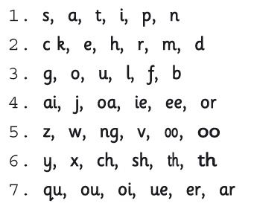
The sounds are taught in a specific order (not alphabetically). This enables children to begin building words as early as possible.
There are five skills taught in Jolly Phonics

- Learning the Letter Sounds
Children are taught the 42 main letters sounds. These include alphabet sounds as well as digraphs such as sh,th, ai and ue.

- Learning letter formations
Using different multi-sensory methods, children learn how to form and write the letters.

- Blending
Children are taught how to blend the sounds together to read and write new words.

- Identifying the sounds in words
Listening for the sounds in words to improve spelling.

- Tricky Words
Tricky words have irregular spellings and children learn these separately.

Tricky Words
a | b | c | d | e | f | g | h | i | j | k | l | m | n
are  all  any  also  always  after | be  by  before  because | come  could  cover | do  down  does | eight  every | four  Father | go  give  goes | he  here  have | I |  |  | like  little  live  love | me  my  many  more  made  Mother | no
o | P | q | r | s | t | u | v | w | x | y | z
one  only  old  other  once  of | put |  | right | she  some  said  so  should  saw | the  to  there  they  too  their | upon |  | was  we  when  what  why  where  who  which  were  want  would |  | you  your

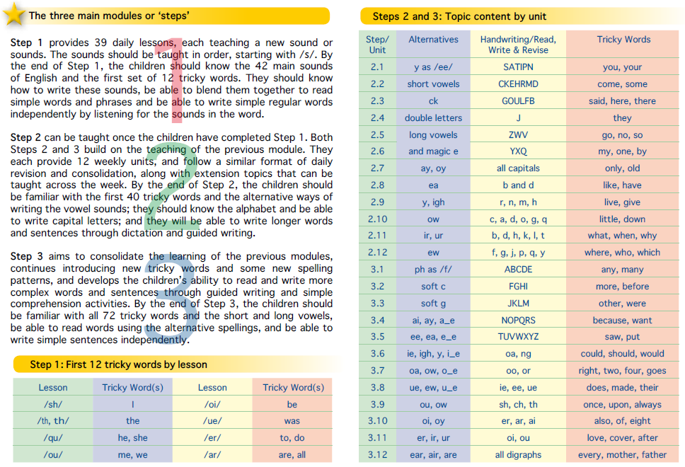
Reading Progression:

Year  Groups | Knowledge and Skills to be acquired
 | Word Reading | Comprehension
EYFS | - Children read simple sentences.  - Use phonic knowledge to decode regular words and read them aloud accurately.  - Read some common irregular words. | - Understand simple sentences they read.  - Demonstrate understanding when talking to other about what they have read.
Year 1 | - Able to match all 40+ graphemes to their phonemes  - Blend sounds of unfamiliar words  - Divide words into syllables  - Read compound words  - Read words with contractions and understand the apostrophe represents the missing letter  - Read phonetically decodable words  - Read words that end with ‘s, -ing, -ed, -est  - Read words that start with un- | - Say what the like don’t like about a book  - Link what has been read or heard to own experiences  - Retell key stories orally using narrative language  - Talk about the main characters in a story  - Learn poem and rhymes off by heart  - Use what is already known to understand texts  - Check reading makes sense and correct when it doesn’t  - Begin to draw inferences from the text and/or illustrations

 | - Add –ing, -ed, and –er, to verbs  - Read words of more than syllable that contain taught grapheme, phoneme correspondents. | - Make predictions about the events  - Explain what I think a text is about
Year 2 | - Can decode automatically and fluently.  - Is able to blend sounds in words that contain the graphemes learnt.  - Recognise and read alternative sounds for graphemes.  - Read accurately words of two or more syllables that contain the same GPCs.  - Read words with common suffixes.  - Read common exception words.  - Read and comment on unusual correspondence between grapheme and phoneme.  - Read most words quickly and accurately when they are known words without sounding out and blending.  - Read most suitable books accurately, showing fluency and confidence. | - Talk about and give an opinion on a range of texts.  - Discuss the sequence of events in books and how they relate to each other.  - Use prior knowledge, including context and vocabulary, to understand texts.  - Retell stories, including fairy stories and traditional tales.  - Read for meaning and check that the text makes sense, go back and re-read when it does not makes sense.  - Find recurring language in stories and poems. Talk about favourite words and phrases in stories and poems.  - Recite some poems by heart, with appropriate intonation.  - Ask and answer questions.  - Make predictions based on what has been read.  - Draw (simple) inferences from illustrations, events, characters’ actions and speech.
Year 3 | - Apply knowledge of root words, prefixes and suffixes to read aloud and to understand the meaning of unfamiliar words.  - Read further exception words, noting the unusual correspondences between spelling and sound.  - Attempt pronunciation of unfamiliar words drawing on prior knowledge of similar looking words. | - Read a range of fiction, poetry, plays, and non- fiction texts.  - Discuss the texts read.  - Read aloud and independently, taking turns and listening to others.  - Explain how non-fiction books are structured in different ways and can use them effectively.  - Explain some of the different types of fiction books.  - Ask relevant questions to get a better understanding of a text.  - Predict what might happen based on details known and read.  - Draw inferences such as inferring a characters’ feelings, thoughts and motives from their actions.  - Use a dictionary to check the meaning of unfamiliar words.  - Identify the main point of a text.  - Explain how structure and presentation contribute to the meaning of texts.  - Use non-fiction texts to retrieve information. Prepare poems to read aloud and to perform, showing understanding through intonation, tone, volume and action.
Year 4 | - Apply knowledge of root words, prefixes and suffixes to read aloud and to understand the meaning of unfamiliar words.  - Read further exception words, noting the unusual correspondences between spelling and sound. | Know which books to select for specific purposes, especially in relation to science, geography and history learning.  - Use a dictionary to check the meaning of unfamiliar words.  - Discuss and record words and phrases that writers use to engage and impact on the reader.

 | - Attempt pronunciation of unfamiliar words drawing on prior knowledge of similar looking words. | - Identify some of the literary conventions in different texts.  - Identify the (simple) themes in texts.  - Prepare poems to read aloud and to perform, showing understanding through intonation, tone, volume and action.  - Explain the meaning of words in context.  - Ask relevant questions to improve my understanding of a text.  - Infer meanings and begin to justify them with evidence from the text.  - Predict what might happen from details stated and from the information deduced.  - Identify where a writer has used precise word choices for effect to impact on the reader.  - Identify some text type organisational features, for example, narrative, explanation and persuasion.  - Retrieve information from non-fiction texts.  - Build on others’ ideas and opinions about a text in discussion
Year 5 | - Apply knowledge of root words, prefixes and suffixes to read aloud and to understand the meaning of unfamiliar words.  - Read further exception words, noting the unusual correspondences between spelling and sound.  - Attempt pronunciation of unfamiliar words drawing on prior knowledge of similar looking words.  - Re-read and read ahead to check for meaning. | - Familiar with and can talk about a wide range of books and text types, including myths, legends and traditional stories and books from other cultures and traditions. Able to discuss the features of each.  - Read non-fiction texts and identify the purpose, structure and grammatical features, evaluating how effective they are.  - Identify significant ideas, events and characters; and discuss their significance.  - Recite poems by heart, e.g. narrative verse, haiku.  - Prepare poems and plays to read aloud and to perform, showing understanding through intonation, tone, volume and action.
Year 6 | - Apply knowledge of root words, prefixes and suffixes to read aloud and to understand the meaning of unfamiliar words.  - Use my combined knowledge of phonemes and word deriviations to pronounce words correctly, e.g. arachnophobia.  - Attempt the pronunciation of unfamiliar words drawing on my prior knowledge of similar looking words.  - Read fluently, using punctuation to inform meaning. | - Read books that are structured in different ways.  - Recognise texts that contain features from more than one text type.  - Evaluate how effectively texts are structured and presented.  - Read non-fiction texts to help with my learning.  - Read accurately and check understanding.  - Able to recommend books to others and give reasons for my recommendation.  - Identify themes in texts.  - Identify and discuss the conventions in different text types.  - Identify the key points in a text.  - Recite a range of poems by heart, e.g. narrative verse, sonnet.  - Prepare poems and plays to read aloud and to perform, showing understanding through intonation, tone, volume and action.

Recommended books for all year groups.
All lists are always in draft form, please add any current books suited to your year group
EYFS
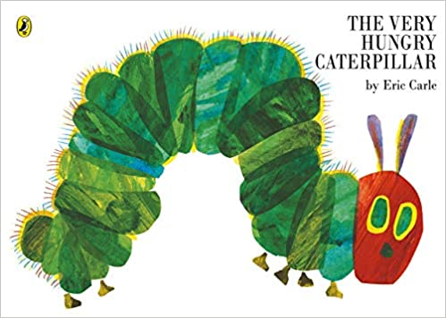
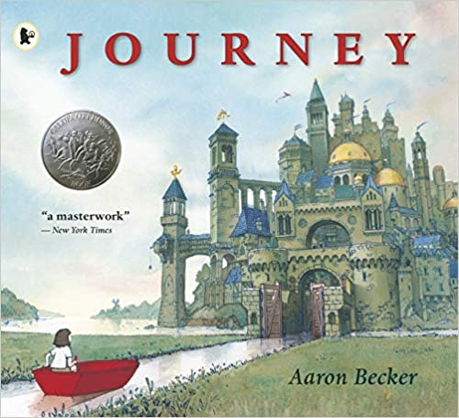
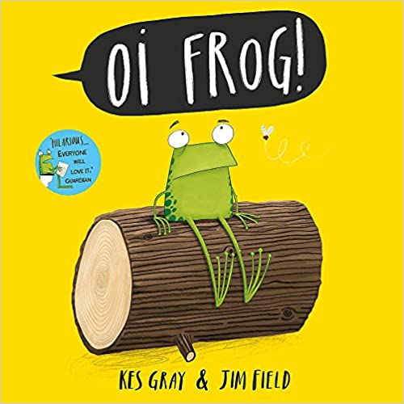
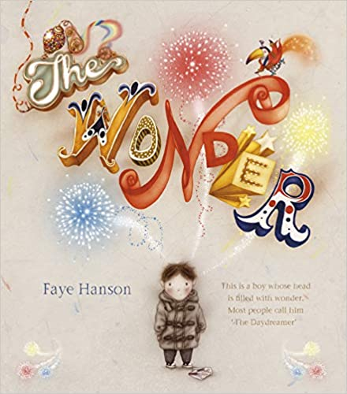
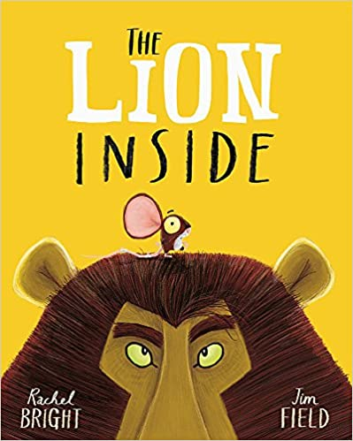

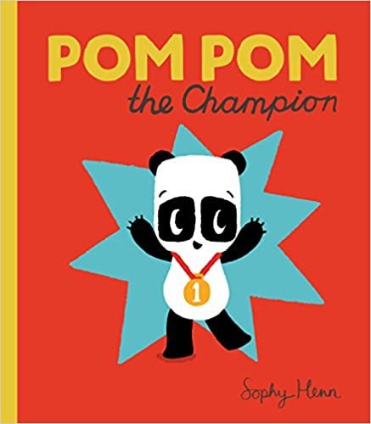
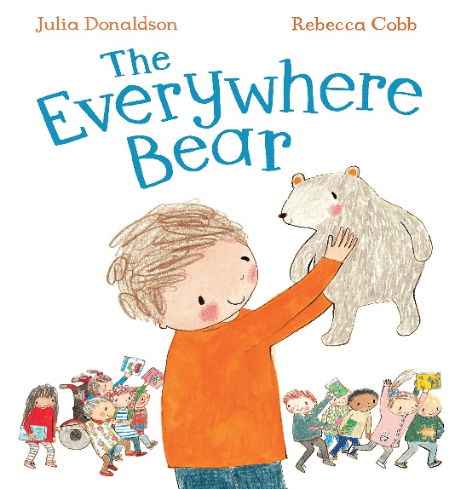
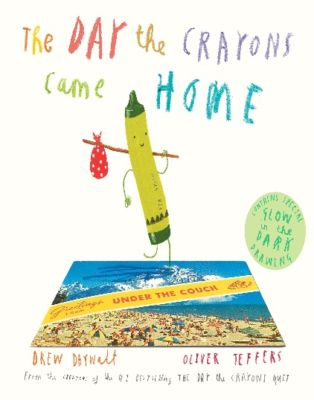
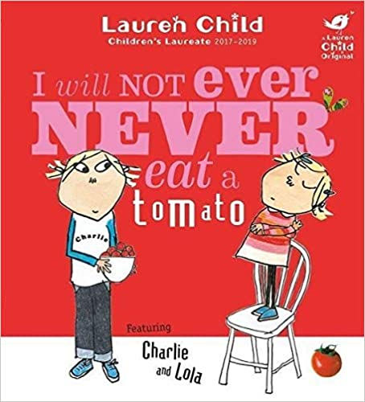
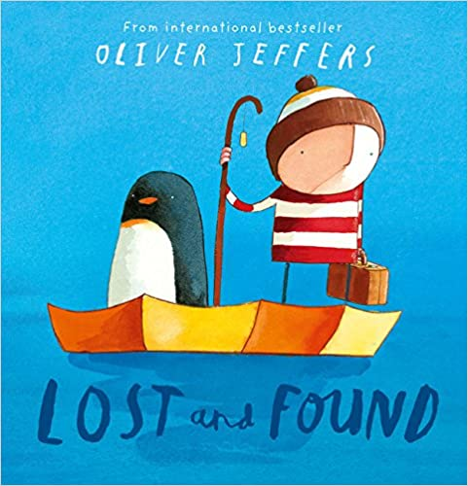

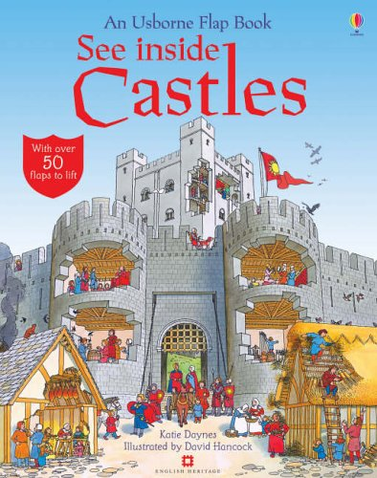
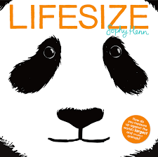
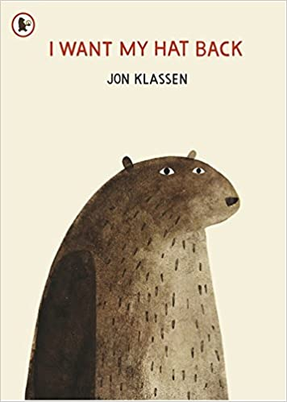
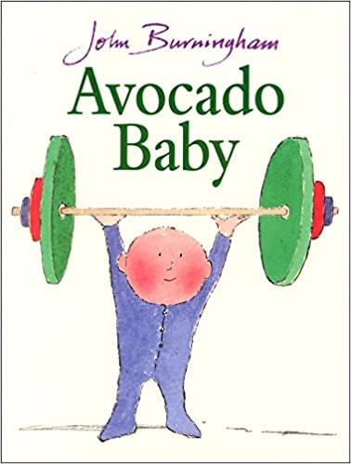
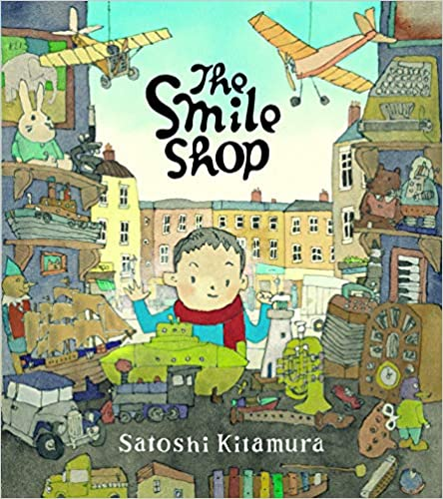
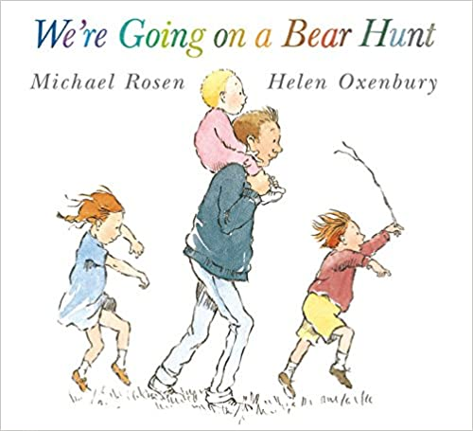
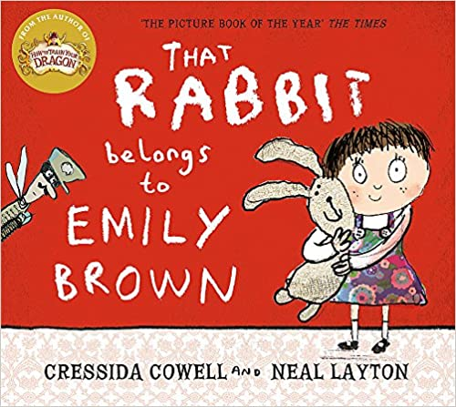
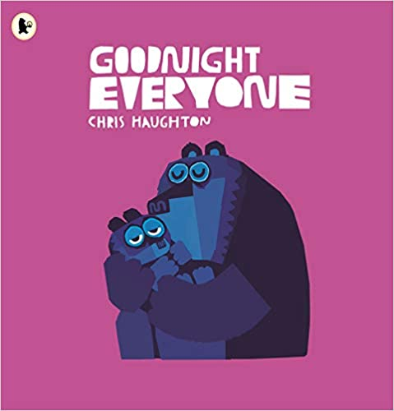
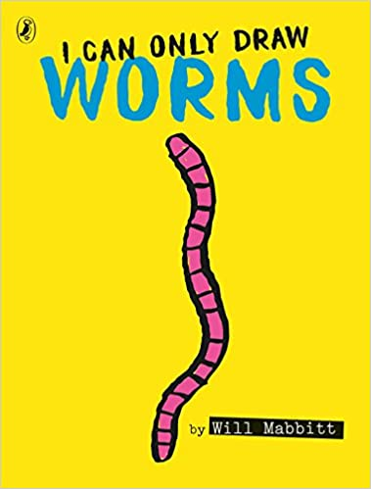
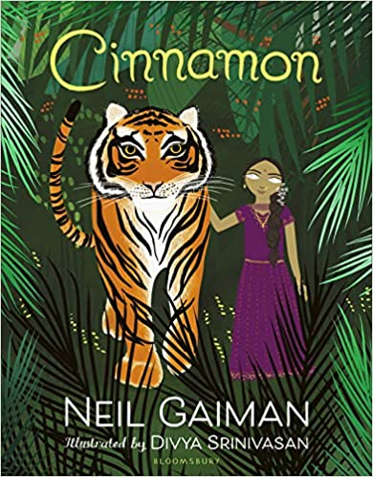
Year 1

Year 2
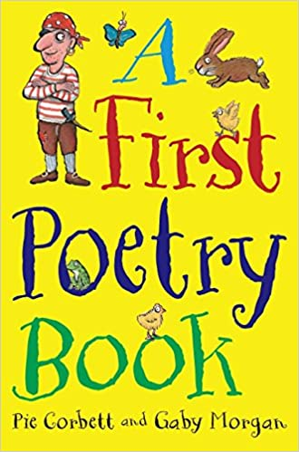
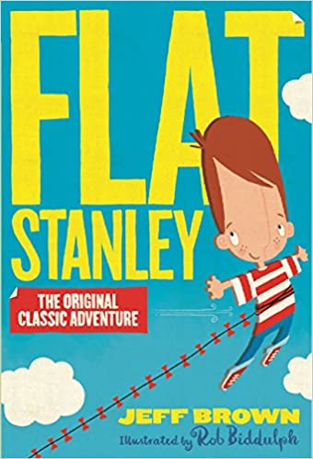
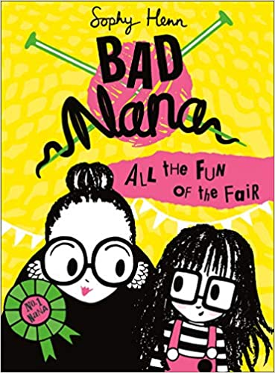
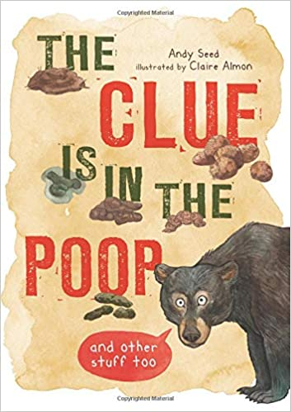
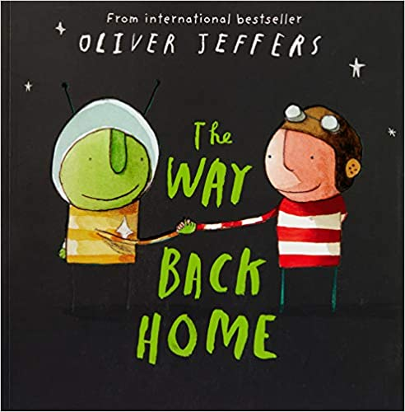
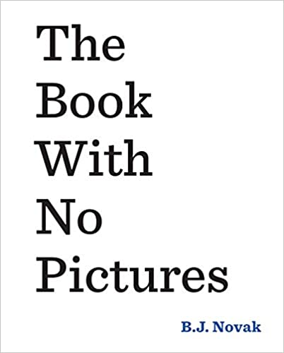
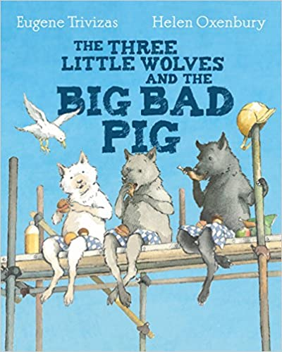
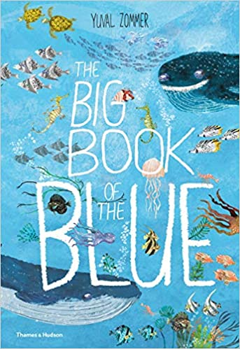
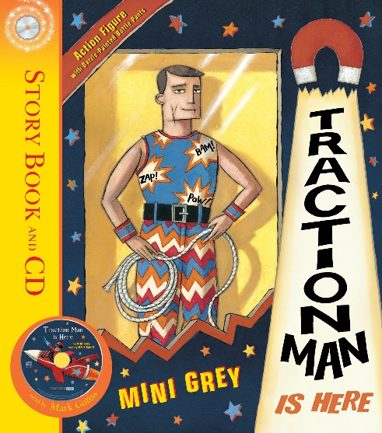
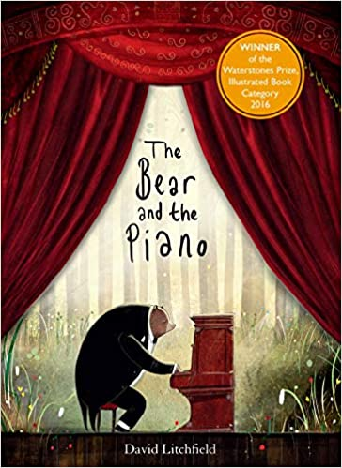

Year 3
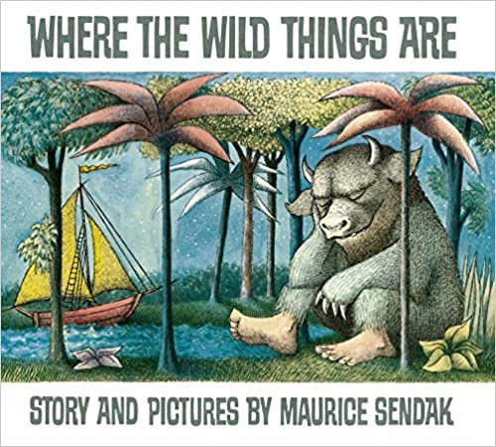
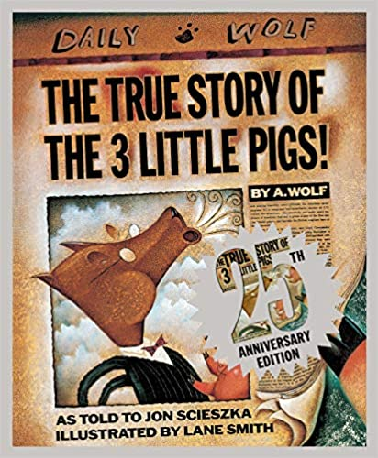
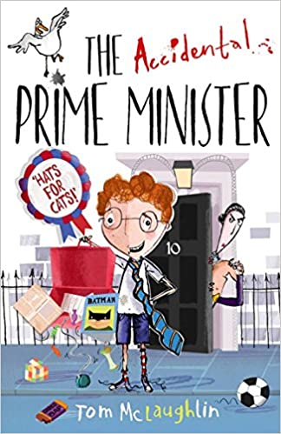
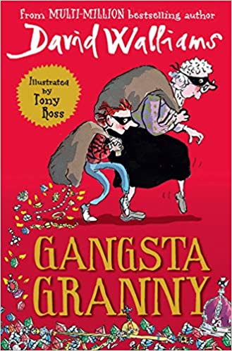
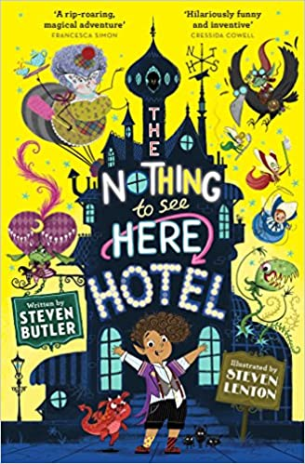
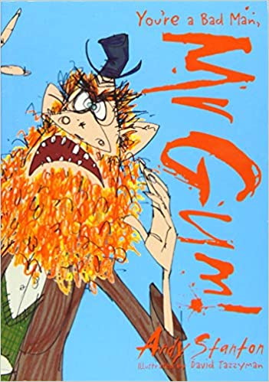
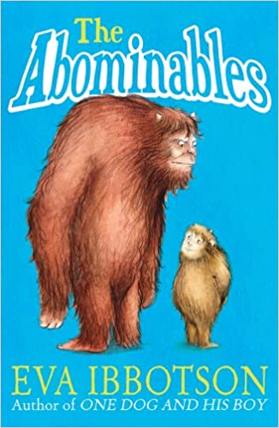
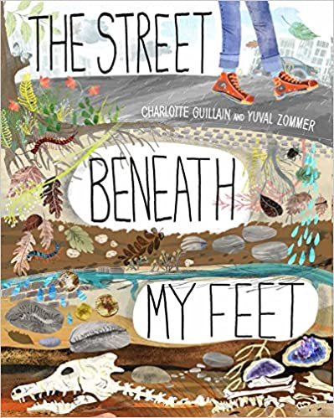
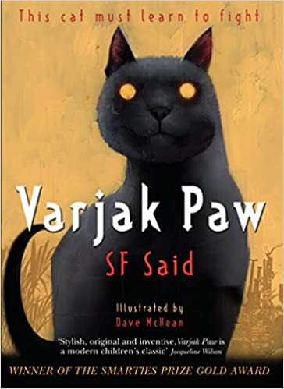
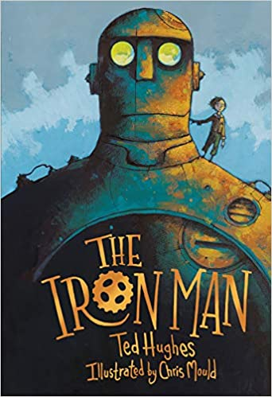

Year 4
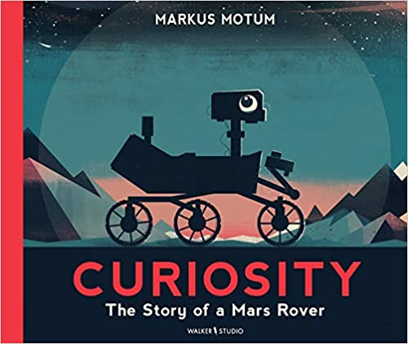
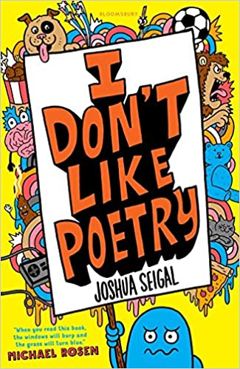
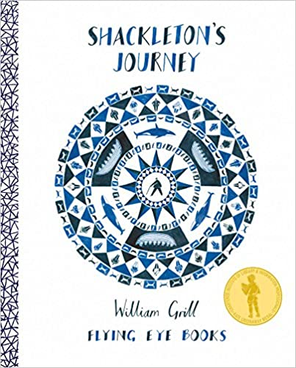
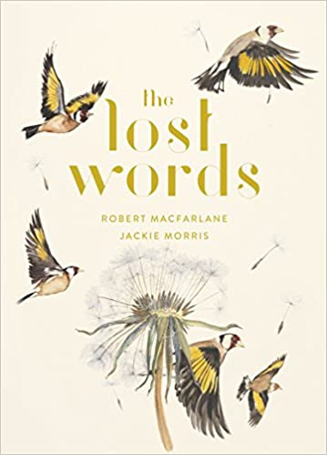
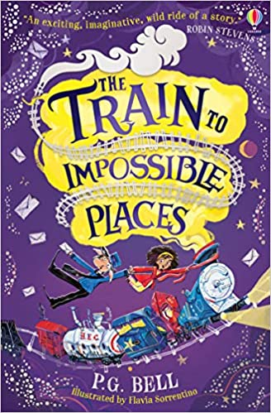
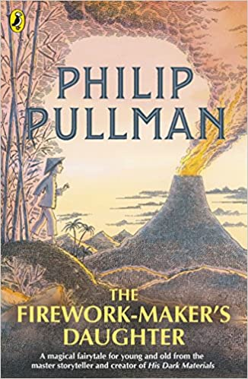
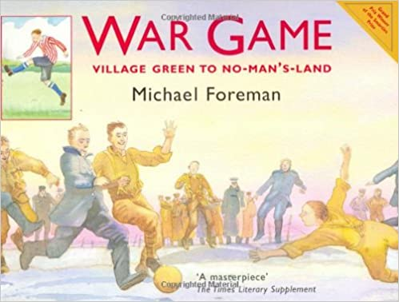
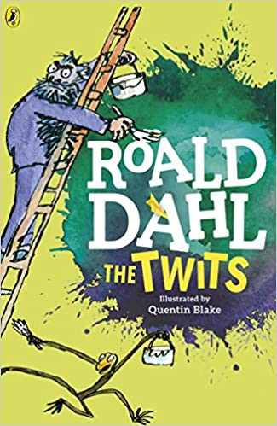
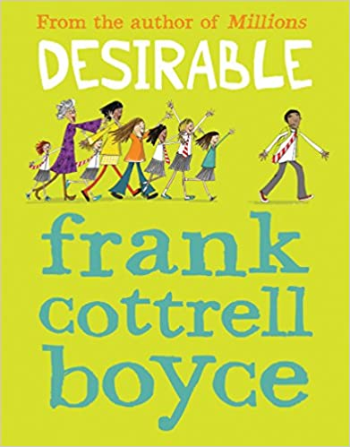
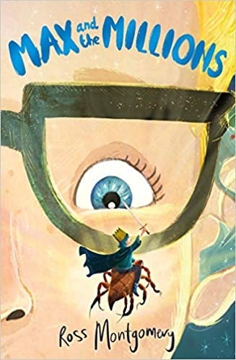

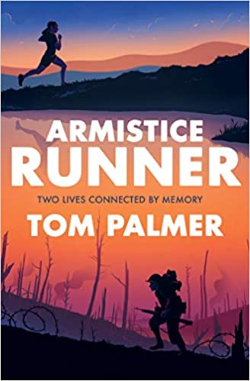
Year 5
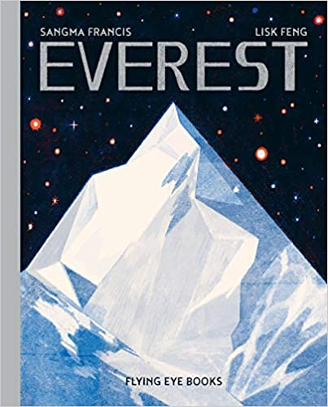
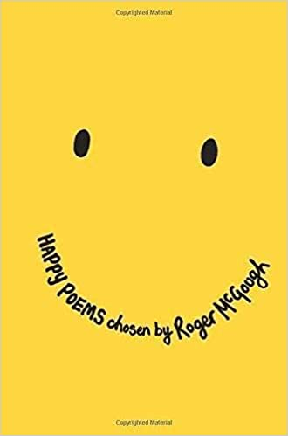
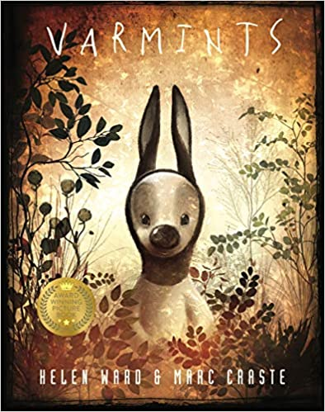
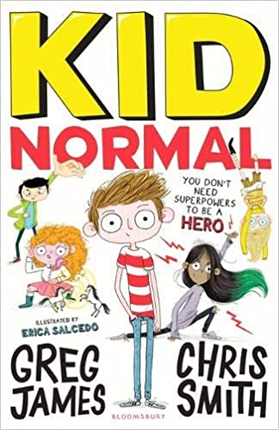
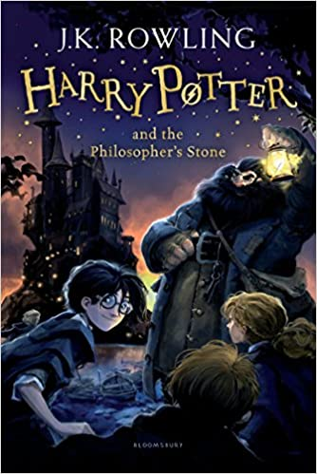
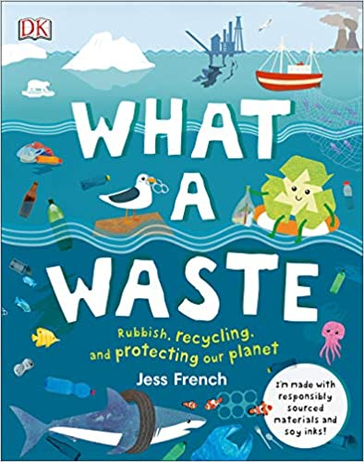
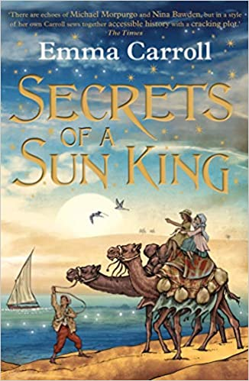
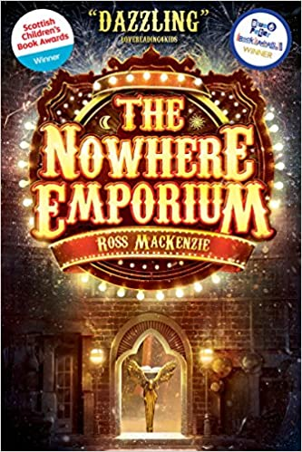
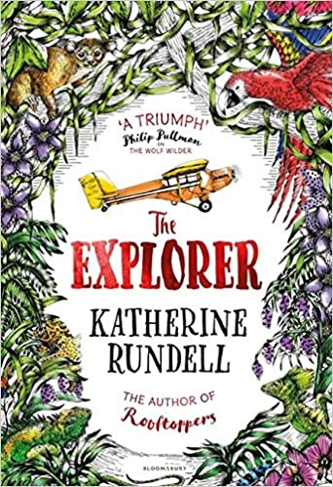

Year 6
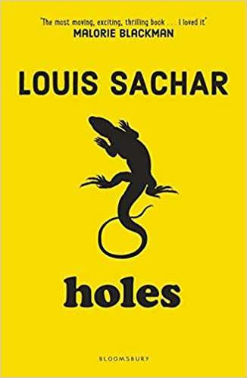
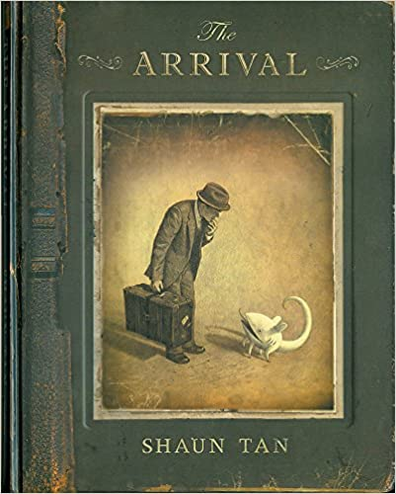
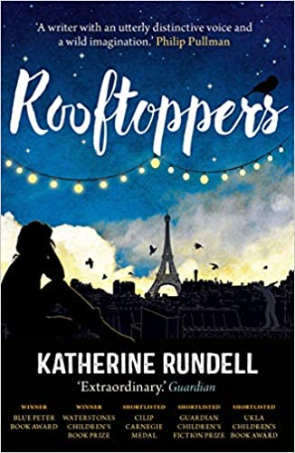
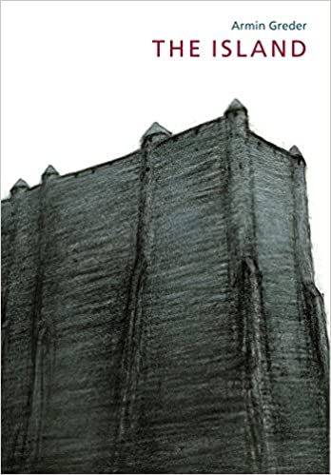
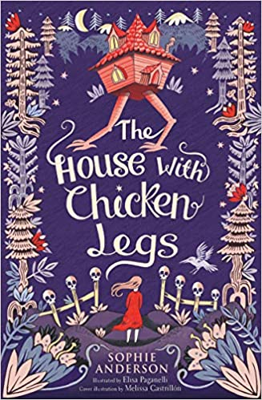
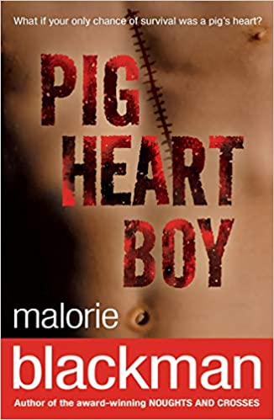
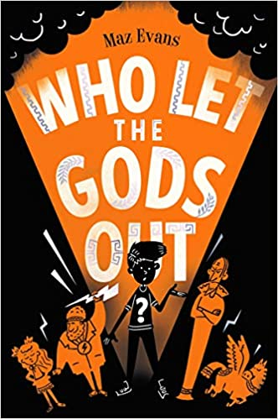
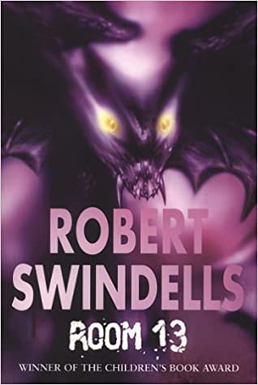
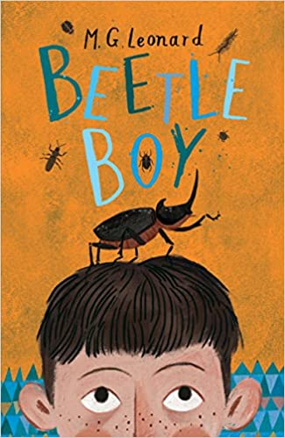
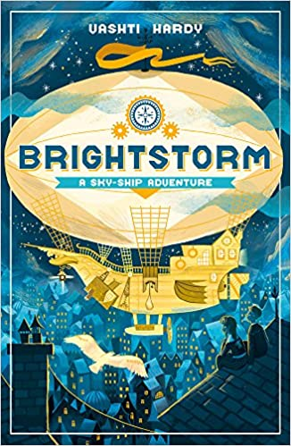

Useful links for the teaching of reading (please add more as you find them):

https://www.lovereading4kids.co.uk/

https://www.booksfortopics.com/

https://www.thereaderteacher.com/

https://www.audible.co.uk/

https://read.amazon.co.uk/

https://www.scholastic.com/parents/books-and-reading.html

https://www.onceuponapicture.co.uk/

https://www.literacyshed.com/home.html

https://www.bbc.co.uk/events/rhvg9r

https://www.scottishbooktrust.com/learning-and-resources/authors-live

https://openlibrary.org/

https://www.oxfordowl.co.uk/for-home/find-a-book/library-page/

