Advent Wreath Instructions:

Please find enclosed the folowing:
X1 sheet with berries
X1 sheet with candles
X2 sheets with leaves
X3 sheets with holly

With your form, during worship over the next week or two - during worship or in tutor time - make an advent wreath for your tutor room door.

- The berries are for decoration
- The candles are important symbols of advent (Hope, Peace, Love, Joy) to be included in your wreath.
- Use the leaves and holly leaves to write prayers of hope, peace, love and joy or just to display Christian values or hopes for the festive season.
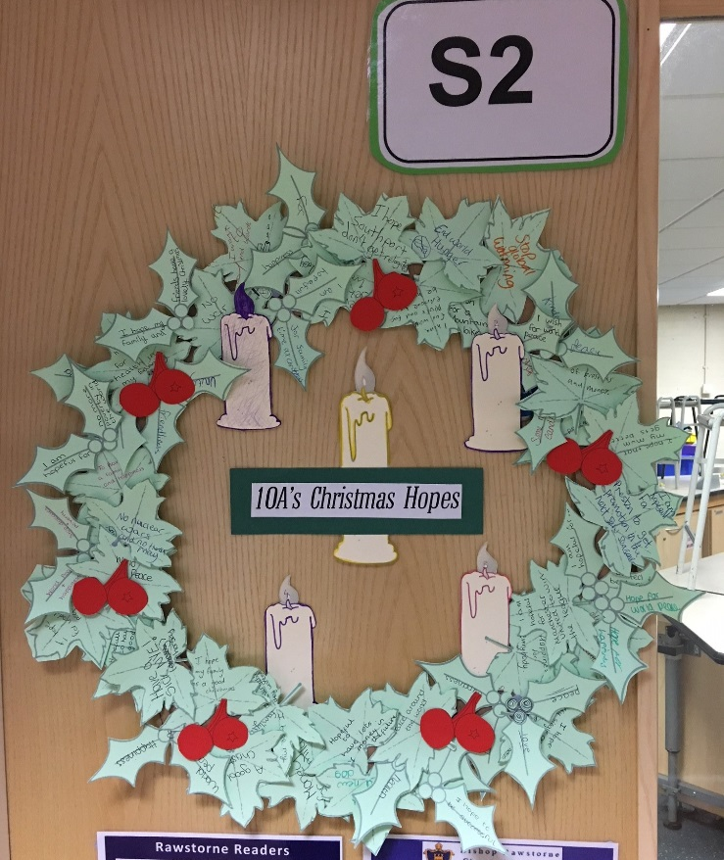
- Cut these out and decorate appropriately – if students would like to write their names on then that would be great. See one of the examples from last year below.

