2023/2024 Year 7 Testimonials

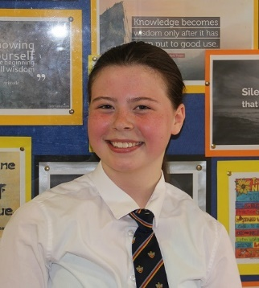
Laurie
Hi, my name is Laurie and I came from Our Lady and All Saints Primary School. I am part of the student voice team here at Bishop Rawstorne and our job is to make our school a better place by taking feedback from other students. I am hoping that when you read this it will provide you with some good advice and knowledge for when you come to our high school. Naturally, I felt nervous on my first day but after a day or two I felt like I belonged at Bishops. My hope for the end of my time at Bishop Rawstorne is to become a fighter pilot in the Royal Air Force (RAF). My tutor group is 7M in S1 which is in the science block. In school, my favourite subjects are art, maths and history. In my spare time, I enjoy hanging out with my friends, drawing and playing outside on my quadbike. When you do arrive here at Bishops, some things to remember are to always bring the right equipment, don’t be afraid to ask for help and overall, have fun!

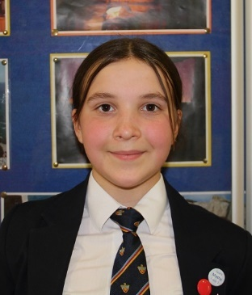
Evie
Hello, my name is Evie and I am a member of The Student Voice Team. It will be great to see all of the new Year 7s next academic year and I would like to give you some top tips about your transition. Just remember, whether you are coming with other people from your primary school or not, everything will be okay. I came from Moss Side Primary School in Leyland, along with six people from my Year 6 class. I was very excited to come to Bishop Rawstorne as I had wanted to go since Year 4. Although I felt quite comfortable, as I knew some people here, I soon made many new friends…and you will too.

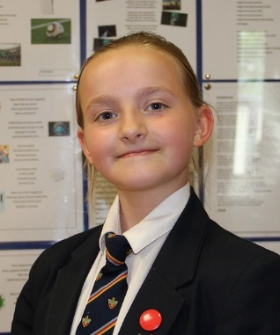
Ava
Hi my name is Ava and I would like to say a warm welcome to all the Year 6s that will be joining us in the next school year. I would like to share some TOP TIPS about your transition to Bishops and know that it is quite an emotional time as you move forward another step in your life.
I came from Trinity St. Michael’s Primary and I admit it is quite emotional when you leave a school you have spent so long in. I was one of the lucky few who had some of my primary classmates to take this big step with. However, even if you come on your own, it gives you an opportunity to make new and wonderful friends. At the start, you might get lost and that’s normal - everyone gets lost at some point and you will never be the only one. I felt scared and nervous at first but soon realised that high school has more creative and fun opportunities than you think. I also started to realise that you have to work hard for your dreams instead of expecting them to just come to you. When I am, older I want to be a doctor so I know I have to work harder than ever. I also realised I have some new favourite lessons, like art; it lets your imagination run free from reality.
The first week is a little scary to be honest, but also exciting. You are no longer the oldest, you are one of the youngest in your school. You get to go to lunch and break early so you can get the hang of how things work. The teachers are kind and helpful so that you are not scared to be late or confused in the first couple of weeks. Top tips from me are to buy your equipment early, smile and be nice to teachers and students, find new friends and HAVE FUN!

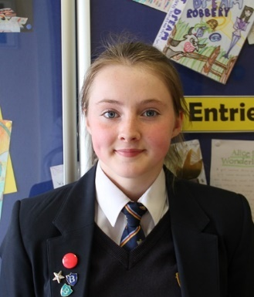
Seren
Hi, my name is Seren. When I came to Bishop Rawstorne, I was really excited. At first, I was quite worried about finding my lessons as I thought the school would be so much bigger and I would get lost. I went to a small primary called Richard Durnings, so it was a change to be somewhere much bigger. When I came to Bishops, I just asked people where my lessons were and they were really nice about it and pointed me in the direction of my lesson. I didn’t even get lost once.
I’m in tutor group 7m and I made some of my closest friends there so don’t worry if you’re alone. Teachers are really nice and understanding. Remembering my time table was hard but I learnt it soon enough. My favourite lesson is most definitely science and PE. When I leave school, I hope to do science A levels and then go on to university.
How to prepare:
- Make sure you’ve got all your equipment
- Pack your bags the night before to be more organised
- Remember your PE kit!
- Try different clubs even if your friends aren’t going
- Make friends/ talk to people
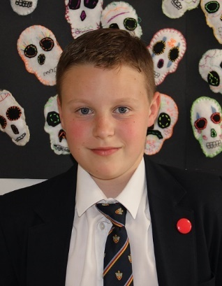
Alfie
Hello, my name is Alfie. School is a massive place at first and in the first couple of weeks I got lost all the time. It was a scary environment to be in at the start, but I managed to find my place in the school, so I settled in quite well. Every single teacher will always be there for you to point you in the right direction. At the start of school, I felt a bit uneasy because it was hard trying to find friends, even though there were many students in the school. I always try to think positively about everything so started to attend school clubs and managed to gain many friends. I feel like all the friends I have now, are ones I have known my entire life!
My favourite subjects are English and PE. I love PE because we are always active and get to do different sports. I also like English because we always are either writing, reading, and analysing our pieces of work. All lessons have their own experiences, but these two are my favourite.
I am in 7h tutor in 7x band. My tutor teacher is an engineering teacher and engineering is the best block because you have all the computers and can do any homework there.
Always have your bag prepared the night before, never be worried about asking questions and always be you. 😊 My future aspirations include becoming wither an engineer or to be a space expert and work for NASA. I LOVE it here in Bishop Rawstorne and I hope you do as well.

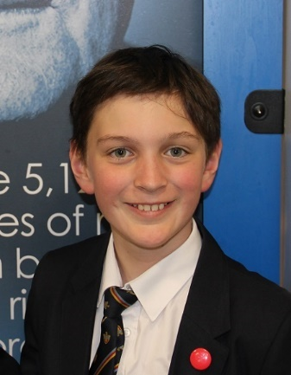
Rafa
Hi, my name is Rafa and when I first started at Bishop Rawstorne, I was worried that I would know no-one in my classes from my primary school, particularly, when I realised that there was only one person from primary on my side of the year and that he would only be in one of my classes. However, I soon found myself making new friends and quickly felt at home.
I love learning new things such as how to work a Bunsen burner, how to use the lathe and learning how to make new friends. Starting high school is one of the best things that has ever happened to me. I learned that teachers don’t mind if you get a question wrong as long as you are trying. I always try to think positively because if I don’t, when I make mistakes, I sometimes doubt myself. The teachers here show us that making mistakes is a good thing and shows we are learning. My favourite subjects are engineering, computer science, maths, P.E. music and science. When I am older, I would love to be a Formula 1 engineer. One of my favourite experiences from this year was going to see Shrek the musical with the music department.
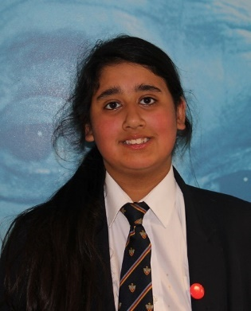
Zarina
Hi, my name is Zarina. When I first moved from Bretherton Endowed CE Primary School, I was both excited and nervous at the same time. I was excited about moving into high school because I was eager to make more friends. Obviously, I was nervous because I was worried I would forget all my lessons and teachers but that fear soon went away because I found it easy to remember and everything here in not that complicated.
Some of my friends from primary came to Bishop Rawstorne which meant I could still talk to them and even if they aren’t in your lessons, you can meet up with them at break and lunch. Beaumonts is the place we buy food or eat our packed lunches so it is easy to find people there. Do not be worried about friendships as when you’re at high school, you will make new friends…. and a lot of them, whilst also keeping some of your old friends from primary.
One of my favourite subjects is maths because I enjoy solving problems and I just love it in general. Another favourite subject is English because it is very fun because we do a little bit of drama in English too. My third favourite subject is art because you get to be creative and use your skills to the limit. My last favourite subjects are RE and geography (I have the same teacher who makes them fun)!
When you come into Bishop Rawstorne, you will be put into different tutor groups and tutor time is so fun, especially on a Friday because our Year 10 mentors play games with us. It doesn’t matter which tutor group you are in, you will always have a year 10 mentor.
In the future I want to be a businesswoman or help in hospitals. Bishops helps with preparing for our future lives because they have so many opportunities to be more responsible. School teaches us we can become whatever we want to be if we work hard. So… don’t worry about coming here. Just make sure you listen in your lessons, work hard but enjoy your time as it goes so fast – this year had flown.

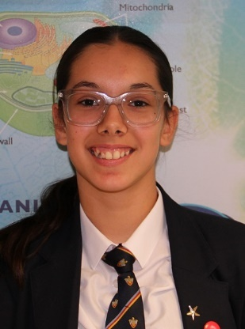
Emily
Hi I’m Emily. I came from Moss Side Primary in Leyland and wasn’t too nervous when I joined in August. Only 6 people from my primary school joined me here so I didn’t know a load of people but I soon made some fantastic friends. Don’t worry about getting to classes as it is quite simple - most lessons are split into blocks or corridors such as the science block or English block.
Also, teachers are lovely here but of course, you need to respect them and the rules. My favourite subject is PE as I always liked active sports all throughout primary. Also, at Bishops we have loads of extra-curricular clubs - sporty and non-sporty. My future aspirations are to become a doctor or semi-pro goalkeeper.
TOP TIPS
Pack your bag the night before to save a rush in the morning
Have all your equipment
Be kind and respectful
Ask someone if you need help
Try to memorise your timetable
Keep on top of homework
Try to make sure you have money if you are getting school dinners
Most importantly have fun!
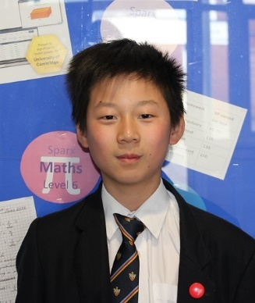
Miaotong
Hi, my name is Miaotong and I am a part of Bishop’s student voice. Our goal is to speak to the teachers about the students' opinions and transform them into ideas to help our school. For example, we have created many events to raise money for charity, like the school disco. As a team, we create solutions to problems, to make school fun for everyone.
I remember before I came to Bishops, I was nervous at first but when I got my head around the way things worked, it made everything easier to understand. For example, in high school, we need to move around to classes instead of staying in one classroom for the whole day. It's a little confusing at first, when you don't know where everything is, but eventually, I figured everything out and it made getting around school more efficient.
A bit about me is that I came from Trinity and St Michael’s and I enjoy science. Here we get to more practical work to get everyone involved. My second favourite subject is music because I'm a musician and I like how the school gets everyone included with playing musical instruments. I'm not sure what my future aspirations are but I'm thinking of becoming a scientist or musician or something else that I enjoy.
My favourite experience is when I went on a school trip to Shrek the musical for half the day. It was fun and everyone enjoyed a small change to a regular school day.

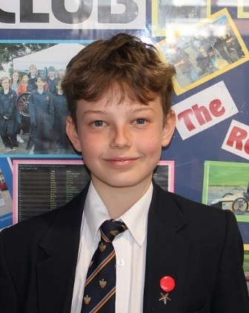
Boris
Hi, my name is Boris. Before starting this chapter of my life, I was nervous about how things would turn out and had no idea I would make so many new friends. The main thing before joining is to know that everybody here is wonderful; the teachers and students are polite and care for one another. A main thing to remember is that high school is a big step up from primary and to not get scared or nervous because many other people are in the same position. Along my journey so far at Bishops, I have become a more confident and resilient person. One main reason for this would be my tutor group; they are like my family there because they support me and help me when I need it. Belonging to a tutor group means I have created friends that I see every day.
I came from Millbrook primary school and was the only one to join Bishops. The way I prepared was to join as many clubs as possible, to meet new people and to make new friends. Our school has a huge number of clubs, especially after school. These activities include things such as football, basketball, athletics, tennis, cricket and many more. Joining these clubs helped me engage in activities like basketball tournaments
My favourite subject has got to be maths, PE, or music because they are interesting and do fun activities almost every week.
In the future, I wish to be a footballer and this school makes that more possible than any other place. It has a school team and runs training every Tuesday for a term. Also, in PE we don’t do the same subject unlike in primary; we do a large variety of sports to engage everyone and this has helped me get fitter and more open to more sports, which is key for an athlete.

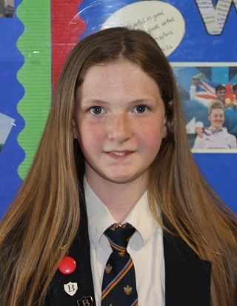
Lily
Hi, I’m Lily. Before I started Bishops, I was not too nervous at the start of the summer but at the end the nerves kicked in. When I did start, I sat on my own in tutor at first and there I met my best friend - she is so lovely and kind. At Bishops you will have a great time; there are many different clubs and I’m sure that you will find one that you will love. I am a very sporty person so I love the after-school sports clubs. Of course, my favourite lessons include PE and I also like history.
For my future, I really want to be a vet because I really love animals and this has been my dream since I was 3. Top tips from me are:
- Have all of your equipment
- Be respectful of other students and teachers
- Keep to the rules
- Believe in yourself
- Have fun and be kind
Remember these top tips and you will do very well at school and you will have loads of friends.

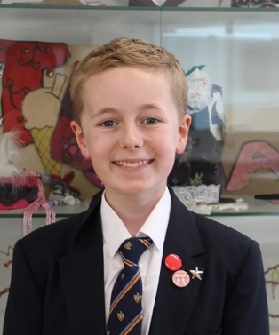
Alexander
Hi, my name is Alexander. Before starting this new, amazing chapter of my life, I felt very nervous as to how it would plan out. However, after joining, I have fit right in. The students here are wonderful, and the teachers are even better. So far, I have really enjoyed my enlightening experience at Bishop Rawstorne and have certainly removed all of my past nerves since joining.
Personally, the only thing I would have changed is to be a bit more confident and to have spoken to new people to make friends. It doesn't matter what primary you come from (I came from Bretherton Endowed) because you're all in the same position at the start. A lot of people - me included – just stayed with the people we knew at the time and waited for everyone else to come and talk to us. Now, after talking to everyone, I have a brilliant, kind group of friends. The other thing to remember is to work hard because first impressions last and you will want to be regarded as an awesome student.
Tutor groups! They are very important to make friends at an early stage. Relationships are key to meeting new, different types of people. I have a lot of friends in my tutor group and have met new people because of it. Everyone has a favourite subject. Personally, mine is maths because I have always enjoyed working with numbers.
Bishop Rawstorne offers so many opportunities for its students. I would like to become either a doctor or a lawyer because they seem like challenging jobs that would take a great deal effort to accomplish, also, they involve revising my favourite subjects. In conclusion, I would 100% agree on coming to Bishop Rawstorne as the supply of opportunities are endless. I hope that you all have a lovely time when you start at Bishops - you will get a very warm welcome.

