|  |
| --- |
| **ASSESSMENT & FEEDBACK POLICY** |

Feedback needs to be given as soon as possible to be effective:

**ASSESSMENT & FEEDBACK POLICY**

*".....learning is like quick drying paint. You have only a short time to correct the mistake or let it harden into permanent error."*

Rogers J (1989)

**Assessment & Feedback**

**Introduction**

At Black Firs Primary School, we strive to provide all pupils with timely and purposeful feedback that furthers their learning. Teachers are expected to gather feedback and assessments that enable them to adjust their teaching both within and across a sequence of lessons.

Assessment

We believe that effective assessment provides information to improve teaching and learning. To do this in our school, we undertake two different but complementary types of assessment: assessment for learning and assessment of learning.

* Assessment for learning (formative assessment) involves the use of assessment in the classroom to raise pupil achievement. We believe that pupils improve most if they understand the aim of their learning, where they are in relation to this aim, and how they can achieve this aim (i.e. to close the gap in their knowledge)
* Assessment of learning (summative assessment) involves judging pupils' performance against the national standards of 2014. Teachers make on-going judgements which culminate in an end of term more formal assessment at which point whole school data analysis is undertaken by the Senior Leadership team [SLT]

Children are given regular feedback on their learning so that they understand what it is that they need to do better to empower them to take action towards improving their own performance.

Objectives

The objectives of assessment in our school are:

* to allow teachers to plan work that accurately reflects the needs of each child, thus moving learning forward
* to enable our children to demonstrate what they know, understand and can do in their work
* to promote a culture of self-improvement and life-long learning, equipping them with tools needed to improve
* to provide regular information for parents that enables them to support their child's learning
* to provide the headteacher and governors with information that allows them to make judgements about the effectiveness of the school

Planning for assessment

* Teachers use the Programmes of Study outlined in the National Curriculum 2014 as well as the DfE assessment guidance to help identify each child's achievements
* Teachers plan lessons with clear learning objectives based upon the teacher's detailed knowledge of each child. We strive to ensure all tasks set are appropriate to each child's ability and promote inclusion for all groups including SEND and G&T
* Teachers share the lesson's learning objective with the children which is presented in the form of a question. This will form the basis of the success criteria against which the work will be judged
* Teachers use a range of strategies including; asking probing questions, quick application tasks, scrutiny of written work, right through to formal tests, to find out what pupils know, what they understand, and to reveal their misconceptions
* Teachers note individuals who do not achieve at the expected level for the lesson. They use this information to plan interventions and next steps

Target-setting & Reporting to Parents

Targets in the core areas are set at the start of an academic year and reviewed three times a year. Progress towards these targets are communicated to parents through termly parent consultations, which serve different purposes, namely:

* Autumn – settling in and pastoral care, though core subject books will also be shared
* Spring – academic progress and attainment; the role of the parent in supporting learning. Core subjects and topic books will be shared
* Summer – invitations are sent to discuss end of year achievements.
* An open door policy is practised at Black Firs and parents are encouraged to meet with the class teacher if they have any concerns about any aspect of their child’s schooling.

Progress of pupils is reviewed formally once a term, or more frequently for vulnerable groups

Feedback

Feedback to pupils is essential, as it tells them what they have done well, and what they need to do to further improve. Feedback should help children to become reflective learners and to close the gap between current and desired performance. We have an agreed code for marking for each key stage, and this ensures marking is consistent across the school.

At Black Firs, we fundamentally believe that the core principles of feedback and marking are:

* To further children’s learning
* To be accessible to all students, therefore written comments should only be used once children can read and fully comprehend them
* To be delivered closest to the point of action in order to have the greatest impact (verbal feedback in lessons is preferred over written comments at a later date)
* Teachers are not expected to evidence verbal feedback or ‘mark’ books purely for external verification, however SLT do expect to see evidence that feedback has been given in the editing and drafting process
* All pupils’ work should be reviewed by teachers at the earliest possible opportunity so that improvements will positively impact future work. When work is reviewed, it should be acknowledged in books. In writing at Black Firs, reviews are expected at the end of a finished piece of work at the end of the independent writing and editing process**.**
* When written feedback is given, we relate this to the question posed in the learning objective
* In maths, we make clear whether the objective has been met, partially met or not met both in workbooks and maths books with LO: √ if the objective has been achieved and if the pupil has required some level of support by teacher (T) or teaching assistant (TA) will be added next to the LO:√ so LO:√ (with T) or LO:√ (with TA)
* Where possible, work should be marked alongside the child, for example, through writing conferences, during class monitoring and as part of guided work sessions

General Marking Objectives

Teachers need to be clear and concise when explaining the learning objective so that the success criterion is fully understood by pupils.

* The learning objective will be displayed at the start of a piece of work and will be presented as a question
* Marking will be consistent by marking to the success criteria set for the task
* Marking must focus on improvement not ‘correction’
* Exhaustive indication of every mistake is not appropriate, particularly for SEND pupils. For example, a maximum of three spelling mistakes will be pointed out across a piece of work.

Marking should be sensitive to the abilities of the child

* Children must be encouraged to acknowledge marking of all forms, read written comments and respond in writing or verbally
* The children will benefit from marking if they understand the marking system. A simple and consistent marking scheme will be used throughout the school
* Work in core subjects must be quality marked in line with the Marking Code
* Work in foundation subjects may be marked with a lighter touch, however it is vital teachers still review work in order to assess against the learning objective. Evidence of this is expected to be seen in books and a written comment at the end of a sequence of learning

· Codes will be used to show if a child has completed work independently (I) with help from a teaching assistant (TA), with help from a teacher (T) and where verbal feedback is given (VF)

Marking Strategies

A variety of marking strategies may be used including;

* Focused marking by the teacher concentrates entirely on the success criteria of the task. The emphasis should be on success against the criteria and the improvement needed so that gaps are closed between achievement and potential achievement.
* Self-marking of closed tasks should take place if appropriate. Children may mark their own or each other’s work against an answer key e.g. mental maths, arithmetic or tables tests. Children should also be trained to self-evaluate, identifying their own successes against learning objectives and looking for points for improvement. Where appropriate, they should check and improve their rough drafts themselves, or use ‘talking partners’ prior to writing out a final draft.
* Peer-marking pupils should be trained to evaluate a partner’s work identifying successes against learning objectives and looking for points for improvement when peer marking.

Teachers need to comment or acknowledge work when it has been peer-marked.

At Black Firs pupils use blue pen for editing and marking.

Frequency of marking

* Where possible feedback should take place before the next lesson
* Feedback and marking can take place during the lesson – providing immediate feedback ( known as ‘live’ marking)

• ‘Distance’ marking should be returned before the next session of that subject

• Long- term projects may be marked on completion – children need to be told this in advance

Marking of Creative and Expressive writing

* Creative and expressive writing must be re-read by the pupil first, with any errors or improvements made. When possible, areas of weakness or areas to be amended, should be indicated by visual codes. If necessary, constructive written comments can be included at the bottom of work.
* Comments should match the success criteria. Additional comments may focus on: quality of content, quality of expression, technical accuracy, punctuation, presentation and effort.

Spellings

* Common practice should be that pupils have the opportunity to use dictionaries to identify, check and self-correct own spelling errors.
* The child ideally should identify incorrect spellings. Blanket marking of errors is not acceptable for some children as it demoralises the child. Teachers will focus on the correct spellings of high frequency and those that include spelling rules appropriate for that year group. Correction of spelling should not inhibit pupils’ experiments with more adventurous vocabulary.

Marking of Maths Work

* Maths work must be marked to show whether each element/answer is correct. Incorrect answers should be shown by a cross. A comment may also be added which tells the child how well he/she has met the success criteria. Stampers will be used to indicate whether a child has met, partially met or not met the learning objective. The teacher may model how to address errors which have arisen or give children further questions to support additional practice.
* Where appropriate, the children’s learning needs to be enhanced or embedded through next step marking. (See Appendix)

Reward Systems

Rewards must be used for good effort, not only excellent work. We use a range of rewards such as

* Praise
* Stars on bookmarks for academic success and improvements in behaviour and classroom engagement
* House points for collaborative working

Marking methods – General principles

* The date and title is recorded by the children (where possible and appropriate) and the learning objective may also be recorded or referred to where appropriate.
* Teachers will mark in green pen
* Purple pens should be used when pupils self-assess their own work, pupils use blue in editing
* Following positive comments, next steps should be identified if appropriate

**Monitoring/Evaluation**

The implementation of the marking policy will be monitored through:

* Work scans (can we see evidence that the marking policy is utilised correctly and consistently?)
* Lesson observations (are children encouraged to ‘self-assess’ or ‘mark’ their work in relation to the success criteria/learning objective?)
* Pupil voice (can children talk about what they are doing well and how they can improve)

This will be undertaken by

* staff peer assessment
* senior school staff
* School Improvement Partners and Ofsted.

A selection of books from each class and subject will be scrutinised at regular intervals throughout the school year.

Summary of Feedback

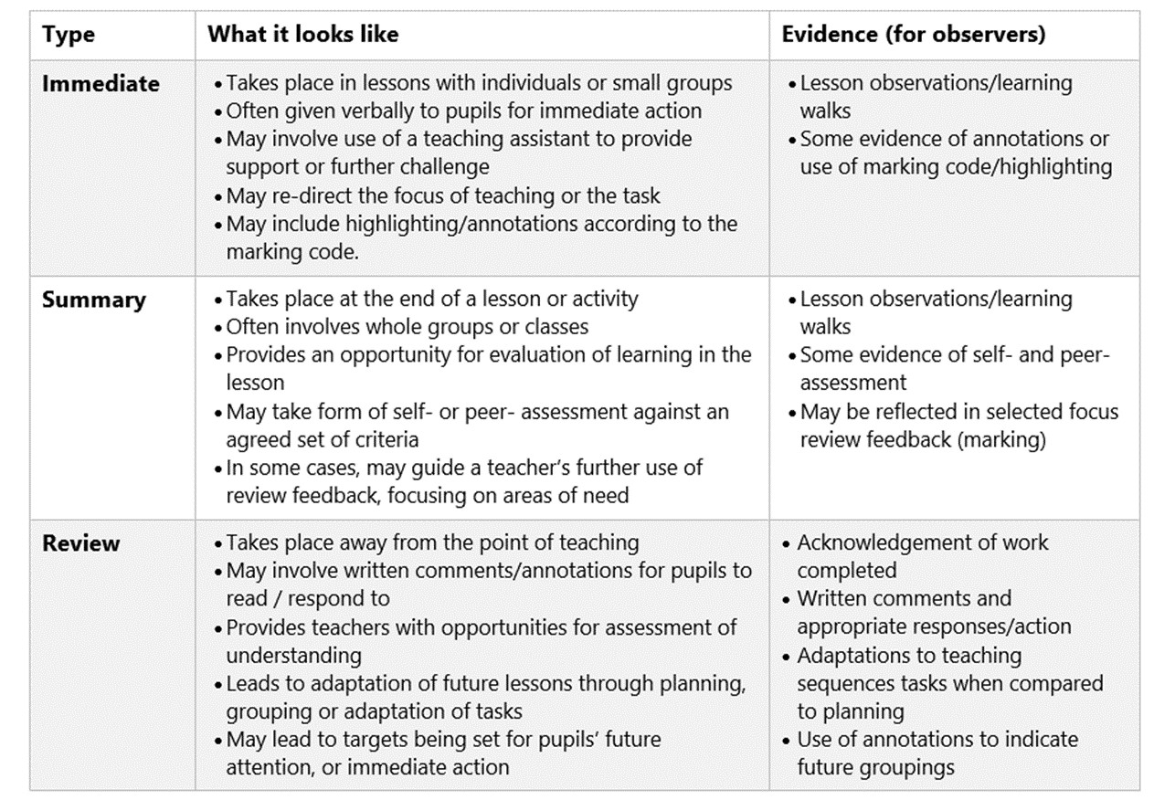

Appendix 1

Marking Codes for Black Firs

**Marking symbols**

**P- punctuation**

**sp - spelling mistake**

**^ - missing word**

**/ - start a new line**

**//- start a new paragraph**



**missing capital letter**

**VF- verbal feedback given in lesson**

**LO: √- learning objective has been met**

**See me- please see me to talk about your writing**

**I - independent writing**

**TA/T- TA/ teacher support**

Next Step Marking

