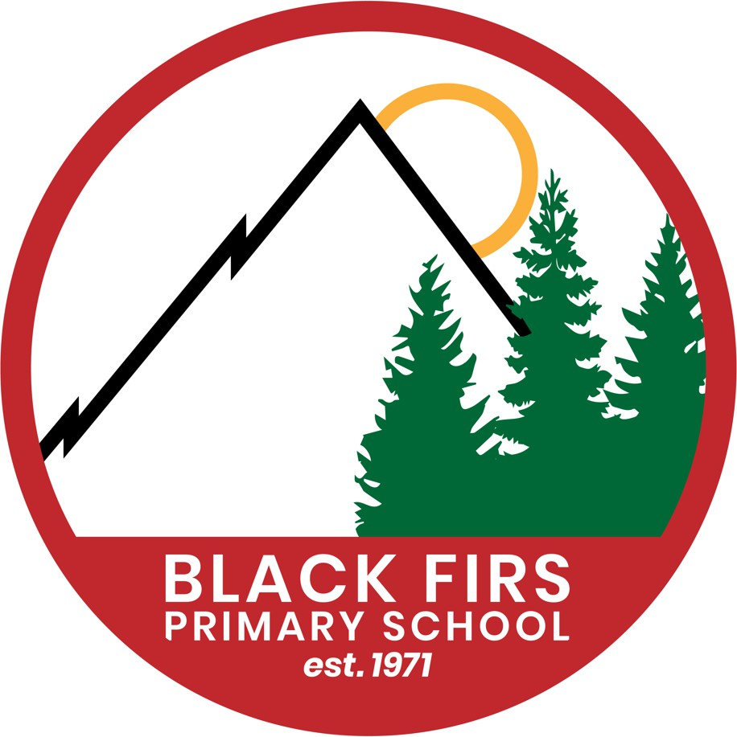

EYFS Policy

**Intent**

At Black Firs, the EYFS curriculum is designed to encourage independent, inquisitive and happy life-long learners who are equipped with the resilience and confidence for life in our ever-changing world. We recognise children’s prior learning and different starting points and create a holistic curriculum that maximises opportunities for first hand experiences and builds strong foundations for the future.

Every child is recognised as a unique individual and we understand that all their learning journeys will be different. We acknowledge and celebrate children’s interests and provide opportunities for children to follow their imagination and creativity through play.

We provide vibrant continuous indoor and outdoor provision that supports and challenges children in investigating, developing and applying their skills.

At Black Firs we see parents as our partners and work with them to encourage and support children to be the best they can be. We value the importance of a successful transition into KS1 and work with our infant team to provide children with the skills, attitudes and behaviours needed to make a strong start in Year 1.

**Implementation**

In Preschool and Reception, we meet the welfare requirements laid down in the Statutory Framework for the Early Years Foundation Stage. We actively safeguard and promote the welfare of all our children. We recognise that children learn most effectively when they are healthy, safe and secure, when their individual needs are met and when they have positive relationships with the adults who care for them. We aim to provide a setting that is a safe and stimulating environment where children can enjoy learning and grow in confidence and independence.

We begin by ensuring a strong foundation in the Prime areas of Personal, Social and Emotional Development, Physical Development and Communication and Language. We know that unless a child is secure in these areas, learning and development in the specific areas of the EYFS framework will be limited.

Children learn through a balance of child-initiated and adult-led activities and challenges organised as a ‘play sandwich’ during our day.

***How does this look in practice…?***

* Black Firs children are provided with plenty of time to engage in exploration through enticing experiences centred on their interests and deeply rooted in a love of books and reading.
* Reading is at the heart of our EYFS curriculum and we follow a DfE validated phonics programme to ensure a strong start for all our children.
* We follow a maths mastery approach in Reception with an emphasis on key skills so that our children develop a deep understanding and acquisition of mathematical language.
* Our inclusive approach means that all children play and learn together but we are timely in our intervention and support for children not reaching their potential or those who are ready for more challenge.
* We are reflective practitioners with a good subject knowledge. We welcome professional discussion and development. This is supported by engagement with other EYFS practitioners across our multi-academy trust.
* We build strong relationships with parents and families from the outset. We keep them informed through our use of Class Dojo, and more formal parent’s evenings. We value parents’ contributions to their child’s journey and share and celebrate successes with them.
* In line with DfE requirements all children in Reception complete the statutory Reception Baseline Assessment, RBA within their first 6 weeks of school.

**Impact**

We aim to ensure all children progress through a balanced and creative EYFS curriculum. We strive to ensure that every child makes a good level of progress from their individual starting points, including vulnerable groups such as though with SEND, PP or EAL children. Every child gets the best possible start to their Black Firs journey. We take the following measures to check we are achieving this;

* Our observations of children inform our professional judgements and steer our planning to ensure our practice remains relevant and appropriate.
* Summative phonics assessments are completed half termly for all our Reception children
* Each term we use Insight to assess children as ‘on track’ or ‘not on track’.

The impact of our curriculum is also measured by how effectively it helps our children develop into well rounded individuals who embody our Black Firs values and carry with them the knowledge, skills and attitudes which will make them lifelong learners and valuable future citizens.

At the end of EYFS Black Firs children;

* Have strong communication skills. Our children listen respectfully and with a tolerance of the views of others. Our children speak up and ask for help.
* Take pride in all that they do and always strive to do and be their best.
* Demonstrate emotional resilience and the ability to persevere when they encounter a challenge.
* Develop a sense of self-awareness and become confident in their own abilities.
* Are kind, respectful and honest, demonstrate inclusive attitudes and have a sense of their role in our wider society.