Black Firs Primary School



 | 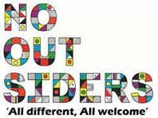 | 

Personal, Social, Health Education and
Relationships, Sex and Health

Name of school | Black Firs Primary School
Member of staff responsible | Jen Harrison April 2025

Approved by Governors Shazma Mahmood-Shakoor, Chair of Governors April 2025

Context
All schools must provide a curriculum that is broadly based, balanced and meets the needs of all pupils. Under section 78 of the Education Act 2002 and the Academies Act 2010, a PSHE curriculum:
- Promotes the spiritual, moral, cultural, mental and physical development of pupils at the school and of society, and
- Prepares pupils at the school for the opportunities, responsibilities and experiences of later life.
This policy meets the requirements that schools publish a Relationships and Sex Education policy and does this within the wider context of Personal, Social and Health Education.

PSHE

At Black Firs Primary School, we teach Personal, Social, Health Education as a whole-school approach to underpin children’s development as people and because we believe that this also supports their learning capacity.

The 1Decision Programme offers us a comprehensive, carefully-planned Scheme of Work which brings consistency and progression to our children’s learning in this vital curriculum area. In addition to this, we also follow the ‘No Outsiders’ curriculum. Picture News resources are available for use in class and key stage assemblies to support some elements of our RSHE curriculum.
Our PSHE curriculum supports the ‘Personal Development’ and ‘Behaviour and Attitudes’ aspects evaluated under the Ofsted Inspection Framework, as well as significantly contributing to the school’s Safeguarding and Equality Duties, the Government’s British Values agenda and the SMSC (Spiritual, Moral, Social, Cultural) development opportunities provided for our children.

Statutory Relationships and Health Education

“The Relationships Education, Relationships and Sex Education and Health Education (England) Regulations 2019, made under sections 34 and 35 of the Children and Social Work Act 2017, make Relationships Education compulsory for all pupils receiving primary education…They also make Health Education compulsory in all schools except independent schools. Personal, Social, Health and Economic Education(PSHE) continues to be compulsory in independent schools.”
DfE Guidance p.8

“Today’s children and young people are growing up in an increasingly complex world and living their lives seamlessly on and offline. This presents many positive and exciting opportunities, but also challenges and risks. In this environment, children and young people need to know how to be safe and healthy, and how to manage their academic, personal and social lives in a positive way.”

“This is why we have made Relationships Education compulsory in all primary schools in England…as well as making Health Education compulsory in all state-funded schools.”
“In primary schools, we want the subjects to put in place the key building blocks of healthy, respectful relationships, focusing on family and friendships, in all contexts, including online. This will sit alongside the essential understanding of how to be healthy.”

“These subjects represent a huge opportunity to help our children and young people
develop. The knowledge and attributes gained will support their own, and others’ wellbeing and attainment and help young people to become successful and happy adults who make a meaningful contribution to society.”
Secretary of State Foreword DfE Guidance 2019 p.4-5

“Schools are free to determine how to deliver the content set out in the DfE guidance 2019 in the context of a broad and balanced curriculum. Effective teaching in these subjects will ensure that core knowledge is broken down into units of manageable size and communicated clearly to pupils, in a carefully sequenced way, within a planned programme of lessons.”
DfE Guidance p.8
“All schools must have in place a written policy for Relationships Education and RSE.”
DfE Guidance p.11

Here, at Black Firs Primary School we value PSHE as one way to support children’s development as citizens and members of our global community, to enable them to understand and respect who they are, to empower them with a voice and to equip them for life and learning.

We include the statutory Relationships and Health Education within our whole-school PSHE Programme.
To ensure progression and a spiral curriculum, we use 1Decision as our chosen teaching and learning programme and tailor it to children’s needs. We also use some resources from the NSPCC’s ‘Pants are Private https://www.nspcc.org.uk/keeping-children-safe/support-for-parents/pants-underwear-rule/.

Our PSHE policy is informed by existing DfE guidance:

- Keeping Children Safe in Education (statutory guidance) Keeping children safe in education - GOV.UK (www.gov.uk)
- Respectful School Communities: Self Review and Signposting Tool (a tool to support a whole school approach that promotes respect and discipline) Respectful School Communities Self-Review and Signposting Tool (educateagainsthate.com)
- Behaviour and Discipline in Schools (advice for schools, including advice for appropriate behaviour between pupils) Behaviour in schools - GOV.UK (www.gov.uk)
- Equality Act 2010 and schools Equality Act 2010: advice for schools - GOV.UK (www.gov.uk)
- SEND code of practice: 0 to 25 years (statutory guidance) SEND code of practice: 0 to 25 years - GOV.UK (www.gov.uk)

- Mental Health and Behaviour in Schools (advice for schools) Mental health and behaviour in schools - GOV.UK (www.gov.uk)
- Social, emotional and mental wellbeing in primary and secondary education. (NICE guidance) Overview | Social, emotional and mental wellbeing in primary and secondary education | Guidance | NICE
- Promoting and supporting mental health and wellbeing in schools and colleges (guidance for schools and colleges) Promoting and supporting mental health and wellbeing in schools and colleges - GOV.UK (www.gov.uk)
- Preventing and Tackling Bullying (advice for schools, including advice on cyberbullying) Preventing bullying - GOV.UK (www.gov.uk)
- The Equality and Human Rights Commission Advice and Guidance (provides advice on avoiding discrimination in a variety of educational contexts) Advice and guidance | Equality and Human Rights Commission (equalityhumanrights.com)
- Promoting Fundamental British Values as part of SMSC in schools (guidance for maintained schools on promoting basic important British values as part of pupils’ spiritual, moral, social and cultural (SMSC) Promoting fundamental British values through SMSC - GOV.UK (www.gov.uk)

What do we teach when and who teaches it? Whole-school approach
1Decision covers all areas of PSHE for the primary phase including statutory Relationships and Health Education. Coverage is shown below with common themes across school where possible. There may be times that teachers use their professional judgement, and knowledge of their classes, to move units in response to current class, school, or community needs.

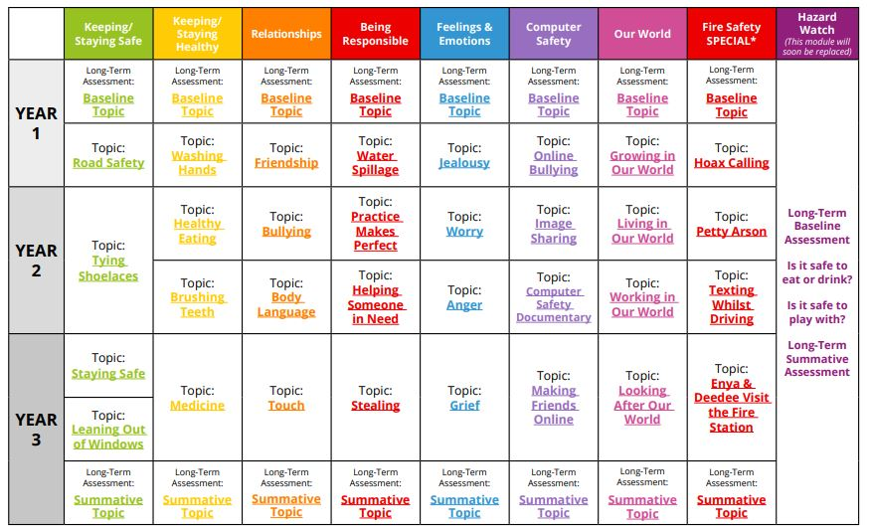
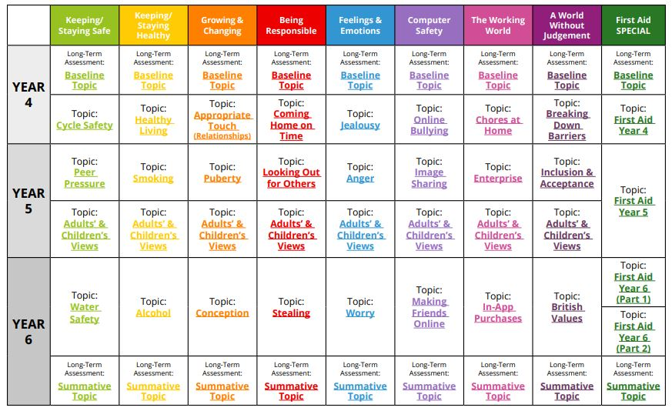

At Black Firs Primary School we allocate time to PSHE each week to teach the PSHE knowledge and skills in a developmental and age-appropriate way.

These explicit lessons are reinforced and enhanced in many ways:
Assemblies, praise and rewards, through relationships child to child, adult to child and adult to adult across the school. We aim to ‘live’ what is learnt and apply it to everyday situations in the school community.
Familiar staff will deliver the weekly lessons to their own classes.

Relationships Education

What does the DfE statutory guidance on Relationships Education expect children to know by the time they leave primary school?
Relationships Education in primary schools will cover ‘Families and people who care for me’, ‘Caring friendships’, ‘Respectful relationships’, ‘Online relationships’, and ‘Being safe’.
The expected outcomes for each of these elements can be found further on in this policy.

Why does school utilise the No Outsiders scheme of work?
As part of our PSHE curriculum, we enhance our 1Decision curriculum by including a scheme called No Outsiders. This scheme was created by Andrew Moffat MBE, who was nominated for the Global Teacher Prize in 2018-19.
No Outsiders has three core values:
- Respect for diversity through education in schools;
- Commitment to community cohesion through understanding and acceptance of difference;
- Promotion of dialogue to counter fear and hate in society.

No Outsiders is a scheme that was introduced to our school community in 2020 and it involves the use of age appropriate story books to teach about seven of the protected characteristics of the Equality Act 2010.
These include:
- age;
- disability;
- gender reassignment;
- race;
- religion or belief;
- gender;
- sexual orientation.
It is important we create a school culture in which children, staff and the whole school community work together to foster an environment of inclusivity through effective spiritual, moral, social and cultural (SMSC) and character education. At Black Firs we use the No Outsiders texts in assemblies or as a starting point for class discussion.

Health Education

What does the DfE statutory guidance on Health Education expect children to know by the time they leave primary school?
Health Education in primary schools will cover ‘Mental wellbeing’, ‘Internet safety and harms’, Physical health and fitness’, Healthy eating’, ‘Drugs, alcohol and tobacco’, ‘Health and prevention’, ‘Basic First Aid’, ‘Changing adolescent body’.
Also, teaching children about puberty is now a statutory requirement which sits within the Health Education part of the DfE guidance within the ‘Changing adolescent body’ strand, and in 1Decision this is taught as part of the ‘Growing and Changing’ theme.

Sex Education
The DfE Guidance 2019 (p.23) recommends that all primary schools ‘have a sex education
programme tailored to the age and the physical and emotional maturity of the pupils.
However, ‘Sex Education is not compulsory in primary schools’. (p. 23)
Schools are to determine the content of sex education at primary school. Sex education ‘should
ensure that both boys and girls are prepared for the changes that adolescence brings and – drawing
on knowledge of the human life cycle set out in the national curriculum for science - how a baby is
conceived and born’.
At Black Firs Primary School, we believe children should understand the facts about human reproduction before they leave primary school so they can made informed decisions about their bodies and relationships.
We define Sex Education as learning about our bodies, feelings and relationships in a safe and supportive way (e.g. understanding human reproduction).

Parents’ right to request their child be excused from Sex Education
“Parents have the right to request that their child be withdrawn from some or all of sex education
delivered as part of statutory Relationships and Sex Education” DfE Guidance p.17
At Black Firs Primary School, puberty is taught as a statutory requirement of Health Education and covered by our 1Decision ‘Growing and Changing’ unit. We conclude that sex education refers to Human Reproduction, and therefore inform parents of their right to request their child be withdrawn from the PSHE lessons that explicitly teach this
All teaching resources for the Y6 unit ‘Conception’ are made available to parents to view in advance of the lessons being taught.

Monitoring and Review
The governing body monitors this policy.

