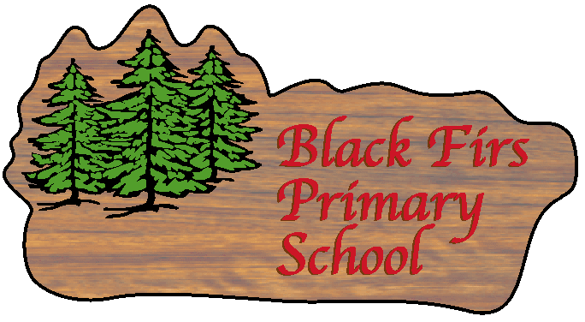
Science Policy 2022-23

Black Firs School

Introduction
“The true definition of science? It’s the study of the beauty of this world.” (Simone Weil) Children are naturally curious. They observe carefully and want to investigate everything. Our aim is to nurture that curiosity, develop their observational skills and give them every opportunity to investigate. Since science is all around us, we must facilitate and guide children in order to develop and challenge what they know about the world.
Making our approach to science open ended and practical in nature allows for children to work together fuelling their curiosity, while using a wide range of engaging resources. From their, we allow the children to lead their own learning that leads to them making their own observations and discoveries. This, in turn, will allow them to develop their investigational skills, ability to problem solve and work as a team (and share an experience together).

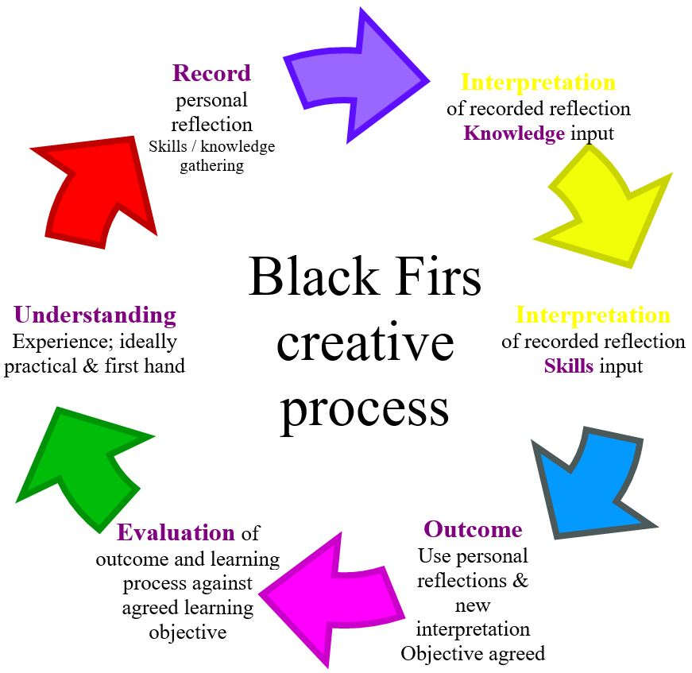 | Creative Process  The creative process can begin at any one point within the cycle. This depends on previous learning, understanding and the topic itself. Some topics begin in one year group and are then built upon in later year groups, whereas others are a completely new starting point. Whichever the case, understanding where the children are at in terms of their learning journey towards the topic at hand will help with the decision of where to start within the creative process.  First-hand experiences, practical investigations and hands-on learning should be the central part for fostering curiosity and raising questions around the science topic. Further to this, further questioning/testing/observing (by teacher and pupils) and sharing findings are also integral to the development of knowledge. Through both of these avenues comes the development of skills gained from studying the topic. Finally, the children should use their newly acquired knowledge and skills to create an outcome that demonstrates their understanding of the topic at hand. Recording of this can be done in any number of ways as long as they clearly show evidence towards the objectives for the topic.  After completion, it is important that the children are given chance to reflect on their learning and evaluate it against the topic-specific objectives set for them.
Intent
Our aims in teaching science are that all children will:
- retain and develop their natural sense of curiosity about the natural world around them, and have an appreciation, care and concern for animals, plants and the maintenance of an unpolluted environment.
- develop the following positive attitudes to science: open mindedness, perseverance, co-operation, awe-and-wonder.
- develop the following skills: come to understand the nature of scientific method involving observation, solving problems in a logical way, design and construction, investigation in a fair way, and the drawing of meaningful conclusions.
- begin to build up a body of scientific knowledge and understanding which will serve as a foundation for the future.
To encourage greater understanding and more creative communication, we are adopting the School’s creative process into our Science teaching.

Implementation
The science curriculum is based on the National Curriculum for Science and is organised round the QCA scheme of work and the CECP scheme of work (made in partnership with Eaton Bank Academy). The school follows the progression of skills document, which incorporates statements from the National Curriculum for Science and follows the scheme of work from both QCA and the CECP. Science is integrated into our timetable throughout the year. Sometimes it is taught as an individual subject, and at other times it is taught as part of a cross curricular topic. On average 2.5 - 3 hours per week is spent on science. Included in this are extra activities for focussing on A.T. 1 to ensure N.C. coverage.

There is a balance between whole class and group activity and scope for individual work. Most practical activities require group work as children are allowed to follow their own investigations. Group work also enables different groups to investigate different problems and report back to the whole class for discussion and analysis. The groups are also encouraged to communicate their findings in a variety of ways.

For science A.T. 1 the type of question we pose leads to different approaches:
- How do snails move? Child answers through observation.
- How many different varieties of snail are there? Child investigates a secondary source.
- Which food do snails prefer? Child devises a fair test.

Impact
- We will continue to emphasise that investigation and enquiry is a life-long learning skill that should be developed and enhanced through practical opportunities.
- We will aim to provide quality first-hand experience as a starting-point to children’s awe & wonder, exploration and understanding.
- We will encourage the children to use our creative process to explore quality outcomes in their development of Science.

Reporting
Reporting to parents is done on a termly basis via Earwig and on a yearly basis at parent interviews and an annual report.

Record Keeping
Records are kept through Earwig, through study work and through assessment sheets.
Evidence is also kept within the Big Book for Science, present on the school science display.

Children with SEND
Please refer to school policy document.
Learning through science can be differentiated to suit the needs of all learners and allow everyone to complete outcomes that are based on their own individual ability.

Equal Opportunities
Please refer to the School Aims & Statement on Equal Opportunities.
All children should be able to access science at Black Firs. As a subject, Science can easily be adapted to suit the needs of all learners to allow everyone to engage and participate fully with the learning at hand. All pupils will receive appropriate support to allow them to access the resources, activities, investigations and equipment.

Role Of Coordinator
- To support staff in the teaching of Science.
- To communicate with staff about the subject.
- To highlight areas for development within the subject and its implementation across school.
- To monitor progression and continuity both key stages.
- To attend courses and cluster group meetings.
- To order Science resources and manage the storage and distribution of those resources.
- To initiate discussion on Science and seek to maintain a high profile for Science as a subject.
- To respond to link initiatives from outside agencies e.g. High Schools, STEM, T.E.C., Zeneca etc.

Health & Safety (see also Health & Safety Policy)
We endeavour to keep staff up to date with the latest guide-lines (from ASE and CLEAPSS) and have read the safety guidelines annually.
Risk assessments are carried out by individuals for the relevant science subjects being taught. These are shared with and approved by the science coordinator (e.g. covering any hazardous materials). Risk assessments are kept within the subject specific folder on the Staff Shared Area and should be uploaded by staff.

Review
This policy will be reviewed by the coordinator, Head teacher and the whole teaching staff to ensure it meets the development priorities from the Whole School Development Plan. Changes and amendments will be presented to the Governing Body for discussion and further approval.

