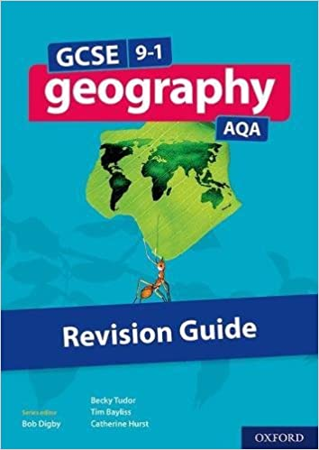
Year 10 GCSE Geography
The UK’s Relief and Landscapes
Use page 58 to answer the following questions in full sentences on lined paper:
- What does the term ‘relief’ mean?
- What does relief depend on / what is it determined by?
- Describe the rock type to the north and west of the red line on Figure 1.
- Describe the rock type to the south and east of the red line on Figure 1.
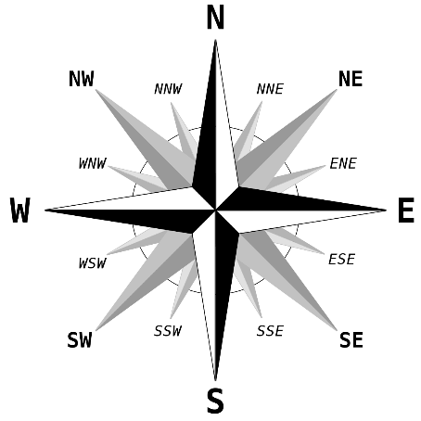
- What is a ‘landscape’?
For the next set of questions, you will need to know the points of a compass and use the map (Figure 1) to find the answers. You will also need to know where England, Scotland, Wales and Northern Ireland are located! Your answer should look like this:
Q: Describe the location of the Northwest Highlands mountain range.
A: The Northwest Highlands mountain range is located in north-west Scotland.
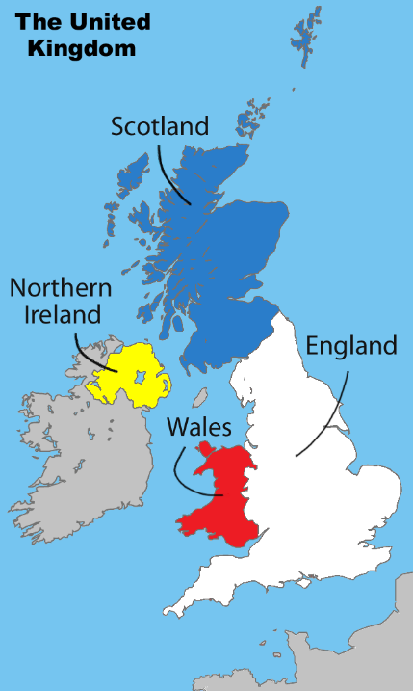
- Describe the location of the Cambrian Mountains.
- Describe the location of the Lake District.
- Describe the location of the Pennines mountain range.
- Describe the location of the Antrim Mountains.
- Describe the location of Dartmoor.
- Describe the location of the North York Moors.
- Describe the location of the River Thames.
- Describe the location of the River Mersey.
- Describe the location of the Irish Sea.
- Describe the location of the North Sea.
- Describe the location of the English Channel.
Now, use the scale in the top-left corner of Figure 1 to help you answer these questions:
- What is the straight-line distance (in kms) from Land’s End to the Lake District?
- What is the straight-line distance (in kms) from the Orkney islands to the mouth of the River Humber?
- What is the straight-line distance (in kms) from the Isle of Man to the Isle of Wight?
- What is the straight-line distance (in kms) from Ben Nevis to Scafell Pike?

