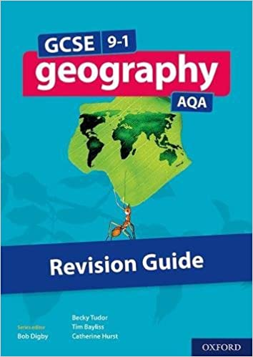
Year 10 GCSE Geography
Rivers and their Valleys
Use page 70 to answer the following questions in full sentences on lined paper:
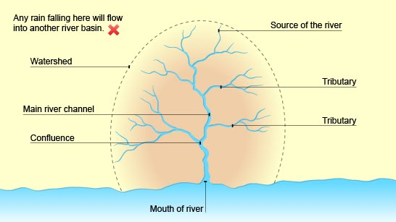
- What is a drainage basin?
- What is the source of a river?
- What is a tributary?
- What is the mouth of a river?
- What is a watershed?
- What is a confluence?
- What is the ‘long profile’ of a river?
- How does a river’s long profile change as a river flows from its source to its mouth?
- What is the ‘cross profile’ of a river?
- How is a cross profile different to the long profile of a river?
- What is the ‘upper course’ of a river?
- What is the ‘middle course’ of a river?
- What is the ‘lower course’ of a river?
- Letter A on Figure 3 (page 70) shows the cross profile of a river in the upper course (what the valley looks like). Letter A on Figure 1 shows the location of the valley in the upper course. Describe the shape and the location of a v-shaped valley in the upper course of a river.
- Letter B on Figure 3 (page 70) shows the cross profile of a river in the upper course (what the valley looks like). Letter B on Figure 1 shows the location of the valley in the upper course. Describe the shape and the location of a valley in the middle course of a river.
- Letter C on Figure 3 (page 70) shows the cross profile of a river in the upper course (what the valley looks like). Letter C on Figure 1 shows the location of the valley in the upper course. Describe the shape and the location of a valley in the lower course of a river.
- Describe how the cross profile (the shape) of a river valley changes from source to mouth.
- Explain why river valleys get wider and deeper as a river makes its journey from source to mouth.
- What is erosion? What type of erosion happens in the upper course? Vertical or lateral? Why?
- What is deposition? In which part of the river’s long profile will there be most deposition?

