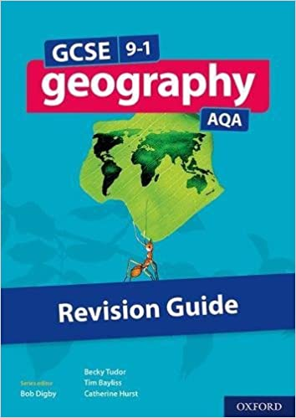
Year 10 GCSE Geography: Fluvial (River) Processes
Use page 71 to answer the following questions in full sentences on lined paper:
- What is vertical erosion? Draw a simple diagram to show vertical erosion.
- What is lateral erosion? Draw a simple diagram to show lateral erosion.
- What is ‘Load’? Clue: Boulder, cobble, pebble, gravel, sand, silt, clay.
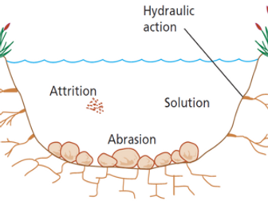
- Hydraulic Action is an EROSIONAL process. Explain how hydraulic action erodes river banks by sketching an annotated diagram (this is a diagram that shows how the process works AND explains (in words) how it works).
- Abrasion is an EROSIONAL process. Explain how abrasion erodes river banks by sketching an annotated diagram.
- Attrition is an EROSIONAL process. Explain how attrition erodes river banks by sketching an annotated diagram.
- Solution is an EROSIONAL process. Explain how solution erodes river banks by sketching an annotated diagram.
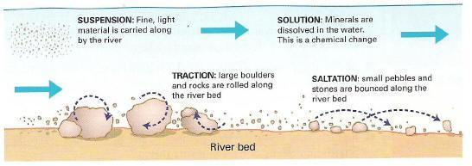
- Traction is a TRANSPORTATION process. Explain how traction transports load in a river by sketching an annotated diagram.
- Saltation is a TRANSPORTATION process. Explain how saltation transports load in a river by sketching an annotated diagram.
- Suspension is a TRANSPORTATION process. Explain how suspension transports load in a river by sketching an annotated diagram.
- Solution is a TRANSPORTATION process. Explain how solution transports load in a river by sketching an annotated diagram.
- What is deposition? Why does a river drop load? When is a river more likely to drop load? What type of load will be deposited first, why?
Now, think about what you did on the last worksheet. Think about what happens in the upper, middle and lower course of a river and answer these final ‘quick-fire’ questions!
- Which course has most erosional power?
- Which course has most deposition?
- Which course has largest load?
- Which course has most traction?
- Which course has most suspension?

