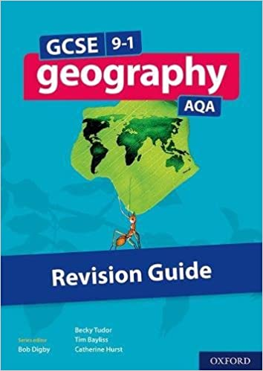
Year 10 GCSE Geography: Upper Course Landforms
Upper course landforms are created by EROSION. They include v-shaped valleys, interlocking spurs, waterfalls and gorges. Use page 72 to help you with these tasks:
V-Shaped Valleys
2
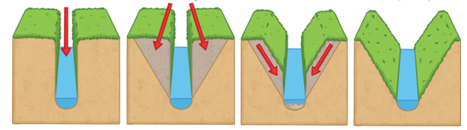
3
4
1

- On a separate piece of paper, make a simple sketch of the diagram above (including the numbers). Using your own knowledge and information from page 72, annotate your diagram to show HOW v-shaped valleys are formed.

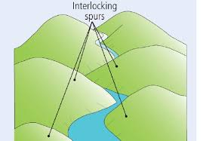
Interlocking Spurs
- On a separate piece of paper, make a simple sketch of the diagram to the left. Using your own knowledge and information from page 72, annotate your diagram to show HOW interlocking spurs are formed in the upper course.

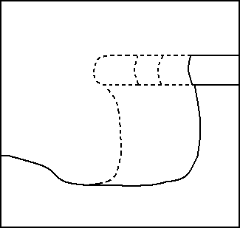
Waterfalls and Gorges
- On a separate piece of paper, make a simple sketch of the diagram to the left. Using your own knowledge and information from page 72, annotate your diagram to show HOW waterfalls and gorges are formed in the upper course. Ensure that you explain the types of erosion that undercut the softer rock.

