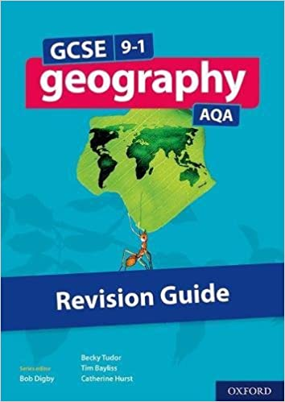
Year 10 GCSE Geography: Middle Course Landforms
Middle course landforms are created by EROSION and DEPOSITION. They include meanders and ox-bow lakes. Use page 73 to help you with these tasks:
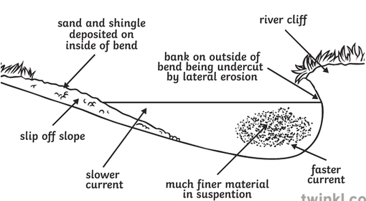
Meanders
Look at this diagram and read the section on meanders and ox-bow lakes at the top of page 73.
- What is a meander?
- On which side of the meander is the fastest flow?
- Erosion will take place where flow is fastest. Explain the types of erosion that will act on the outside bend.
- A river cliff forms on the outside bend. Explain how a river cliff is formed.
- On which side of the meander is the slowest flow?
- A slip-off slope forms on the inside bend of a meander. Explain the formation of a slip-off slope.

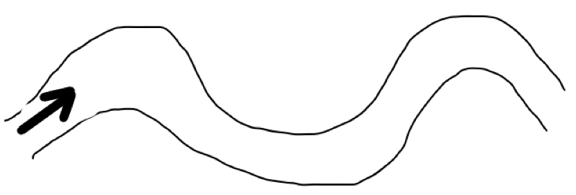
- On this diagram, draw a line to show the fastest flow in the river.
- Shade the eroded area in one colour.
- Shade the area where deposition will take place in another colour.
- Add labels to show where a river cliff and a slip-off slope would form.
- Explain what happens to meanders over time.
Ox-bow Lakes

- Use the three diagrams above and the information on page 73 to explain (in detail) how ox-bow lakes form on meanders. Don’t forget to explain both erosion and deposition!
- Floodplains form around meanders in the middle and lower course. Explain the formation of a floodplain.
- Levees form around meanders in the middle and lower course. Explain the formation of a levee.

