EXAM QUESTIONS

1.Label the diagram of the different body types (3 marks)

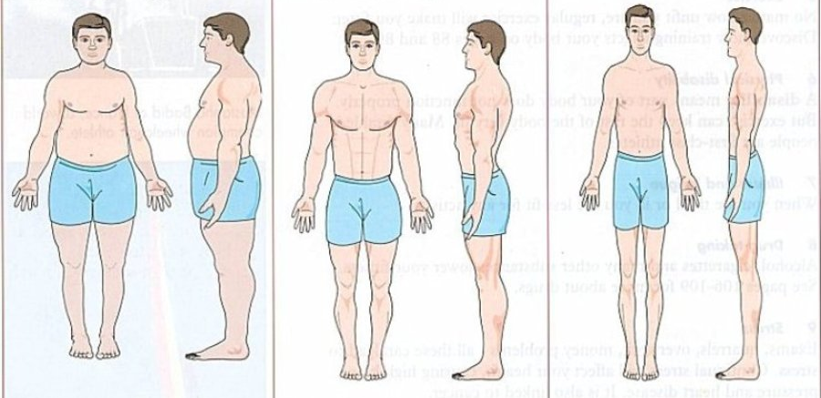

2. Explain what long term effects an endurance runner would experience as a result of their training. (6 marks)

3. Explain what long term effects a weight lifter would experience as a result of their training. (4 marks)

4. Explain why blood pressure reduces with long term exercise (3 marks)

5. Describe how body shape can be effected by exercise (3 marks)

