**Standard Form**

**Things to remember:**

* a x 10b

1 ≤ a < 10

**1.** A floppy disk can store 1 440 000 bytes of data.

(a) Write the number 1 440 000 in standard form.

……………………………………

**(1)**

A hard disk can store 2.4 × 109 bytes of data.

(b) Calculate the number of floppy disks needed to store the 2.4 × 109 bytes of data.

……………………………………

**(3)**

**(Total 4 marks)**

**2.** A nanosecond is 0.000 000 001 second.

(a) Write the number 0.000 000 001 in standard form.

……………………………………

**(1)**

A computer does a calculation in 5 nanoseconds.

(b) How many of these calculations can the computer do in 1 second?  
Give your answer in standard form.

……………………………………

**(2)**

**(Total 3 marks)**

**3.** (a) (i) Write 40 000 000 in standard form.

……………………………………

(ii) Write 3 x 10–5 as an ordinary number.

……………………………………

**(2)**

(b) Work out the value of

3 x 10–5 x 40 000 000

Give your answer in standard form.

……………………………………

**(2)**

**(Total** **4** **marks)**

**4.** Work out (3.2 × 105) × (4.5 × 104)

Give your answer in standard form correct to 2 significant figures.

……………………………………

**(Total 2 marks)**

**5.** (a) Write the number 40 000 000 in standard form.

……………………………………

**(1)**

(b) Write 1.4 × 10–5 as an ordinary number.

……………………………………

**(1)**

(c) Work out

(5 × 104) × (6 × 109)

Give your answer in standard form.

……………………………………

**(2)**

**(Total 4 marks)**

**6.** Write in standard form

(a) 456 000

……………………………………

**(1)**

(b) 0.00034

……………………………………

**(1)**

(c) 16 × 107

……………………………………

**(1)**

**(Total 3 marks)**

**7.** (a) Write 5.7× 10–4 as an ordinary number.

……………………………………

**(1)**

(b) Work out the value of (7 × 104) × (3 × 105)

Give your answer in standard form.

……………………………………

**(2)**

**(Total 3 marks)**

**8.** (a) Write 30 000 000 in standard form.

……………………………………

**(1)**

(b) Write 2 × 10–3 as an ordinary number.

……………………………………

**(1)**

**(Total 2 marks)**

**9.** (a) (i) Write 7900 in standard form.

……………………………………

(ii) Write 0. 00035 in standard form.

……………………………………

**(2)**

(b) Work out $\frac{4×{10}^{3}}{8×{10}^{-5}}$

Give your answer in standard form.

……………………………………

**(2)**

**(Total 4 marks)**

**10.** Work out



Give your answer in standard form correct to 3 significant figures.

……………………………………

**(Total 3 marks)**

**11.** (a) Write 6.4 × 104 as an ordinary number.

……………………………………

**(1)**

(b) Write 0.0039 in standard form.

……………………………………

**(1)**

(c) Write 0.25 × 107 in standard form.

……………………………………

**(1)**

**(Total 3 marks)**

**Laws of Indices**

**Things to remember:**

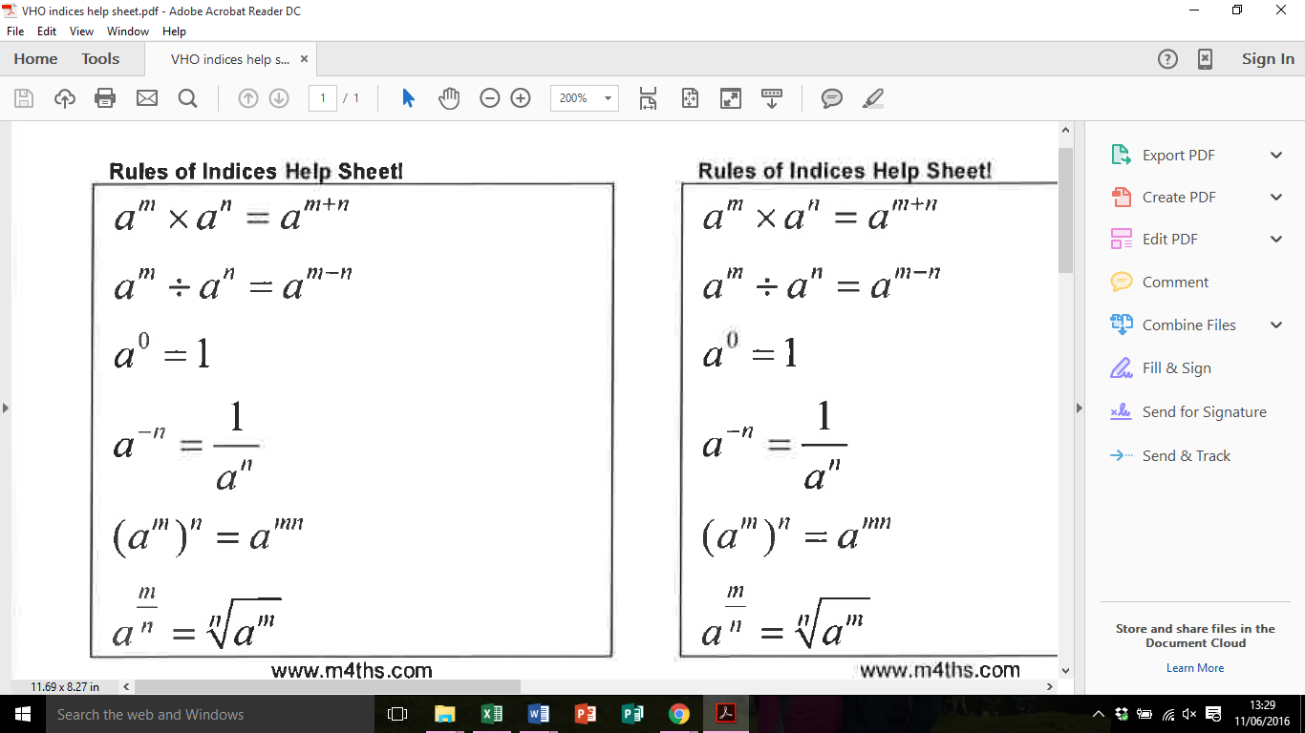 

**Questions:**  
**1.** (a) Simplify *m*5 ÷ *m*3

……………………………………

**(1)**

(b) Simplify 5*x*4*y*3 × *x*2*y*

 ……………………………………

**(2)**

**(Total for Question is 3 marks)**

**2.** Write these numbers in order of size.  
 Start with the smallest number.



    …...........................................................................................................................................

**(Total for Question is 2 marks)**

**3.** Write down the value of 125

……………………………………

**(Total for question is 1 mark)**

**4.** (a) Write down the value of 10–1

……………………………………

**(1)**

(b) Find the value of 

……………………………………

**(2)**

**(Total for Question is 3 marks)**

**5.** (a) Find the value of        5°

……………………………………

**(1)**

(b) Find the value of ${27}^{1/3}$

……………………………………

**(1)**

(c) Find the value of        2-3

……………………………………

**(1)**

**(Total for Question is 3 marks)**

**6.** (a) Write down the value of ${27}^{1/3}$

……………………………………

**(1)**

(b) Find the value of ${27}^{{-1}/3}$

……………………………………

**(2)**

**(Total for Question is 3 marks)**

**7.** (a)   Write down the value of 

……………………………………

**(1)**

(b)   Find the value of 

……………………………………

**(2)**

**(Total for question = 3 marks)**

**8.** (a)   Write down the value of 60

……………………………………

**(1)**

(b) Work out 64

……………………………………

**(2)**

**(Total for question = 3 marks)**

**Estimating Calculations**

**Things to remember:**

* Round each number to one significant figure first (e.g. nearest whole number, nearest ten, nearest one decimal place) – this earns you one mark.
* Don’t forget to use the correct order of operations.

**Questions:**

**1.** Work out an estimate for $\frac{3.1 × 9.87}{0.509}$

……………………………………

**(Total for Question is 3 marks)**

**2.** Margaret has some goats.  
 The goats produce an average total of 21.7 litres of milk per day for 280 days.  
 Margaret sells the milk in ½ litre bottles.

Work out an estimate for the total number of bottles that Margaret will be able to fill with the milk.

You must show clearly how you got your estimate.

……………………………………

**(Total for Question is 3 marks)**

**3.** Work out an estimate for the value of $\frac{89.3×0.51}{4.8}$

……………………………………

**(Total for Question is 2 marks)**

**4.** Work out an estimate for $\sqrt{1.98+2.16×7.35}$

……………………………………

**(Total for question = 3 marks)**

**5.** A ticket for a seat at a school play costs £2.95

There are 21 rows of seats.  
 There are 39 seats in each row.

The school will sell all the tickets.

Work out an estimate for the total money the school will get.

£ ……………………………………

**(Total for Question is 3 marks)**

**6.** Jayne writes down the following

3.4 × 5.3 = 180.2

Without doing the exact calculation, explain why Jayne’s answer cannot be correct.

…..........................................................................................................................................

…..........................................................................................................................................

…..........................................................................................................................................

**(Total for question is 1 mark)**

**Bounds**

**Things to remember:**

* Calculating bounds is the opposite of rounding – they are the limits at which you would round up instead of down, and vice versa.

**Questions:**

**1.** A piece of wood has a length of 65 centimetres to the nearest centimetre.

(a) What is the least possible length of the piece of wood?

 ……………………………………

**(1)**

(b) What is the greatest possible length of the piece of wood?

……………………………………

**(1)**

**(Total for Question is 2 marks)**

**2.** Chelsea’s height is 168 cm to the nearest cm.

(a)   What is Chelsea’s minimum possible height?

…........................................................ cm

**(1)**

(b)   What is Chelsea’s maximum possible height?

…........................................................ cm

**(1)**

**(Total for Question is 2 marks)**

**3.** Dionne has 60 golf balls.   
Each of these golf balls weighs 42 grams to the nearest gram.

Work out the greatest possible total weight of all 60 golf balls.   
Give your answer in kilograms.

…………………………………… kg

**(Total for Question is 3 marks)**

**4.** The length, *L* cm, of a line is measured as 13 cm correct to the nearest centimetre.

Complete the following statement to show the range of possible values of *L*

…............................ ≤ *L* < …............................

**(Total for question is 2 marks)**

**5.** Jim rounds a number, *x*, to one decimal place.   
The result is 7.2

Write down the error interval for *x*.

……………………………………

**(Total for question = 2 marks)**

**6.** A pencil has a length of 17 cm measured to the nearest centimetre.

(a) Write down the least possible length of the pencil.

……………………………………

**(1)**

(b) Write down the greatest possible length of the pencil.

……………………………………

**(1)**

**(Total for Question is 2 marks)**

**Expand and Factorise Quadratics**

**Things to remember:**

* Use FOIL (first, outside, inside, last) or the grid method (for multiplication) to expand brackets.
* For any quadratic ax² + bx + c = 0, find a pair of numbers with a sum of b and a product of ac to factorise.

**Questions:**

**1.** Expand and simplify (*m* + 7)(*m* + 3)

……………………………………

**(Total for question = 2 marks)**

**2.** (a) Factorise      6 + 9*x*

……………………………………

**(1)**

(b) Factorise      *y*2 – 16

……………………………………

**(1)**

(c) Factorise      2*p*2 – *p* – 10

……………………………………

**(2)**

**(Total for Question is 4 marks)**

**3.** Solve, by factorising, the equation      8*x*2 – 30*x* – 27 = 0

……………………………………

**(Total for Question is 3 marks)**

**4.** Factorise *x*2 + 3*x* – 4

……………………………………

**(Total for question is 2 marks)**

**5.** Write *x*2 + 2*x* – 8 in the form (*x* + *m*)2 + *n* where *m* and *n* are integers.

……………………………………

**(Total for question is 2 marks)**

**6.** (a) Expand    4(3*x* + 5)

……………………………………

**(1)**

(b) Expand and simplify    2(*x* – 4) + 3(*x* + 5)

……………………………………

**(2)**

(c) Expand and simplify    (*x* + 4)(*x* + 6)

……………………………………

**(2)**

**(Total for Question is 5 marks)**

**7.** (a) Factorise      *x*2 + 5*x* + 4

……………………………………

**(2)**

(b) Expand and simplify    (3*x* −1)(2*x* + 5)

……………………………………

**(2)**

**(Total for Question is 4 marks)**

**8.** (a) Expand    3(2 + *t*)

……………………………………

**(1)**

(b) Expand    3*x*(2*x* + 5)

……………………………………

**(2)**

(c) Expand and simplify (*m* + 3)(*m* + 10)

……………………………………

**(2)**

**(Total for Question is 5 marks)**

**9.** (a) Factorise                    *x*2 + 7*x*

……………………………………

**(1)**

(b) Factorise                   *y*2 – 10*y* + 16

……………………………………

**(2)**

*(c) (i) Factorise             2*t*2 + 5*t* + 2

……………………………………

        (ii) *t* is a positive whole number.  
         The expression 2*t*2 + 5*t* + 2 can never have a value that is a prime number.  
         Explain why.

       ………..................................................................................................................

       ………..................................................................................................................

       ………..................................................................................................................

**(3)**

**(Total for Question is 6 marks)**

**Rearranging Formulae**

**Things to remember:**

* Firstly decide what needs to be on its own.
* Secondly move all terms that contain that letter to one side. Remember to move all terms if it appears in more than one.
* Thirdly separate out the required letter on its own.

**Questions:**

**1.** Make *u* the subject of the formula

*D* = *ut* + *kt*2

*u* = …................................

**(Total** **2** **marks)**

**2.** (a) Solve 4(*x* + 3) = 6

*x* = ………………….

**(3)**

(b)Make *t* the subject of the formula *v* = *u* + 5*t*

*t* = ………………….

**(2)**

**(Total 5 marks)**

**3.** (a) Expand and simplify

(*x – y*)2

….............................................

**(2)**

(b) Rearrange *a*(*q* – *c*) = *d* to make *q* the subject.

*q* = ….......................................

**(3)**

**(Total 5 marks)**

**4.** Make *x* the subject of

5(*x* – 3) = *y*(4 – 3*x*)

*x* = …..................................

**(Total 4 marks)**

**5.** 

Rearrange the formula to make *a* the subject.

*a =*…..................................

**(Total 4 marks)**

**6.** 

Make *x* the subject of the formula.

*x* =….............................

**(Total 4 marks)**

**Linear Simultaneous Equations**

**Things to remember:**

1. Scale up (if necessary)
2. Add or subtract (to eliminate)
3. Solve (to find x)
4. Substitute (to find y) (or the other way around)

**Questions:**

**\*1.** The Singh family and the Peterson family go to the cinema.

The Singh family buy 2 adult tickets and 3 child tickets.   
They pay £28.20 for the tickets.

The Peterson family buy 3 adult tickets and 5 child tickets.   
They pay £44.75 for the tickets.

Find the cost of each adult ticket and each child ticket.

**(Total for question = 5 marks)**

**2.** Solve the simultaneous equations

3*x* + 4*y* = 5

2*x* – 3*y* = 9

*x* = …........................................................

*y* = …….....................................................  
**(Total for Question is 4 marks)**

**3. S**olve the simultaneous equations

4*x* + 7*y* = 1  
 3*x* + 10*y* = 15

*x* = …........................................................

*y* = …….....................................................  
**(Total for Question is 4 marks)**

**4.** Solve

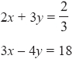

*x* = …........................................................

*y* = …….....................................................  
**(Total for Question is 4 marks)**

**5.** Solve the simultaneous equations

4*x* + *y* = 25   
*x* – 3*y* = 16

*x* = …........................................................

*y* = …….....................................................  
**(Total for Question is 3 marks)**

**6.** Solve the simultaneous equations

                         3*x* – 2*y* = 7   
                          7*x* + 2*y* = 13

*x* = …........................................................

*y* = …….....................................................  
**(Total for Question is 3 marks)**

**7.** A cinema sells adult tickets and child tickets.

The total cost of 3 adult tickets and 1 child ticket is £30   
The total cost of 1 adult ticket and 3 child tickets is £22

Work out the cost of an adult ticket and the cost of a child ticket.

adult ticket   £…........................................................

child ticket  £…........................................................

**(Total for question = 4 marks)**

**\*8.** Paper clips are sold in small boxes and in large boxes.

There is a total of 1115 paper clips in 4 small boxes and 5 large boxes.

There is a total of 530 paper clips in 3 small boxes and 2 large boxes.

Work out the number of paper clips in each small box and in each large box.

**(Total for Question is 5 marks)**