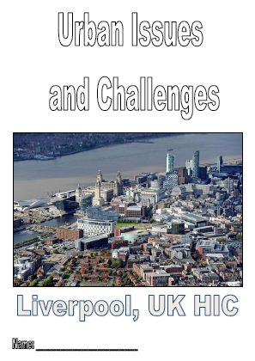
Year 11 GCSE Geography
Use the revision guide to answer the following questions in full sentences on lined paper.

Page 3 - ‘Population Distribution in the UK’. Read the information first!
- Describe the location of London.
- Describe the location of Inverness.
- Describe the location of sparsely populated areas of the UK.
- Describe the location of densely populated areas of the UK.
Page 4 – ‘Urban Models in the UK’. Read the information first!
- Describe the location of the CBD.
- Describe the features of the CBD (what is it like?).
- Describe the location of the Inner City.
- Describe the features of the Inner City (what is it like?).
- Describe the location of the Suburbs.
- Describe the features of the Suburbs (what is it like?).
- Describe the location of the Rural Urban Fringe.
- Describe the features of the Rural Urban Fringe (what is it like?).
Page 5 – ‘Liverpool: Location and Importance’. Read the information first!
- Describe the location of Liverpool.
- What is a ‘dock’ and how did it allow Liverpool to grow rapidly?
- Liverpool rapidly became a successful port. What goods were imported and exported through Liverpool?
- What happened to Liverpool in the 1980’s? Why did this happen?
Page 6 – ‘National and International Migration into Liverpool’. Read the information first!
- What did Welsh migration bring to Liverpool? How have they changed the character of Liverpool?
- What did Irish migration bring to Liverpool? How have they changed the character of Liverpool?
- What did Chinese migration bring to Liverpool? How have they changed the character of Liverpool?
Page 7, 8 and 9 – ‘How has Urban Change created OPPORTUNITIES for Liverpool?’. Read the information first!
- What does ‘cultural mix’ mean?
- Explain how recreation and entertainment have provided opportunities for the people of Liverpool? (this should be a one-page answer)
- Explain how employment and transport have provided opportunities for the people of Liverpool? (this should be a one-page answer)
- Explain how urban greening has provided opportunities for the people of Liverpool? (this should be a one-page answer)
Page 10 and 11 - ‘How has Urban Change created CHALLENGES for Liverpool?’. Read the information first!
- What is meant by ‘urban deprivation and inequality’?
- Describe the social and economic characteristics of Toxteth. Why are levels of deprivation and inequality so high?
- Explain the environmental challenges facing Liverpool (dereliction, brownfield sites and waste disposal). Why are these such huge challenges in Liverpool?
Page 12 – ‘Urban Regeneration – Liverpool ONE’. Read the information first!
- Explain why regeneration was needed in Liverpool’s CBD.
- Explain what the regeneration scheme did to improve the area.
- Explain the importance of Liverpool ONE to the city’s economy.
Page 13 – ‘Sustainable Urban Living’. Read the information first!
- What is a ‘sustainable city’?
- Describe and explain the characteristics of a sustainable urban living strategy (BEDZED). This should be a one-page answer.
Page 14 – ‘Traffic Congestion in HIC Cities’. Read the information first!
- Explain the environmental problems caused by traffic congestion in HIC cities.
- Explain how fuel efficiency and electric cars can reduce the impact environmental issues.
- Explain how congestion charging in HIC cities can reduce traffic congestion.

