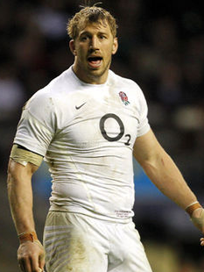
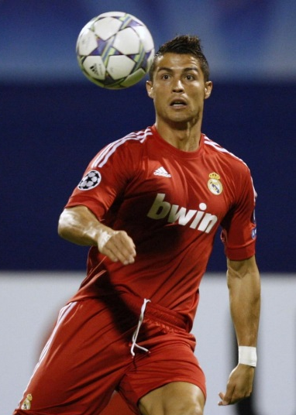
Select 5 different sports performers and write a paragraph about how they use the components of health and skill highlighted on the card. E.g. Ronaldo needs high levels of speed when sprinting down the pitch for the ball or when trying to beat opponents.

Cristiano Ronaldo
Chris Robshaw

Power  Agility  Balance  Co-ordination  Speed  Reaction Time | 95  71  69  87  52  53

Power  Agility  Balance  Co-ordination  Speed  Reaction Time | 84  93  91  94  96  89

Power  Agility  Balance  Co-ordination  Speed  Reaction Time | 84  93  89  96  83  87

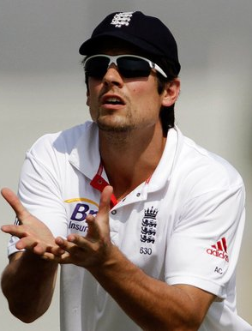
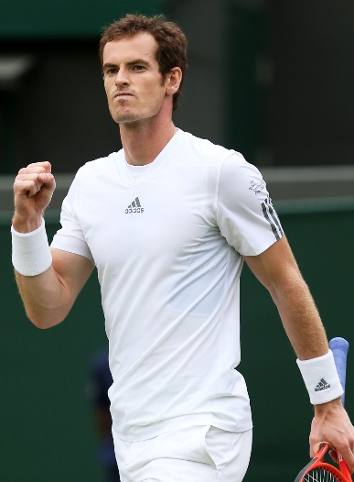

Alastair Cook
Andy Murray

Power  Agility  Balance  Co-ordination  Speed  Reaction Time | 81  48  73  90  56  76

Power  Agility  Balance  Co-ordination  Speed  Reaction Time | 89  60  47  88  74  81
Power  Agility  Balance  Co-ordination  Speed  Reaction Time | 86  41  47  54  99  78
Power  Agility  Balance  Co-ordination  Speed  Reaction Time | 94  32  73  79  48  45
Power  Agility  Balance  Co-ordination  Speed  Reaction Time | 81  38  81  93  83  53
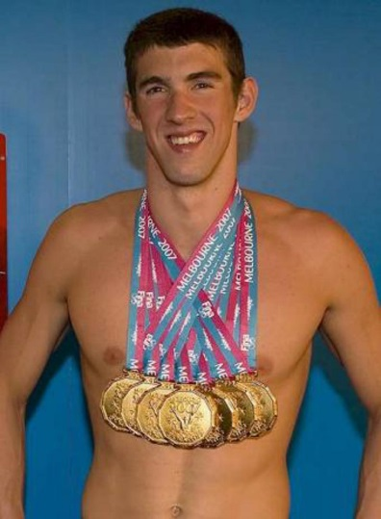
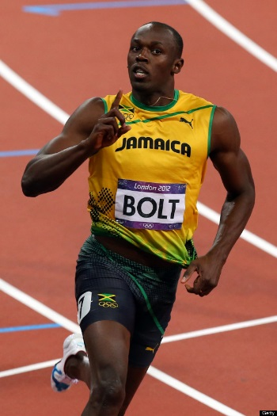

Michael Phelps
Usain Bolt

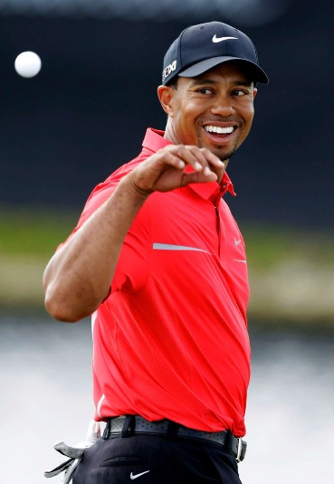
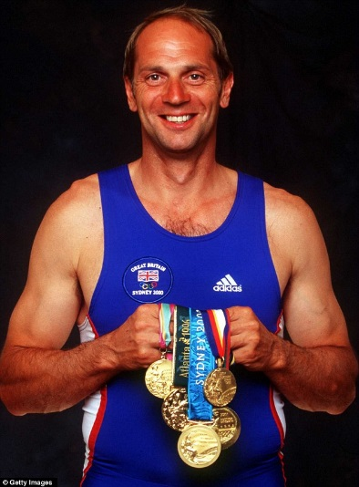

Tiger Woods
Sir Steve Redgrave

Power  Agility  Balance  Co-ordination  Speed  Reaction Time | 74  85  80  78  71  78
Power  Agility  Balance  Co-ordination  Speed  Reaction Time | 91  77  68  51  84  62
Power  Agility  Balance  Co-ordination  Speed  Reaction Time | 81  96  94  85  48  43
Power  Agility  Balance  Co-ordination  Speed  Reaction Time | 82  64  61  83  79  63
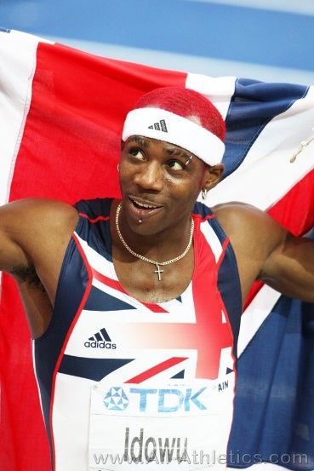
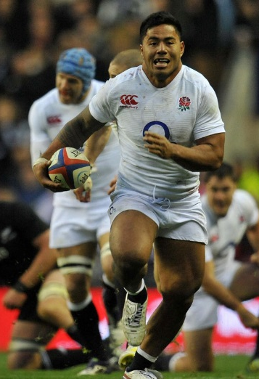

Phillips Idowu
Brodie Smith

Beth Tweddle
Manu Tuilagi

Laura Trott
Kobe Bryant

Power  Agility  Balance  Co-ordination  Speed  Reaction Time | 94  53  83  80  75  75

Power  Agility  Balance  Co-ordination  Speed  Reaction Time | 86  87  96  93  79  76

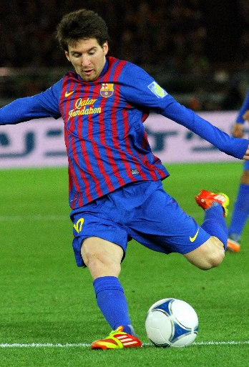
Mo Farah
Lionel Messi

Power  Agility  Balance  Co-ordination  Speed  Reaction Time | 61  37  65  54  61  32
Power  Agility  Balance  Co-ordination  Speed  Reaction Time | 65  91  91  84  89  81

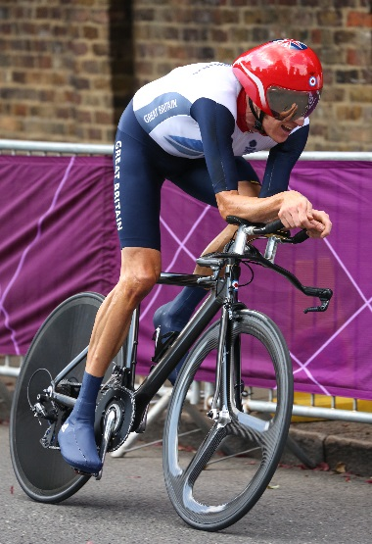
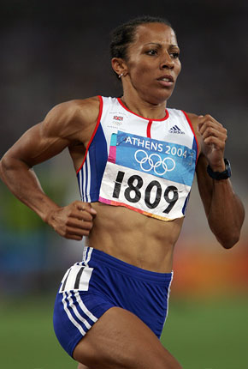

Dame Kelly Holmes
Bradley Wiggins

Power  Agility  Balance  Co-ordination  Speed  Reaction Time | 88  37  40  52  78  41
Power  Agility  Balance  Co-ordination  Speed  Reaction Time | 78  63  51  57  85  64

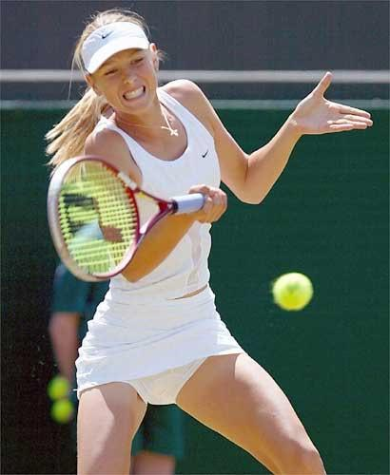
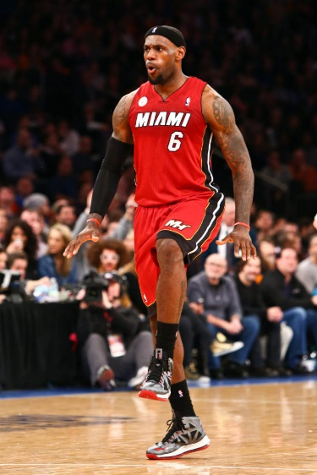
Power  Agility  Balance  Co-ordination  Speed  Reaction Time | 83  95  90  85  80  84

Maria Sharapova
LeBron James

Power  Agility  Balance  Co-ordination  Speed  Reaction Time | 73  75  87  83  66  79

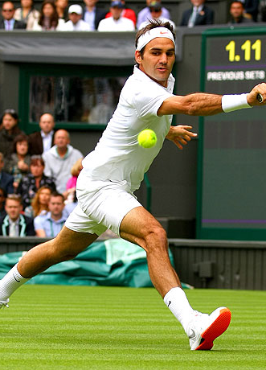
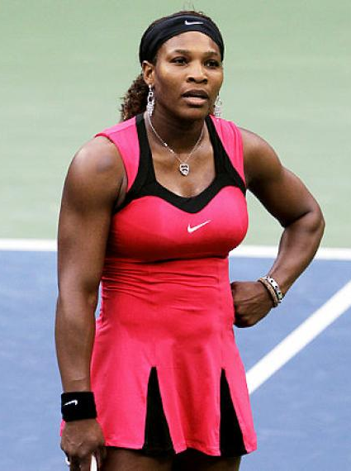

Serena Williams
Roger Federer

Power  Agility  Balance  Co-ordination  Speed  Reaction Time | 86  84  91  90  81  86
Power  Agility  Balance  Co-ordination  Speed  Reaction Time | 82  83  80  85  82  73

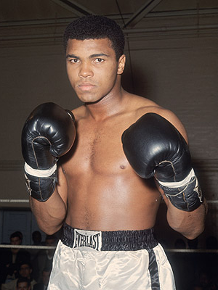
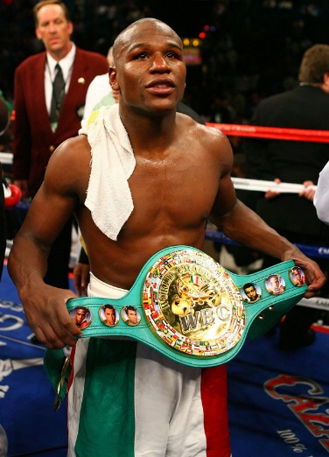

Muhammad Ali
Floyd Mayweather Jr.

Power  Agility  Balance  Co-ordination  Speed  Reaction Time | 88  81  74  87  79  87
Power  Agility  Balance  Co-ordination  Speed  Reaction Time | 98  96  95  99  94  97

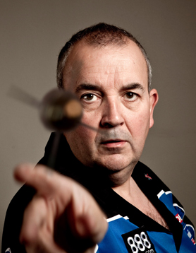
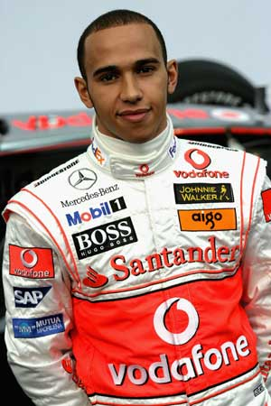

Lewis Hamilton
Phil Taylor

Power  Agility  Balance  Co-ordination  Speed  Reaction Time | 74  54  61  90  72  93

Power  Agility  Balance  Co-ordination  Speed  Reaction Time | 32  12  51  86  28  43

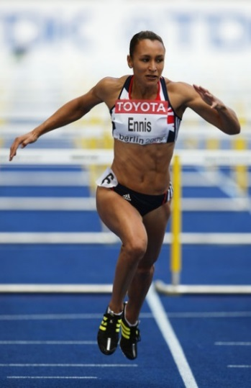
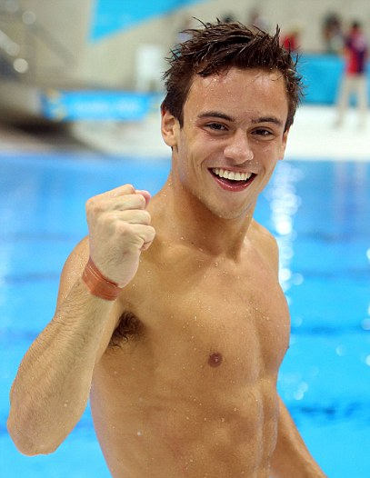

Jessica Ennis
Tom Daley

Power  Agility  Balance  Co-ordination  Speed  Reaction Time | 69  74  81  88  57  62
Power  Agility  Balance  Co-ordination  Speed  Reaction Time | 88  81  74  87  79  87

