
Pearson
Edexcel
3-Year Scheme of Work: Term 7 Assessment
Higher Tier

Instructions
- The time for the test is 1 hour.
- Answer all questions.

- Answer the questions in the spaces provided
– there may be more space than you need.
- Questions that require a calculator are marked with the symbol .

Information
- The total mark for this paper is 50.
- The marks for each question are shown
– use this as a guide as to how much time to spend on each question.

Advice
- Read each question carefully before you start to answer it.
- Keep an eye on the time.
- Try to answer every question.
- Check your answers if you have time at the end.

1 Write down the letter of the graph that shows variables in inverse proportion.
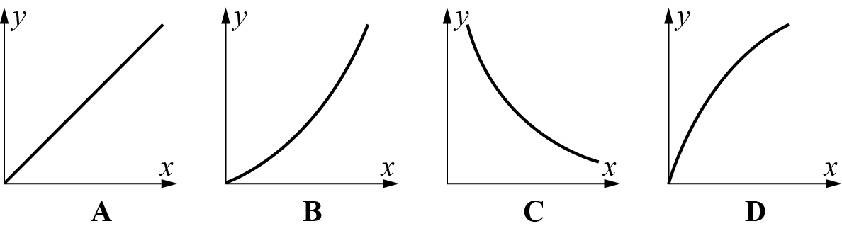
........................................
(1 mark)
2 e = f =
Write as a column vector
a 3e

........................................
(1 mark)
b e + f

........................................
(1 mark)
c 3e – 2f

........................................
(2 marks)
3 Find the length of the vector . Give your answer in surd form.

........................................
(3 marks)
4 In triangle OMN, = 3c and = 4d.
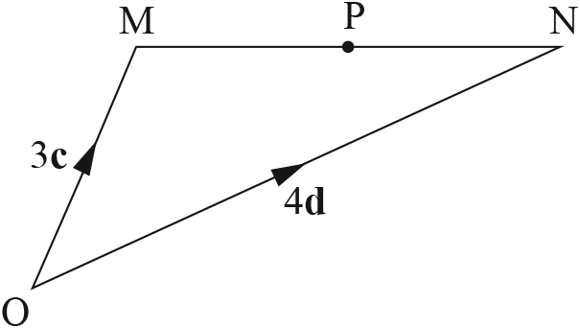
a Work out, in terms of c and d, the vector .

........................................
(1 mark)
P is the midpoint of MN.
b Work out, in terms of c and d, the vector .

........................................
(2 marks)
5 A factory makes different-sized containers in the shape of a cylinder.
The cost, C, of a container is directly proportional to the square of the radius, r cm.
When r = 3 cm, C = £22.50.
a Find a formula for C in terms of r.

........................................
(3 marks)
b Calculate the cost of a container when the radius is 15 cm.

........................................
(1 mark)
c Calculate the radius when the cost is £360.

........................................
(1 mark)
6 y is inversely proportional to x².
When y = 2.5, x = 4.
a Find an expression for y in terms of x.

........................................
(3 marks)
b Find the value of y when x = 2.

........................................
(1 mark)
c Find the value of x when y = 90.

........................................
(1 mark)
7 y is inversely proportional to the square root of x.
When y = 3, x = 16.
a Write a formula for y in terms of x.

........................................
(3 marks)
b Calculate the value of y when x = 25.

........................................
(1 mark)
c Calculate the value of x when y = 9.

........................................
(1 mark)
8 In triangle ABC, = 2d, = d and = 2c.
a Work out, in terms of c and d, the vector .
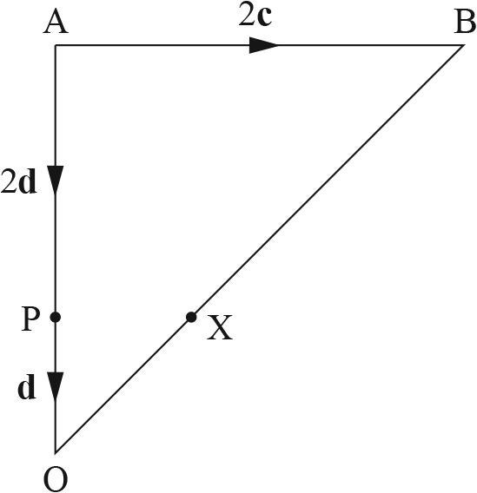

........................................
(1 mark)
The point X divides OB in the ratio 1 : 2.
b Show that PX is parallel to AB.

........................................
(4 marks)
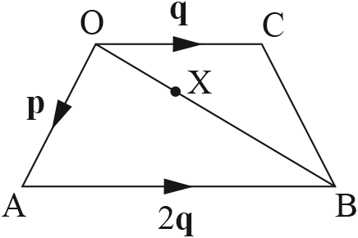
9 OABC is a trapezium.
= p = q
AB = 2OC
a Write an expression for in terms of p and q.

........................................
(1 mark)
The point X divides OB in the ratio 1 : 2.
b Prove that AXC is a straight line.

........................................
(4 marks)
10 The sketch shows the graph of y = f(x).
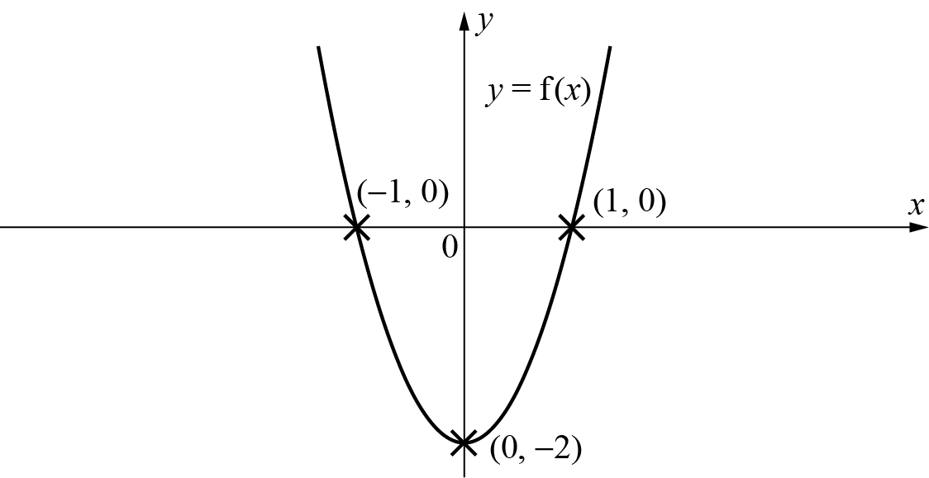
a Sketch the graph of y = f(x + 3) on the diagram.
(2 marks)
b Write the coordinates of the minimum point of y = f(x + 3).

........................................
(1 mark)
11 The velocity–time graph shows a motorbike travelling along a straight road from
a set of traffic lights. The time from the traffic lights, t, is measured in seconds.
The velocity, v, is measured in metres per second.
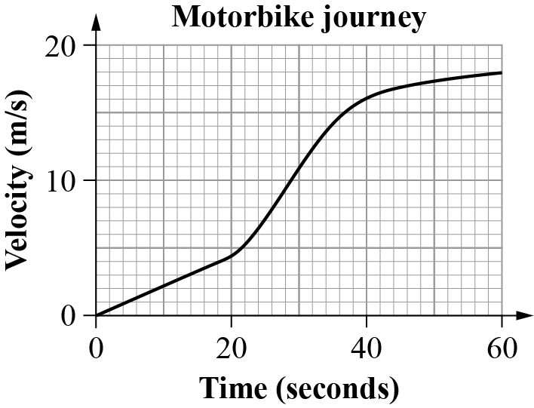
a Estimate the rate of acceleration at t = 20.

........................................
(3 marks)
b Estimate the distance travelled between t = 20 and t = 40.

........................................
(2 marks)
12 The diagram shows a sketch of the curve y = ab^{x}.
The curve passes through points S(1, 15) and T(3, 375).
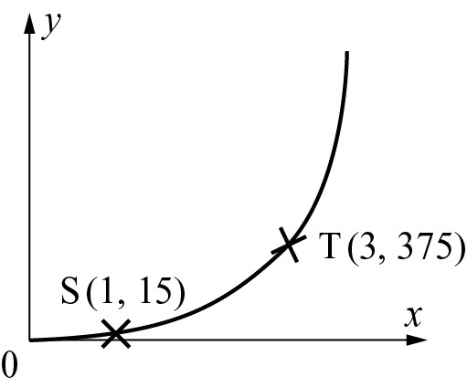
a Find the values of a and b.

a =
b =
(5 marks)
b Find the value of y when x = 2.

........................................
(1 mark)

TOTAL FOR PAPER = 50 MARKS

