1950’s Music

The world was emerging from the end of the Second World War and society was changing rapidly. Two new phrases hit America in the 1950’s which were to change things forever – teenagers and Rock and Roll. Before the 1950’s teenagers had no music (or money) to call their own.
The new music caused a sensation throughout the world.

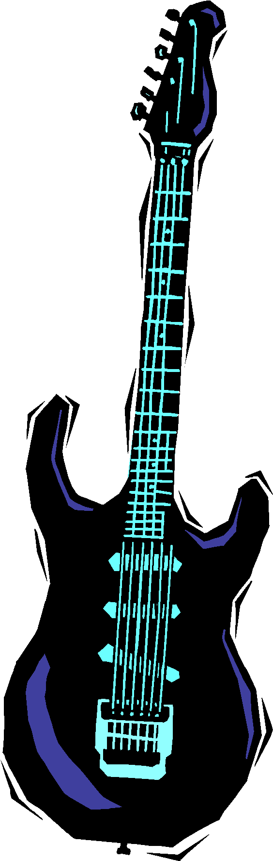
The music was raw, energetic, simply arranged and based on blues formats with light, fun lyrics. ‘Shake Rattle and Roll’, ‘Rip it up’ and ‘See you later Alligator’ were typical of the style and became further hits for Bill Hayley and the Comets.
With strong hooks and riffs these songs made you want to get up and dance. Other artists made famous in the 1950’s were Chuck Berry, Little Richard, Gene Vincent and Elvis Presely.

Elvis stunned audiences with his blues style singing, wild dancing and good looks. He was named ‘King of Rock and Roll’ and his music appealed to every generation.
1960’s Music

The Beatles formed in the 1950’s but became most famous in the 1960’s. They were discovered in Liverpool. All four members of the band – John Lennon, Paul McCartney, Ringo Starr and George Harrison – wore a strange, long new haircut.
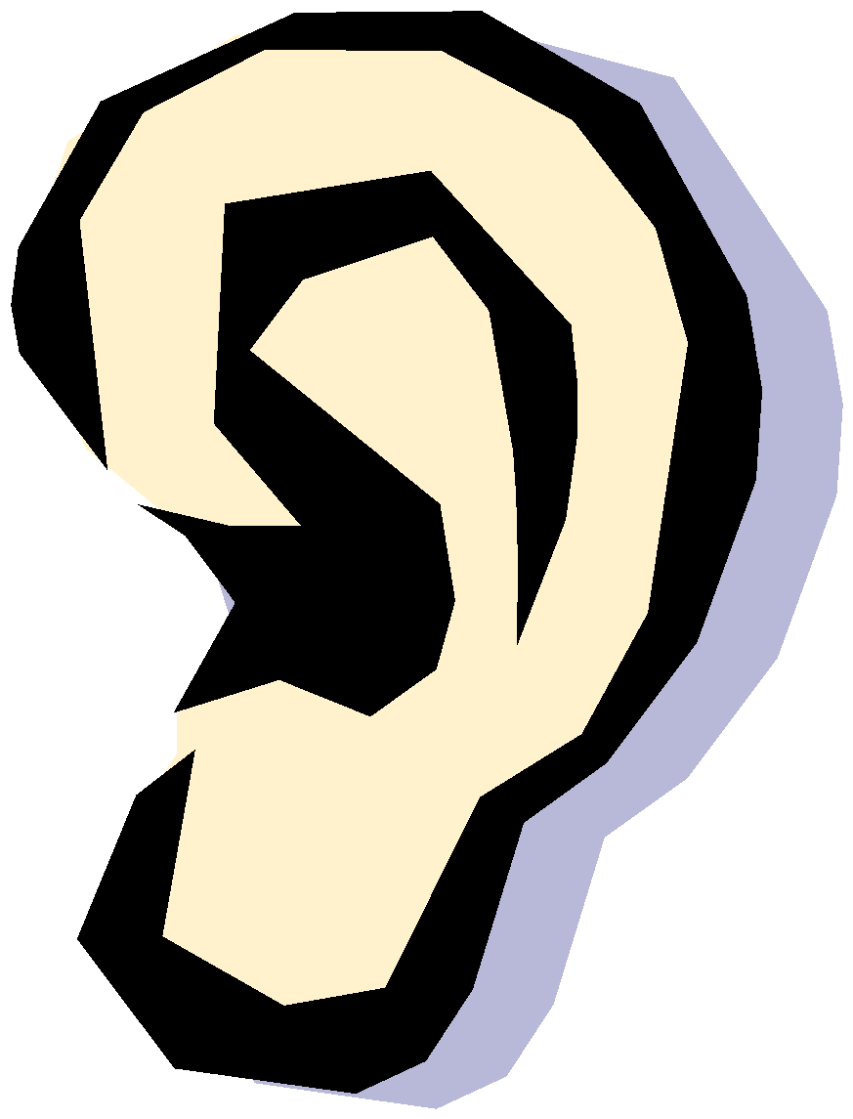
Listening Task ‘Can’t buy me Love’

Another band that was made famous in the 1960’s was the Rolling Stones
Their most famous hit was ‘Satisfaction’ which was a blend of soul, blues-based instrumentation and aggressive lyrics. This marked the end of British R & B (Rhythm & Blues) and began the age of rock.
Listening Task ‘Satisfaction’

Motown music was also around in the 1960’s. It was sometimes known as soul. Motown artists wore suits and sequined dresses. Artists included Martha and The Vandellas, The Temptations, Marvin Gaye, Smokey Robinson, The Supremes, The Four Tops and Gladys Knight and The Pips. The music had a distinctive loud, punchy, syncopated bass line.
Listening task 3 Motown music

