Blues and Jazz Instruments Quiz

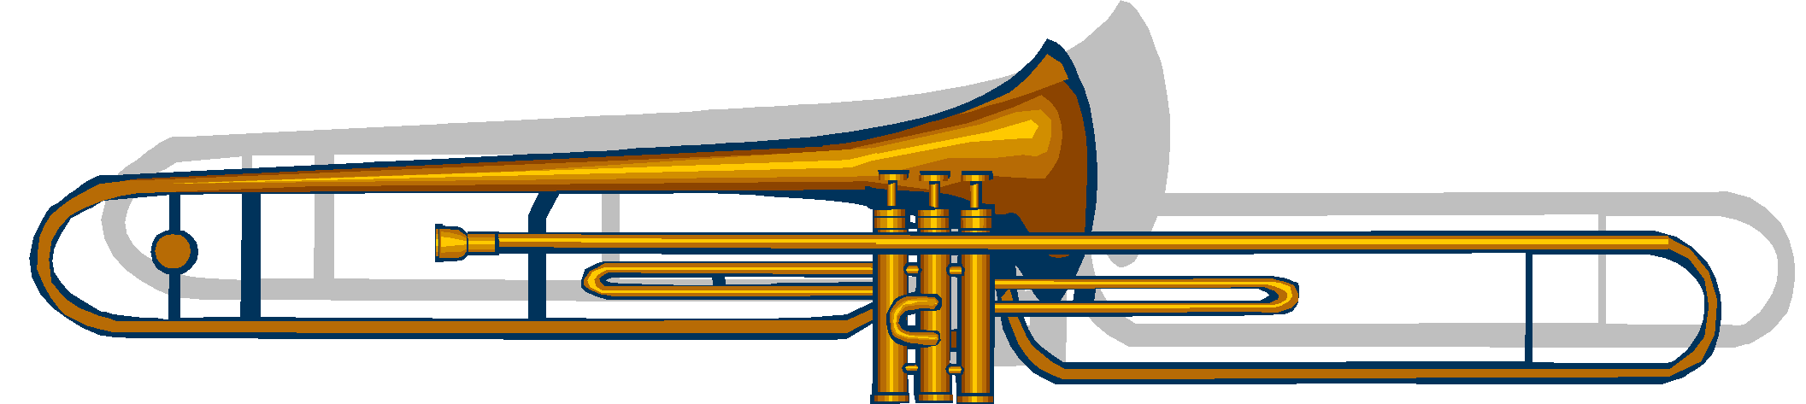
Listen to the examples of Blues / Jazz Instruments, guess the instrument and match it to the picture by drawing an arrow.
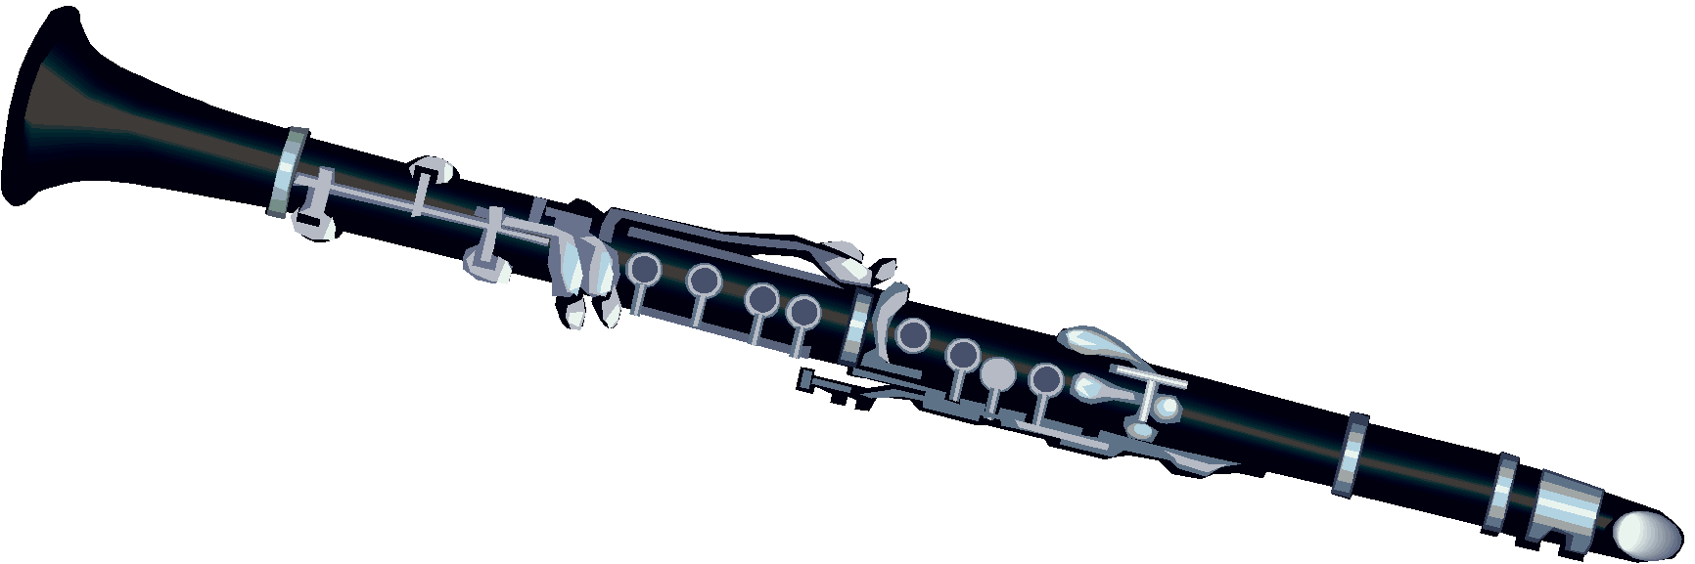

1.________________________________________

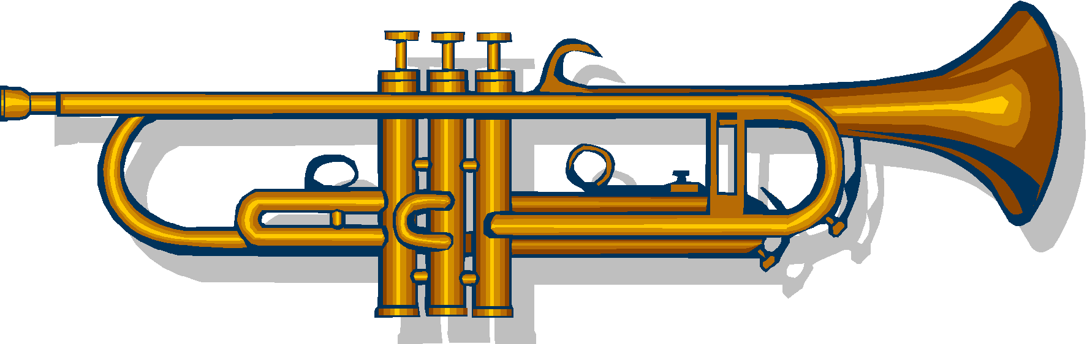
2.________________________________________

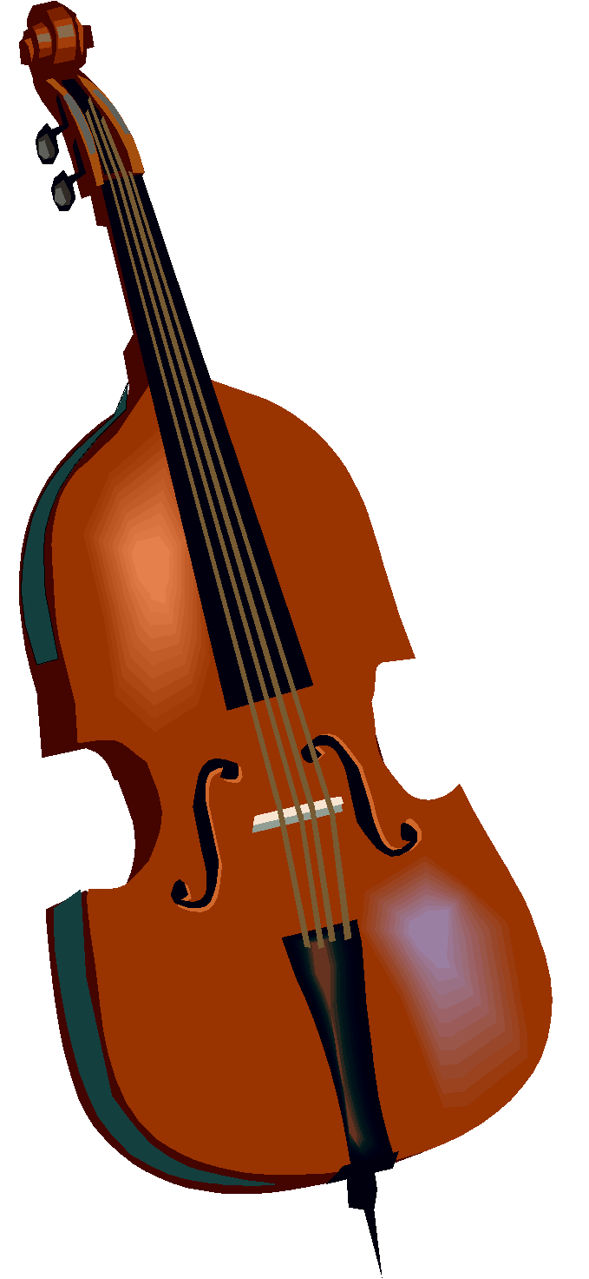
3. ________________________________________

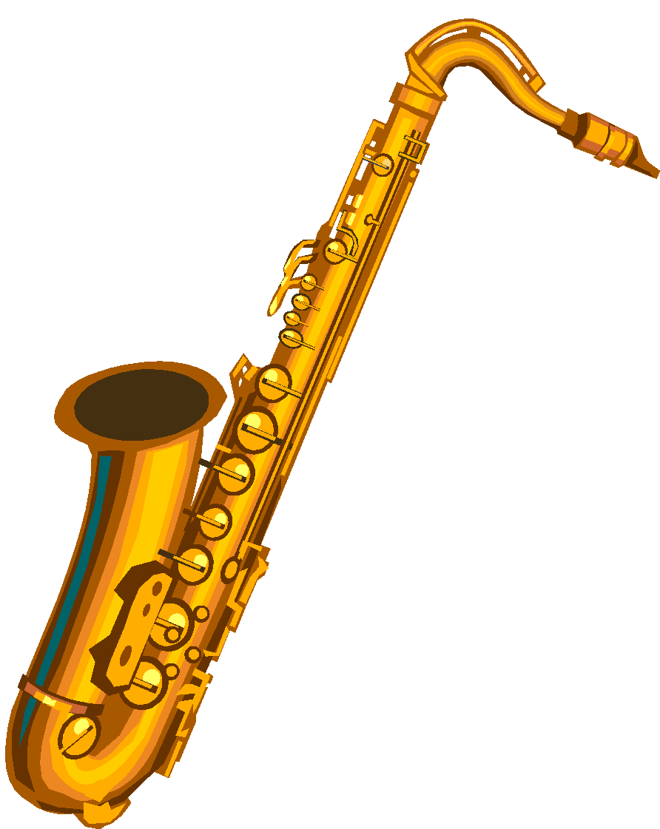
4. ________________________________________

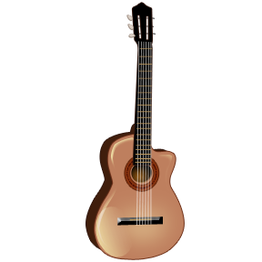
5. ________________________________________

6.________________________________________

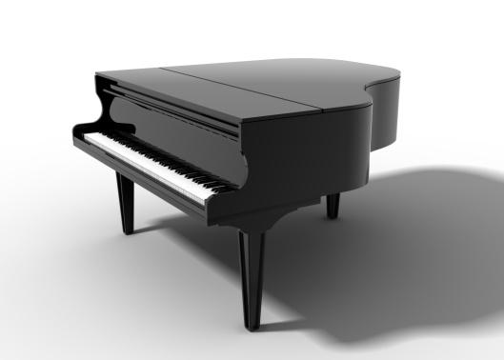
7.________________________________________

