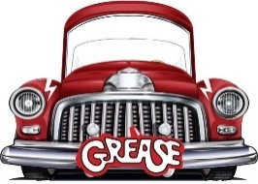
Lesson 1
GO Task: Complete the Grease word search.
Golden Question: What happens in Grease the Musical?
S | D | K | E | N | I | C | K | I | E | G | S
X | C | S | H | G | I | J | O | P | T | U | R
R | D | A | Q | W | C | V | F | H | M | I | G
A | A | N | D | W | E | B | R | M | T | Y | N
E | R | D | A | N | N | Y | E | Q | Z | S | A
Y | H | Y | K | L | M | R | I | Z | Z | O | N
R | N | B | A | E | N | E | I | G | G | F | W
O | I | O | L | I | G | H | T | N | I | N | G
I | D | G | G | R | T | S | E | S | T | I | O
N | C | H | C | E | R | I | O | P | K | S | F
E | T | R | Y | D | E | L | L | H | I | G | H
S | R | Y | D | L | O | I | N | B | N | F | R

SANDY RIZZO RYDELL HIGH SUMMER NIGHTS
DANNY KENICKIE LIGHTNING SENIOR YEAR

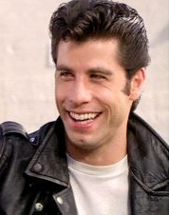
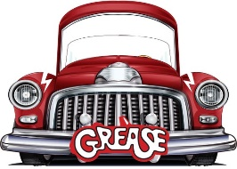
Lesson 2
GO Task: Complete the character match-up.
Golden Question: What happens at the end of Grease the Musical?
KENICKE
FRENCHY
DOODY
RIZZO
DANNY
MARTY
SONNY
SANDY
ROGER
JAN

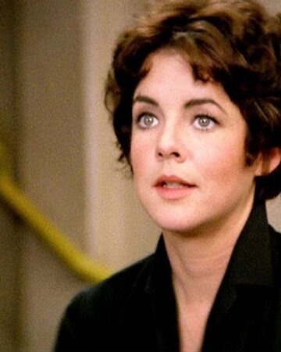
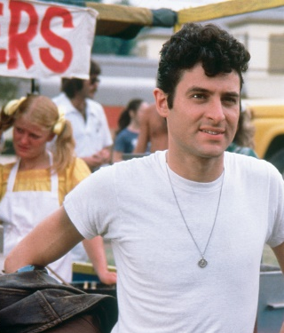
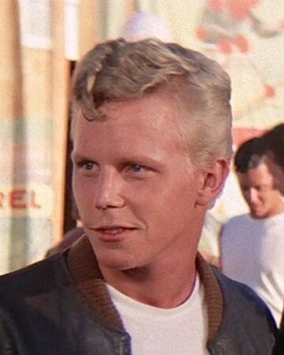
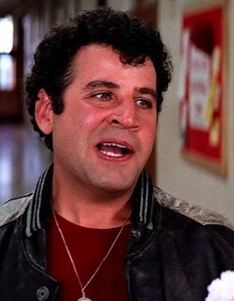
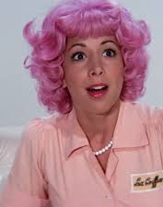
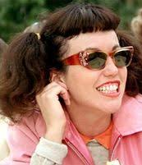
Lesson 3
GO Task: Answer the questions in the Grease Quiz.
Golden Question: What is included in a theatre review?

- What school is the musical set in?
______________________________________________________________________
- Who sings ‘Hopelessly Devoted to You’?
______________________________________________________________________
- Which Pink Lady has a pregnancy scare?
______________________________________________________________________
- How many times does Frenchie change her hair colour throughout the film?
______________________________________________________________________
- Which of the T-Birds plays guitar?
______________________________________________________________________
- What is the name of the car that the T-Birds race in at Thunder Road?
______________________________________________________________________
- Who hosts the High School dance contest that is broadcast live on TV?
______________________________________________________________________
- Who sings ‘There Are Worse Things I Could Do’?
______________________________________________________________________
- What is the name of the school’s Principal?
______________________________________________________________________
- What makes Sandy sick at the Pink Ladies sleepover?
______________________________________________________________________

GREASE THEATRE REVIEW
Personal response:
Was I stimulated, provoked, inspired, angered, entertained, upset, bored, amused etc during this musical? Why?
_______________________________________________________________________________________________________________________________________________________________________________________________________________________________________________________________________________________________________________________________________________________________________________________

Did I enjoy the musical? Why/why not?
_______________________________________________________________________________________________________________________________________________________________________________________________________________________________________________________________________________________________________________________________________________________________________________________

What would I rate this musical out of 10?
___________________________________________________________________________

What were the best and worst aspects of the production?
Best aspects | Worst aspects

The plot:
What was the musical about?
_______________________________________________________________________________________________________________________________________________________________________________________________________________________________________________________________________________________________________________________________________________________________________________________
____________________________________________________________________________________________________________________________________________________________________________________________________________________________________________________________________________________________________________

Who were the main characters?
______________________________________________________________________________________________________________________________________________________

Was there a major theme in the play? (e.g. love, hate, family, religion etc). Give examples of this from throughout the musical: _______________________________________________________________________________________________________________________________________________________________________________________________________________________________________________________________________________________________________________________________________________________________________________________

Was the ending or plot predictable? Why/why not?
_______________________________________________________________________________________________________________________________________________________________________________________________________________________________________________________________________________________________________________________________________________________________________________________
Who was your favourite character? Why?
____________________________________________________________________________________________________________________________________________________________________________________________________________________________________________________________________________________________________________

Who was your least favourite character? Why?
____________________________________________________________________________________________________________________________________________________________________________________________________________________________________________________________________________________________________________

The costumes:
What were the costumes like? Draw a costume for a Pink Lady and a T-Bird – add labels.

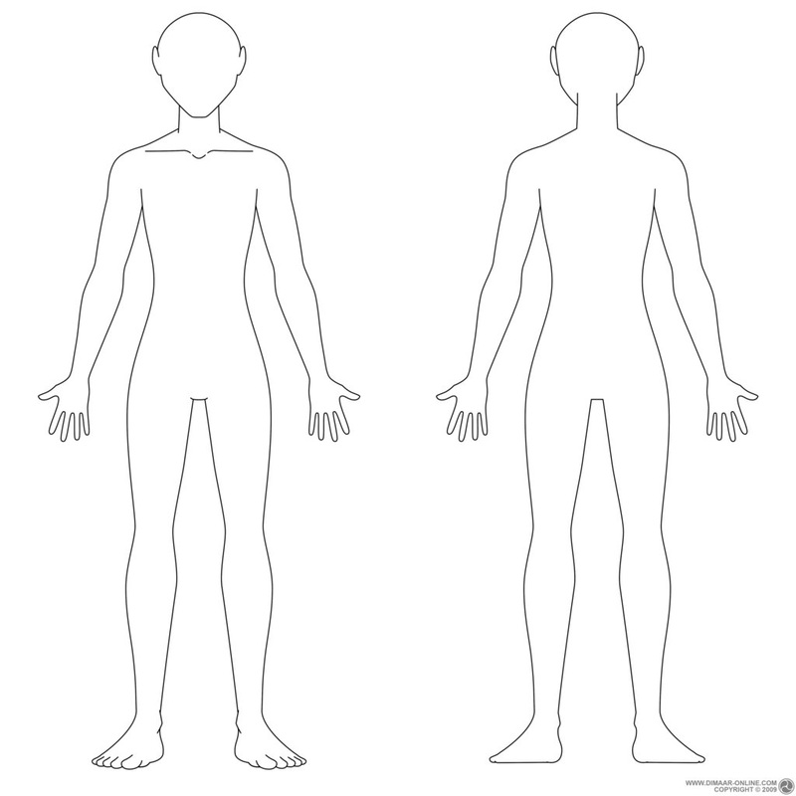

Dialect is language that is used in a specific region or by a specific social group. In Grease, the language is full of Americanisms. Find the definitions for the following words:

Jeez
______________________________________________________________________________

Baggin’ it
______________________________________________________________________________

Luggin’
______________________________________________________________________________

Cram it
______________________________________________________________________________

Lip
______________________________________________________________________________

Chick
______________________________________________________________________________

Barf
______________________________________________________________________________

Clod
______________________________________________________________________________

Shakin’
______________________________________________________________________________
Chlorax
______________________________________________________________________________

Lesson 4
GO Task: Using your knowledge organiser, find the definitions for the following words.
Golden Question: What is dialect and how is it used in Grease?
GREASE SCRIPT
SCENE: The high school cafeteria. JAN and MARTY enter wearing their Pink Ladies jackets and carrying trays, JAN’S loaded with food. As each female character enters, she joins the others at one large table.
JAN: Jeez, I wish it was still summer. Look, it’s only a quarter after twelve and I feel like I been here a whole year already.
MARTY: Yeah, what a drag. Hey, you wanna sit here?
LORI: Yeah, Rizzo’s coming, and Frenchy’s bringing that new chick.
MARTY: Huh. You want my coleslaw?
JAN: I’ll see if I have room for it.
MARY-JO: Hey Rizzo, Over Here
RIZZO: Hey, hey, hey! Where’s all the guys?
JAN: Those slobs. You think they’d spend a dime on their lunch? They’re baggin’ it.
RIZZO: Pretty cheap.
Lights fade on the cafeteria, come up on ROGER and DOODY sitting on the school steps.
DOODY: Hey, Rump, I’ll trade you a sardine for a peanut butter and jelly.
ROGER: I ain’t eating one of those things. You had ‘em in your ice box since last Easter.
KENICKIE: Hey! Where you at?
ROGER: Hey, Kenickie. What’s happening?
DOODY: Hey, Kenickie!
ROGER: Hey, Knicks, where were ya’ all summer?
KENICKIE: Luggin’ boxes at Bargain City.
DOODY: WOOOO!
ROGER: Nice job!
KENICKIE: Hey, cram it! I’m saving up to get me some wheels.
ROGER: You gettin’ a car, Kenicks?
DOODY: Hey, cool! What kind?
KENICKIE: I don’t know what kind yet, moron. But I got a name all picked out. “Greased Lightnin!”
ROGER: Oh, nifty!
ROGER does pig snorts, DOODY laughs, SONNY enters wearing wraparound sunglasses. As he enters, he pulls a class schedule out of his pocket.
ROGER: Hey, whattaya say, Sonny?
SONNY: Drop dead! I got Old Lady Lynch for English again. She hates my guts.
ROGER: Nah, she thinks you’re cute, Sonny. That’s why she keeps puttin’ ya back in her class.
SONNY: Yeah, well this year she’s gonna wish she never seen me.
KENICKIE: Oh, yeah?
SONNY: I’m just not gonna take any of her lip, that’s all. I don’t take that jive from nobody.
MISS LYNCH enters.
LYNCH: What’s all the racket out here?
DOODY: Hi, Miss Lynch.
ROGER: Hello, Miss Lynch.
LYNCH: Aren’t you supposed to be in class right now?
SONNY: Yes, Ma’am.
DOODY AND ROGER: Yes, Ma’am.
LYNCH: That’s a fine way to start the new semester, Mr. LaTierri.
DODDY AND ROGER: Mr. LaTierri.
LYNCH: Well? Are you going to stand there all day?
SONNY: No, Ma’am.
DOODY AND ROGER: No, Ma’am.
LYNCH: Then move!
SONNY: Yes, Ma’am.
LYNCH exits.
DOODY AND ROGER: Yes, Ma’am.
ROGER: I’m sure glad she didn’t give you any “lip”, Son. You would have really told her off, right?
SONNY: Shaddup!
Lights fade on bleachers and up again on benches.
MARTY: Jan, who’s that chick with Frenchy? Is she the one you were tellin’ me about?
JAN: Yeah, her name’s Sandy. She seems pretty cool. Maybe we could let her in the Pink Ladies.
RIZZO: Just what we need. Another chick hangin’ around.
FRENCHY and SANDY enter, carrying trays.
FRENCHY: Hi, you guys. This is my new next-door neighbor, Sandy Dumbrowski. This here’s Rizzo and that’s Marty and you remember Jan.
JAN: Sure. Hi.
SANDY: Hi. Pleased to meet you.
FRENCHY: Come on, sit down.
RIZZO: How long you been livin’ around here?
SANDY: Since July. My father just got transferred here.
JAN: You gonna eat your coleslaw, Sandy?
SANDY: It smells kinda funny.
FRENCHY: Wait’ll you have the chipped beef. Better known as “Barf on a Bun.”
LORI: How do you like the school so far, Sandy?
SANDY: Oh, it seems real nice.
PATTY: Hi, kids!!!
RIZZO: Look who’s comin’. Patty Simcox, the Little Lulu of Rydell High.
ALL: Oh no!!!
PATTY enters in cheerleader outfit.
PATTY: Well, don’t say hello.
RIZZO: We won’t.
PATTY: Is there room at your table?
MARTY: Oh, yeah, move over, French.
PATTY: Oh, I just love the first day of school, don’t you?
RIZZO: It’s the biggest thrill of my life.
PATTY: You’ll never guess what happened this morning.
RIZZO: Prob’ly not.
PATTY: Well, they announced this year’s nominees for the Student Council, and guess who’s up for Vice- President?
MARTY: Who?
PATTY: Me! Isn’t that wild?
RIZZO: Wild.
PATTY: Oh, you must think I’m a terrible clod! I never even bothered to introduce myself to your new friend.
SANDY: Oh, I’m Sandy Dumbrowski.
PATTY: It’s a real pleasure, Sandy. We certainly are glad to have you here at Rydell.
SANDY: Thanks.
Lights fade on GIRLS, come up on GUYS on the steps.
DOODY: Hey, ain’t that Danny over there?
SONNY: Where?
DOODY: HEY, DANNY! WHATCHA DOIN’?
ROGER: That’s good, Dood. Play it real cool.
DANNY: Hey, you guys, what’s shakin’?
DOODY: Where ya’ been all summer, Danny?
DANNY: Well, I spent a lot of time down at the beach.
KENICKIE: Hey, didja meet any new chicks?
DANNY: Nah.
ALL: Come on, Zuko...
DANNY: Just met this one that was sorta cool, ya know?
ALL: Oh, yeah.
DANNY: You don’t want to hear all the mushy details, anyway.
SONNY: Sure we do! Let’s hear a little!
GUYS join in playfully mauling DANNY as the lights fade on them and come back up on the GIRLS at the cafeteria table.
SANDY: I spent most of the summer down at the beach.
MARY-JO: What for? We got a brand new pool right in the neighborhood. It’s real nice.
RIZZO: Yeah, if ya’ like swimmin’ in Clorox.
SANDY: Well—actually, I met a boy there.
MARTY: You hauled your cookies all the way to the beach for some guy?
SANDY: This was sort of a special boy.
RIZZO: Are you kiddin’? There ain’t no such thing.

Lesson 5
GO Task: Label the working stage areas on the diagram below.
Golden Question: How would you design a set for the musical Grease?
Centre stage
Upstage
Downstage
Stage left
Stage right
Wings
Rydell High

Greased Lightning Garage
Character Name Unscramble

Andyn Kuzo
____________________________________________________________________

Ysnad Dbumrisko
____________________________________________________________________

Izorz
____________________________________________________________________

Nekiikce
____________________________________________________________________

Ssim Ylchn
____________________________________________________________________

Ccaoh Lcalhaan
____________________________________________________________________
Lesson 6
GO Task: Unscramble the character’s names.
Golden Question: How do the characters differ in the musical?
Choose two characters from the musical and compare them using the Role on the Wall worksheets. Put facts about the character on the outside and words to describe their personality on the inside.

Write a new scene for the musical which involves the characters you have analysed and compared. The scene must take place at Rydell High, involve only two characters and last one page. Make sure you follow the structure of a script.
_______________________________________________________________________________________________________________________________________________________________________________________________________________________________________________________________________________________________________________________________________________________________________________________
____________________________________________________________________________________________________________________________________________________________________________________________________________________________________________________________________________________________________________
_______________________________________________________________________________________________________________________________________________________________________________________________________________________________________________________________________________________________________________________________________________________________________________________
____________________________________________________________________________________________________________________________________________________________________________________________________________________________________________________________________________________________________________
_______________________________________________________________________________________________________________________________________________________________________________________________________________________________________________________________________________________________________________________________________________________________________________________
____________________________________________________________________________________________________________________________________________________________________________________________________________________________________________________________________________________________________________
_______________________________________________________________________________________________________________________________________________________________________________________________________________________________________________________________________________________________________________________________________________________________________________________
____________________________________________________________________________________________________________________________________________________________________________________________________________________________________________________________________________________________________________
______________________________________________________________________________________________________________________________________________________
Character I would like to play: __________________________________________

Memory Machine
1.
2.
3.
4.
5.
6.
7.
8.
9.
10.
11.
12.
13.
14.
15.
16.
17.
18.
19.
20.
21.
Lesson 6
GO Task: Read through the script and decide which character you would like to play.
Golden Question: What is the most successful way to learn lines?

Techniques for learning lines:

