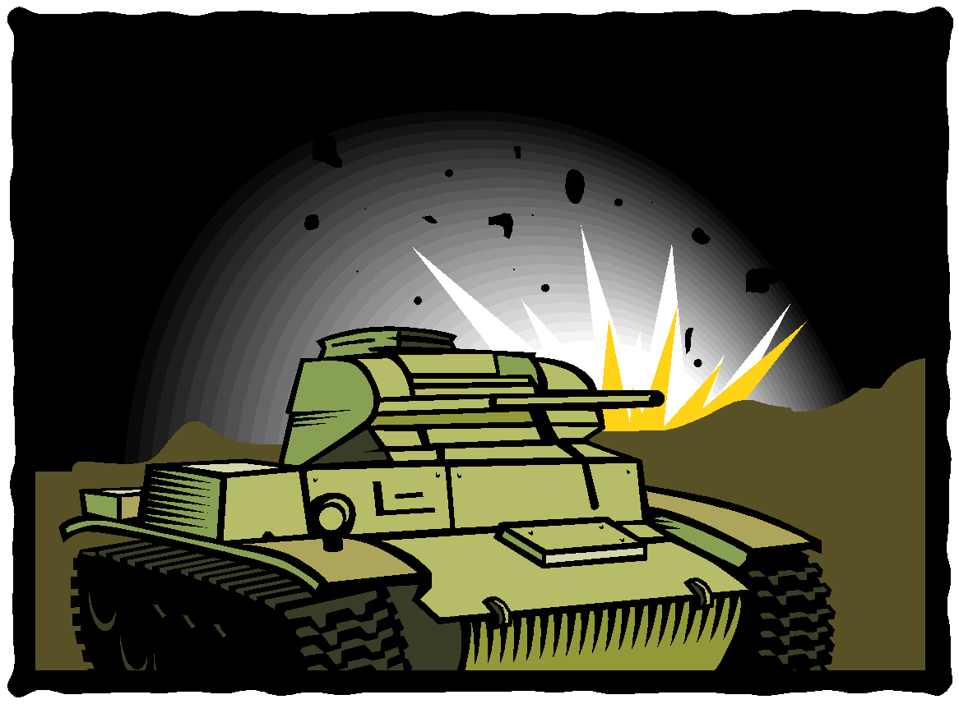
Music and War

Music has always played an important part in war.
- Instruments like bugles and drums were used to pass signals and messages on the battlefield.
- Songs were written to describe the horrors of war, to try and stop wars and to show the pointlessness of them.
- Music has been written for films about war.
- Music has been written for soldiers to march into battle.
- Music has been written to commemorate war.

The last post is a fanfare to commemorate war played on Remembrance Day every November 11th.

Answer the following questions:

- Why is the Last Post so important when commemorating war?

________________________________________________________________

________________________________________________________________

- What type of music was listened to in the 1930’s and 1940’s during World War II?

________________________________________________________________

- What instruments are in this type of band?

________________________________________________________________

________________________________________________________________

________________________________________________________________

- Who was Vera Lynn and what was her famous song?

________________________________________________________________

________________________________________________________________

