RAP AND HIP HOP
The Sugarhill Hill Gang! - Rappers Delight
Rap music uses a lot of slang. What is slang?
Find and circle all the slang words in this rap below:
BIG MAC RAP!
I need double Cheese burger and hold lettuce....
Don’t be frontin’ son
No seeds on the bun.
We be up in this drive thru
Order for two....
I got the cravin for a number nine
Lock my shoe.
We need some chicken up in here
In this dizzle
For rizzle my mizzle
Extra salt on the brizzle.
Docta Peppa my brotha,
anotha for ya motha
Double Double supersize and don’t forget the fries!

I said a hip hop the hippie the hippie
to the hip hip hop, a you dont stop
the rock it to the bang bang boogie say up jumped the boogie
to the rhythm of the boogie, the beat
now what you hear is not a test I'm rappin to the beat
and me, the groove, and my friends are gonna try to move your feet
see i am wonder mike and i like to say hello to the black, to the white, the red, and the brown, the purple and yellow
but first i gotta bang bang the boogie to the boogie
say up jump the boogie to the bang bang boogie
let's rock, you dont stop, like the rhythm that’ll make your body rock
The Sugarhill Gang is an American hip hop trio.
Their 1979 hit "Rapper's Delight" was the first
rap single to become a Top 40 hit on the
Billboard Hot 100.

"Hopeful" – Bars & Melody
Oh-oh-oh Check it out
Oh no Here we go
Verse 1
Please help me God, I feel so alone, I'm just a kid, how can I take it on my own
I've cried too many tears, yeah, writing this song, Trying to fit in, where do I belong?
I wake up every day, don't wanna leave my home, My momma's askin' me why I'm always alone
Too scared to say, too scared to holler, I'm walking to school with sweat around my collar
I'm just a kid, I don't want no stress, My nerves are bad, my life's a mess
The names you call me, they hurt real bad, I want to tell my Mom
She's havin' trouble with my Dad, I feel so trapped, there's nowhere to turn come to school
Don't wanna fight I wanna learn
So please mister Bully Tell me what I've done
You know I have no Dad I'm livin' with my Mom
Chorus
Just be hopeful, yes I am
Hopeful for today
Take this music and use it
Let it take you away
And be hopeful, hopeful
And He'll make a way
I know it ain't easy but that's okay
Just be hopeful
Verse 2
Why do you trip every single day? I didn't ask to be born but now I have to pay
I ain't got no money, you take all I have When I give it to you, I search through my bags
I feel so scared when you shut me down You kick me, punch me, throw me to the ground
When I ask you, yo, what have I done? You hit me again, and make fun of my Mom!
Chorus

Verse 3
What I wear is all I have We lost our home, I'm livin' from a bag
Yo mister Bully, help me please I'm flesh and blood, accept me please
Hey mister Bully, I don't know what to do My mind, it can't explain what I did to you
Mister Bully, take in all my please Every single day you bring me to my knees
Chorus

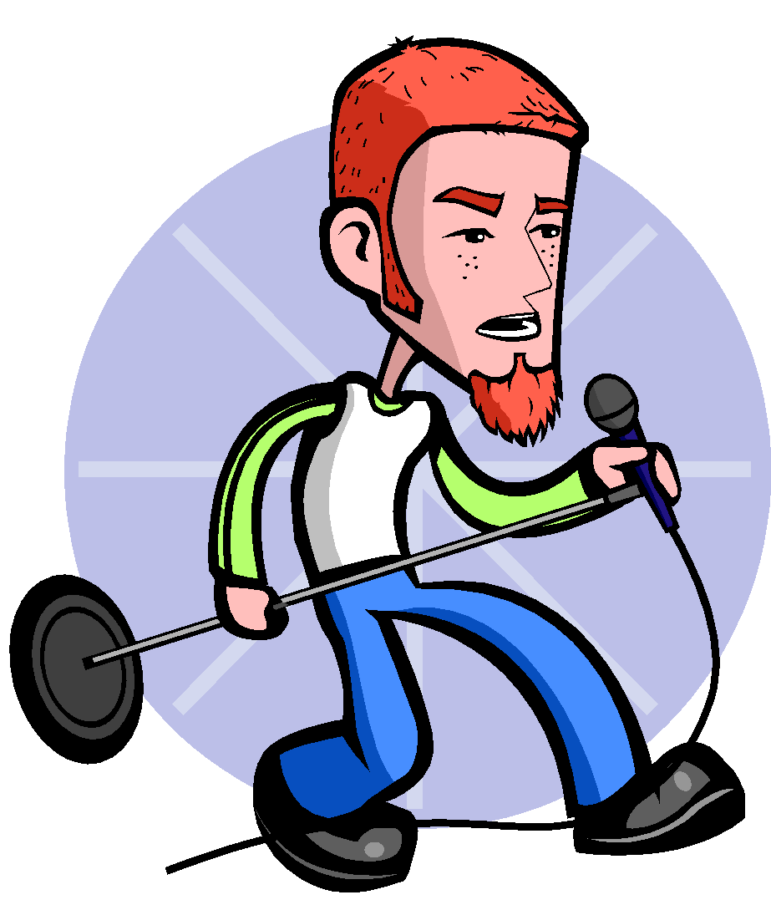
Group Rap
Remember:
- Use some rhyming
- Make sure it fits into a beat
- The lyrics do not have to make sense all the time – you can use slang words!
Rap
_____________________________________________________________________________________
_____________________________________________________________________________________
_____________________________________________________________________________________
_____________________________________________________________________________________
_____________________________________________________________________________________
_____________________________________________________________________________________
_____________________________________________________________________________________
_____________________________________________________________________________________
_____________________________________________________________________________________
_____________________________________________________________________________________
_____________________________________________________________________________________
_____________________________________________________________________________________
_____________________________________________________________________________________
_____________________________________________________________________________________
_____________________________________________________________________________________
_____________________________________________________________________________________
_____________________________________________________________________________________
_____________________________________________________________________________________
_____________________________________________________________________________________
_____________________________________________________________________________________
_____________________________________________________________________________________
_____________________________________________________________________________________

