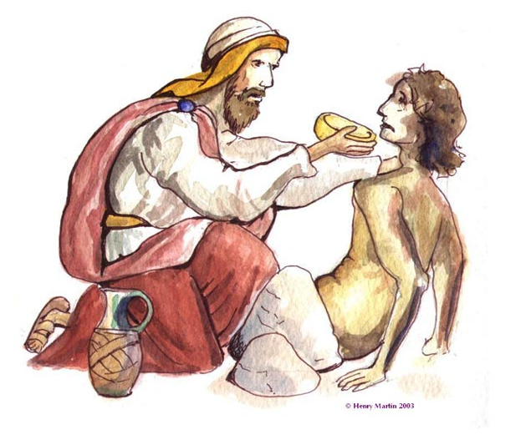

The Samaritan took some water and cleaned the man’s eyes and gave him something to drink.

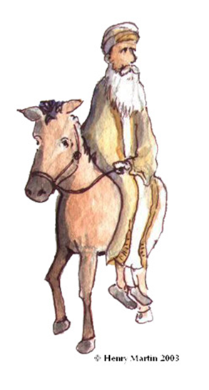

The religious leader thought, ‘Oh, he looks terrible. But, I’m sure he’s no one I know.’

And he passed him by as well.

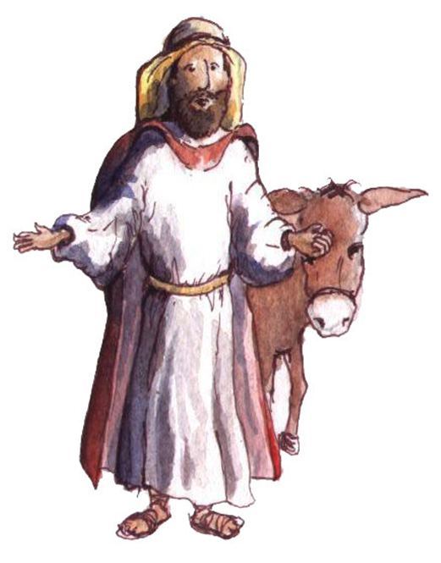

The robbers attacked the man, beat him up and stole everything he had, even his clothes.

The man could barely raise his head to beg for help but the priest only backed away.

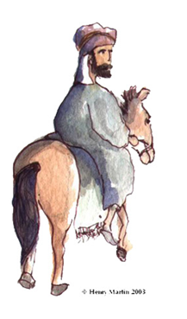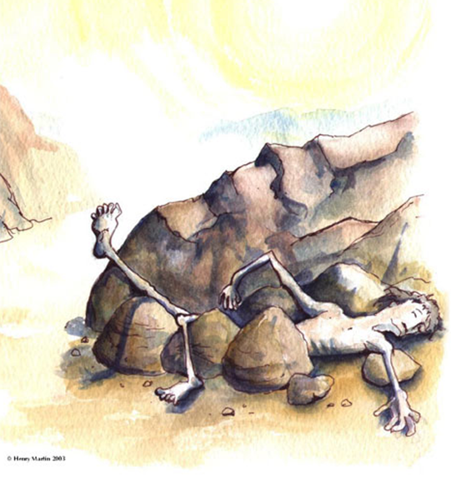

The Samaritan came over to the man lying on the side of the road.

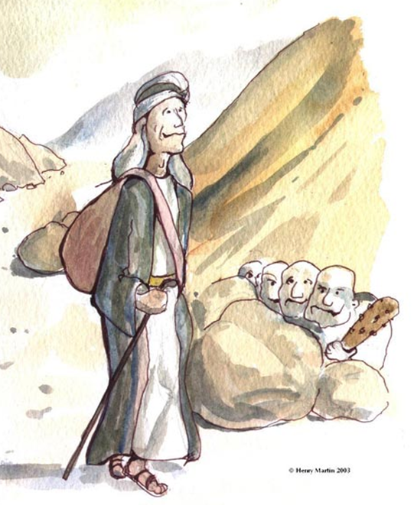

There once was a man walking a very long way.