**Types of Numbers**

**Things to remember:**

* A factor is a whole number that divides exactly into another number.
* A multiple is a number that may be divided by another a certain number of times without a remainder.
* A prime number only has 2 factors – 1 and itself.
* A power tells us how many times the base number has been multiplied by itself
* A root is the opposite of a power.
* A square number is the result of multiplying an integer (whole number) by itself.

**Questions:**

**1.** (a) Write down the square of 8

…………………….

**(1)**

(b) Write down the value of 10³

…………………….

**(1)**

(c) Estimate the value of $\sqrt{20}$

…………………….

**(1)**

**(Total for Question is 3 marks)**

**2.** Here is a list of eight numbers: 4 5 14 25 29 30 33 39 40

From the list, write down

1. a factor of 20

…………………….

(ii) a multiple of 10

…………………….

(iii) the prime number that is greater than 15

…………………….

**(Total for Question is 3 marks)**

**3.** Express 180 as a product of its prime factors.

…........................................................

**(Total for Question is 3 marks)**

**4.** (a) Write down the value of 7²

…………………….

**(1)**

(b) Write down the value of $\sqrt{25}$

…………………….

**(1)**

(c) Write down the value of 2³

…………………….

**(1)**

**(Total for Question is 3 marks)**

**5.** (a) Write down the value of $\sqrt{81}$

…………………….

**(1)**

(b) Work out the value of 5² + 2³

…………………….

**(2)**

**(Total for Question is 3 marks)**

**6.** Here is a list of numbers:

2 3 10 12 15 16 24

From the list write down

1. an odd number

…………………….

**(1)**

(b) a multiple of 6

…………………….

**(1)**

(c) a factor of 18

…………………….

**(1)**

**(Total for Question is 3 marks)**

**7.** Here is a list of numbers.

2 3 5 8 10 16 21 24

From the numbers in the list,

(a) write down an odd number

…………………….

**(1)**

(b) write down the square number

…………………….

**(1)**

(c) write down the number which is a multiple of 6

…………………….

**(1)**

**(Total for Question is 3 marks)**

**8.** Here is a list of numbers.

1 2 4 5 7 11 13 14 15 17

From the list, write down three different prime numbers that add together to make 20

…........................................................

**(Total for Question is 3 marks)**

**Place Value**

**Things to remember:**

Label columns as below

|  |  |  |  |  |  |  |
| --- | --- | --- | --- | --- | --- | --- |
| Thousands | Hundreds | Tens | Units | $$\frac{1}{10}$$ | $$\frac{1}{100}$$ | $$\frac{1}{1000}$$ |

**Questions:**

**1.** (a) Write the number **seven thousand and twenty five** in figures.

…........................................................

**(1)**

(b) Write the number 9450 in words.

…………………………………………………………………………………………………..

**(1)**

(c) Write the number 28.75 to the nearest whole number.

…........................................................

**(1)**

(d) Write the number 7380 to the nearest thousand.

…........................................................

**(1)**

**(Total for Question is 4 marks)**

**2.** Write down the value of the 3 in the number 4376

…........................................................

**(Total for question = 1 mark)**

**3.** Write down the value of the 3 in 16.35

…........................................................

**(Total for question is 1 mark)**

**4.** (a) Work out 90 ÷ 10

…........................................................

**(1)**

(b) Write these numbers in order of size. Start with the smallest number.

2.8 4.71 0.6 13.4

…………………………………………………………………………………………………..

**(1)**

(c) Write 7⁄10 as a decimal.

…........................................................

**(1)**

**(Total for Question is 3 marks)**

**5.** (a)  Write these numbers in order of size. Start with the smallest number.

3517 7135 5713 1357

…………………………………………………………………………………………………..

**(1)**

(b)   Write these numbers in order of size. Start with the smallest number.

0.354 0.4 0.35 0.345

…………………………………………………………………………………………………..

**(1)**

**(Total for Question is 2 marks)**

**6.** Here are four cards. There is a number on each card.



(a)   Write down the largest 4-digit even number that can be made using each card only

once.

…........................................................

**(2)**

(b)   Write down all the 2-digit numbers that can be made using these cards.

…………………………………………………………………………………………………..

**(2)**

**(Total for question is 4 marks)**

**7.** (a)   Write these numbers in order of size. Start with the smallest number.

3007           4435           399           4011           3333

…………………………………………………………………………………………………..

**(1)**

(b)   Write these numbers in order of size. Start with the smallest number.

3.7           5.62           0.7           14.3

…………………………………………………………………………………………………..

**(1)**

(c)   Write $\frac{9}{10}$ as a decimal.

…........................................................

**(1)**

**(Total for question = 3 marks)**

**8.** Write the following numbers in order of size. Start with the smallest number.

0.61           0.1           0.16           0.106

…………………………………………………………………………………………………..

**(Total for question = 1 mark)**

**Directed Numbers**

**Things to remember:**

* Mixed means minus!
* Use a number line – if you’re adding you need to move in a positive direction (right), if you’re subtracting you need to move in a negative direction (left).

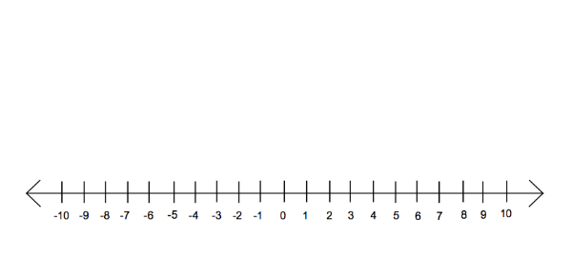

**Questions:**

**1.** Here is a map of the British Isles.

The temperatures in some places, one night last winter are shown on the map.

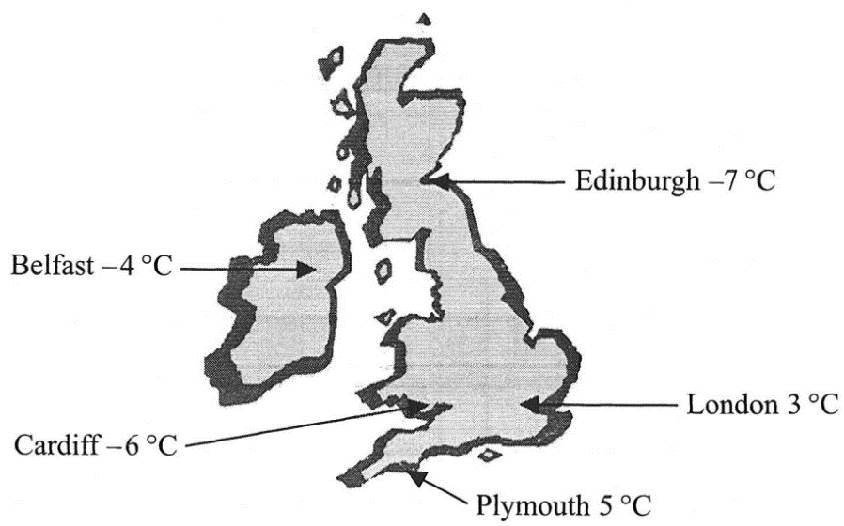

(a) (i) Write down the names of the two places that had the biggest difference in

temperature.

…........................................................

…........................................................

(ii) Work out the difference in temperature between these two places.

….........................°C

**(3)**

(b) Two pairs of places have a difference in temperature of 2 °C.  
Write down the names of these places.

(i) …......................................... and ….............................................

(ii) …......................................... and ….............................................

**(2)**

**(Total 5 marks)**

**2.** Sally wrote down the temperature at different times on 1st January 2003.

|  |  |
| --- | --- |
| **Time** | **Temperature** |
| midnight | – 6 °C |
| 4 am | –10 °C |
| 8 am | – 4 °C |
| noon | 7 °C |
| 3 pm | 6 °C |
| 7 pm | –2 °C |

(a) Write down

(i) the **highest** temperature,

….........................°C

(ii) the **lowest** temperature.

….........................°C

**(2)**

(b) Work out the difference in the temperature between

(i) 4 am and 8 am,

….........................°C

(ii) 3 pm and 7 pm.

….........................°C

**(2)**

At 11 pm that day the temperature had fallen by 5 °C from its value at 7 pm.

(c) Work out the temperature at 11 pm.

….........................°C

**(1)**

**(Total 5 marks)**

**3.** The table shows the temperature on the surface of each of five planets.

|  |  |
| --- | --- |
| **Planet** | **Temperature** |
| Venus | 480 °C |
| Mars | – 60 °C |
| Jupiter | – 150 °C |
| Saturn | – 180 °C |
| Uranus | – 210 °C |

(a) Work out the difference in temperature between Mars and Jupiter.

….........................°C

**(1)**

(b) Work out the difference in temperature between Venus and Mars.

….........................°C

**(1)**

(c) Which planet has a temperature 30 °C higher than the temperature on Saturn?

…........................................................

**(1)**

The temperature on Pluto is 20 °C lower than the temperature on Uranus.

(d) Work out the temperature on Pluto.

….........................°C

**(1)**

**(Total 4 marks)**

**4.** (a) Write down the temperature shown on the thermometer.

….........................°C

**(1)**

The temperature falls by 8°C.

(b) Work out the new temperature.

….........................°C

**(1)**

**(Total 2 marks)**

**5.** The table shows the highest and lowest temperatures one day in London and Moscow.

|  |  |
| --- | --- |
| **Highest** | **Lowest** |
| London | 8°C | –6°C |
| Moscow | –3°C | –8°C |

(a) Work out the difference between the **lowest** temperature in London and the **lowest**temperature in Moscow.

….........................°C

**(1)**

(b) Work out the difference between the **highest** and **lowest** temperature in London.

….........................°C

**(1)**

**(Total 2 marks)**

**6.** The table shows the midday temperatures in 4 different cities on Monday.

|  |  |
| --- | --- |
| **City** | **Midday temperature (°C)** |
| Belfast | 5 |
| Cardiff | –1 |
| Glasgow | –6 |
| London | –4 |

(a) Which city had the lowest temperature?

…........................................................

**(1)**

(b) Work out the difference between the temperature in Cardiff and the temperature in Belfast.

….........................°C

**(1)**

By Tuesday, the midday temperature in London had risen by 7 °C.

(c) Work out the midday temperature in London on Tuesday.

….........................°C

**(1)**

**(Total 3 marks)**

**7.** Mr Snow stayed some time at the South Pole.

The highest temperature there was –30 °C.  
The lowest temperature there was –57 °C.

(a) Work out the difference between the highest temperature and the lowest temperature at the South Pole.

….........................°C

**(1)**

Mr Snow returned to his house in London.  
The temperature outside his house was –2 °C.  
The temperature inside his house was 12 °C higher.

(b) Work out the temperature inside his house.

….........................°C

**(1)**

**(Total 2 marks)**

**8.** Write these temperatures in order. Start with the lowest temperature.

7ºC –2ºC 10ºC –5ºC 3ºC

…………………………………………………………………………………………………..

**(Total for question = 1 mark)**

**Coordinates**



**Things to remember:**

Along the corridor, up the stairs 🡪 (x,y)

**Questions:**

**1.** (a) Write down the coordinates of the

point *P*.

(…....... , ….......)

**(1)**

(b) (i) On the grid, plot the point

(0, 3). Label the point *Q*.

(ii) On the grid, plot the point

(–2, –3). Label the point *R*.

**(2)**

**(Total 3 marks)**

**2.** (a) Write down the coordinates of the point

(i) *A*,

( ……… , …….. )

(ii) *B*.

( ……… , …….. )

**(2)**

(b) On the grid, mark with a cross (×) the midpoint

of the line *AB*.

**(1)**

**(Total 3 marks)**

**3.** (a) (i) Write down the coordinates of the

point A.

(……………,………….)

(ii) Write down the coordinates of the

point *B.*

(……………,………….)

**(2)**

(b) (i) On the grid, mark the point (6, 4) with

the letter *P.*

(ii) On the grid, mark the point (3, 0) with

the letter *Q.*

**(2)**

**(Total 4 marks)**

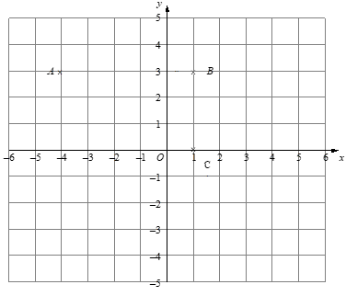**4.** (a) Write down the coordinates of

the point

1. *A*,

(…......... , ….........)

(ii) *C*.

(…......... , ….........)

**(2)**

(b) (i) On the grid, mark the

point *D* so that *ABCD*

is a rectangle.

(ii) Write down the

coordinates of *D*.

(…......... , ….........)

**(2)**

**(Total 4 marks)**

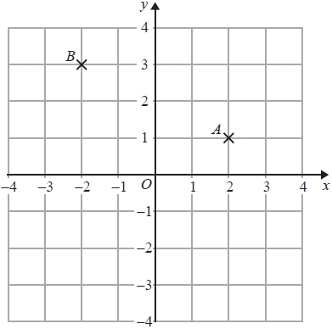**5.** (a)   Write down the coordinates of the point *A*.

(…......... , ….........)

**(1)**

(b)   Write down the coordinates of the point *B*.

(…......... , ….........)

**(1)**

(c)   On the grid, mark with a cross (×) the point

(−3, −1). Label this point *C*.

**(1)**

**(Total for question = 3 marks)**

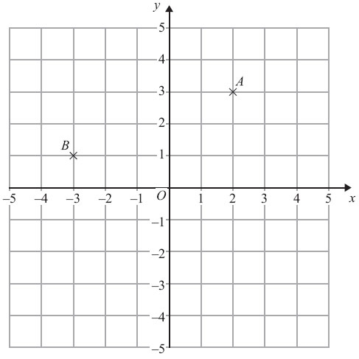

**6.** (a) (i) Write down the coordinates of

the point *A*.

(…......... , ….........)

(ii) Write down the coordinates of

the point *B*.

(…......... , ….........)

**(2)**

(b) On the grid, mark with a cross the

point (3, –4). Label this point *C*.

**(1)**

**(Total for Question is 3 marks)**

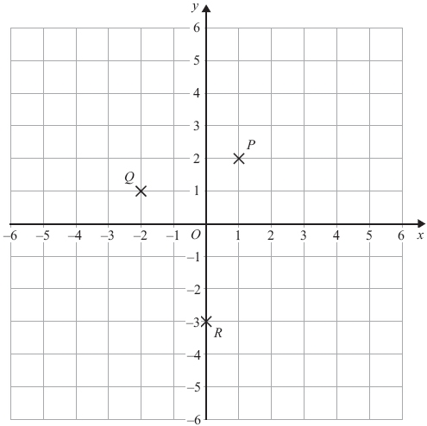**7.** (a) Write down the coordinates of

the point *P*.

(…......... , ….........)

**(1)**

(b) Write down the coordinates of

the point *R*.

(…......... , ….........)

**(1)**

*P*, *Q* and *R* are three vertices of a

parallelogram.

(c) Write down the coordinates of

the fourth vertex of this

parallelogram.

(…......... , ….........)

**(1)**

**(Total for Question is 3 marks)**

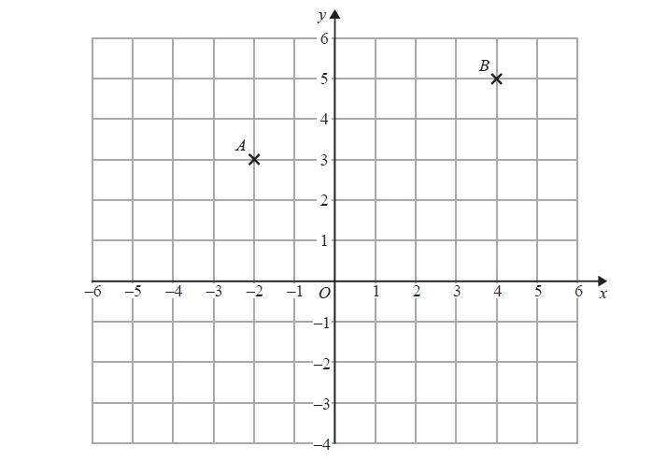

**8.** (a)   Write down the coordinates of

point *B*.

(…......... , ….........)

**(1)**

(b)   Find the coordinates of the

midpoint of *AB*.

(…......... , ….........)

**(1)**

**(Total for question = 2 marks)**

**Patterns and Sequences**

**Things to remember:**

* If there is a pattern, look carefully at how many sticks/blocks are being added on each time.
* Work out the rule (for example: add 4 or multiply by 2) to help you work out the next term.

**Questions:**

**1.** Here are some patterns made from sticks.

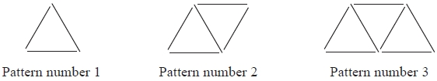

In the space below, draw Pattern number 4

**(1)**

(b) Complete the table.

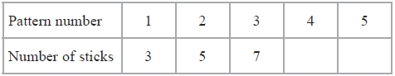

**(1)**

(c) How many sticks make Pattern number 15?

…........................................................

**(1)**

**(Total for Question is 3 marks)**

**2.** Here are the first four terms of a number sequence.

|  |  |  |  |
| --- | --- | --- | --- |
| 6 | 10 | 14 |  |

(a) Write down the next term in this sequence.

…........................................................

**(1)**

(b) Find the 10th term in this sequence.

…........................................................

**(1)**

(c) The number 101 is **not** a term in this sequence. Explain why.

…..................................................................................................................................

…..................................................................................................................................

**(1)**

**(Total for Question is 3 marks)**

**3.** Here are the first four terms of a number sequence.

3     7     11      15

(a) Write down the next term of this sequence.

…........................................................

**(1)**

The 50th term of this number sequence is 199

(b) Write down the 51st term of this sequence.

…........................................................

**(1)**

The number 372 is **not** a term of this sequence.

(c) Explain why.

…..................................................................................................................................

…..................................................................................................................................

**(1)**  
**(Total for Question is 3 marks)**

**4.** Here are some patterns made from white centimetre squares and grey centimetre squares.

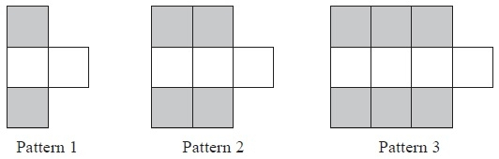

(a)   In the space below, draw Pattern 4

**(1)**

(b)   Find the number of grey squares in Pattern 6

…........................................................

**(1)**

A Pattern has 20 grey squares.

(c)  Work out how many white squares there are in this Pattern.

…........................................................

**(2)**

**(Total for Question is 4 marks)**