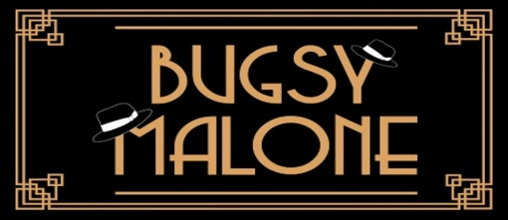
Lesson 1
GO Task: Complete the Bugsy Malone word search.
Golden Question: What happens in Bugsy Malone?
S | D | Y | S | G | U | B | D | R | T | G | S
X | C | F | H | G | I | J | O | P | T | S | P
F | D | A | Q | W | C | V | F | H | P | I | L
L | A | T | D | W | E | B | R | E | G | Y | U
A | R | S | Y | U | P | L | A | Q | A | S | R
P | H | A | K | L | M | K | V | G | N | B | G
P | N | M | A | E | E | E | I | G | G | F | E
E | I | O | T | A | L | L | U | L | A | H | G
R | D | G | S | R | T | S | E | S | T | I | U
S | C | Y | R | E | T | S | G | N | A | G | N
E | D | F | J | K | B | L | O | U | S | E | Y
E | R | Y | D | L | O | I | N | B | N | F | R

BUGSY TALLULAH GANGSTER SPEAKEASY
BLOUSEY FAT SAM FLAPPERS SPLURGE GUN

Lesson 2
GO Task: Complete the character match-up.
Golden Question: What happens at the end of Bugsy Malone?
FAT SAM
BLOUSEY BROWN
TALLULAH
DANDY DAN
BUGSY MALONE
FIZZY
LEROY

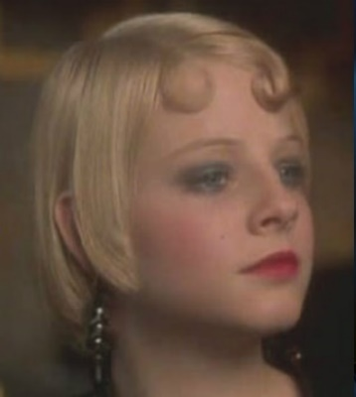
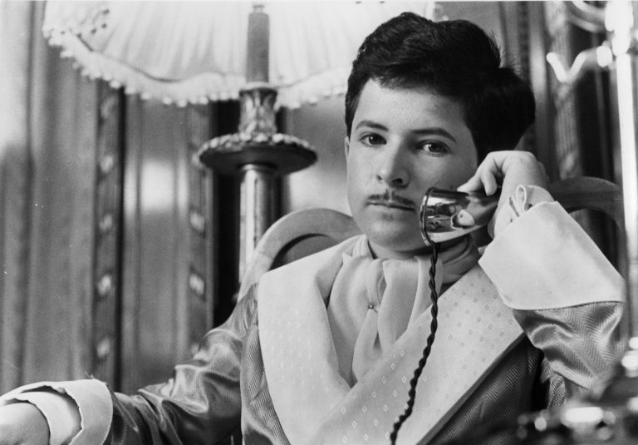
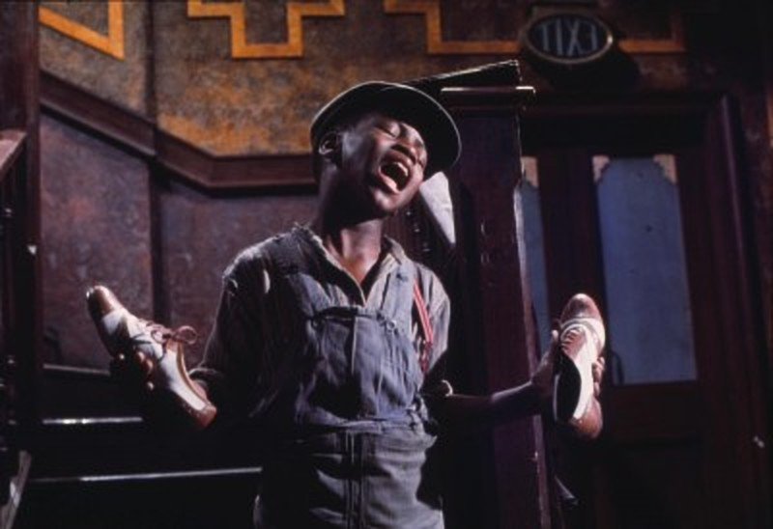
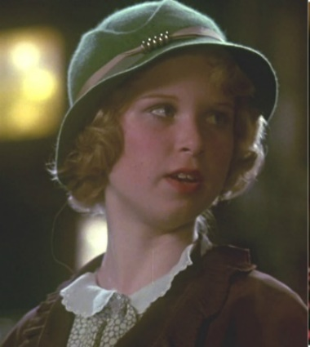
Lesson 3
GO Task: Answer the questions in the Bugsy Malone Quiz.
Golden Question: What is included in a theatre review?
- What is the name of the speakeasy the musical is set in?
______________________________________________________________________
- Who sings ‘Ordinary Fool’?
______________________________________________________________________
- What is used instead of bullets in the splurge guns?
______________________________________________________________________
- Who is Fat Sam’s rival?
______________________________________________________________________
- Which character is the cleaner of Fat Sam’s?
______________________________________________________________________
- Where is Fat Sam’s gang ambushed by the rival gang?
______________________________________________________________________
- Who becomes a boxer?
______________________________________________________________________
- Who sings ‘So You Wanna Be A Boxer’?
______________________________________________________________________
- What is the name of Fat Sam’s girlfriend?
______________________________________________________________________
- What happens at the end after the final fight?
______________________________________________________________________

BUGSY MALONE THEATRE REVIEW
Personal response:
Was I stimulated, provoked, inspired, angered, entertained, upset, bored, amused etc during this musical? Why?
_______________________________________________________________________________________________________________________________________________________________________________________________________________________________________________________________________________________________________________________________________________________________________________________

Did I enjoy the musical? Why/why not?
_______________________________________________________________________________________________________________________________________________________________________________________________________________________________________________________________________________________________________________________________________________________________________________________

What would I rate this musical out of 10?
___________________________________________________________________________

What were the best and worst aspects of the production?
Best aspects | Worst aspects

The plot:
What was the musical about?
_______________________________________________________________________________________________________________________________________________________________________________________________________________________________________________________________________________________________________________________________________________________________________________________
____________________________________________________________________________________________________________________________________________________________________________________________________________________________________________________________________________________________________________

Who were the main characters?
______________________________________________________________________________________________________________________________________________________

Was there a major theme in the play? (e.g. love, hate, family, religion etc). Give examples of this from throughout the musical: _______________________________________________________________________________________________________________________________________________________________________________________________________________________________________________________________________________________________________________________________________________________________________________________

Was the ending or plot predictable? Why/why not?
_______________________________________________________________________________________________________________________________________________________________________________________________________________________________________________________________________________________________________________________________________________________________________________________
Who was your favourite character? Why?
____________________________________________________________________________________________________________________________________________________________________________________________________________________________________________________________________________________________________________

Who was your least favourite character? Why?
____________________________________________________________________________________________________________________________________________________________________________________________________________________________________________________________________________________________________________

The costumes:
What were the costumes like? Draw a costume for a gangster and a flapper – add labels.

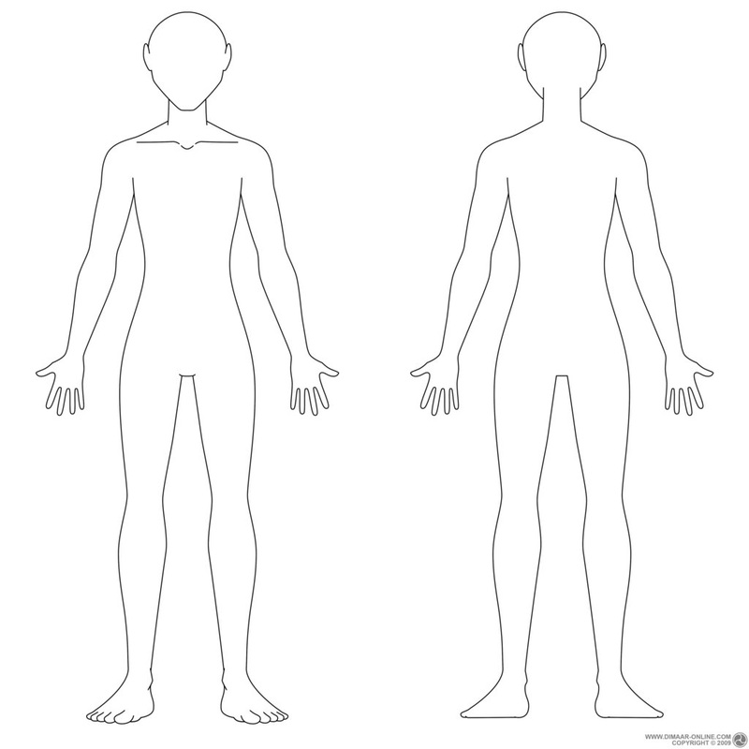

Speakeasy
____________________________________________________________________________________________________________________________________________________________________________________________________________________________________________________________________________________________________________________________________________________________________________________________________________________________________

Prohibition
____________________________________________________________________________________________________________________________________________________________________________________________________________________________________________________________________________________________________________________________________________________________________________________________________________________________________

Flappers
____________________________________________________________________________________________________________________________________________________________________________________________________________________________________________________________________________________________________________________________________________________________________________________________________________________________________

Gangsters
____________________________________________________________________________________________________________________________________________________________________________________________________________________________________________________________________________________________________________________________________________________________________________________________________________________________________

Lesson 4
GO Task: Using your knowledge organiser, find the definitions for the following words.
Golden Question: What happened in the Prohibition era?
Design the entrance to your own speakeasy. How would you disguise your illegal bar? What would be the key to enter?

Lesson 5
GO Task: Label the working stage areas on the diagram below.
Golden Question: How would you design a set for the musical Bugsy Malone?
Centre stage
Upstage
Downstage
Stage left
Stage right
Wings
Fat Sam’s Speakeasy

Cagey Joe’s Boxing Ring
Character Name Unscramble

Ybgsu Melnoa
____________________________________________________________________

Ylubsoue Bnwor
____________________________________________________________________

Taf Msa
____________________________________________________________________

Ndday Nad
____________________________________________________________________

Alllutha
____________________________________________________________________

Gacey Oej
____________________________________________________________________
Lesson 6
GO Task: Unscramble the character’s names.
Golden Question: How do the characters differ in the musical?
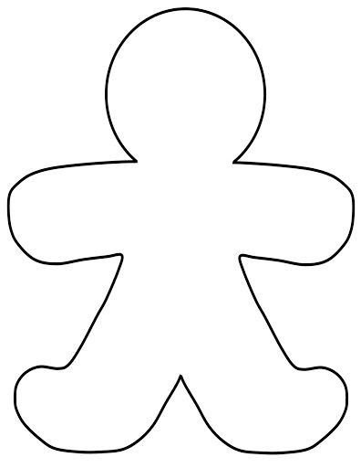
Choose two characters from the musical and compare them using the Role on the Wall worksheets. Put facts about the character on the outside and words to describe their personality on the inside.

Write a new scene for the musical which involves the characters you have analysed and compared. The scene must take place at Fat Sam’s Speakeasy, involve only two characters and last one page. Make sure you follow the structure of a script.
_______________________________________________________________________________________________________________________________________________________________________________________________________________________________________________________________________________________________________________________________________________________________________________________
____________________________________________________________________________________________________________________________________________________________________________________________________________________________________________________________________________________________________________
_______________________________________________________________________________________________________________________________________________________________________________________________________________________________________________________________________________________________________________________________________________________________________________________
____________________________________________________________________________________________________________________________________________________________________________________________________________________________________________________________________________________________________________
_______________________________________________________________________________________________________________________________________________________________________________________________________________________________________________________________________________________________________________________________________________________________________________________
____________________________________________________________________________________________________________________________________________________________________________________________________________________________________________________________________________________________________________
_______________________________________________________________________________________________________________________________________________________________________________________________________________________________________________________________________________________________________________________________________________________________________________________
____________________________________________________________________________________________________________________________________________________________________________________________________________________________________________________________________________________________________________
______________________________________________________________________________________________________________________________________________________
Character I would like to play: __________________________________________

Memory Machine
1.
2.
3.
4.
5.
6.
7.
8.
9.
10.
11.
12.
13.
14.
15.
16.
17.
18.
19.
20.
21.
Lesson 6
GO Task: Read through the script and decide which character you would like to play.
Golden Question: What is the most successful way to learn lines?

Techniques for learning lines:

