What is Reincarnation?
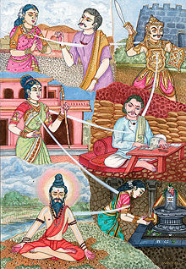
- All human beings have a soul
- Your soul can be reborn into another body after you die
- You can be reborn human, animal or spirit
- Common belief in Indian religions
- Karma – our actions affect what will happen in our next life.

Do you think reincarnation is possible?

How could we prove/disprove reincarnation?

How is reincarnation different/the same as what you believe about life after death?

Any other opinions?

