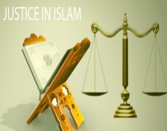

How would the following concepts be used in an Islamic discussion about Social Injustice?

|  |  |  |
| --- | --- | --- |
| Islamic idea | Relates to challenging social injustice because… | **Example?** |
| Ummah |  |  |
| Jihad |  |  |
| Tawhid |  |  |
| Akirah |  |  |
| Shariah |  |  |

**“O’ People, We have created you from a single pair (a male and a female), and We have made you nations and tribes so that you get to know each other, the best of you is the one that is most conscious of God” (49: 13)**

“Indeed, we sent our messengers with clear signs, and sent down with them The Book and The Scales of Justice that people may establish justice”(57:25)

**“I have decreed that injustice is unlawful”**

**“Say, my Lord has commanded justice” (7:29)**

**“Certainly God commands justice”(16:90)**

**The Just, the Equitable (Names of Allah)**

**“O’ you who believe, stand firm for justice and bear witness for the sake of God, even though it be against yourselves, your parents, or your relatives. It does not matter whether the party is rich or poor” (4:135)**

**“O you who believe, Be steadfast for the sake of God and bear true witness and let not the enmity of a people incite you not do justice. Be just, this is nearer to righteousness.”(5:8)**

1. **Highlight key ideas in the following 4 quotes-**
2. **Write 2-3 sentences next to each quote commenting on how these ideas relate to social justice and social injustice.**