Aspiring
Apprentices

APPRENTICESHIP VACANCIES  – Fylde area | APPRENTICESHIP VACANCIES  – Wider area
Closing date: 19th October 2023  Closing date: 26th October 2023  Closing date: 18th October 2023  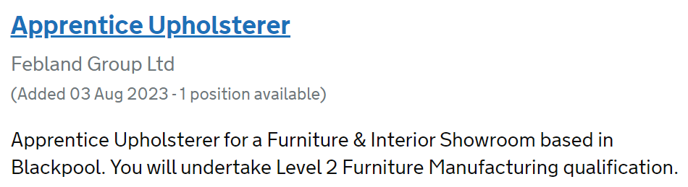  Closing date: 2nd November 2023  Closing date: 18th November 2023  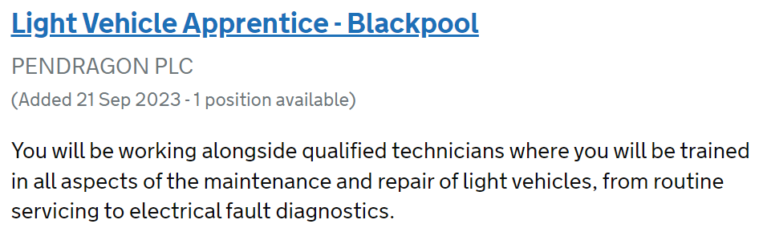  Closing date: 30th November 2023  Closing date: 2nd December 2023  Closing date: 13th December 2023  Closing date: 18th December 2023  Closing date: 18th December 2023 | Closing date: 18th October 2023  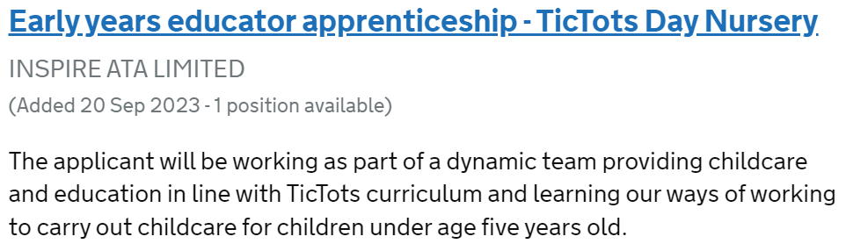  Closing date: 20th October 2023  Lancaster  Closing date: 11th November 2023  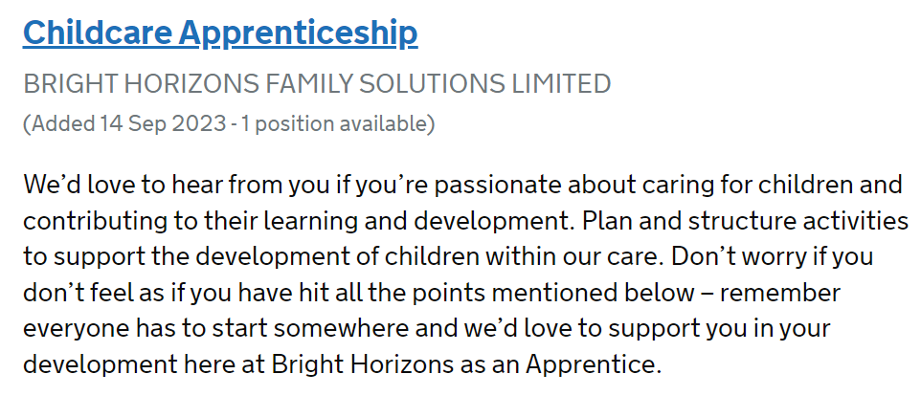  Lancaster  Closing date: 20th October 2023  Lancaster  Closing date: 31st October 2023  Preston  Closing date: 22nd November 2023  Manchester  Closing date: 23rd February 2023  Manchester  Closing date: 29th November 2023

For more apprenticeship opportunities, or to explore any of these options more closely, go to
https://www.gov.uk/apply-apprenticeship

