Slavery: The Greatest Thing For Business In Britain:

Slavery, the biggest money maker for Britain in the 18th century. Europe would transport goods in exchange for African slaves, which would then be sent to North America to farm goods, load the boats up and stay, as the boats would leave to go back to Europe, the slaves would stay; farming for the British on high work low and barely enough food to eat. Slaves were overworked and beaten, but do you think this was acceptable? Do you think these innocent people should have been treated this way for money?

So why was slavery abolished you ask? Why would they get rid of something that was generating mass amounts of money a year? Well, not everyone was happy, after just a century, it was abolished in March of 1807. Many people contributed to this abolish, William Wilberforce was a key figure, campaigning tirelessly against the Slave Trade. Julian Fedon led a violent slave rebellion in 1795 and Josiah Wedgewood joined the anti-slavery side and designed an iconic logo.
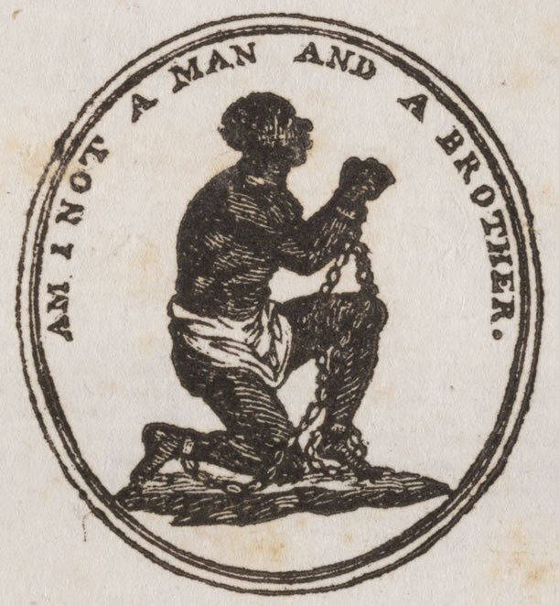

What really cut it though? What was the final straw to end it? Well, many sugar farms in North America were starting to close down due to sugar becoming very cheap to import from Brazil; this meant that less slaves were needed. Also, people's beliefs must’ve had an input. Many Quakers had thought that slavery was a sin to God, at the time, Religion was a very big part of life. Also, The Society for the Abolition of the Slave Trade was set up in 1787, this meant that people could get together and discuss views on the Slave Trade. Between 1730 and 1797, there were slave rebellions against the English, and an ex slave had written a book about his life as a slave, which had changed many Brits opinions.

Many protests against the English government took place in the century. Many Anti-slavery petitions were signed and given to Parliament In 1791. A freed slave led a slave revolt on an island in France. Slaves in England went to court to get their freedom and Granville Sharp used the law courts to give slaves their freedom. Eventually, The Houses Of Parliament voted to end legal slavery in March of 1807. So, thats how the Slave Trade was abolished.

Gabe

