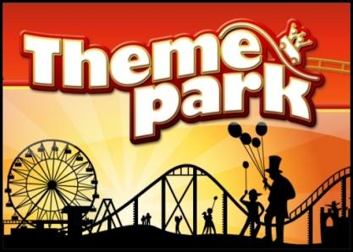
Theme Park Logo Design
Design 3 potential logos for your Theme Park
WONDERLAND THEME PARK!!! | WONDERLAND THEME PARK!!! | WONDERLAND THEME PARK!!!

Now write about which logo you prefer and why?
I prefer the 2nd one because my theme will open at night and the place will be shining with lights everywhere. There will be a place to see the stars and it will be high and shiny.

