Subject | Workbook | Online
Art | Continuing with the theme Human Figure:  Produce a research page on the work of Slinkachu. | https://classroom.google.com
Business | Read page 22 – 24 about Product. Make flashcards covering the key terms; a mind map explaining the PLC and Boston Matrix and how they work and answer the exam questions. | https://classroom.google.com  Under the topic 25th Feb – The Marketing Mix & Product, watch the video which guides you through the learning and complete each of the tasks
Digital Technologies | Read page 33 – 37 about using technology to store data. Make flashcards covering the key terms; a mind map explaining the different methods and how they work and answer the exam questions. | https://classroom.google.com  Under the topic 24th Feb – Using Tech to Store Data, watch the video which guides you through the learning and complete each of the tasks
English | New booklet for language paper 1. Work through the booklet and complete the tasks. | https://classroom.google.com  Attend live lessons/ loom lessons if you can and complete the work then share it with me or send pictures.
Geography | This is a revision task about the Tropical Rainforest section. Using the Aspire paper revision guide or the revision book complete the grid questions. Go through the syllabus question sheet, how well do you know the topic? | Use the revision guide and your note since January to complete the google slide revision slide. There are attached exam questions to help you on the classroom.  https://classroom.google.com
History | .Read all of notes 1.5, 1.6 & 1.7 in your work book and complete all tasks. | https://classroom.google.com  Attend live lessons or watch loom presentations and complete all tasks.
Maths | There is a new work booklet to be collected from school, please complete part 2 | https://classroom.google.com
MFL | In your workbook  1 Read and take notes on where you live p60  2 Complete the reading question on p60  3 Write a paragraph in French of 40 words describing where you live. | https://classroom.google.com  Complete the lesson under the topic week beginning 22 February
Performing Arts | Work on your component 1 presentations for West Side Story. | https://classroom.google.com  Work on your component 1 presentations for West Side Story.
Health and Fitness | If you are working on paper you need the revision booklet that you were all given. If you don’t have it then contact the school and we will get another one to you.  Synovial Joint Structure and Movement  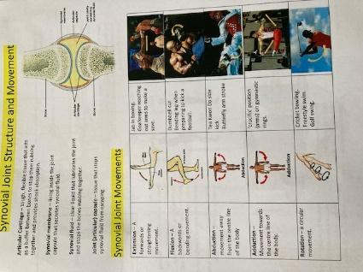  Your task Read through the information on each section of the page. Take notes on each and try to remember all key facts and labels. | https://classroom.google.com  Open up my loom video and play it as you work through the Google Slides presentation that goes with it.  After you have completed the slides, use the knowledge that you have gained to attempt the quiz.
PE | Complete the following circuit programme  Warm up  30 seconds jogging on the spot  Heel flicks (30 seconds)  Stretches (1 minute)  Main workout  25-star jumps  20 squats  30 walking lunges  18 press ups  45 seconds Arm circles  30 mountain climbers  Plank (35 seconds)  25 Air punches  Cool down  Light stretches | https://classroom.google.com  There will be a number of tasks set in the google classroom this week.  1.Remote Learning workout  2. Remote learning quiz  Don’t forget you could also complete the Joe Wicks workouts (Monday/Wednesday/Friday) if you wish to be more active.
RE | Using pages 46 to 55 of the revision guide answers the questions on page7 to page 27 in the Islamic practices booklet. | https://classroom.google.com  Complete the work set on google classrooms Death and afterlife.. Make sure you take part in the live lessons and watch the loom video’s for extra help.
Science | Use the AQA GCSE 9-1 Combined science trilogy to complete the following:  - Read through pages 140 - 141  - Complete the practise questions on page 155  - Complete the questions on page 175  Use pages 140 - 141 to create your own resource (poster/leaflet/spider diagram) about the Chemical Analysis unit. | https://classroom.google.com  Combined science:  https://senecalearning.com/en-GB/ Class code: s7ldbd0c7b  Separates science:  https://senecalearning.com/en-GB/ Class code: pyzonq00f6
Hospitality & Catering | Complete the worksheet on nutrition, menu planning & costing. | https://classroom.google.com
PHSE | Studentents to work throught the sheets ‘same sex relationships’.  Complete the reading out loud activity then work through the case study.  Send a picture of completed work to your call teacher. | https://classroom.google.com

