Subject | Workbook | Online
Art | Produce an A4 drawing of one of your artist images linking to HUMAN FORM. Look at your research and produce a drawing of a piece of their work.  If you do not have the research find a magazine or newspaper and find an image of a HUMAN FORM. Draw it on the A4 paper. | https://classroom.google.com
Business | Using your revision guide, focus on pg. 12 - 14. Turn the key terms into flash cards, create a revision clock for Sole Trader; create a revision clock for Partnership; create a revision clock for Limited Company. Create a revision mind-map about the advantages and disadvantages of those three types of ownership. | https://classroom.google.com  Look at the Topic “Legal Structures - Part 1” and watch the video. As you watch the video, pause it and complete the other tasks as directed. Use the Golden Task Plan to help you tick off the tasks as you complete them.
Digital Technologies | Use your revision guide, focus on pg. 14 - 22. Turn the key terms into flash cards, create a revision clock each type of planning tool. Create a revision mind-map about the advantages and disadvantages of planning tools. | https://classroom.google.com  Look at the Topic “Project Documentation” and watch the video. As you watch the video, pause it and complete the other tasks as directed. Use the Golden Task Plan to help you tick off the tasks as you complete them.  Also, where possible, continue working on Progress Cakes.
English | Work through the revision packs for language paper 2 and have a go at the practice papers at the end. | https://classroom.google.com
Geography | - Read the Golden Task Plan.  - Read the Living World information sheets  - Complete the ‘Living World tasks.  You can also make notes from your blue GCSE revision guide, pages 39-40. | https://classroom.google.com  Complete this week’s assignment on ‘The Living World’. Use the Golden Task Plan to help you complete all the tasks in the correct order. Please contact Mr Tock through Google Classroom if you have any questions.
History | - Using your revision book read pages 100-1032and make notes.  - Answer exam question on P102 Q. Why did England defeat the Spanish Armada in 1588? This question is worth 8 marks so should be between 2 and 3 paragraphs. | https://classroom.google.com  Golden Question: Did the English cause the defeat of the Spanish Armada?  Task 1 complete google form  Task 2 watch loom presentation  Task 3 complete the account exam question  Task 4 complete the interpretation exam question.
Maths | Complete the review section of term 1 from the booklet. | https://classroom.google.com
MFL | 1 In your workbook, read and takes notes on pages 83-84 healthy and unhealthy living.  2 Using the CD at the back of the workbook, complete the listening activities on page 86. | https://classroom.google.com
Performing Arts | Work on your component 1 presentations for West Side Story. | https://classroom.google.com  Work on your component 1 presentations for West Side Story.
Health and Fitness | If you are working on paper you need the revision booklet that you were all given. If you don’t have it then contact the school and we will get another one to you.  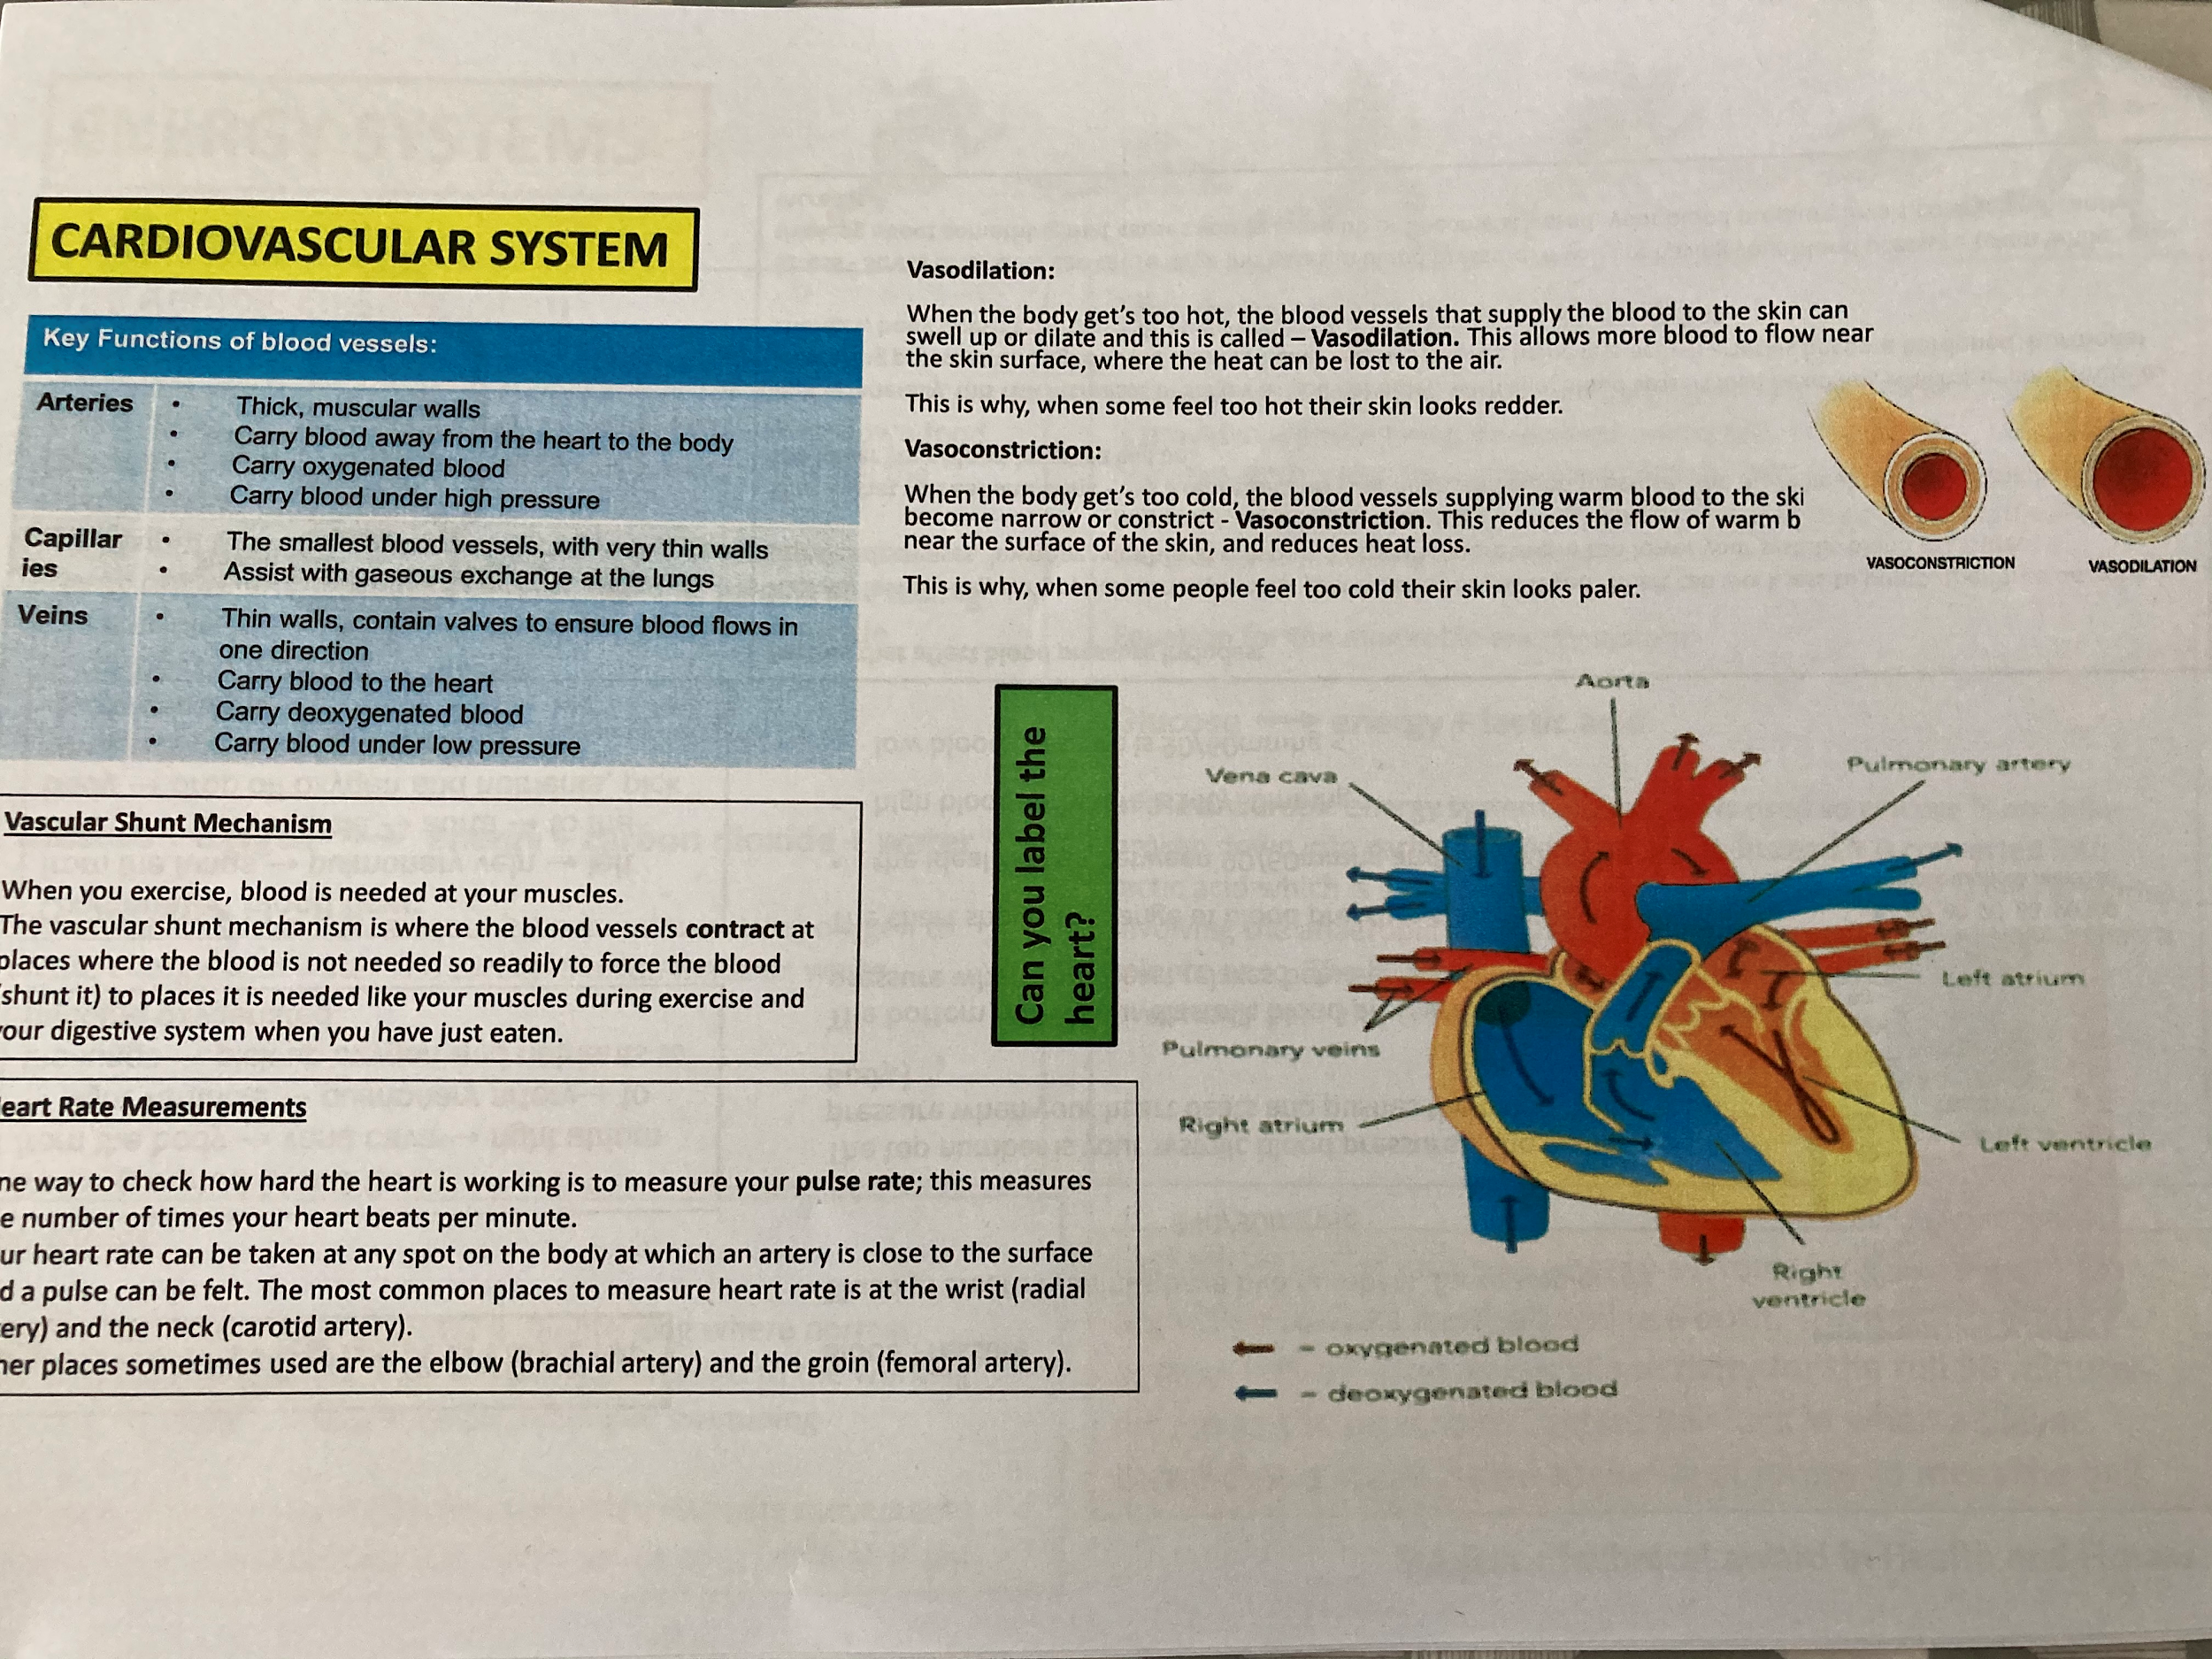  Your task Read through the information on each section of the page. Take notes on each and try to remember all key facts and labels.  Try the following techniques to help you learn:-  - Look, cover, remember and write on a note.  - Create small flash cards with bits of information on them.  - Get someone in your house to come in and test you on it.  - Try to draw the diagram from memory on some paper. | https://classroom.google.com  Open up my loom video and play it as you work through the Google Slides presentation that goes with it.  After you have completed the slides, use the knowledge that you have gained to attempt the quiz.
PE | Complete the following circuit programme  Warm up  30 seconds jogging on the spot  Heal flicks (30 seconds)  Stretches (1 minute)  Main workout  15 star jumps  10 squats  20 walking lunges  10 press ups  30 seconds Arm circles  20 mountain climbers  Side plank (30 seconds each side)  Cool down  Light stretches | https://classroom.google.com  There will be a number of tasks set in the google classroom this week.  1.Remote Learning workout – week 3  2. Teacher Challenge  3. Remote learning quiz – week 3  4. Joe Wicks workouts (Monday/Wednesday/Friday)
RE | Using pages 28 to 41of the revision guide answers the questions on page 6 to page 23 in the Christianity practices booklet. (GCSE option only) | https://classroom.google.com  Read through the google sheets on the value of the world. Complete the task set on the powerpoin.  Non- option class. Class code: 2nabji4  https://classroom.google.com/c/MjQ5Nzk5MzQ1OTUw?cjc=2nabji4
Science | Use the AQA GCSE 9-1 Combined science trilogy to complete the following:  - Read through pages 158 to 169  - Complete the practise questions on pages 178 - 180  - Complete the questions on pages 198-190  Create a mind map for the forces unit.  Use the glossary to create flashcards for the key words in this topic.  At the end of the week, complete the exam questions.  Mark the exam questions using the mark scheme. | https://classroom.google.com  Combined science:  https://senecalearning.com/en-GB/  Separates science:  https://senecalearning.com/en-GB/
Hospitality & Catering | Complete the following pages in the WJEC Catering revision book:  - Culinary terms  - Exam questions  - Equipment in the food room  - Powered equipment  - Exam questions  - Job roles  - Types of employment  - Exam questions | https://classroom.google.com
PHSE | To start PSHE after Feb half term. | https://classroom.google.com

